实验编号：实验004
实验题目：新的迭代面向对象设计
实验日期：2026-05-06
实验内容：
用户需求：
小强要离校外出实习，找了好友小雨帮忙，并告诉了华经理。小强简单介绍了背景、进展，把程序都教给了小雨。特别告诉小雨，华经理对程序没有清晰、完整的想象，经常增加新的功能，有时候会改变一些需求。小雨正刚刚学完面向对象技术，正想练习一下，就参考小强的描述和程序，重新编写程序。

分析：
- “把程序都教给了小雨……”：其实是第2章的程序示例。Public class Exercise ……
- “华经理对程序没有清晰、完整的想象，经常增加新的功能”：需求经常在改变，更应该注意“高内聚、低耦合”的设计原则，抽象出对象，减少类、对象的改变对整体程序的冲击；
- “学完面向对象技术，正想练习一下”：应该使用Java程序，加入类的设计。

实验报告：
- 构建并运行P69案例设计一，要求：（a）包含BinaryOperation类（b）包含Exercise3_1类（c）补全缺失代码
- 画出UML类关系图（可以拍照、vscode、visio等作图）

案例设计一的完整代码：
#include <iostream>
#include <vector>
#include <set>
#include <cstdlib>
#include <ctime>
#include <string>
#include <iomanip>
#include <algorithm>

using namespace std;

class BinaryOperation {
public:
virtual bool valid(int a, int b, int max) const = 0;
virtual string symbol() const = 0;
virtual int calc(int a, int b) const = 0;
virtual ~BinaryOperation() {}
};

// 加法运算
class AddOperation : public BinaryOperation {
public:
bool valid(int a, int b, int max) const override {
return a + b <= max;
}
string symbol() const override {
return " + ";
}
int calc(int a, int b) const override {
return a + b;
}
};

// 减法运算
class SubOperation : public BinaryOperation {
public:
bool valid(int a, int b, int max) const override {
return a - b >= 0;
}
string symbol() const override {
return " - ";
}
int calc(int a, int b) const override {
return a - b;
}
};

struct Question {
string expr;
int answer;
};

class Exercise {
private:
int total;
int maxNum;
vector<BinaryOperation*> ops;
vector<Question> questions;

public:
Exercise(int tot, int maxVal, const vector<BinaryOperation*>& opList)
: total(tot), maxNum(maxVal), ops(opList) {
generateUniqueQuestions();
}

// 去重
void generateUniqueQuestions() {
set<string> seen;
questions.clear();

while ((int)questions.size() < total) {
int a = rand() % (maxNum + 1);
int b = rand() % (maxNum + 1);
BinaryOperation* op = ops[rand() % ops.size()];
if (op->valid(a, b, maxNum)) {
string expr = to_string(a) + op->symbol() + to_string(b);
if (seen.find(expr) == seen.end()) {
seen.insert(expr);
questions.push_back({expr, op->calc(a, b)});
}
}
}
}

// 打印练习题
void printExercise() const {
if (questions.empty()) return;

int serialWidth = to_string(questions.size()).length() + 1;
int maxExprLen = 0;
for (const auto& q : questions) {
if ((int)q.expr.length() > maxExprLen)
maxExprLen = q.expr.length();
}

cout << "\n=== " << maxNum << " 以内练习题 ===" << endl;
for (size_t i = 0; i < questions.size(); ++i) {
cout << setw(serialWidth) << i + 1 << ". ";
cout << left << setw(maxExprLen) << questions[i].expr;
cout << " = ______" << endl;
}
}

// 打印答案
void printAnswers() const {
int serialWidth = to_string(questions.size()).length() + 1;
cout << "\n=== 参考答案 ===" << endl;
for (size_t i = 0; i < questions.size(); ++i) {
cout << setw(serialWidth) << i + 1 << ". " << questions[i].answer << endl;
}
}

// 获取题目数量
int getTotal() const { return total; }
};

int main() {
srand(time(nullptr));

int total, maxNum;
cout << "请输入题目数量：";
cin >> total;
cout << "请输入约束条件（最大数值）：";
cin >> maxNum;

AddOperation add;
SubOperation sub;

//全加法习题
vector<BinaryOperation*> onlyAdd = {&add};
Exercise addEx(total, maxNum, onlyAdd);
addEx.printExercise();

//全减法习题
vector<BinaryOperation*> onlySub = {&sub};
Exercise subEx(total, maxNum, onlySub);
subEx.printExercise();

//混合运算习题
vector<BinaryOperation*> mixed = {&add, &sub};
Exercise mixedEx(total, maxNum, mixed);
mixedEx.printExercise();

//是否打印答案
char choice;
cout << "\n是否打印全加答案？(y/n): ";
cin >> choice;
if (choice == 'y' || choice == 'Y') addEx.printAnswers();

cout << "\n是否打印全减答案？(y/n): ";
cin >> choice;
if (choice == 'y' || choice == 'Y') subEx.printAnswers();

cout << "\n是否打印混合答案？(y/n): ";
cin >> choice;
if (choice == 'y' || choice == 'Y') mixedEx.printAnswers();

return 0;
}
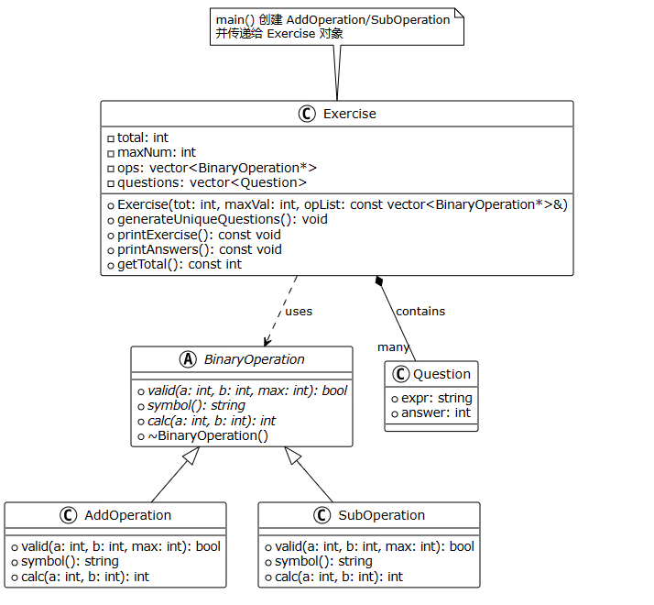

参考文献：
1.
2.

