Traditional Platform Structure
Match the Customers with the Producers (Vendors) through a platform (Disruption of traditional brick-and-mortar)
Dr Roy Schoenberg - Converge Clinical Broker Engine/Switchboard
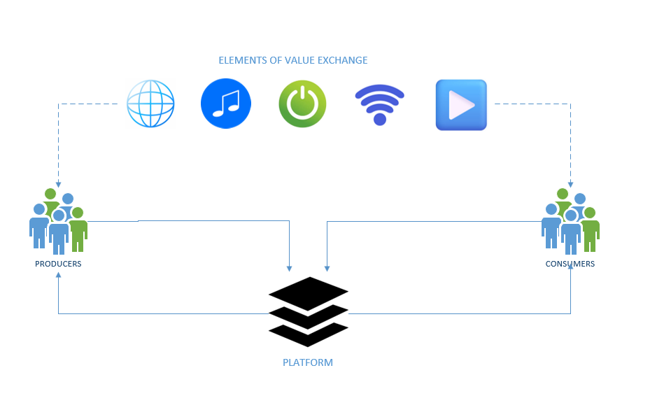
Market Platform (Dr Randy Willams & Dr Vince Kuraitis)- Father’s of the healthcare platform
- Curating Vendors
  - Identify reliable sellers who add value
- Attracting Customers
  - Attract people
  - Solicited customer feedback and recommendations
  - Network effect – more customers attract more vendors that attract even more customers
- Matching Customers Needs to “Best Fits” Vendors
  - The more the customer uses the platform the better the platform can identify customers likes vs dislikes
  - Platform provides suggestions to products and services
  - Platform attributes
    - Ease of use
    - Transparency
    - Options
  - The better the attributes a platform has the better it becomes to providing a customer “best fit”
  - Traditional business models compete on cost, quality, and market breadth, focusing on value chain based on intellectual property, resources, geography, and brand called mergers and acquisitions (M&A) to grow. Platform ecosystems can help organizations improve and expand their services as they tap into the expertise of other organizations.
Connection and Collaboration
The whole is great than the sum of its parts. Aggregating all the resources in the world providing to provide the best personalized concierge experience to your customers.
The EHRs silo issue.. data is not shared on a platform, no transparency or ability to compare providers or retrieve detailed descriptions.
Next-gen healthcare platforms will have robust infostructure, network capabilities, and exceptional customer experience. – “NETWORK EFFECT” – diverging from traditional model the 100th customer benefits far better than the first customer in the system. Platform enables you to customize your user experience as you interact with it more utilizing AI and analytics.
How the platform benefits stakeholders
Flywheel – platform strategy – ei:Amazon Prime example
The objective is to make user interactions a “daily habit”
4 factors that will drive healthcare platform adoption (Vince & Randy)
- Value- Based Care and Payments
  - Open alternative payments outside of FFS systems while lowering cost
  - Incentivize referrals to the best services
- Consumerism
  - Informing customers to empower them to make informed decisions on their own healthcare.
- Home-Based Care Ecosystems and Virtual Care
  - Streaming healthcare providing services at the convenience of the home or personal device (24/7) care model.
- Interoperability and data Sharing
  - Share information through platforms that connect with stakeholder patient, beyond the current digital wall where data is captured and is siloed. Transitioning the data in the hands of the consumer fosters access, sharing, communication, and consulting freedom.
Implication of healthcare leaders
Titans – Flywheel effect, decades of consumer orientation, Convivence, Strong customer base
Walmart, CVS, Best Buy, Amazon
Humana, United Health – payviders –

