Movement to more humanistic equitable
- The Senior care movement – unprecedented number of seniors needing care
  - Baby boomers by 2060 there will be 95 million people over 65 compared to 56 million in 2023.
  - Older people are more likely to live alone
  - Have 543 % increase in total debt for individuals over 70
  - Future seniors will be less likely to have pensions or adequate retirement plans
  - Life expectancy continues to grow
  - 80% of seniors over 65 have chronic diseases and 68% have comorbidities
  - Clinical resources shortage there is 1 geriatrician for every 10,000 seniors and that gap is projected to widen further by 2030 by a fifth of the previous estimate, this gap causes clinical burden to our general PCPs and weaken care support for seniors that require specialized palliative, hospice, nursing home, and cognitive care.
  - To address this, we have Medicare part C & D to address the Fee-For Service model (FFS) – but this policy was too general and does not address the needs specific to the senior population
  - Senior Care Clinics to address FFS payments and limit general primary care. Limiting Medicare Advantage payments to monthly rate.
    - Landmark Health – Dr. Mike Le (home-based medical care model)
      - Offering blood tests, x-rays, ultrasounds, IVs, catheter replacements, wound care, and suturing to the elderly at home, resulting in 26% reduction in mortality rates
        - 4 Pillars
          - 24/7 care model
          - SDOH identification model
          - Palliative care training requirements
          - Embedded Pharmacist team
          - Frequent touch points with patients to monitor care.
    - Papa – Andrew Parker – Loneliness increases the odds of death by 26%
      - Companionship, transportation, and additional assistance
      - These services are fully covered by Medicare because the produce better patient outcomes at lower costs – less emergency visits and hospital admissions. “10x” – strive to be ten times better than the nondigital product!
    - ChenMed Platform - Dr Chris Chen
      - Senior Concierge services
      - Scaling back patient ratios from 700:1 to 400:1
      - Monthly frequent well visits to the patient
      - SDOH offering additional services to their patients like transportation and social gatherings
      - Holding their clinicians to high accountability standards and bootcamp training.
      - Medicare Advantage payments per month basis per member not FFS
- The Contextual care movement – approach to have a deeper understanding of significate factors that impact patient care
  - Personalize SDOH factors
  - Contextual issues can be the root cause ie: loss of family member, financial stress
    - Laguna Health – (Veterans Health Affairs - VHA) Dr. Saul Weiner & Dr Alan Schwartz – using AI to systematize contextual care targeting readmission rates within 30 days – reducing CMS penalties
      - Laguna 3 prong approach
        - “Choose your own Journey” - A technology enabled solution with multimodal patient interfaces (telephonic, digital app, and family/caregiver app)
        - “Harmony” - A care management platform
        - “Care Engine” - A care engine to orchestrate everything and integrate the clinical and contextual pathways
    - Find out more about the individual before providing advise – addressing quality of care issues
    - 1 in 8 failure if contextual issues were not addressed
    - Contextual errors are the number 1 reason patients develop serious posthospital recovery failures
    - Contextual care is about understanding the patient’s life issues – challenges in life circumstances or challenges in behaviors
      - Contextual care checklist
        - 6 domains of Contextual issues based on the patient’s healthcare situation – pg 109
          - Access to care
          - Competing responsibilities
          - Social support disruption
          - Financial issues
          - Change in environment
          - Change in Resources
        - 6 domains of Contextual issues based on the patient’s behavioral or interpersonal circumstances – pg 110
          - Skills, abilities, and knowledge
          - Emotional State
          - Cultural perspectives and Spiritual beliefs
          - Attitude toward illness
          - Attitude toward the provider and the healthcare system
          - Health behavior

      - Asking questions
        - Take the time to ask questions
        - Learning to ask the right questions
      - Addressing gap in contextual care protocols
        - Pick up on clues that the patient is experiencing a contextual issue
        - Ask “fearless questions” that directly address the contextual issue. These questions may feel uncomfortable, but they are necessary to get at the true reality of the situation and patient is encountering
        - Continue probing until you can identify the root cause of the contextual issue.
        - Create a plan of care to address that issue.
- The Whole Person Health movement – going beyond treating clinical ailments, widen focus on the patient’s overall health. Understand the patient medical and human needs such as emotional, relational, spiritual needs, and sense of purpose and SDOH.
  - VHA’s Whole Health Program- Dr Ben Kligler - Widen the Aperture of whole health
  - Individuals that have a low sense of purpose is associated to health and longevity. Purpose is a way to live a longer life even in the harshest conditions observed among holocaust survivors.
  - The Good Life – Dr. Robert Waldinger Psychiatry at Harvard - 5 key insights on relationships as core social determinant of health (SDOH). There are 3 components to Whole Health
      - Assessment is Personal Health Inventory (PHI)
        - Choose your own Adventure from the Wheel of Health
        - Setting personalized goals
      - Well Being Program
        - Access to nutrition, Tai Chi, Yoga, Meditation, and Health coaches
        - Access to Therapies such as acupuncture, biofeedback, and clinical hypnosis
      - Whole Health Clinical Care
        - Regular medical visits with Care team (PCP or Specialists)
        - Peer-to-peer interactions (peer coaches and health coaches)
    - Good relationship keeps us happier and healthier. Loneliness shortens lives
    - Relationships require active maintenance; determinant of health and longevity should be on patient’s problem list. If not addressed they can lead to high mortality rates
    - Relationships of all kinds matter (family, friends, coworkers, and even casual relationships). Learning how to navigate these challenges is critical
    - Maintaining and nurturing relationships require time, intention, and commitment. Action plans are required to maintain healthy relationships
    - It’s never too late to improve relationships and connect with others in a positive way influence health outcomes.
    - Help decrease clinician burnout by allowing care team to reframe their experience with connecting with patients in a healthier manner.
    - Decrease in mental health pharmacy cost from 12.5% to 3.5%
Decrease outpatient pharmacy cost from 15.8% to 4.3%
Projected decrease in healthcare spending in 2040 from 11.8 trillion to 8.3 trillion.

    - Wheel of Health of self-care
      - Nutrition
      - Physical activity
      - Mindfulness
      - Relationships
      - Personal development
      - Spiritual health
      - Recharging
      - Physical & Emotional surroundings
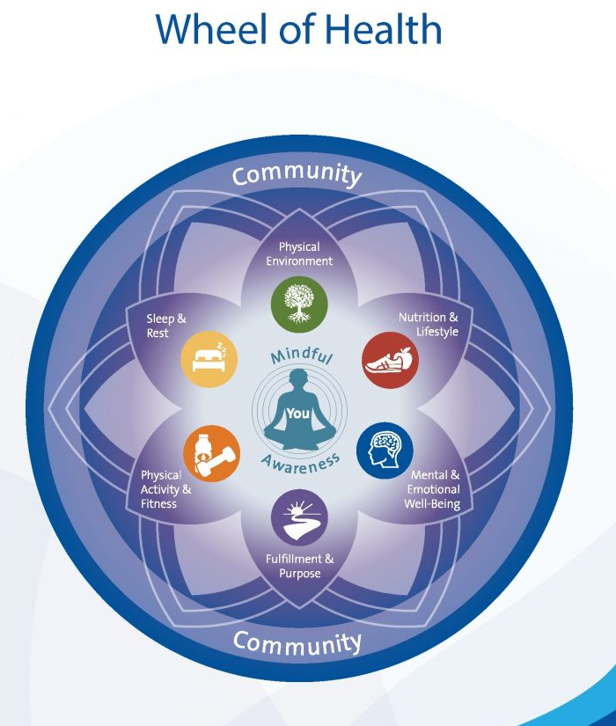
  - Whole Health focus on relationships motivators for healthy behaviors.
  - The two essential whole health questions
    - What is most important to you, in your life, right now?
    - What is the thing that you would be willing and able to do today or tomorrow to move closer to that?
Inequity cost $320 billion and is expected to grow beyond $1 trillion by 2040 if not addressed.
Despite the growing evidence for Whole Health approach, there are disparities on what Whole Health encompasses in the community. Access and affordability obstacles along with challenges with FFS payment model makes “well-being” difficult to implement beyond the VHA.

