- Who are their major partners?
- If the company is a startup, who is funding them, and how much funding have they received?
- Do they sell hardware, software, services, or a mix? What is their business and/or delivery model? How do they make or plan to make money? What are their most significant products?
AKASA was founded in 2018 by Malika Walaliyadde, Varun Ganapathi, Ben Beadle-Ryby, and Andy Atwal. All four of these co-founders remain actively involved in AKASA’s operations.
The companies primary focus is on revenue cycle optimization. The offer many software solutions in this area, from coding, CDI and prebilling optimizations to claims and authorization status management, and finally AI advisory solution to help document retrieval and payer inquiries.
The Cleveland Clinic also announced its’ partnership on December 23rd, 2025, with AKASA through their implementation of AI-powered solutions improving billing and claims processing transforming patient care.
Malika Walaliyadde is CEO and Ben Beadly-Rybe is the CRO of AKASA, while Andy Atwal is VP of engineering with Varun Ganapathi as advisor. They also have an extensively reputable board membership team comprised of the following Julie Yoo, Noah Knauf, Frank Williams, Toby Cosgrove, Amy Raymond, Ryan Roland, and Zach Barrett.
In addition to their strong founder ship, they also have prestigious partnerships with Andreesen Horowitz, Bond Capital, Jim Momtazee, and Costanoa Ventures. Their Series A was started in June of 2020 with a16z as (lead investor), Jim Momtazee and Costanoa Ventures. Then they raised total of 60 million dollars from Bond Capital (lead investor), a16z and Costanoa Ventures on Series B transactions on March 23rd, 2021. Since than AKASA total equity has risen to 200 million dollars.
AKASA utilizes a Software as Service (SaaS) model, customers are charged based on the utilization of their products.

References:
- https://akasa.com/solutions/
- https://akasa.com/leadership
- AKASA | LinkedIn
- https://www.thecompanycheck.com/company/b/akasa/7rsqhwebebgtub19s
- https://www.beckershospitalreview.com/healthcare-information-technology/ai/cleveland-clinic-taps-ai-to-streamline-medical-coding/
- https://newsroom.clevelandclinic.org/2025/04/29/cleveland-clinic-and-akasa-announce-strategic-collaboration-to-launch-ai-tools-for-the-revenue-cycle
- https://a16z.com/announcement/investing-in-akasa-pka-alpha-health/

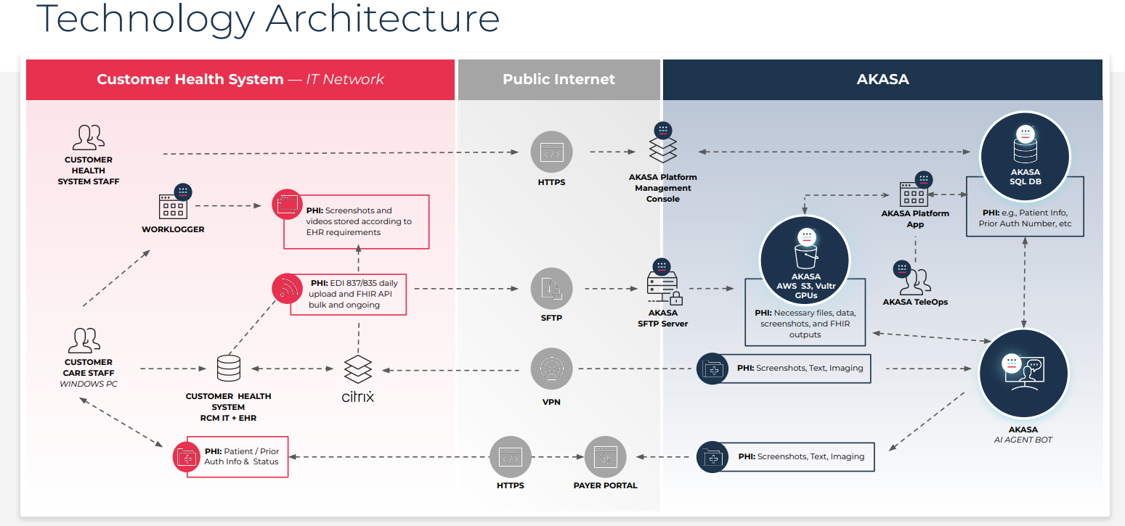
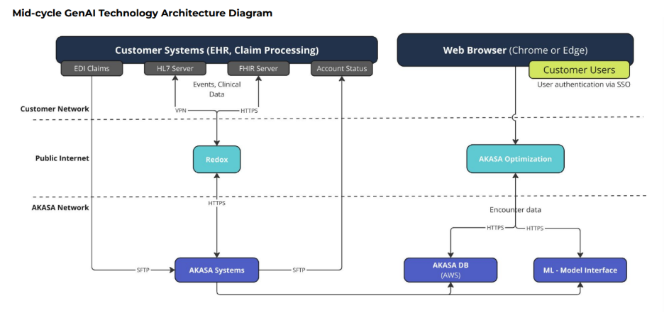
Technology stack analysis:
The solution is uses TypeScript and Python programming languages and implements Fast API back end and React for front end. For storage AKASA uses AWS Aurora/RDS & RedShift.
At the heart of our proposal is the AKASA Optimization Suite, an integrated prebill platform combining our Coding Optimizer and CDI Optimizer into a unified, AI-powered solution.
AKASA maintains an overall Resilience Program performs an annual penetration testing, regular vulnerability scanning, annual risk assessment, and annual HITRUST/SOC 2 audits. Encrypted backups with tested recovery procedures. Documented DR plan aligned with HIPAA and HITRUST. Supports RPO/RTO requirements of healthcare partners. Data centers compliant with ISO 27001, HIPAA, and HITRUST and maintain access logging, monitoring, and incident response in place.

