Ambiguity found in classification of the values on the readmitted field. The designation of ‘NO’ could be mis-interpreted as a missing value. Since we are focusing our study on patients with readmission within 30 days. I have created a numerical translation of this field with the value ‘1’ to indicate patients with ‘<30’ and ‘0’ for entries with either ‘NO’ or ‘>30’ on the readmitted field. By grouping entries in this fashion, I was able to group the patients by age to determine which age ranges had the highest readmission rates.
In the diagram below we observe most readmissions are from age 20 to 30 group; however, if we review the data in its entirety, we can see this group is underrepresented and could be interpreted incorrectly.
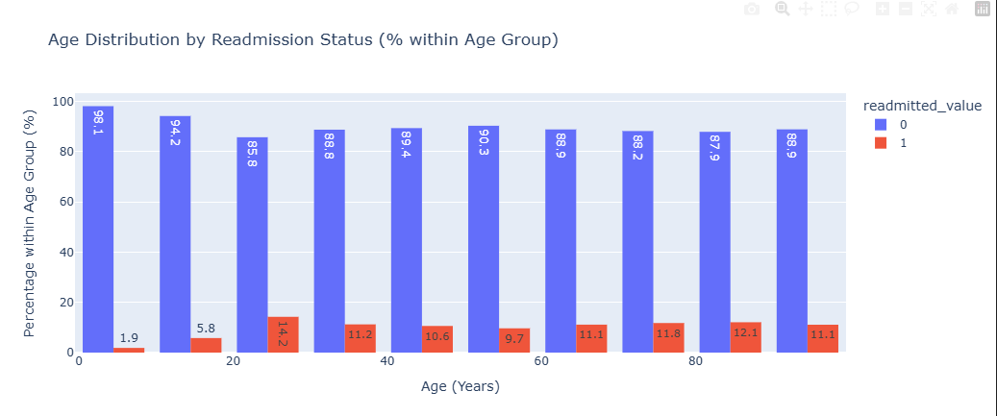
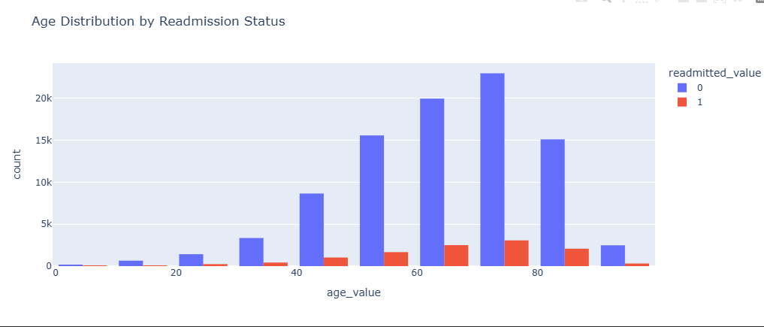
The primary diagnoses of 428 – Heart failure is the most represented accounting for 14.2% of the patient’s readmission. Followed by diagnoses code 414 – Chronic heart disease at 9% and code 410 – Acute myocardial infraction representing 10% of the population. This indicates patients with heart conditions are at a higher risk of readmission.
If the data is sorted by the median value, it would indicate a different story, V58 – Post Procedures representing 41%, followed by code 250.41 – Diabetes mellitus at 26% and diagnoses code 567 – Intestinal obstruction representing 24.5%.
I would say both analysis is important to review but can be deceiving depending on the way we would like to proceed with our research.
Should we focus on the largest percentage of patients with readmissions based on their primary diagnoses or do we want to emphasize what is representing the majority of our patient’s encounters?
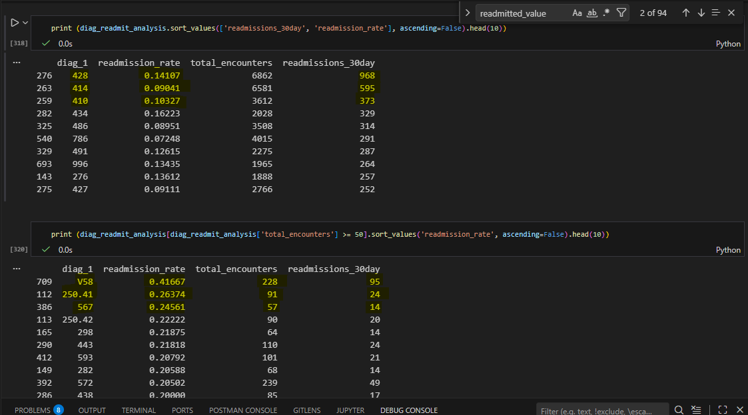
Next, I examined admission type, discharge disposition, and number of medications as it relates to readmission rates with the raw data, next the clean dataset, and finally with the clean dataset without medication columns. With the aid of this visualization, we can easily determine the encounters are mostly from an acute care unit. This information aligns with the behavior observed on the weight field as many are blank. Other key factor is the number medications, we see majority of patients that are receiving 20-30 medications are among the highest in readmissions and most are from home setting with no support, this indicates a trend that might need further examination.
Additionally, while the matrix between the cleaned with medical columns and without medical columns did not produce any differences, inclusion of the different medications may provide additional support in determining correlations of readmissions rates based on medication fluctuations.
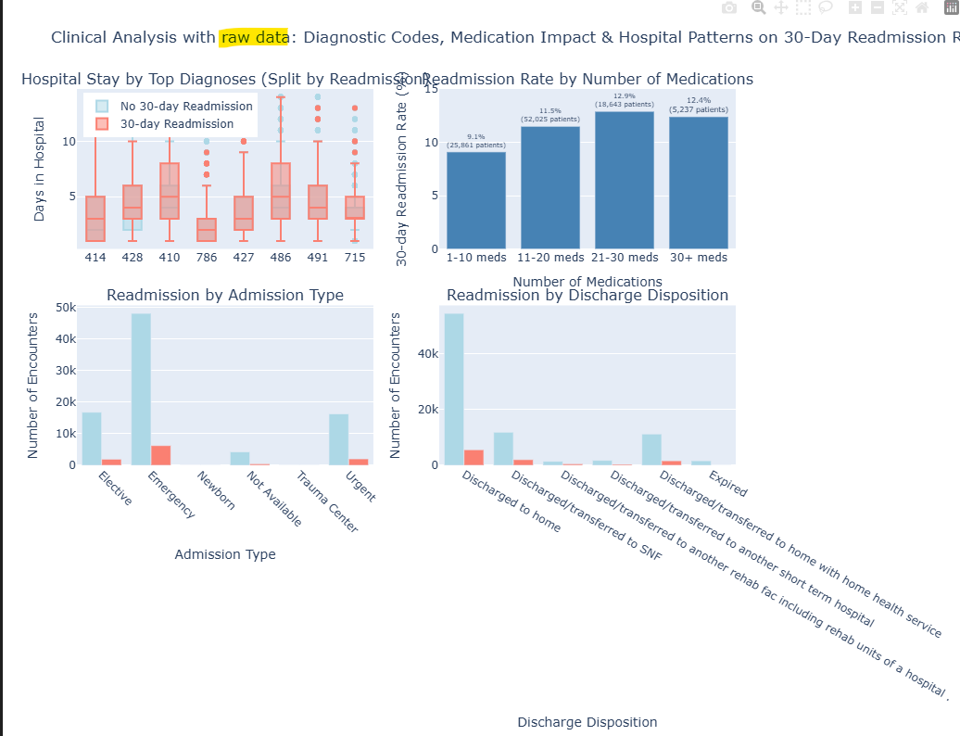
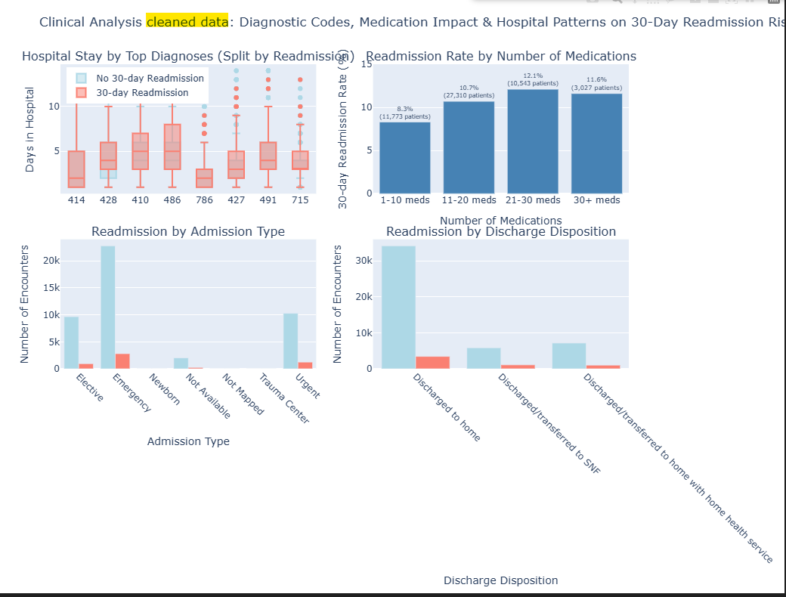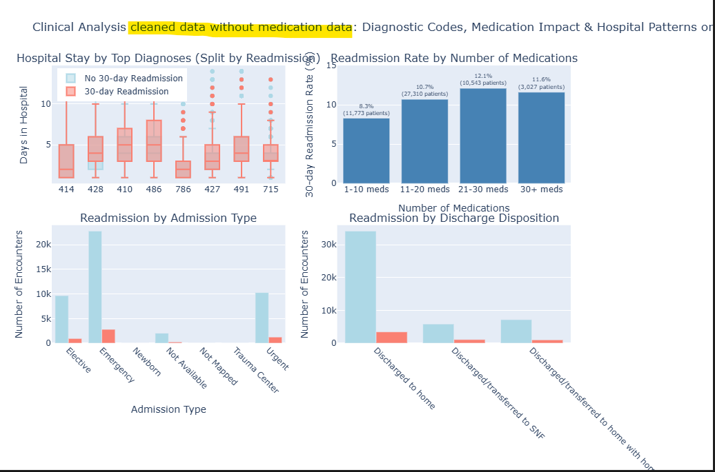
Based on this exploratory analysis, I will prioritize raw/cleaned/cleaned without medications dataset and focus on diagnosis-based on readmission patterns to develop our predictive model. The first data frame will store the raw data, the second will have our cleaned data set with strategic columns and rows removed based on (race, weight, and age), and the third will be our cleaned data set without the medication columns.

