The results from the decision tree showed a significant bias and instability with our dataset with specificity value of 1.0 and recall of 0.001. We can conclude with these results this model lacks predictive abilities.
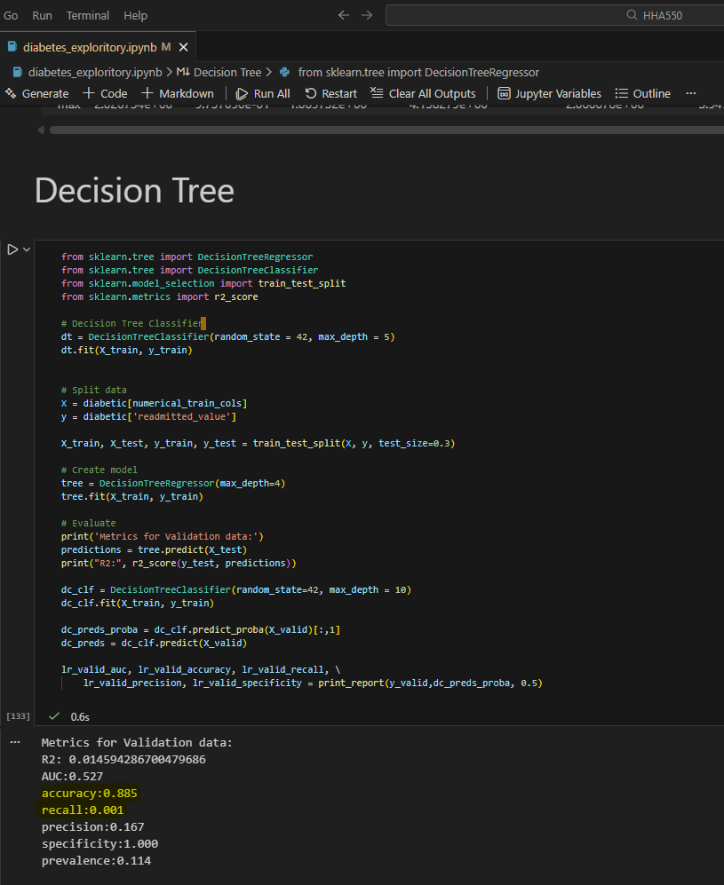
To improve precision in our models I performed the following steps

- Restored previously excluded rows related to discharge disposition and age. 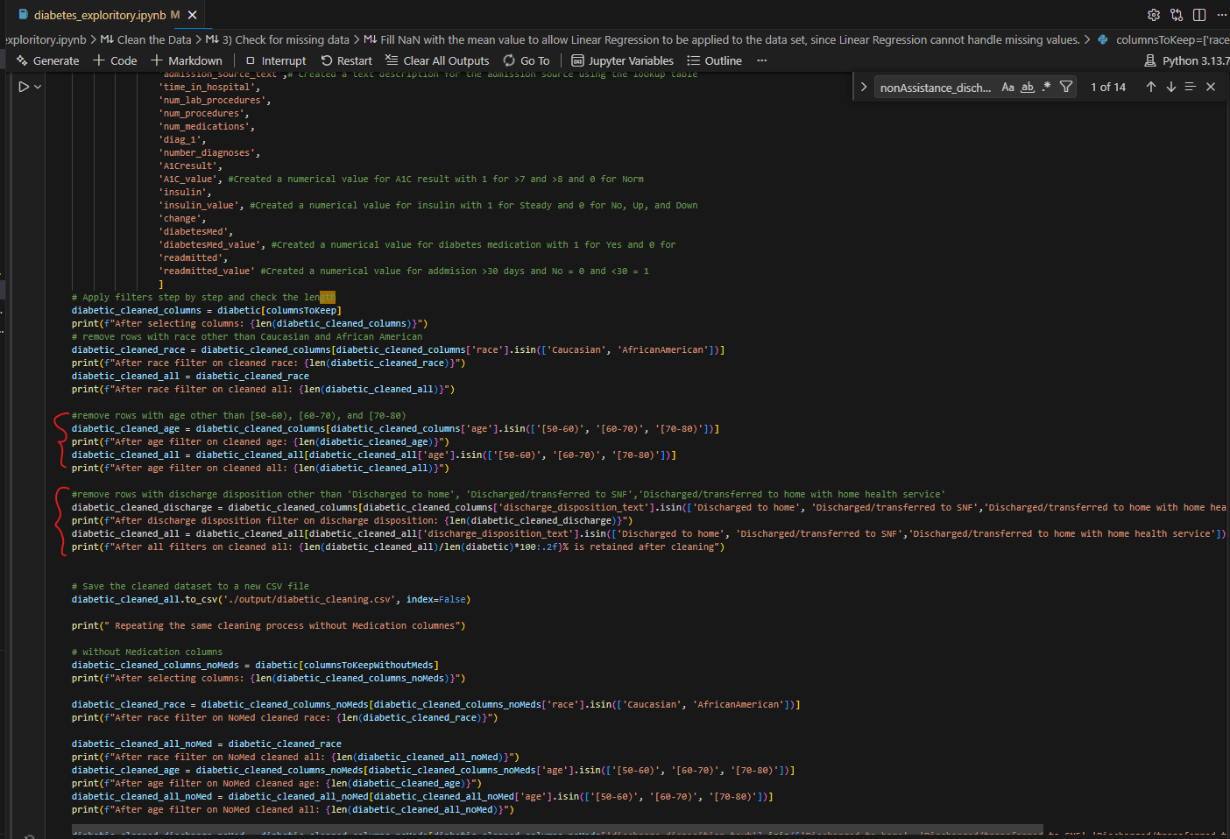
- Removed A1C_value and max_glu_serum from our training set, due to the significant missing values present in the columns.
- Converted the discharge disposition, admission type, and age ranges to binary values as outlined in step 5 below.
- Converted additional fields to binary values (age, admission_type, discharge_disposition, time_in_hospital,num_procedures, num_medications, diag_1, number_diagnoses, change, and diabetesMed)
- List of new binary fields and it’s logic below:
- 'age_target_range_value', # binary variable for age group 50-90 = 1 else zero
- 'critical_admission_type_value', # categorical text ("Emergency" and "Urgent" = 1, otherwise 0) converted to zero and one
- 'nonAssistance_discharge_disposition_value', # categorical text ("Discharged to home" = 1, otherwise 0) converted to zero and one
- 'time_in_hospital_value', # Convert time in hospital to a binary variable with 1 for more than 3 days and 0 for 3 or fewer days
- 'num_procedures_value', # Created a binary value for number of procedures with 1 for more than 4 procedures and 0 for 4 or fewer procedures
- 'num_medications_value', # Created a binary value for number of medications with 1 for more than 10 medications and 0 for 10 or fewer medications
- 'diag_1_heart_failure_value', # categorical Heart Failure ("428"=1, otherwise 0) converted to zero and one
- 'diag_1_procedure_aftercare_value', # categorical text ("V58"=1, otherwise 0) converted to zero and one
- 'number_diagnoses_value', # Created a binary value for number of diagnoses with 1 for more than 5 diagnoses and 0 for 5 or fewer diagnoses
- 'change_value', # categorical text ("Ch" = change in medications is 1, "No" = no change in medications is 0)

After including the binary fields, improvements were observed on most of our metrics. The AUC increased marginally by 0.042, but recall showed a significant increase from 0.001 to 0.654. Although precision dropped by 0.34 and accuracy by 0.396, the model is now better at identifying positive cases, resulting in a more balanced and stable prediction due to the specificity decrease from 1.00 to 0.448. Overall, these adjustments looked promising.
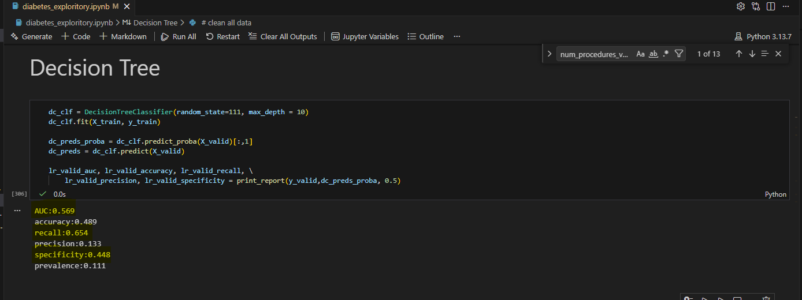
Further improvements were seen on Random Forest results on the raw dataset and similar, but less favorable results were produced on our cleaned data focused on Caucasian and African American patients.
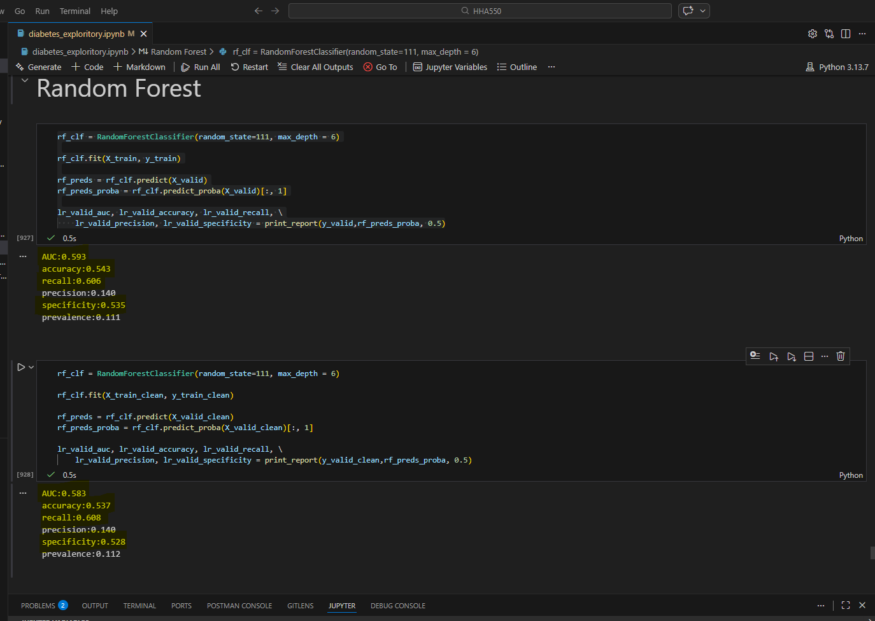
These results prompted me to create specific columns to identify Caucasian an African American patients instead of having a generic column that groups both races together. This small adjustment improved recall by .004 with trade-off of accuracy decreasing and specificity by .002 on the raw dataset.
The cleaned dataset had similar trade-offs due with the new changes.
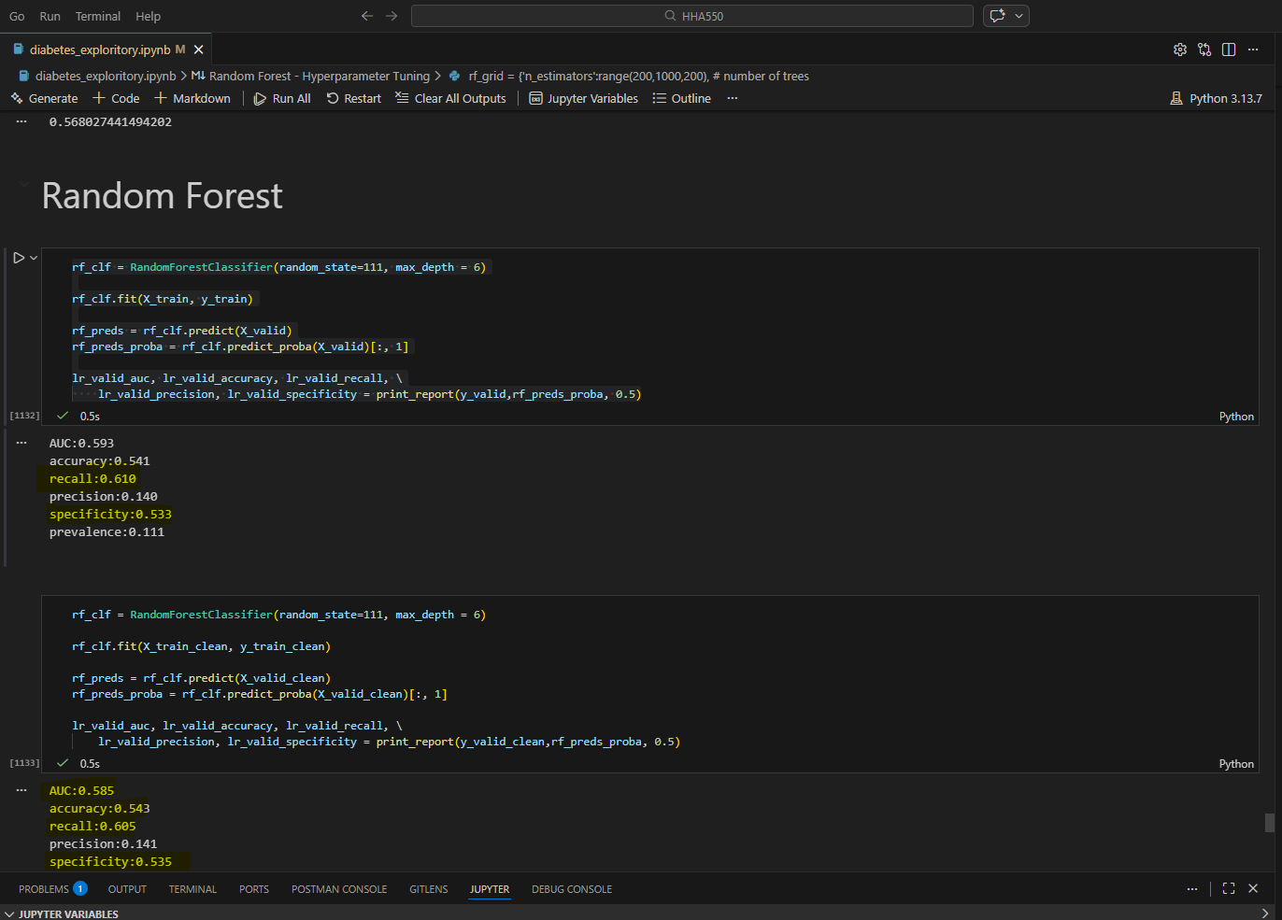
After more in depth review of the code, I found the num_inpatient, num_outpatient, and num_emerency fields were omitted inadvertently. By reincorporating these fields back to the dataset and adding a custom field to identify patients with frequency the model demonstrated significant performance enhancements.
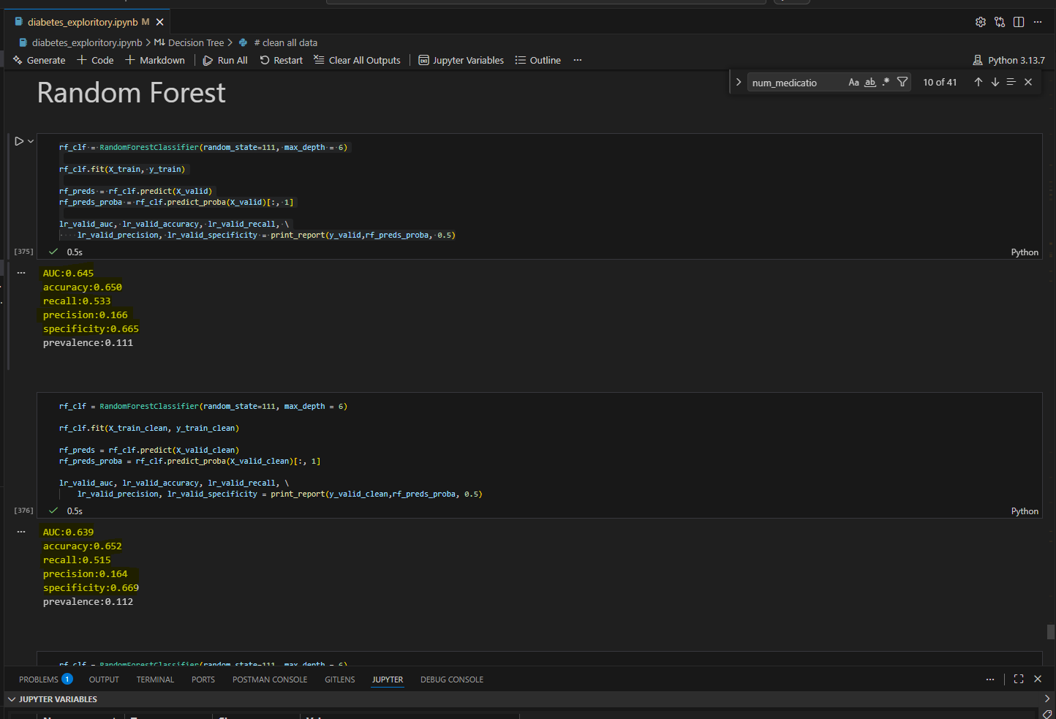
When the max_depth was adjusted from 6 to 10 this improved all metrics with AUC of .65 on the raw data and .642 on the cleaned dataset. While the AUC is slightly lower on the cleaned dataset the accuracy is also increased. We see a trade-off between the raw data and the cleaned dataset between recall and accuracy. The cleaned dataset without medication recall was .021 better than the cleaned data with all 21 meditations. This indicates that medication status has no significant impact on readmission rates.
Comparison Table (Random Forest Max Depth 10)
Metric | Cleaned (No Meds) | Cleaned (With Meds) | Raw Data
AUC | .643 | .642 | .650
Accuracy | .605 | .625 | .603
Recall | .594 | .575 | .611
Precision | .160 | .164 | .161
Specificity | .607 | .631 | .603

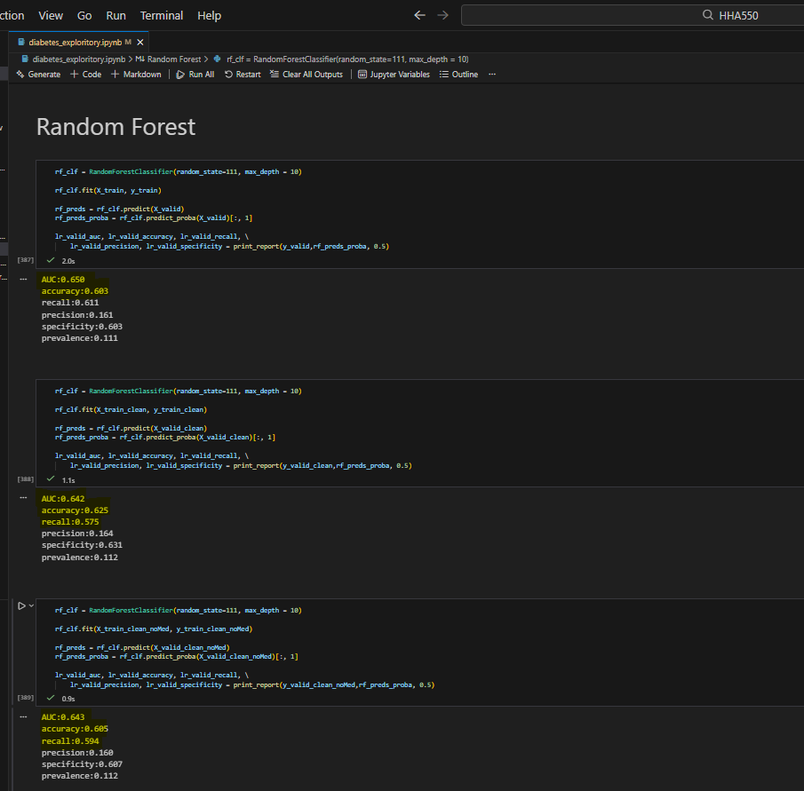

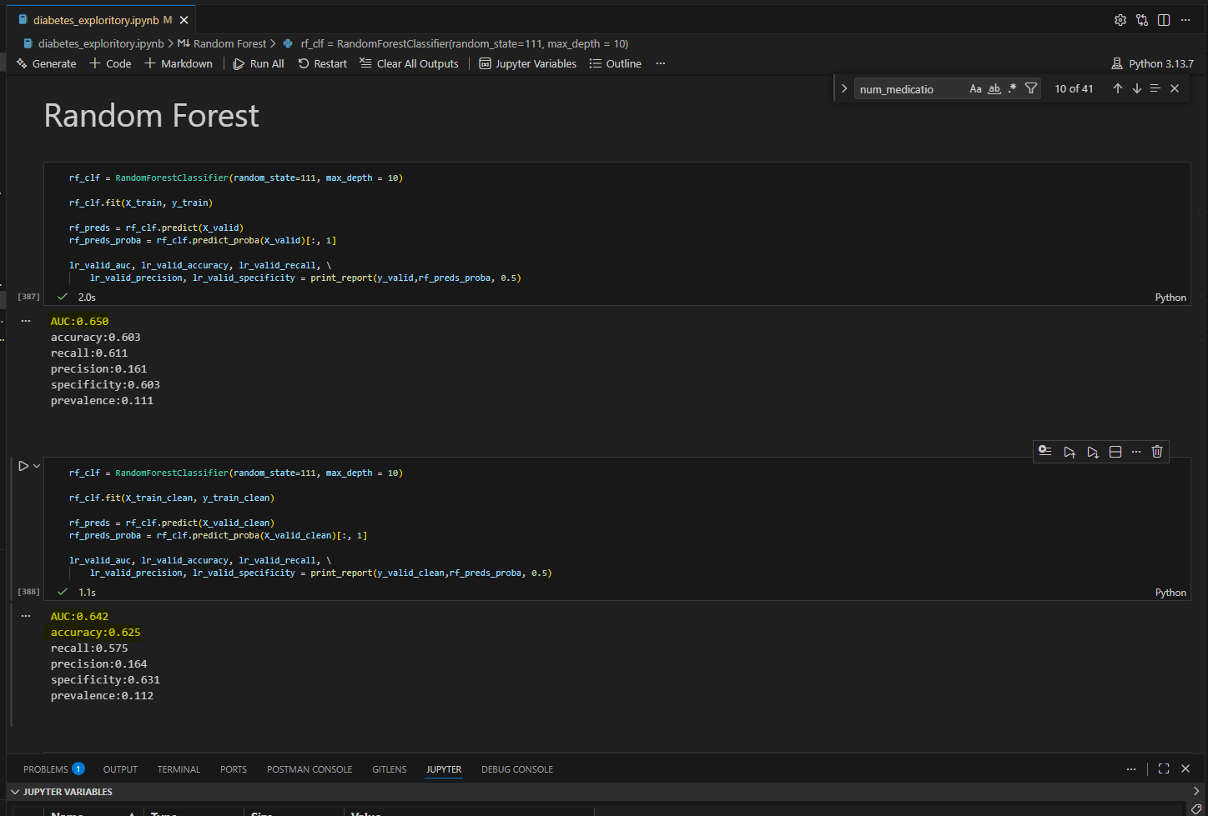
In conclusion, the fields that have the most impact on readmission rates are the number of inpatient, outpatient, and emergency visits. A1C results in this dataset does not have a significant impact due to the missing values. Random Forest model yielded the best outcomes with slight trade-offs found in the cleaned versus the raw dataset.

Summary of Data Cleaning
Columns Removed Due to Missing Data
Column Name | Number of missing data | Percentage of missing data
weight | 98569 | 96.8%
max_glu_serum | 96420 | 94.7%
A1Cresult | 84748 | 83.3%
medical_specialty | 49949 | 49.1%
payer_code | 40256 | 39.6%

Columns Converted to Binary Values
Column Name | Zero value | One value
is_repeat_patient | num_visits = 0  <num_visits custom field calc pat visits> | num_visits > 0
gender_value | gender = "Male" | gender = "Female"
race_value | race = "Asian", "Hispanic", "Other" | race = "Caucasian", "African American"
race_african_american_value | race = "Asian", "Hispanic", "Caucasian", "Other" | race = "African American"
race_caucasian_value | race = "African American", "Asian", "Hispanic", "Other" | race = "Caucasian"
age_target_range_value | age < 50 or age ≥ 90 | 50 ≤ age < 90
change_value | change = "No" | change = "Ch"
critical_admission_type_value | admission_type_text ≠ "Emergency" or "Urgent" | admission_type_text = "Emergency" or "Urgent"
nonAssistance_discharge_disposition_value | discharge_disposition_text ≠ "Discharged to home" | discharge_disposition_text = "Discharged to home"
diabetesMed_value | diabetesMed = "No" | diabetesMed = "Yes"
time_in_hospital_value | time_in_hospital ≤ 3 | time_in_hospital > 3
num_procedures_value | num_procedures ≤ 4 | num_procedures > 4
num_medications_value | num_medications ≤ 10 | num_medications > 10
number_diagnoses_value | number_diagnoses ≤ 5 | number_diagnoses > 5
diag_1_heart_failure_value | diag_1 ≠ "428" | diag_1 = "428"
diag_1_procedure_aftercare_value | diag_1 ≠ "V58" | diag_1 = "V58"
readmitted_value | readmitted = ">30" or "No" | readmitted = "<30"
A1C_value | A1Cresult = "Norm" | A1Cresult = ">7" or ">8"
insulin_value | insulin = "No", "Up", "Down" | insulin = "Steady"
metformin_value | metformin = "No", "Up", "Down" | metformin = "Steady"
repaglinide_value | repaglinide = "No", "Up", "Down" | repaglinide = "Steady"
nateglinide_value | nateglinide = "No", "Up", "Down" | nateglinide = "Steady"
chlorpropamide_value | chlorpropamide = "No", "Up", "Down" | chlorpropamide = "Steady"
glimepiride_value | glimepiride = "No", "Up", "Down" | glimepiride = "Steady"
acetohexamide_value | acetohexamide = "No", "Up", "Down" | acetohexamide = "Steady"
glipizide_value | glipizide = "No", "Up", "Down" | glipizide = "Steady"
glyburide_value | glyburide = "No", "Up", "Down" | glyburide = "Steady"
tolbutamide_value | tolbutamide = "No", "Up", "Down" | tolbutamide = "Steady"
pioglitazone_value | pioglitazone = "No", "Up", "Down" | pioglitazone = "Steady"
rosiglitazone_value | rosiglitazone = "No", "Up", "Down" | rosiglitazone = "Steady"
acarbose_value | acarbose = "No", "Up", "Down" | acarbose = "Steady"
miglitol_value | miglitol = "No", "Up", "Down" | miglitol = "Steady"
troglitazone_value | troglitazone = "No", "Up", "Down" | troglitazone = "Steady"
tolazamide_value | tolazamide = "No", "Up", "Down" | tolazamide = "Steady"
examide_value | examide = "No", "Up", "Down" | examide = "Steady"
citoglipton_value | citoglipton = "No", "Up", "Down" | citoglipton = "Steady"
glyburide-metformin_value | glyburide-metformin = "No", "Up", "Down" | glyburide-metformin = "Steady"
glipizide-metformin_value | glipizide-metformin = "No", "Up", "Down" | glipizide-metformin = "Steady"
glimepiride-pioglitazone_value | glimepiride-pioglitazone = "No", "Up", "Down" | glimepiride-pioglitazone = "Steady"
metformin-rosiglitazone_value | metformin-rosiglitazone = "No", "Up", "Down" | metformin-rosiglitazone = "Steady"
metformin-pioglitazone_value | metformin-pioglitazone = "No", "Up", "Down" | metformin-pioglitazone = "Steady"

Columns Created Numerical (Non_Binary) Values
Column Name | Logic
age_value | Midpoint age between the categorical range provided in age field
num_visits | number of encounter_id per patient_nbr in dataset

