The Linear Regression test on the raw dataset produced prediction ranging between 0.4 to 0.6.
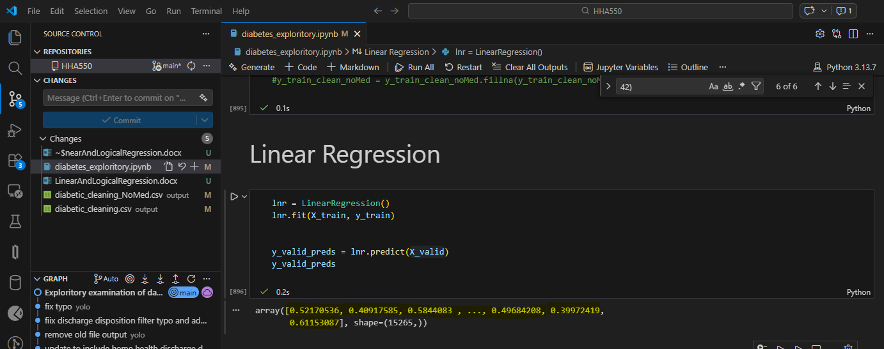
Unfortunately, after cleaning the dataset, the model begins to go south, yielding predictions values from 361 to 622. This suggested there might be an issue with StandardScaler.
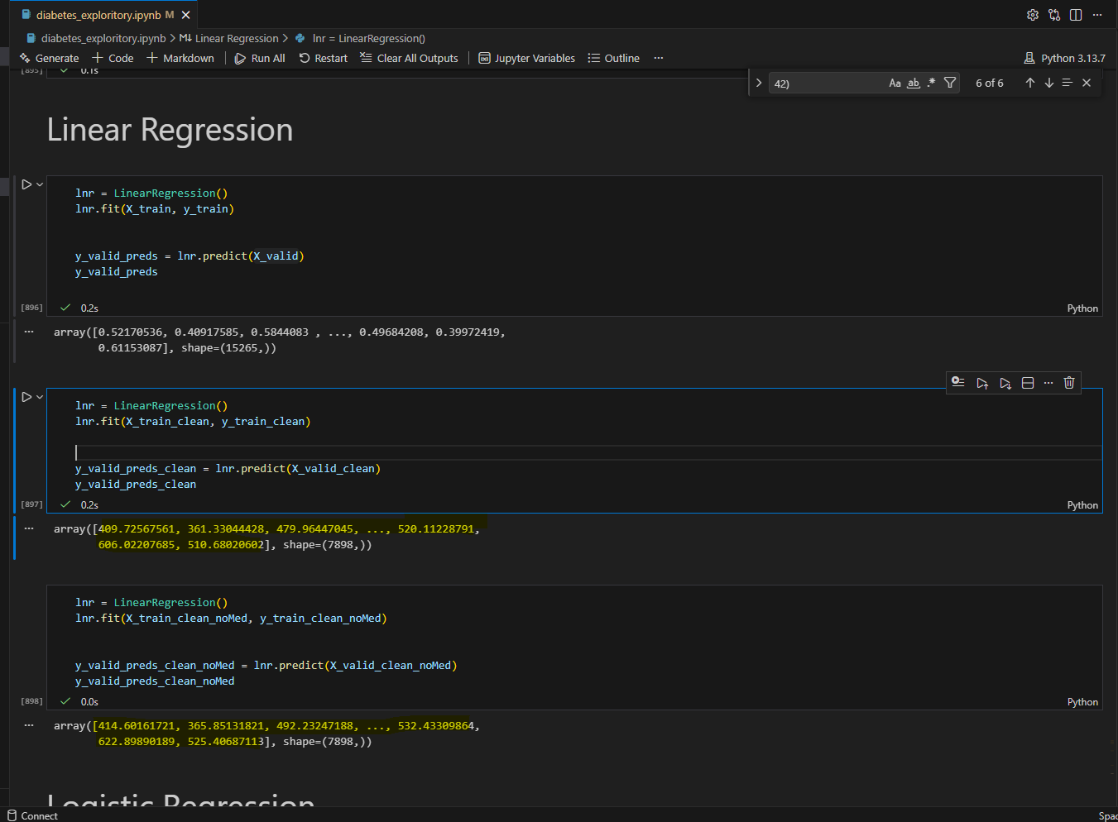
After reviewing the code, I discovered a copy-paste error where the StandardScaler was not applied to X_valid and X_test. Once the code was corrected, the prediction results for the clean dataset returned to the expected range of 0.4 to 0.55, closely matching the raw data results above.
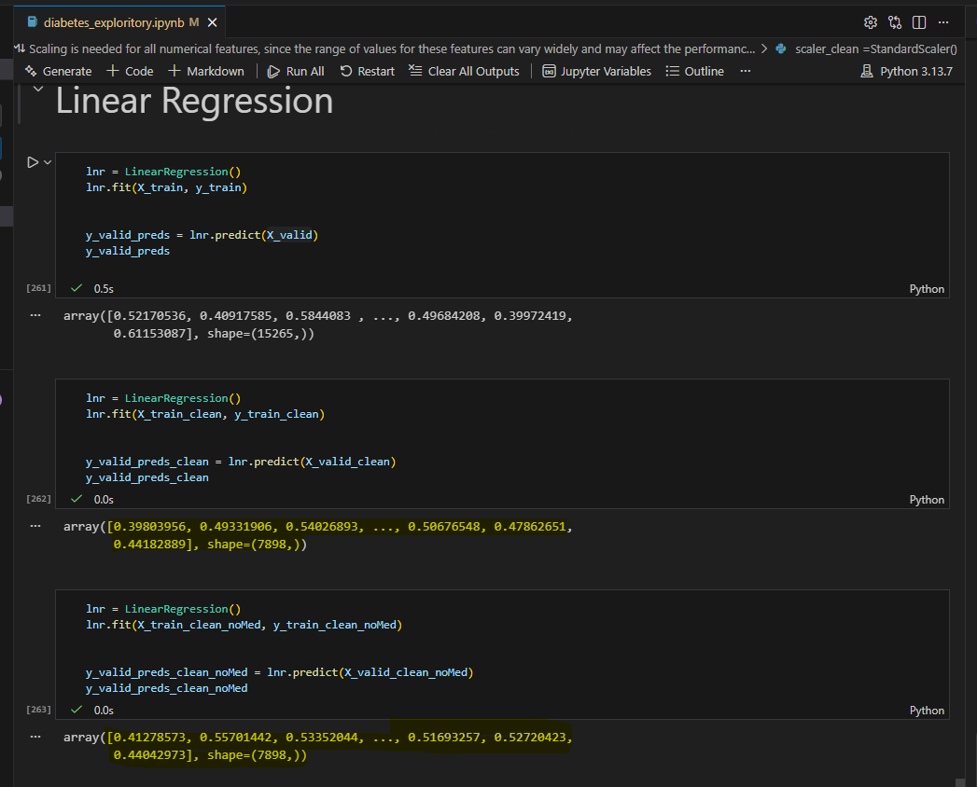
Next, I applied logistic regression test on the raw dataset and the accuracy was at 53.7% with precision of 13.6% for predicting patient readmission within 30 days. The AUC value is 56.7%, indicating the model performs only 6.7% better than random chance, suggesting weak ability to distinguish the difference between patients who will or will not be readmitted within 30 days. 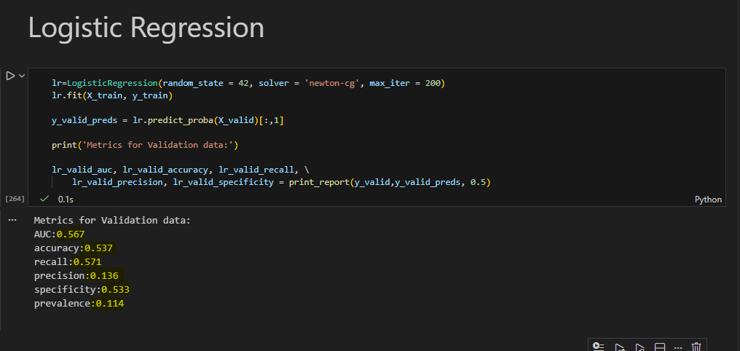

After applying the logistic regression test on the clean dataset, we see slight improvement on the AUC value from 56.7% to 57.3%, as well as a slight increase in accuracy from 53.7% to 54.5%. However, the recall decreased from 57.1% to 55.5%. This suggests whether we clean the dataset or not, the test results would still yield a negligible ability to produce reliable predictions based on the nature of the dataset. 