  - Diabetic Data Analysis
Upon initial review and some research on diabetes, obesity, patient biological sex, genetic predisposition, race, and lifestyle can be contributing factors to diabetic outcomes.
Data Limitations
After more extensive review of the data, I noticed the patient weight information is largely missing. 97% of the encounters are missing weight measurement, this absence of information limited the research ability to examine obesity as a correlation to diabetic health analysis and therefore the field was removed from the final dataset.
Demographic Imbalances
Additional imbalance information was revealed as many sub groups were underrepresented. Most of the patient encounters are within the age range of 50 to 80 with a high representation from Caucasians, representing 74.78% of the encounters. While African American is our second largely presented group, they only represent 19.31% encounters available for analysis with Hispanics at 2.05%, Other at 1.51% and Asians at 0.64%
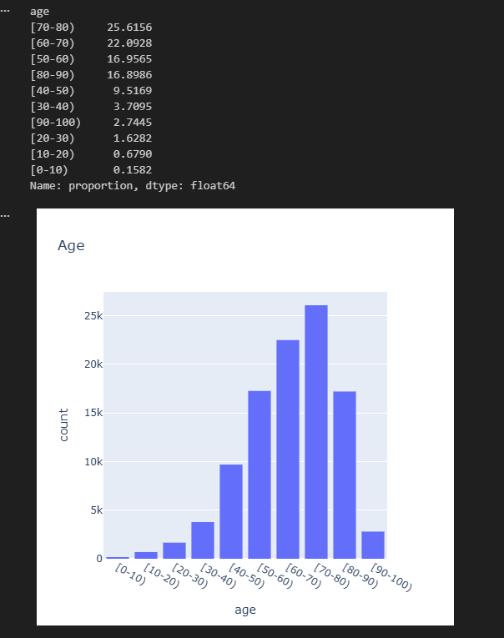
Another ambiguity found is classification of the value ‘NO’ on the readmitted field. This designation could mean ‘NO’ readmission or that the data was simply missing. In our data analysis we assume this value as ‘NO” readmission present, but we must be cautious in our evaluations and this difference can skew our results and conclusions drastically.

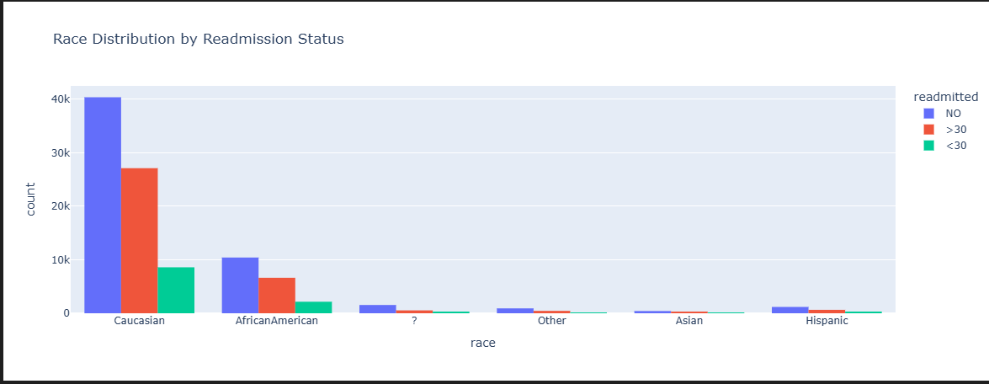
As I furthered my analysis with the inclusion of admission and discharge lookup values. It was evident this cohort has a large representation of chronic patients taking many medications mainly centric on emergency and urgent care services for patients with comorbidities discharged home or to skilled nursing facility or home health services.
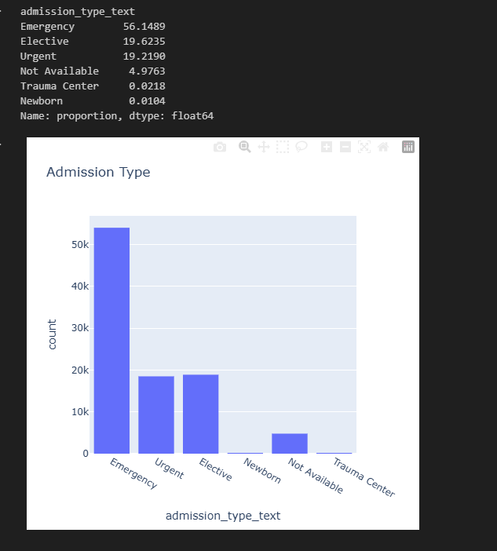
Many of the patients have 6 to 9 diagnoses receiving 10 to 20 medications, with hospital length of stay spanning 2 to 6 days.
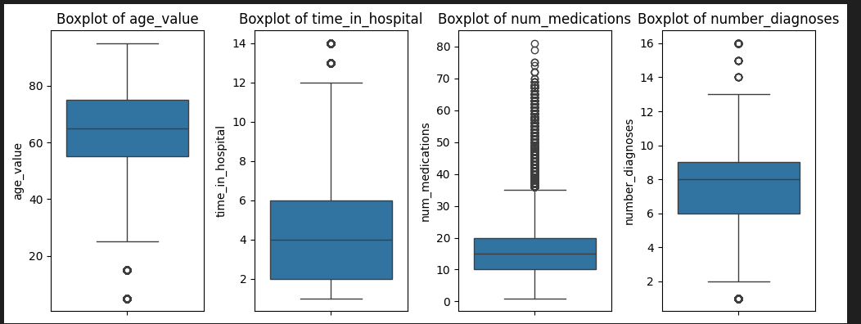
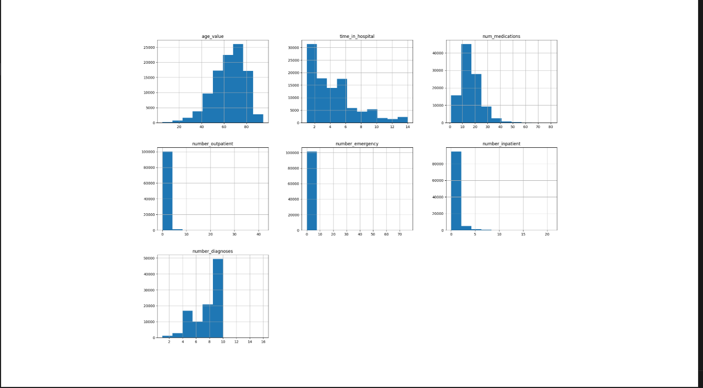
Cleaning Decisions
With all the above consideration, I removed the weight, medical_specialty, all medication fields (glipizide, glyburide, metformin, etc) are not need for our analysis and were omitted on the clean data set. The number_outpatient, number_emergency, and number_inpatient fields were not required for the analysis performed we have determined this cohort predominately represents patients with diabetes in emergency service setting with other comorbidities.
Additionally, due to the underrepresentation of other race groups, the omission of other, Hispanic, and Asian encounters to avoid ambiguity in our statistical analysis. I’ve also isolated the data set to only include encounters for patients between the age of 50 to 80 with discharge disposition of either to the home, to SNF, or to home health care.
Final Dataset
This resulted only retaining only 51.74% of the data ( 52653 out of 101766 encounters) after the cleaning process was completed.
