首先找到ultralytics\utils\loss.py这个loss.py文件
第一步：把这个代码复制到loss.py文件中
def wasserstein_loss(pred, target, eps=1e-7, constant=12.8):
r"""Implementation of paper `Enhancing Geometric Factors into
Model Learning and Inference for Object Detection and Instance
Segmentation <https://arxiv.org/abs/2005.03572>`_.
Code is modified from https://github.com/Zzh-tju/CIoU.
Args:
pred (Tensor): Predicted bboxes of format (x_min, y_min, x_max, y_max),
shape (n, 4).
target (Tensor): Corresponding gt bboxes, shape (n, 4).
eps (float): Eps to avoid log(0).
Return:
Tensor: Loss tensor.
"""
# 拆分坐标
b1_x1, b1_y1, b1_x2, b1_y2 = pred.split(1, dim=-1)
b2_x1, b2_y1, b2_x2, b2_y2 = target.split(1, dim=-1)
# 计算框的宽度和高度
w1, h1 = b1_x2 - b1_x1, b1_y2 - b1_y1 + eps
w2, h2 = b2_x2 - b2_x1, b2_y2 - b2_y1 + eps
# 计算框的中心坐标
b1_x_center, b1_y_center = (b1_x1 + b1_x2) / 2, (b1_y1 + b1_y2) / 2
b2_x_center, b2_y_center = (b2_x1 + b2_x2) / 2, (b2_y1 + b2_y2) / 2
# 计算中心距离和宽高距离
center_distance = (b1_x_center - b2_x_center).pow(2) + (b1_y_center - b2_y_center).pow(2) + eps
wh_distance = ((w1 - w2).pow(2) + (h1 - h2).pow(2)) / 4
# Wasserstein 距离
wasserstein_2 = center_distance + wh_distance
# 返回损失
return torch.exp(-torch.sqrt(wasserstein_2) / constant)

第二步：找到这个类 class BboxLoss(nn.Module):用我的这部分代码替换原来的
class BboxLoss(nn.Module):
"""Criterion class for computing training losses during training."""
def __init__(self, reg_max=16, nwd_loss=False, iou_ratio=0.5):
"""Initialize the BboxLoss module with regularization maximum and DFL settings."""
super().__init__()
self.iou_ratio = iou_ratio
self.nwd_loss = nwd_loss
self.dfl_loss = DFLoss(reg_max) if reg_max > 1 else None
def forward(self, pred_dist, pred_bboxes, anchor_points, target_bboxes, target_scores, target_scores_sum, fg_mask):
"""IoU loss."""
weight = target_scores.sum(-1)[fg_mask].unsqueeze(-1)
iou = bbox_iou(pred_bboxes[fg_mask], target_bboxes[fg_mask], xywh=False, CIoU=True)
loss_iou = ((1.0 - iou) * weight).sum() / target_scores_sum
if self.nwd_loss:
nwd = wasserstein_loss(pred_bboxes[fg_mask], target_bboxes[fg_mask])
nwd_loss = ((1.0 - nwd) * weight).sum() / target_scores_sum
loss_iou = self.iou_ratio * loss_iou + (1 - self.iou_ratio) * nwd_loss
# DFL loss
if self.dfl_loss:
target_ltrb = bbox2dist(anchor_points, target_bboxes, self.dfl_loss.reg_max - 1)
loss_dfl = self.dfl_loss(pred_dist[fg_mask].view(-1, self.dfl_loss.reg_max), target_ltrb[fg_mask]) * weight
loss_dfl = loss_dfl.sum() / target_scores_sum
else:
loss_dfl = torch.tensor(0.0).to(pred_dist.device)
return loss_iou, loss_dfl

第三步：找到这个类class v8DetectionLoss:
用我提供的这部分代码替换如下截图的部分代码！
class v8DetectionLoss:
"""Criterion class for computing training losses."""
def __init__(self, model, tal_topk=10): # model must be de-paralleled
"""Initializes v8DetectionLoss with the model, defining model-related properties and BCE loss function."""
device = next(model.parameters()).device # get model device
h = model.args # hyperparameters
m = model.model[-1] # Detect() module
self.bce = nn.BCEWithLogitsLoss(reduction="none")
self.hyp = h
self.stride = m.stride # model strides
self.nc = m.nc # number of classes
self.no = m.nc + m.reg_max * 4
self.reg_max = m.reg_max
self.device = device
self.use_dfl = m.reg_max > 1
self.nwdloss = self.hyp.nwdloss
self.iou_ratio = self.hyp.iou_ratio
self.assigner = TaskAlignedAssigner(topk=tal_topk, num_classes=self.nc, alpha=0.5, beta=6.0)
self.bbox_loss = BboxLoss(m.reg_max, nwd_loss=self.nwdloss,iou_ratio=self.iou_ratio).to(device)
self.proj = torch.arange(m.reg_max, dtype=torch.float, device=device)

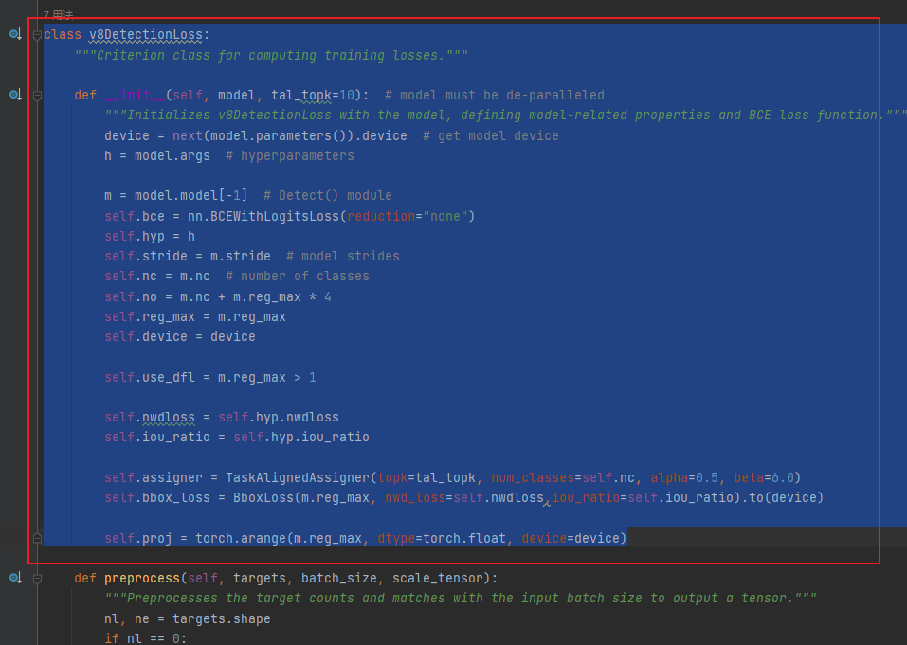

第四步：找到这个文件ultralytics\cfg\default.yaml
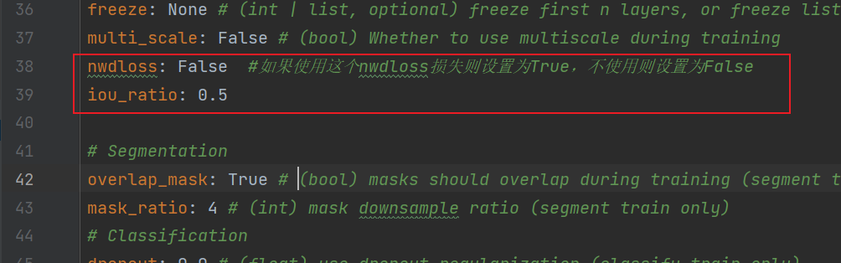
添加这两行代码：
nwdloss: False #如果使用这个nwdloss损失则设置为True，不使用则设置为False
iou_ratio: 0.5

完成以上4步就可以了！

