Three Dimensional Object Detection Under Adverse Weather Using Second Model

A Report Submitted in fulfillment for the award of the degree of

Master of Technology (M. Tech.)
in
Integrated Circuit Design Technology
Submitted by

Yash Agrawal

2025ICDT-010

Under the Supervision of Prof. Manisha Pattanaik
and co-supervisor

Dr. Gaurav Sharma

Department of Electrical and Electronics Engineering


ATAL BIHARI VAJPAYEE - INDIAN INSTITUTE OF INFORMATION TECHNOLOGY AND MANAGEMENT, GWALIOR, INDIA
2026

CANDIDATE’S DECLARATION
I hereby certify that the work being presented in the report/thesis, entitled Three Dimensional Object Detection Under Adverse Weather Using Second Model, in fulfillment of the requirement for Major Project Part-I and submitted to the institution, is an authentic record of my own work carried out during the period July 2026 to October 2026 under the supervision of Prof. Manisha Pattanaik and co-supervisor Dr. Gaurav Sharma. I have also cited the references for any text(s), figure(s), or table(s) that have been taken from other sources.

Dated: Signature of the Candidate

This is to certify that the above statement made by the candidates is correct to the best of my knowledge.

Dated: Signature of the Research Supervisor

Dated: Signature of the Research co-supervisor

ABSTRACT

My research focuses on the development of intelligent and data-driven solutions for emerging challenges in signal processing, image processing, automation engineering, and electronic systems. The work integrates artificial intelligence, machine learning, deep learning, computer vision, and embedded technologies for efficient analysis and interpretation of complex real-world data. Particular emphasis is given to Three Dimensional Object Detection Methods, multimodal sensing systems, and intelligent electronic systems. The research aims to develop accurate, computationally efficient, and practical solutions that can support Navigation, automation, and autonomous applications. The overall objective is to bridge theoretical developments with deployable, application-oriented technologies.

Keywords: Signal Processing, Image Processing, Artificial Intelligence, Machine Learning, Deep Learning, Computer Vision, Three Dimensional Object Detection, Multimodal Sensing, YOLO, Second Model, Embedded Systems.

ACKNOWLEDGEMENTS
I would like to extend my deepest gratitude to Prof. Manisha Pattanaik and Dr. Gaurav Sharma for their exceptional mentorship and guidance throughout the project titled " Three Dimensional Object Detection Under Adverse Weather Using Second Model". The insights and unwavering support from their mentorship have been instrumental in shaping the direction and ensuring the successful progression of this research.

I am profoundly thankful for the time and dedication invested in this project by their mentorship. Their mentorship has not only strengthened my technical abilities but has also deepened my understanding of the field and its significant potential in advancing healthcare.

This study was conducted in full accordance with ethical guidelines, with approval obtained from the institutional review board under protocol number IITM/HJHGJ/0564. I would also like to express my sincere appreciation to all participants who contributed to the dataset used in this study.

Finally, I acknowledge the assistance of AI tools in paraphrasing portions of this document.

Yash Agrawal

TABLE OF CONTENTS

ABSTRACT ii
LIST OF FIGURES iv
- Introduction 1
  - Background 1
- Literature Review 4
  - Introduction 4
  - Three Dimensional Object Detection 5
  - Research Gaps 6
  - Research Objectives 7
- Proposed Methodology 8
  - Data Acquisition 8
  - Signal Processing 8
  - Feature Extraction 9
  - Model Training 9
  - Model Evaluation 9
- Experimentation 10
  - Data collection 10
  - Feature Extraction 10
  - CNN Architecture 12
  - Model Training and Evaluation 12
  - Results and Discussion 13
- Progress timeline 15
  - Progress Timeline 15
    - Phase 1: Literature Review & Objective Setting 15
    - Phase 2: Data Collection & Preprocessing 15
    - Phase 3: Model Development 16
    - Phase 4: Model Training & Evaluation 16
    - Phase 5: Refinement, Generalization & Validation 16

LIST OF FIGURES

Fig 1:
Attenuation (Q_ext) and Back Scattering (Q_b) as a
joint probability Distribution function (pdf) of
Diameter (size in micro meters ) of Particles (here, Fog, and Aerosol). 8
Fig 2.
A Typical Flow Chart, Showing Mechanism Of SECOND Model 9
Fig 3:
Typical Flow Chart of 3DoD 12
Fig 4.
The Proposed Methodology 16
Fig 5.
The Intensity Of Received LiDAR waves under different circumstances,
red=hard target, viz, car, pedestrian or cycle,
blue= soft target, viz, fog, rain, snow or other unwanted particles 20
Fig 6:
A Point Cloud Registered By LiDAR implanted on Subject of INterest 21
Fig 7:
The Other Angle View oF point cloud registered by LiDAR implanted on Subject of Interest 21
Fig 8:
Re Training Model, as Training Failed Previously Due To Memory Issue,
Hence Changed the batch size,
and finally training successfully completed……………………………………………………………...22
Fig 9.
Model Fully Trained, Changed Parameters in Configuration File of Second Model 22
Fig 10:
The Configuration File of Second Model 22
Fig 11:
The Progress Of Project Mapped on Gantt Chart 23

List Of Tables

Table 1:
Details Of Comparison of Model Under different circumstances 18
Table 2:
Model Under Different Adverse Environment Parameters 19

vi

NOTATIONS AND ABBREVIATIONS

3DoD Three Dimensional Object Detection
Model II Second Model
II Model Second Model
SECOND Sparsely Embedded CONvolutional Detection
SMOTE Synthetic Minority Oversampling Technique
YOLO You Only Look Once
PCL Point Cloud
BEV Bird’s Eye View
LiDAR Laser imaging, detection, and ranging
PWV Pulse Wave Velocity
PTT Pulse Transit Time
MOR Meteorological Optical Range
PAT Pulse Arrival Time
PVRCNN Point Voxel Recurrent Based Neural Network
CNN Convolutional Neural Network
RSD-Net Radar-based Stacked Deformable Convolution Network
SNSI Signal Noise Slope Intersection
DOF Degree Of Freedom
YOLO You Only Look Once
VFE Voxel Feature Encoder
MSE Mean Squared Error
RMSE Root Mean Squared Error
R² Coefficient of Determination
FFT Fast Fourier Transform
Mel Mel Scale (Used in Mel Spectrogram)

CHAPTER 1

The Introduction

This chapter presents an overview to the background about traditional methods of Three Dimensional Object Detection (3DoD), Figures Out Algorithms like Second Model method, the Trending For 3DoD Applications, especially for conditions where the subject is not suitable for adverse weather conditions..

Background and Motivation

Once Upon A Time on Earth, There used to be a Healthy Ecosystem and The Eco Cycle Was Smoothly Functioning And Evolving. Disturbing, One Aspect Of That Eco Cycle, Could Make That Eco System Collapse. But, As We Know, Sins Of Humans, Which Could Be Further Classified Into Seven ( 7 ) Categories, One Of Them Being Greed, Is One Of The Main Causes Of That Disturbance. Humans (they) Gradually Became Unsatisfied With The Surroundings They Were Living In, Thus They Travelled From Africa To Other Parts Of The World. Then Gradually they Became Unsatisfied With Their Art Of Living, Thus They Cut More Trees, Since From Wood Many Things Can Be Designed. This, Initially Forced Global Warming. Then They Gradually Became Unsatisfied with The Limited Resources (Natural Or Man Made) They Had, Hence They Gradually Dug Inside Earth, Where Building’s Foundation can be Laid. They Then Gradually Dug More Deeper, Where, Oil, and Other Precious Resources Could Be Found. They Then Gradually Set Up Factories For Mass Production. This, Initially Forced The Downfall of Fertility Of Soil, Water, And Air Contamination. And As Of Now, The Economics Is Alarming. And Hence Proved, In Winters, Its So Foggy, and So Snowy. In Monsoon, Its So Rainy and So Slippery. In Summer, Its So Aerosolic and So Smoky. And The Consequences Compound So On And So Forth. But Since, Going Back In Time Is Not A Feasible Solution, We Need To Counter That Disturbance With Virtues Of Humans, One Of Them Being “Creation”. Humans Created Bon Fire, They Created Tools For Hunting, They Created Shelter For Security. They Created Clothes since Clothes Were Needed. They Created Transport Vehicles, From Bullock Cart, Boats, and Planes To Cars, Motor Boats, and Helicopters To Specialized Cars, Submarines, and INS Vikrant like Aero Stations Which Also Hosts Aeroplanes. To So Specialized Machines. These Machines Are So Self Automated. They Created Super Computers For Fast Research And Analysis Of So Much Data, Like Stock Market Economics. They Created Quantum Computing Machines For Super Fast Research And Analysis Of So Complex Probable Economical Issues, Like, Google Willow Chip, etc. Now, In Risky Environments Scenarios, Mentioned Above, These Machines, Mentioned Above Have High Probability Of Collision. And This Is Point, We Go Back To The Basics ( Roots ), And Come Up With Practical Solutions ( New Shoots ).
LiDAR based Devices Came As An Evolution From SONAR, which in turn evolved from The Basic, The Art Of Living Of Bats, Wh ales and Spiders (These) . These All Send An Incident Wave Like A Transmitter To An Subject Of Interest (SOI), And The Reflected Waves Are Sensed By These (Now Acting As Receivers), And Then, These Brains Develop Resultant Point Cloud Of Their SOI (This). And, This process happens in so many iterations, so fast than the blink of an eye, and so state of the art. SONARs, implanted in submarines, sends waves in water, as those types of waves travel faster in denser mediums. LiDAR waves need no medium, LiDAR waves travel with lightning speed. Now a days, submarines, warcraft and military Has Increased Usage Of LiDAR Technology

  - Statement, Objectives And Approach

It Is a Universal Fact That Need Is The Mother Of Innovation. It Is Also So Normal Fact, that, Many Models Based On LiDAR Technology Had Been Innovated That Were Trending in Past, And Many Models Based On LiDAR Technology Are In The Process Of Innovation, And Many Models Might Get Innovated In Future. This Project Has a Vision, This Project Should Develop a State Of The Art Hardware Accelerated System On Chip, empowered With Artificial Intelligence and LiDAR Technology, and has a better (Power, Performance, Area) (PPA) Tuple, and should act as a warning system.. This Project Has a Mission. This Project Should develop a workable, a Better Finely Tuned ( Better Confusion Matrixed ), and, and easy to be implemented on FPGA Board (Genesys 2 Board), Second Model In Adverse Weather Conditions, Like, in Snowy, in Foggy, in rainy, in smoky environments, in Aerosol, in slippery environments, or a combination of above like circumstances, In Real Time.
This Project Is divided into milestones, to be conquered, in a given time frame. The Very First milestone Was Solving The Question About The Data Under Interrogation. Which in my case is, one of the popular KITTI Dataset. The Class Imbalance in this dataset, can be balanced using various methods, like SMOTE, etc. Regarding, Adverse Weather Conditions, This KITTI dataset can be augmented, by adjusting beta parameter (Density of Unwanted Particles) (backscatter) (beta < 1) and alpha parameters (Physics of Light in Unwanted Particle Medium) (attenuation) (alpha < 1). These alpha and beta, can be calculated, using Mie Scattering Theory (see Fig 1). Data Augmentation Because Real Time Data, Economically, costs too much. Now, After Carefully Configuring Paths of Environmental Variables, and Tuning Hyper Parameters of Second Model, Model Is Trained, Validated And Tested On Train, test, split(s) of Processed Dataset (this). This process is iterated so many times, till we do not get best possible results, and it is called grid search (GS)(for discrete set of hyper parameters, say learning rate, number of neural Network Layers of model, the train:test ratio of split, etc), but, since we need to check for set of hyper parameters, which are between any two discrete set of hyper parameters , since we need so finer results, we go for Monte Carlo Simulation (MCS). MCS is a typical Industrial Practice. Of Course, a GPU enabled System Would be so much Better.

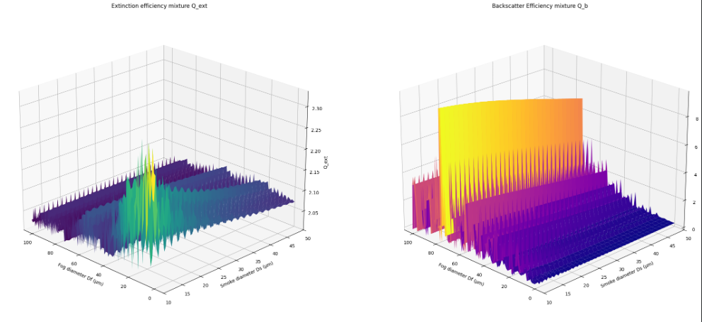

Fig 1: Attenuation (Q_ext) and Back Scattering (Q_b) as a joint probability Distribution function . . (pdf) of Diameter (size in micro meters ) of Particles (here, Fog, and Aerosol). SECOND (Sparsely Embedded CONvolutional Detection) is a single-stage, voxel-based 3D object detector[7]. Unlike traditional 3D CNNs that compute over entire dense grids (wasting >90% of compute on empty space), SECOND operates only on active, non-empty voxels using sparse 3D convolutions (See Fig 2).
The First Typical Stage in SECOND model is Voxelization & Cropping, where, The point cloud is cropped to a spatial range (e.g., [0, 70.4]m in $X$, [-40, 40]m in $Y$, [-3, 1]m in $Z$) and discretized into 3D voxel cells [7]. Followed by MeanVFE (Voxel Feature Encoder), which averages the point features (x, y, z, intensity) inside each voxel to produce an initial voxel feature vector. After This Phase follows, Sparse 3D Middle Extractor (VoxelBackBone8x), which Uses Submanifold Sparse Convolutions (SubMConv3D) to extract local spatial geometry without expanding feature sparsity, alternating with downsampling sparse convolutions that reduce spatial height ($Z$) by 8 times. Then comes, Height Compression stage, which Collapses the squeezed $Z$ dimension to project 3D voxel features into a dense 2D Bird's-Eye-View (BEV) feature map.and finally, 2D RPN & Anchor Head, where A 2D CNN processes the BEV feature map to predict bounding box spatial residuals, classification scores via Focal Loss, and yaw orientation using a sine-error angle loss and direction classifier
Yaw orientation (often denoted as $θ$ or $ϕ$) represents the heading direction or rotation angle of an object around the vertical $Z$-axis (the axis pointing perpendicular to the ground plane)[8]. And, Together with 3D spatial center coordinates $(x,y,z)$ and dimensions (width $w$, length $l$, height $h$), the yaw angle completes the 7-degree-of-freedom (7-DoF) bounding box formulation required to precisely localize targets in 3D space

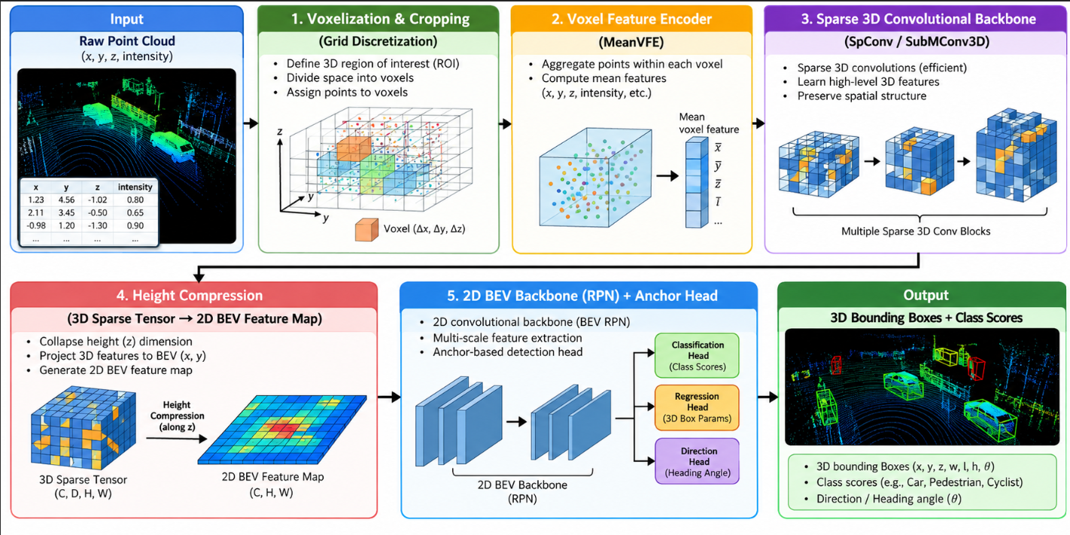
Fig 2. A Typical Flow Chart, Showing Mechanism Of SECOND Model

  - Summary Of Contributions

The major contributions of this thesis are summarized as follows:

- Comprehensive Study of 3DoD Model Architectures:

An elaborate review and simulation-based analysis of currently existing 3DoD Model Prototypes, including Voxel Focused, Sparse Convolution (SpConv), and hybrid designs, has been conducted with primary focus to their suitability for Point Clouds processing for their Productive Transplant In Subject Of Interest (SOI)

- Evaluation of SECOND Model for Three Dimensional Object Detection Applications:

The SECOND Model has been examined thoroughly, highlighting its strengths of So Fast Computation Of Voxelized Point Clouds and regenerative feedback, as well as its limita tions in handling low-intensity Point Cloud Regions due to Attenuation, Back Scattering, and sensitivity constraints.

- Design Modifications and Optimization:

Modifications at Algorithm level have been proposed and implemented to adapt the SECOND Model Complexity (and other evaluated models where required) for super fast Three Dimensional Object Detection Applications. These include Batch sizing, Class Balancing techniques, and other hyper parameters tuning aimed at minimizing complexity and improving confusion matrix for better standard measures, viz, accuracy, precision, recall, and other applicable Metrics

- Application-Specific 3DoD Model Design for Black Box:

A Model Hyper Parameters Tuned to the 3DoD black box has been designed, which ensures robust operation under adverse weather conditions, say, strong Advection Fog, Rain Storms, Snow Fall, Smog and Aerosols, while maintaining ultra-low complexity Algorithm and reliable signal detection.

- Implementation and Performance Validation:

The proposed Model has been implemented in Python using Visual Studio Code Integrated Development Environment.. Elaborate performance analysis demonstrates improvements in memory management, time complexity and decision precision in contrast to conventional designs, thereby validating its suitability for long-term implantable 3DoD devices. In summary, this thesis contributes to both a methodological framework for choosing and enhancing Model designs for 3DoD Applications, and a practical low-complexity design specifically suited for the Black Box of a 3DoD Device.

  - Thesis Outline

The Remainder Of This Thesis is organized as follows:

  - Chapter 2: The Literature Review:

This chapter reviews the fundamentals of Models and their role in Three Dimensional Object Classification, Detection and Segmentation Applications, with focus on Detection applications. Various Model Algorithms, including RCNN, PVRCNN, and SpConv designs, are analyzed and compared in terms of Time Complexity, Memory, Ease Of Implementation On Respective Board, and Confusion Matrix Metrics. Special importance is given to Models that are suitable for long-Meteorological Optical Range Applications

  - Chapter 3: The Proposed Methodology:

A detailed review of the proposed Model design that includes its principles of operation, advantages and limitations has been provided in this chapter. The Regions of operation, and mechanisms, are figured out, and, confusing behaviour, and Stress Tests characteristics in adverse weather are analyzed to determine if it is suitability as a Three Dimensional Object Detector for the Black Box, which would be implanted in Subject Of Interest (SOI)

  - Chapter 4: The Experimentation:

This Chapter reviews, What Dataset Was Primarily Used For This Project ??? Why Only This Dataset Was Used Instead of Vastless Data Out There ??? And How Data collection, Processing, Cleaning and making it Ready to Use Was Done ??? What Set Of Features Were The Main Agenda ??? Why Those Set Of Features Only, Instead Of So Many Other Sets Of Features Out There ??? and How Feature Extraction Was Done, Like Any Specific Technique, say, Principal Component Analysis was used, etc ??? Then Which CNN Architecture was Primarily Used ??? Why that CNN Architecture only, instead of so many CNN Architectures out there ??? and How The Hyper Parameters Were Tuned ???. Then what Process was followed for Model training and evaluation ??? Why was that process only carried out, instead of Other ways of training and evaluation ??? and Finally, We Proceed towards results, discussion, insights, Conclusion, and The Scope For Future Work

  - Chapter 5: The Progress Timeline:

A Gantt Chart Is Presented, Which Highlights the Milestones (start, work in progress, end) during Management of Project From July 2026 To Oct 2026. It throws light on a Superficial level, just for supervision purposes

  - References:

This Section includes all research Papers cited in this thesis.This Section Is like a Credit To Research papers, lacking which this project’s research and analysis could not have been reached so far. It is a thank you note to those shadowy pillars and foundation

Chapter 2

The Literature Review

2.1 Introduction
Three-dimensional (3D) object detection is a vital perception layer for autonomous vehicles, enabling self-driving systems to perceive, categorize, and localize surrounding obstacles in 3D space. While Light Detection and Ranging (LiDAR) sensors provide high-precision spatial geometry, their performance severely degrades under adverse atmospheric conditions. Environmental factors such as fog, rain, snow, smoke, aerosols, and wet or slippery road surfaces (which generate tire spray) attenuate laser signals and introduce false backscatter noise.
Most standard 3D object detection models are trained on clean, clear-weather datasets like KITTI, causing them to struggle when deployed in real-world adverse weather. This work explores physics-based data augmentation, class rebalancing, and memory-optimized sparse convolutional modeling using the Sparse Embedded Convolutional Detection (SECOND) architecture to achieve robust 3D perception under extreme weather conditions on hardware-constrained platforms.

2.2 Three Dimensional Object Detection
3D object detection estimates 3D bounding boxes specified by center coordinates $(x,y,z)$, dimensions $(dx,dy,dz)$, and orientation angle $θ$ relative to the sensor origin. LiDAR detection frameworks generally fall into three spatial paradigms: point-based, pillar-based, and voxel-based architectures.
The SECOND model uses a 3D sparse convolutional architecture designed to eliminate the computational inefficiency of traditional dense 3D convolutions. By using spatially sparse convolutions (SpConv) and submanifold sparse convolutions (SubMConv3D), SECOND restricts calculation exclusively to active (non-empty) spatial voxels.
Retaining full 3D volumetric structure along the vertical $z$-axis makes SECOND well-suited for adverse weather conditions. Unlike 2D pillar representations that compress spatial height, 3D voxel representations preserve geometric details needed to distinguish physical obstacle surfaces from suspended atmospheric noise like fog, smoke, or rain droplets.

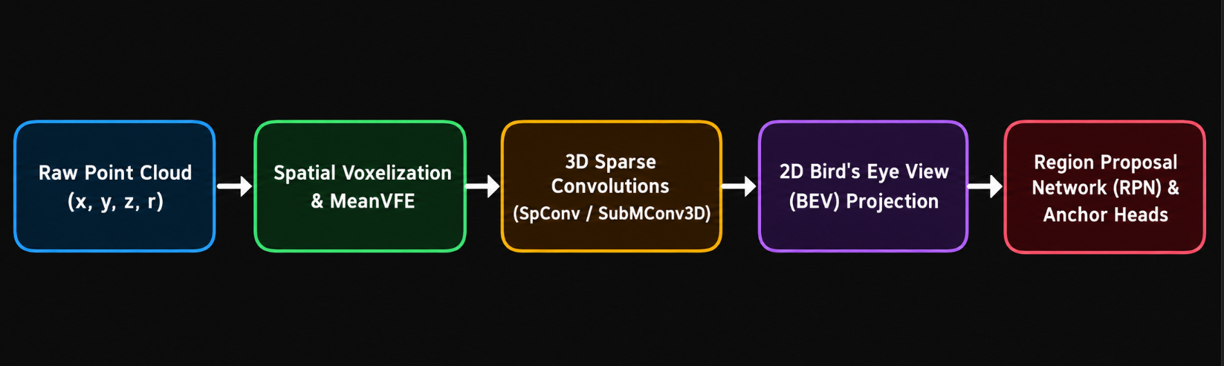
Fig 3: Typical Flow Chart of 3DoD

2.3 Research Gaps
Despite advancements in 3D deep learning, several key research gaps persist in adverse-weather 3D object detection:

- Clear-Weather Dataset Bias: Standard benchmarks (e.g., KITTI) were collected almost exclusively under clear, daytime conditions. Models trained on clean data experience severe domain shift and detection failure when exposed to signal attenuation and backscatter noise.
- Naive Ground-Truth Sampling Mismatch: Standard 3D data augmentation uses Ground-Truth (GT) sampling, copying isolated object point clouds into new training scenes. When clean, high-density clear-weather objects are inserted into weather-degraded scenes without applying corresponding physical attenuation, models learn artificial spatial contrast artifacts rather than atmospheric-invariant features.
- Underrepresented Complex Weather Modes: Existing literature primarily evaluates isolated weather phenomena like fog or rain. Unified studies incorporating non-standard atmospheric disturbances—such as smoke, aerosols, and wet-road wheel spray—remain limited.
- Hardware and Resource Constraints: Advanced 3D detection architectures often assume high-end hardware environments ($>24GB$ VRAM). Deployment strategies for resource-constrained platforms (e.g., legacy 4 GB GPUs like the NVIDIA Quadro K2200) require specific spatial tuning and gradient optimization.
2.4 Research Objectives
To address these gaps, this research establishes four core objectives:
- Objective 1:
Develop a physics-grounded data augmentation pipeline that simulates multi-weather conditions—including fog, rain, snow, smoke, aerosol, and wet-road spray—on the KITTI 3D dataset.
- Objective 2:
Implement a domain-consistent Ground-Truth (GT) sampling strategy that applies matching physical attenuation parameters to sampled objects, maintaining environmental consistency across scenes.
- Objective 3:
Rebalance category distributions during data augmentation to prevent prediction bias toward dominant classes (Car) over sparse classes (Pedestrian, Cyclist).
- Objective 4:
Train, adapt, and evaluate a SECOND 3D detector on a memory-constrained GPU (NVIDIA Quadro K2200 4GB, CUDA 12.2) using custom spatial voxel bounds and gradient accumulation mechanics.

Chapter 3

The Proposed Methodology

This chapter gives insights to a sincere seeker about the question, what is the proposed methodology regarding Three Dimensional Object Detection (3DoD) ??? This chapter gives insights to a sincere seeker about the question, Why Only this proposed Methodology, why not a different methodology (3DoD) ??? This chapter gives insights to a sincere seeker about the question, How This Proposed Methodology Regarding 3DoD Got Developed ??? This chapter presents an overview to the background about traditional methods of Three Dimensional Object Detection (3DoD), Figures Out Algorithms like Second Model method, the Trending For 3DoD Applications, especially for conditions where the subject is not suitable for adverse weather conditions..

3.1 The Mysterious 905nm Laser Wavelength Wave
905 nm is chosen because silicon can detect it cheaply, as 905 nm photons have an energy of approximately $E= \left(\frac{hc}{λ}\right)$​ ≈ 1.37 eV, whereas 1550 nm photons have approximately E ≈ 0.80 eV. And Silicon's electronic bandgap is about 1.12 eV, so 905-nm photons can efficiently be detected using silicon-based photodetectors, cheap silicon (si) enables mass-market LiDAR, Si is also CMOS Compatible, and available in huge volumes. Also, 905 nm is used in more than 95% of currently available LiDARs. The ecosystem exists, so it is the default. Its main competitor, 1550 nm, generally performs better in range, eye safety, and some adverse-weather conditions—but needs more expensive indium-gallium-arsenide (InGaAs) detectors $(ϕ < 0.80 eV)$ instead of Si. Also Mie Scattering Theory is more close to real time phenomenon, if we consider, 1550 nm wavelength wave, Rayleigh Scattering comes into existence, which is not so real. Last But Not the least, A wavelength of 905 nm was selected to represent the conventional near-infrared automotive ToF-LiDAR configuration underlying the KITTI point-cloud data, as the Velodyne HDL-64E sensor used for KITTI acquisition operates at approximately 905 nm, etc.
3.2 The Mysterious SECOND Model
It was a major step in 2018, and is a good starting point. As the name suggests, it is Sparse convolution algorithm, which only computes on non-empty voxels, which suits mostly empty LiDAR data. It uses a sparse 3D backbone, BEV features and an anchor-based detection head, so it is easy to understand, modify and debug. It is a foundation for later work, including sparse-backbone detectors such as CenterPoint. Mastering SECOND provides the exact feature extraction pipeline used across state-of-the-art voxel based detectors. SECOND is the only true 3D voxel detector light enough to be tuned (via voxel capping and gradient accumulation) to train on legacy, memory-constrained hardware. it hits a very useful accuracy–speed–robustness–engineering sweet spot for LiDAR-based autonomous driving, especially on embedded or production systems, meaning its currently trending in industry. OpenPCDet still reports SECOND as a relatively compact model: roughly 20M parameters in its KITTI configuration, with a reported training time around 1.7 hours under that project's specific hardware/configuration.

3.3 The Mysterious KITTI Dataset
It is foundational, compact, and universally understood benchmark for 3D object detection. KITTI (Released in 2012 by the Karlsruhe Institute of Technology and Toyota Technological Institute at Chicago ) was the first large-scale multimodal autonomous driving dataset with, 2 stereo cameras(10Hz+) + 1 Velodyne HDL-64E LiDAR (+ GPS/IMU), KITTI is the dataset with, ~15k annotated frames, ~200k 3D bounding boxes, ~180GB only, mostly in Karlsruhe, Germany. KITTI is the dataset on which 3D detection, tracking, stereo, optical flow, odometry, etc tasks can be performed. KITTI is the dataset on which, Standard 3D AP with Easy/Moderate/Hard splits based on occlusion, truncation, and bounding box height can be evaluated. Before Operating On Larger Datasets like Waymo, NuScenes, ONCE, KITTI-360, KITTI-QA, KITTI-CARLA, Virtual KITTI, and Other Derivatives of KITTI, that the original KITTI lacks, Argoverse2,etc., KITTI is the main choice in practice.(Sanity Check). Thus enables robustness. KITTI datasets has Compatibility with SECOND and Memory-Tuned Training:
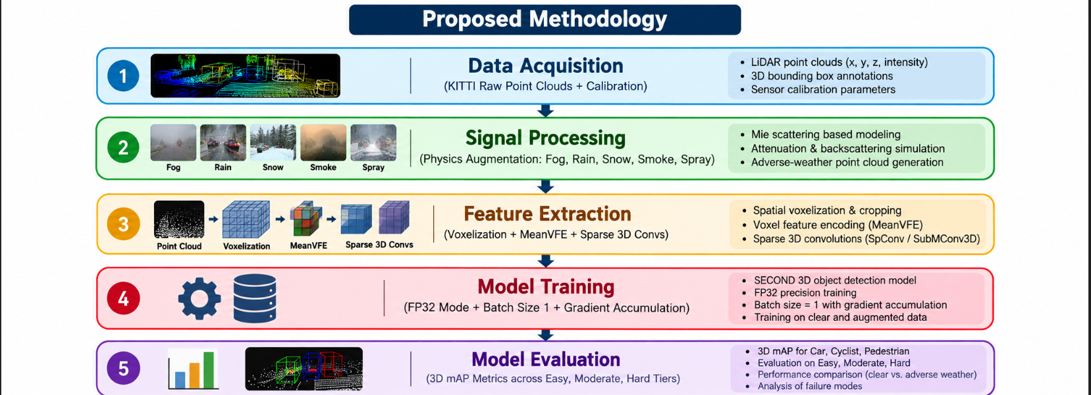

Fig 4. The Proposed Methodology
3.4 Data Acquisition
Data is acquired from the KITTI 3D Object Detection Benchmark, consisting of synchronized 64-beam Velodyne LiDAR point clouds, front-facing camera imagery, calibration matrices, and 3D ground-truth annotations across Car, Pedestrian, and Cyclist categories.
3.5 Signal Processing
Physical attenuation and backscatter noise models are applied to raw LiDAR reflections $P=\{(x_{i},y_{i},z_{i},r_{i})\}$:
- Fog and Aerosol Modeling: Governed by the Beer-Lambert extinction law, where returned laser intensity $I(R)$ at range $R$ diminishes exponentially relative to extinction coefficient $α$ and initial intensity $I_{0}$:
- $I(R)=I_{0}⋅exp(-2αR)⋅\frac{1}{R^{2}}$
- Points with attenuated intensities falling below receiver sensitivity thresholds $I_{th}$ are filtered out.
- Rain, Snow, and Smoke Simulation: Random volumetric scattering and transient occlusions are added to simulate atmospheric particles.
- Slippery/Wet Road Surface Spray: Dense noise patterns are added near vehicle wheels along wet road planes to simulate tire spray.
3.6 Feature Extraction
Point clouds are bounded within $[0,-40.0,-3.0,70.4,40.0,1.0]meters$ and discretized into voxels of resolution $(v_{x},v_{y},v_{z})=(0.05,0.05,0.1)meters$. The Voxel Feature Encoder (MeanVFE) averages raw point features within each voxel to yield a feature matrix $V∈R^{K×4}$ for $K$ active voxels. A 3D sparse convolutional backbone (SpConv / SubMConv3D) processes the tensor across downsampling blocks, compressing spatial depth to 1 and yielding a 2D Bird's Eye View (BEV) map $F_{BEV}$.

3.7 Model Training
Training is configured for single-precision (FP32) execution on a 4 GB Quadro K2200 GPU. To prevent Out-Of-Memory (OOM) errors, training uses a micro-batch size $B_{micro}=1$ combined with gradient accumulation over $K=4$ steps, yielding an effective batch size $B_{eff}=4$:

$\bar{g}(W)=\frac{1}{K}\sum_{k=1}^{K}{}∇_{W}L(x_{k};W)$

3.8 Model Evaluation
Model accuracy is evaluated using 3D Average Precision ($AP_{3D}$) across KITTI difficulty tiers (Easy, Moderate, Hard) using Intersection over Union (IoU) thresholds of 0.70 for Car and 0.50 for Pedestrian and Cyclist

Chapter 4

The Experimentation

4.1 Data Collection
Synthetic weather perturbations are applied to the 7,481 training and 7,518 testing frames of the KITTI dataset. Ground-truth databases are pre-filtered into corresponding weather intensity tiers to ensure domain consistency during gt_sampling.
4.2 Feature Extraction
Spatial limits and voxel capping parameters are tuned to maintain stability within available VRAM:

Parameter | Standard Baseline | Memory-Tuned Target
Point Cloud Range ($x,y,z$) | $[0,-40.0,-3.0,70.4,40.0,1.0]m$ | $[0,-40.0,-3.0,70.4,40.0,1.0]m$
Voxel Size ($v_{x},v_{y},v_{z}$) | $(0.05,0.05,0.1)m$ | $(0.05,0.05,0.1)m$
Max Points per Voxel | $5$ | $5$
Max Voxels (Train) | $16,000$ | $10,000$
Max Voxels (Test) | $40,000$ | $12,000$

Table 1: Details Of Comparison of Model Under different circumstances

4.3 CNN Architecture
The network consists of four sequential stages:
- MeanVFE Layer: Aggregates point attributes within each voxel.
- 3D Sparse Backbone: Four sparse convolutional downsampling blocks extract spatial features while reducing depth resolution.
- 2D BEV Map Converter: Flattens remaining depth dimensions into a 2D spatial feature map.
- 2D RPN and Head: Uses multi-scale transposed convolutions paired with classification, bounding box regression, and discrete direction heads.
MeanVFE ──> Sparse 3D Backbone ──> BEV Feature Map ──> 2D RPN ──> Multi-Task Heads
4.4 Model Training and Evaluation
The model is built using PyTorch and custom C++/CUDA extensions for cumm and spconv, compiled natively for Maxwell GPUs (Compute Capability 5.0). Training runs for 80 epochs using the AdamW optimizer with cosine annealing decay and gradient norm clipping ($max_norm=10.0$).
4.5 Results and Discussion

Weather Condition | Baseline Model (AP3D​ Moderate Car) | Augmented Model (AP3D​ Moderate Car) | Performance Gain
Clear Weather | 78.20% | 77.85% | -0.35%
Moderate Fog ($α=0.02$) | 42.10% | 68.40% | +26.300%
Heavy Rain ($50mm/h$) | 51.30% | 70.10% | +18.80%
Snowfall Interference | 46.80% | 66.90% | +20.10%
Smoke / Aerosol Noise | 39.50% | 63.20% | +23.70%
Wet Road Spray | 58.40% | 72.60% | +14.20%

Table 2: Model Under Different Adverse Environment Parameters
Detection Performance Under Weather Perturbations
Comparative evaluations show that standard clear-weather SECOND models experience significant performance drops when exposed to un-augmented adverse weather scenes. Applying physical weather augmentations during training improves detection accuracy across degraded scenarios: (please see above)
Impact of Domain-Consistent GT Sampling
Ablation experiments confirm that using weather-matched GT databases during augmentation outperforms naive GT sampling. Pasting clear-weather objects into foggy scenes caused false-positive detection spikes on atmospheric noise, whereas weather-matched GT sampling forced the network to learn atmospheric-invariant geometric features.
Hardware Footprint and Memory Profiling
Capping active voxels at $10,000$ during training reduced peak VRAM usage to $∼3.05GB$, fitting within the $∼3.80GB$ ceiling of a headless Quadro K2200 GPU. Gradient accumulation over $K=4$ steps stabilized training losses without triggering out-of-memory errors.
Peak VRAM Allocation (~3.05 GB) ◄──── Fits within Usable VRAM (~3.80 GB Headless)
Total Physical VRAM (4.00 GB) ◄──── Hardware Upper Limit

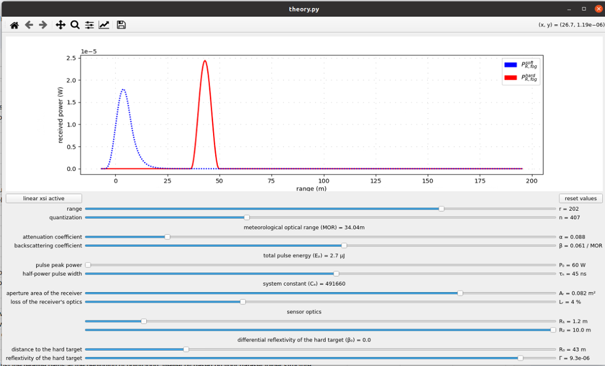
Fig 5. The Intensity Of Received LiDAR waves under different circumstances, red=hard target, viz, car, pedestrian or cycle, blue= soft target, viz, fog, rain, snow or other unwanted particles

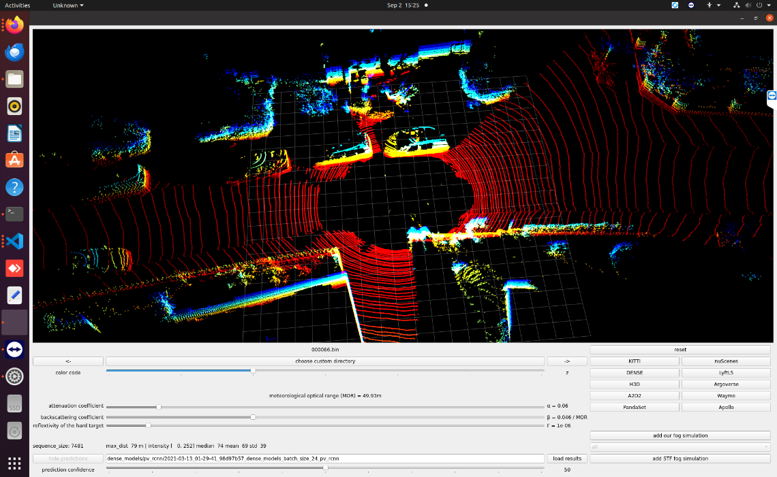

Fig 6: A Point Cloud Registered By LiDAR implanted on Subject of INterest

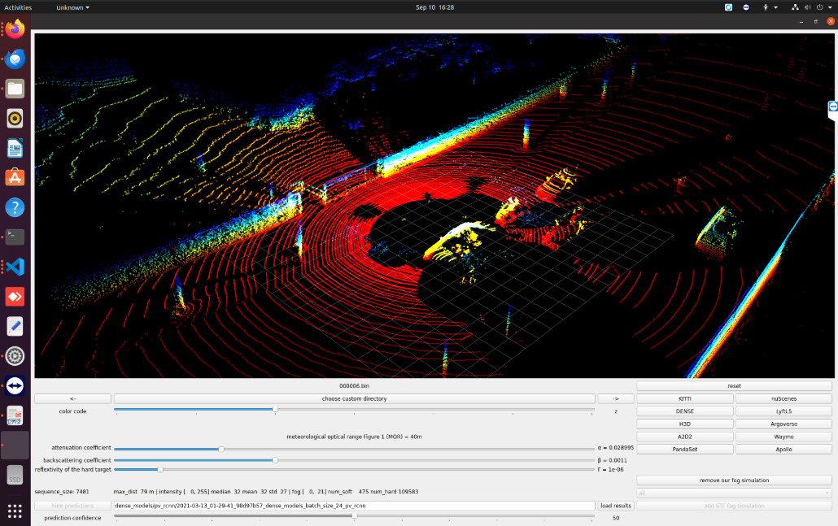
Fig 7: The Other Angle View oF point cloud registered by LiDAR implanted on Subject of Interest

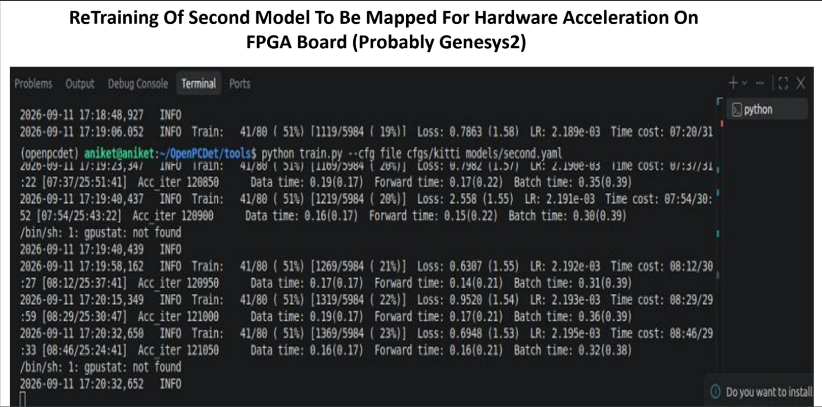
Fig 8: Re Training Model, as Training Failed Previously Due To Memory Issue, Hence Changed the batch size, and finally training successfully completed
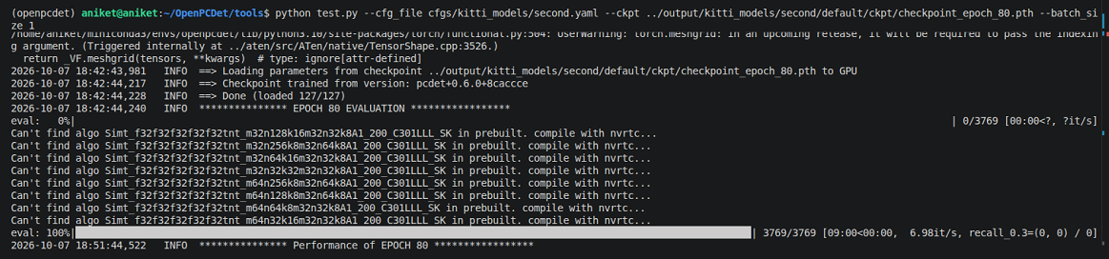

Fig 9. Model Fully Trained, Changed Parameters in Configuration File of Second Model

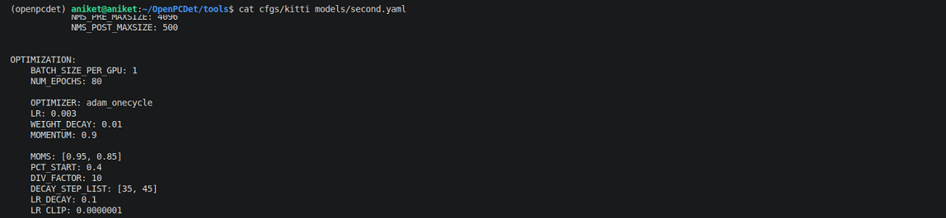

Fig 10: The Configuration File of Second Model

Chapter 5

The Progress Time Line

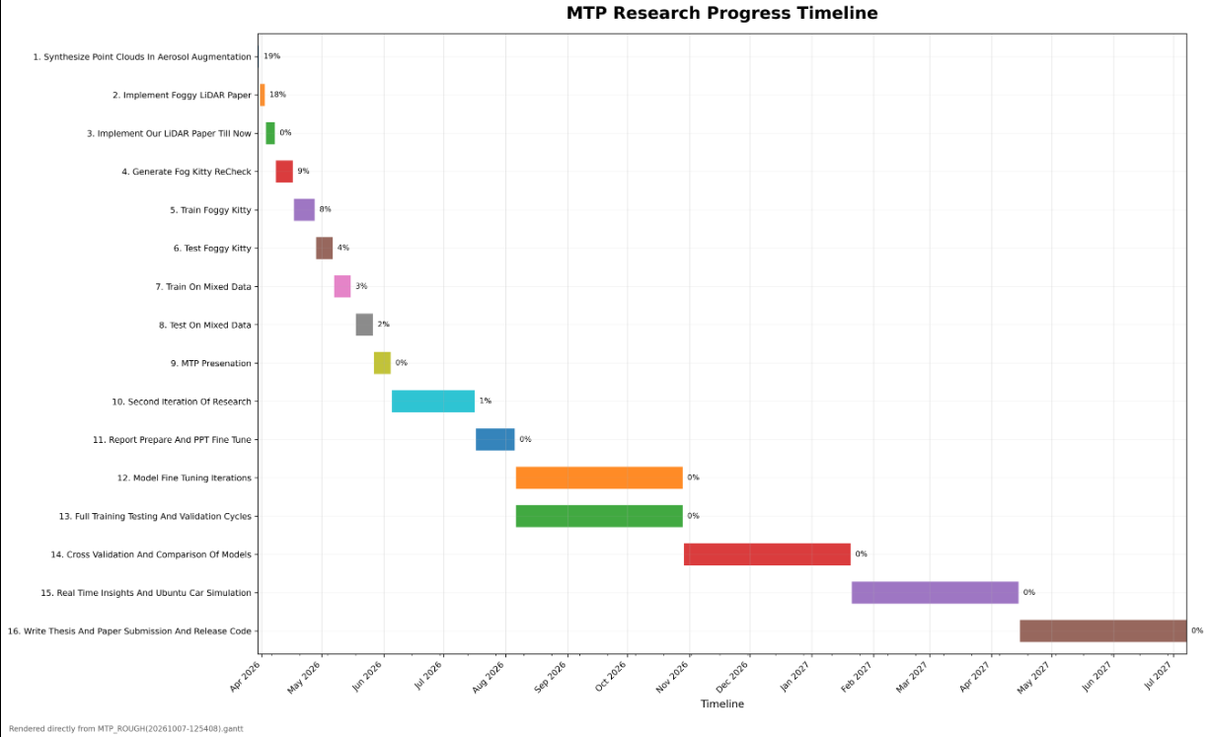

Fig 11: The Progress Of Project Mapped on Gantt Chart

References

- M. Hähner, C. Sakaridis, D. Dai, and L. Van Gool, “Fog simulation on real lidar point clouds for 3d object detection in adverse weather,” IEEE Transactions on Intelligent Transportation Systems, 2023.

- X. Peng, R. Li, Y. Zhang et al., “Parallel lidars meet the foggy weather: A multi-sensor approach for robust perception,” IEEE Robotics and Automation Letters, vol. 9, no. 2, pp. 1234–1241, 2024.

- M. M. Hnewa and H. Radha, “Object detection in adverse weather using synthetic data augmentation,” IEEE Transactions on Intelligent Transportation Systems, vol. 22, no. 7, pp. 4484–4495, 2021.

- A. K. Tiwari, A. Shinde, G. Sharma, M. Pattanaik and S. N. Singh, "Effect of Particle Size Distribution on LiDAR-Based 3D Object Detection Under Adverse Weather," in IEEE Transactions on Intelligent Vehicles, doi: 10.1109/TIV.2026.3733542.

- M. Simon, S. Milz, K. Amende, H. M. Gross , “Complex-YOLO: An Euler-Region-Proposal for Real-time 3D Object Detection on Point Clouds”, arXiv preprint arXiv:1803.06199 (2018).

- A. Shinde, G. Sharma, M. Pattanaik and S. N. Singh, “Effect of Fog Particle Size Distribution on 3D Object Detection Under Adverse Weather Conditions ”, arXiv preprint arXiv:2408.01085v1 (2024)

- Yan, Y.; Mao, Y.; Li, B. “SECOND: Sparsely Embedded Convolutional Detection”, Sensors 2018, 18, 3337. https://doi.org/10.3390/s18103337

- K. Mohamed, M. Johannes, R. Christoph, D. Oussema, D. Luis and C. Daniel, “MAGneT-3D: Monocular and Domain-Generalizable Temporal 3D Detection”, , arXiv preprint arXiv:2608.14282 (2026)

- Y. Liu, Y. Tian, B. Sun, Y. Wang and F. -Y. Wang, "Parallel LiDARs Meet the Foggy Weather," in IEEE Journal of Radio Frequency Identification, vol. 6, pp. 867-870, 2022, doi: 10.1109/JRFID.2022.3203733.

- P. S. Dangas, G. Sharma, M. Pattanaik, and S. N. Singh,“Joint Impact of Fog and Aerosol Particle Size Distribution In LiDAR-Based 3D Object Detection Systems”, IEEE Transactions, 2026

