**Docker Swarm**

Docker Swarm is an open source container orchestration platform built and maintained by Docker.

Cluster: is a collection of nodes and node is a VM.

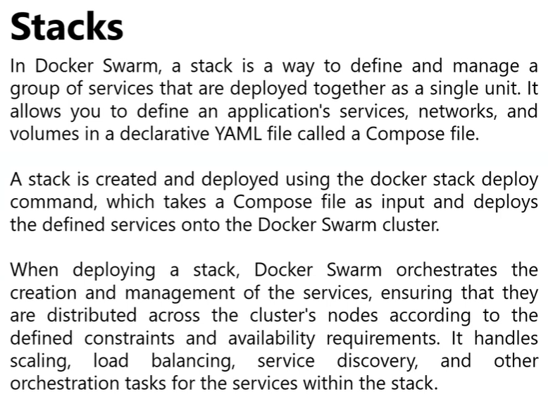

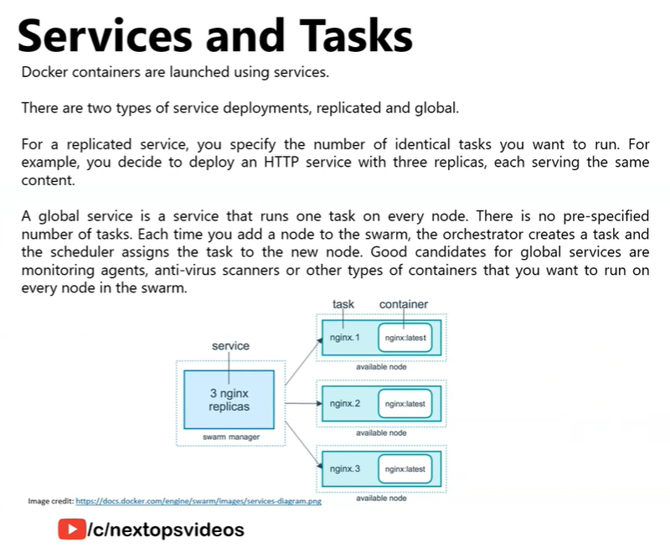

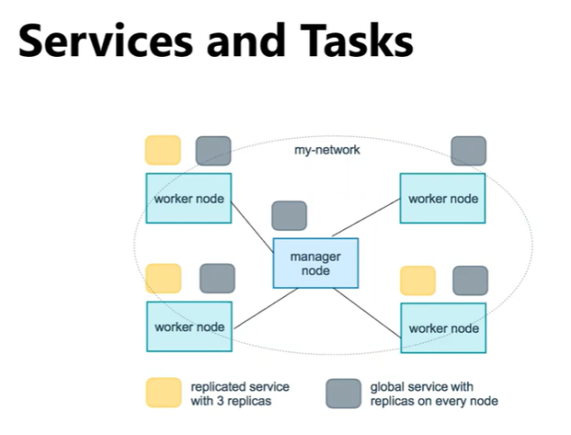

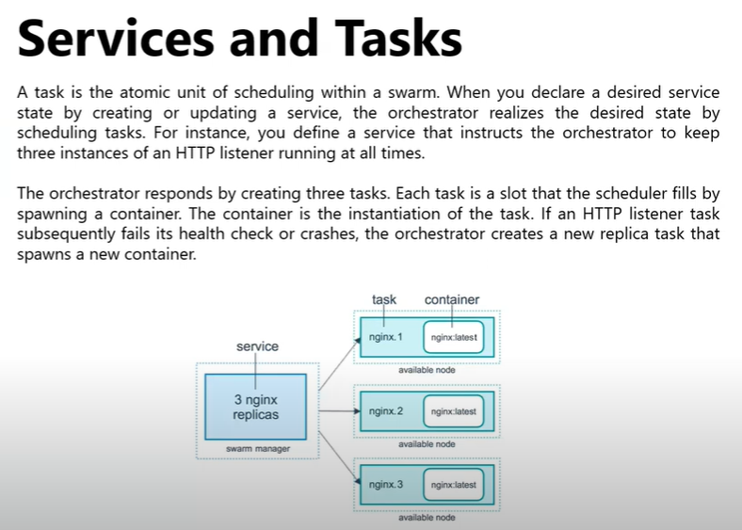

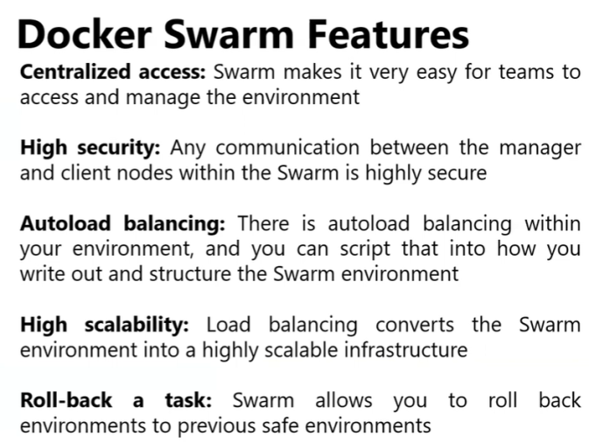

**Docker Swarm Cpommands:**

Docker swarm follows a master-slave / manager-worker architecture in which a manager node is created on VM1 and worker node on VM2.

Manager node schedules and assigns the services as tasks from compose file to across the worker nodes to achieve the desired state.

1. To initialize the docker swarm in a machine(Master Node):

***docker swarm init --advertise-addr <HostIPAddress>***

1. To check available nodes: ***docker node ls***
2. Worker node: when you perform above command it shows the worker node command.

Execute that command on the worker node machine.

1. To create a replica(1) service : ***docker service create --name <containerName> <image>:<version>***

***By default a service will be considered as Replica service and that service would be replicated first on to the Manager Node.***

1. To create n replica(n) services : ***docker service create --name <containerName> --replicas:<n> <image>:<version>***

If we have only 2nodes(manager&worker), if we give replica count as 4, then it equally distributes the services in 2 nodes. (2 tasks in manager and 2 in worker)

1. To create a global service : ***docker service create --mode global --name <containerName> <image>:<version>***

a global service assign the tasks to everynode including manager node irrespective of number of replicas

1. To view list of services : ***docker service ls***

**Docker Compose in Docker Swarm:**

There are few differences between regular compose ans swarm compose file

1. In regular compose we can create images as well but here images needs to present before running the docker compose.
2. In regular compose the network should will be bridge but in swarm compose the netwotk type should be **overlay**
3. Container_name and restart policy are not supported in docker swarm compose
4. To deploy a stack:

***docker stack deploy -c docker-compose.yaml <stackName>***

1. To view list of stacks:

***docker stack ls***

1. To view list of services in a stack

***docker stack services <stackName>***

1. To view list of container created from a stack:

***docker stack ps <stackName>***

1. To remove a stack:

***docker stack rm <stackName>***

1. To creae a overlay network

***doker network create -d overlay <networkName>***

1. To unassign a worker node from manager node

***docker swarm leave***

1. To remove a worker node from manager

***docker node rm <WorkerNode>***

1. To remove a manager node it self

***docker swarm leave --force***

**Docker SwarmPit:**

Docker swarmPit is GUI for docker swarm where we can manage all of our stacks, services, networks, volumes in a UI.

Open <https://swarmpit.io/> and execute the command Host Machine where our docker-compose.yaml is exists.

It performs the operations same as how swarm does with stack, the dashboard of the swarmpit can seen at <HostIp>:888

