Vue实训项目文档

项目结构
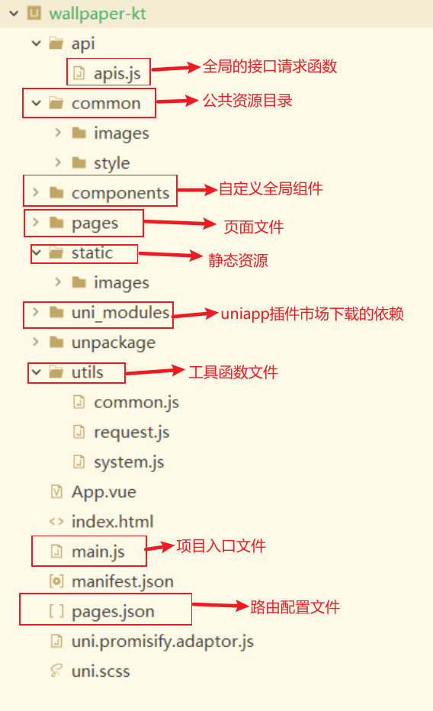

工具函数

common.js 格式化时间
export function compareTimestamp(timestamp) {
const currentTime = new Date().getTime();
const timeDiff = currentTime - timestamp;

if (timeDiff < 60000) {
return '1分钟内';
} else if (timeDiff < 3600000) {
return Math.floor(timeDiff / 60000) + '分钟';
} else if (timeDiff < 86400000) {
return Math.floor(timeDiff / 3600000) + '小时';
} else if (timeDiff < 2592000000) {
return Math.floor(timeDiff / 86400000) + '天';
} else if (timeDiff < 7776000000) {
return Math.floor(timeDiff / 2592000000) + '月';
} else {
return null;
}
}

export function gotoHome(){
uni.showModal({
title:"提示",
content:"页面有误将返回首页",
showCancel:false,
success: (res) => {
if(res.confirm){
uni.reLaunch({
url:"/pages/index/index"
})
}
}
})
}

request.js 接口请求

export function request(config={}){
let {url,data}=config
return new Promise((resolve,reject)=>{
uni.request({
url:url,
data:data,
header:{
"access-key":'20050920'
},
success:res=>{
if(res.data.errCode===0){
resolve(res)
}else if(res.data.errCode===400){
uni.showModal({
title:"错误提示",
content:res.data.errMsg,
showCancel:false
})
reject(res.data)
}else{
uni.showToast({
title:res.data.errMsg,
icon:'none'
})
reject(res.data)
}

},
fail:err=>{
reject(err)
}
})
})

}

system.js 获取设备状态栏高度

export const getStatusBarHeight = () => {
const SYSTEM_INFO = uni.getSystemInfoSync();
console.log('系统信息:', SYSTEM_INFO); // 调试用
return SYSTEM_INFO.statusBarHeight || 0;
};

export const getSystemInfo = () => {
return uni.getSystemInfoSync();
};

页面概览

推荐页
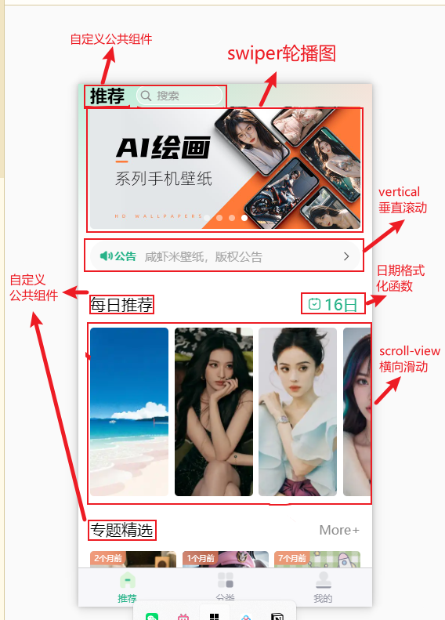
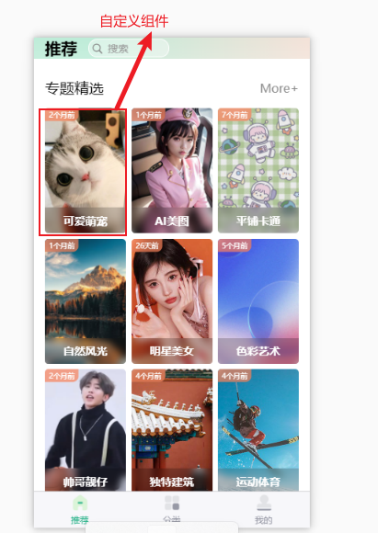

theme-item组件
<template>
<view class="themeItem">
<navigator :url="`/pages/classlist/classlist?id=${item._id}&name=${item.name}`" class="box" v-if="!isMore">
<image class="pic" :src="item.picurl" mode="aspectFill"></image>
<view class="mask">{{item.name}}</view>
<view class="tab">{{compareTimestamp(item.updateTime)}}</view>
</navigator>

<navigator url="/pages/classify/classify" open-type="reLaunch" class=" box more" v-if="isMore">
<image class="pic" src="/common/images/more.jpg" mode="aspectFill"></image>
<view class="mask">
<uni-icons type="more-filled" size="34" color="#fff"></uni-icons>
<view class="text">更多</view>
</view>

</navigator>
</view>
</template>

<script setup>
import {compareTimestamp} from "@/utils/common.js"
defineProps({
isMore: {
type: Boolean,
default: false
},
item: {
type: Object,
default: () => ({
name: '默认名称',
picurl: '/common/images/more.jpg',
updateTime: new Date().toLocaleString()
})
}
})

</script>

<style lang="scss" scoped>
.themeItem {
.box {
width: 100%;
height: 340rpx;
border-radius: 10rpx;
overflow: hidden;
position: relative;

.pic {
width: 100%;
height: 100%;
}

.mask {
width: 100%;
height: 70rpx;
position: absolute;
bottom: 0;
left: 0;
background: rgba(0, 0, 0, 0.2);
color: #fff;
display: flex;
align-items: center;
justify-content: center;
backdrop-filter: blur(10rpx); //模糊效果
font-weight: 600;
font-size: 30rpx;
}

.tab {
position: absolute;
left: 0;
top: 0;
background: rgba(250, 129, 90, 0.7);
backdrop-filter: blur(20rpx);
color: #fff;
font-size: 22rpx;
padding: 6rpx 14rpx;
border-radius: 0 0 20rpx 0;
transform: scale(0.8);
transform-origin: left top;
}
}

.box.more {
.mask {
width: 100%;
height: 100%;
flex-direction: column;
}

.text {
font-size: 28rpx;
}
}

}
</style>

分类页面
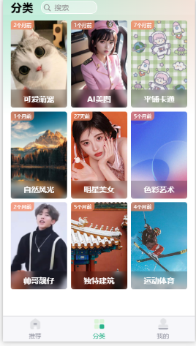

列表
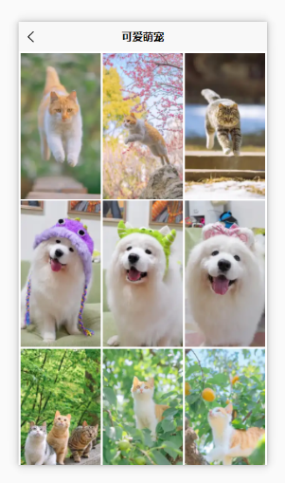

重点代码
//获取分类列表网络数据
const getClassList = async ()=>{
// console.log("执行到getClassList");
let res;
if(queryParams.classid) res = await apiGetClassList(queryParams);
// console.log(res);
if(queryParams.type) res = await apiGetHistoryList(queryParams);

classList.value = [...classList.value , ...res.data.data];
if(queryParams.pageSize > res.data.data.length) noData.value = true;
uni.setStorageSync("storgClassList",classList.value);
console.log(classList.value);
}
onUnload(()=>{
uni.removeStorageSync("storgClassList")
})

（4）预览页面
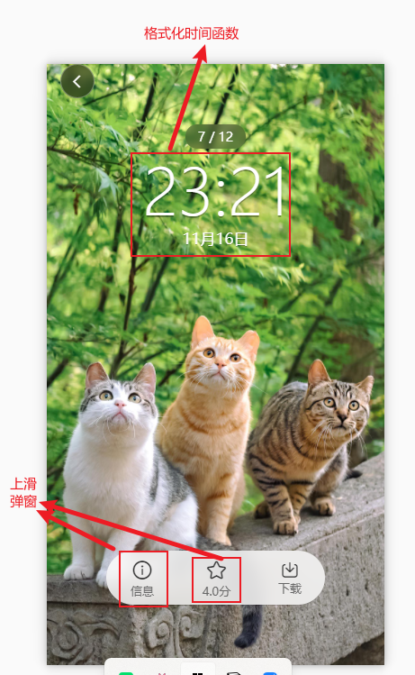

重点代码
//加载壁纸
onLoad(async (e) => {
currentId.value = e.id;
console.log(e.id);
if (e.type == 'share') {
let res = await apiDetailWall({
id: currentId.value
});
classList.value = res.data.map(item => {
return {
...item,
picurl: item.smallPicurl.replace("_small.webp", ".jpg")
}
})
}
currentIndex.value = classList.value.findIndex(item => item._id == currentId.value)
currentInfo.value = classList.value[currentIndex.value]
readImgsFun();
})
//计算当前壁纸上一个索引或者下一个索引
function readImgsFun() {
readImgs.value.push(
currentIndex.value <= 0 ? classList.value.length - 1 : currentIndex.value - 1,
currentIndex.value,
currentIndex.value >= classList.value.length - 1 ? 0 : currentIndex.value + 1
)
readImgs.value = [...new Set(readImgs.value)];
}

（5）个人中心
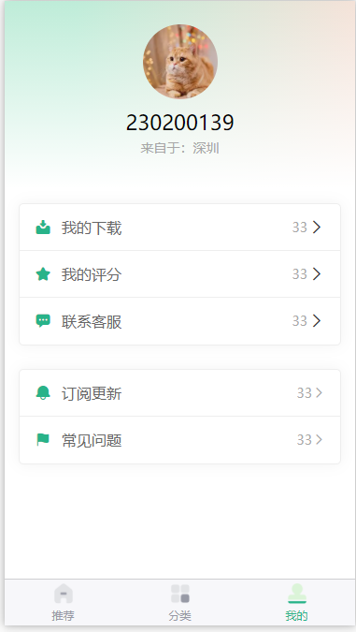

（6）搜索页面
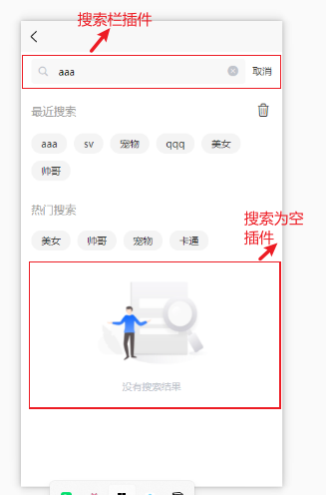



组件地址：
uni-search-bar:uni-app官网
uv-empty：uv-empty 内容为空 全面兼容vue3+2、app、h5、小程序等多端 - DCloud 插件市场

重点代码：
const searchData = async ()=>{
try{
let res = await apiSearchData(queryParams.value);
console.log(res);
classList.value = [...classList.value,...res.data.data] ;
uni.setStorageSync("storgClassList",classList.value);
if(queryParams.value.pageSize > res.data.data.length) noData.value = true;
if(res.data.data.length == 0 && classList.value.length==0) noSearch.value = true;
console.log(res);
}finally{
uni.hideLoading()
}

}

