# **Python Packet Sniffer.**

A **simple yet powerful packet sniffer** with a **friendly graphical interface** built using **Tkinter** and **Scapy**. This tool allows you to **monitor live IPv4 traffic**, view **source/destination IP addresses**, and see **real-time protocol statistics** — all within a **streamlined GUI**.

## 🚀 Features

* 🔄 **Real-time IP packet sniffing** powered by Scapy
* 🎛️ **Interactive GUI** built with Tkinter
* 🌐 Displays **source/destination IPs** and **protocols** (TCP, UDP, ICMP, Others)
* 📊 **Live statistics**: packet counts per protocol and total captured
* 🟢 Start and 🔴 Stop sniffing with buttons
* 🧾 **Summary report** upon stopping the capture

## 🖼️ Screenshot

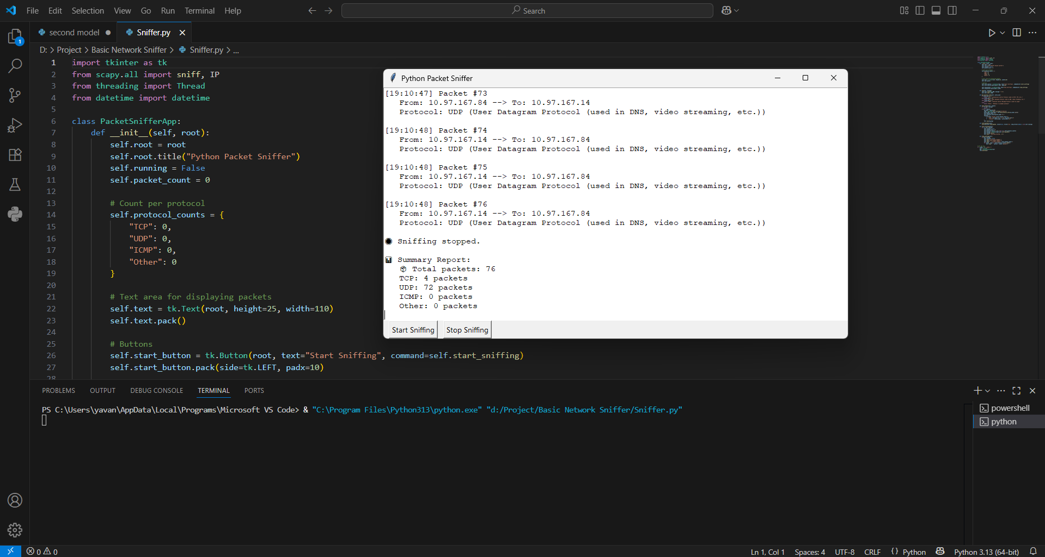

## 📦 Requirements

* Python 3.x
* Scapy (pip install scapy)
* Tkinter *(usually included with Python by default)*

## 🔧 Installation

git clone https://github.com/yourusername/packet-sniffer-tk.git  
cd packet-sniffer-tk  
pip install scapy

✅ Tkinter is bundled with most Python distributions.

## ▶️ Usage

**python packet_sniffer_gui.py**

* Click **“Start Sniffing”** to begin monitoring.
* Click **“Stop Sniffing”** to halt the capture and view the summary.

🔐 **Note:** Administrator/root access may be required:

sudo python packet_sniffer_gui.py

## 📌 Notes

* Only **IPv4** traffic is captured and displayed.
* Designed for **educational** and **network diagnostic** use.
* ⚠️ **Do not use on unauthorized networks**.

## 📄 License

This project is licensed under the **MIT License**.

**Happy sniffing!** 🕵️‍♂️💻