Requirements

  - Introduction
This section of the report will talk about the functional and non-functional requirements for the website I will be developing. These functionalities will be influenced by analyzing competitor and conducting interviews. Based on this research, functionalities will be listed and ranked from most essential to less. Additionally, the interviews, that will be conducted, would influence the prioritization of functionalities and non-functionalities.

Lastly, a feasibility analysis will be conducted. Analyzing programming language that will be used and see If there are any functionalities to be aware of. Additionally, is there are any hindrances that would occur due to the web framework or administration tools that will be used whilst developing.
  - Requirements gathering
    - Similar applications
Website: https://www.ethicalconsumer.org/
This website talks about brands based on their own scoring system based on their own requirements to be environmentally friendly, animal friendly and workers rights and what this entails.

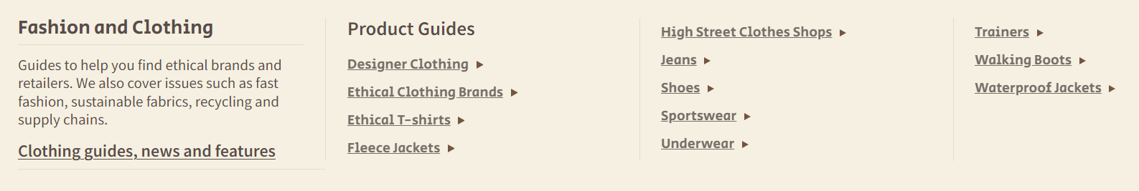
The color scheme of this website is quite bland. The home button is hidden in the navbar. However, they a good selection of categories and is further divided into understandable sub-sections. However, the combination between beige and light brown makes it difficult to read. The information above the navbar is not on the same line.

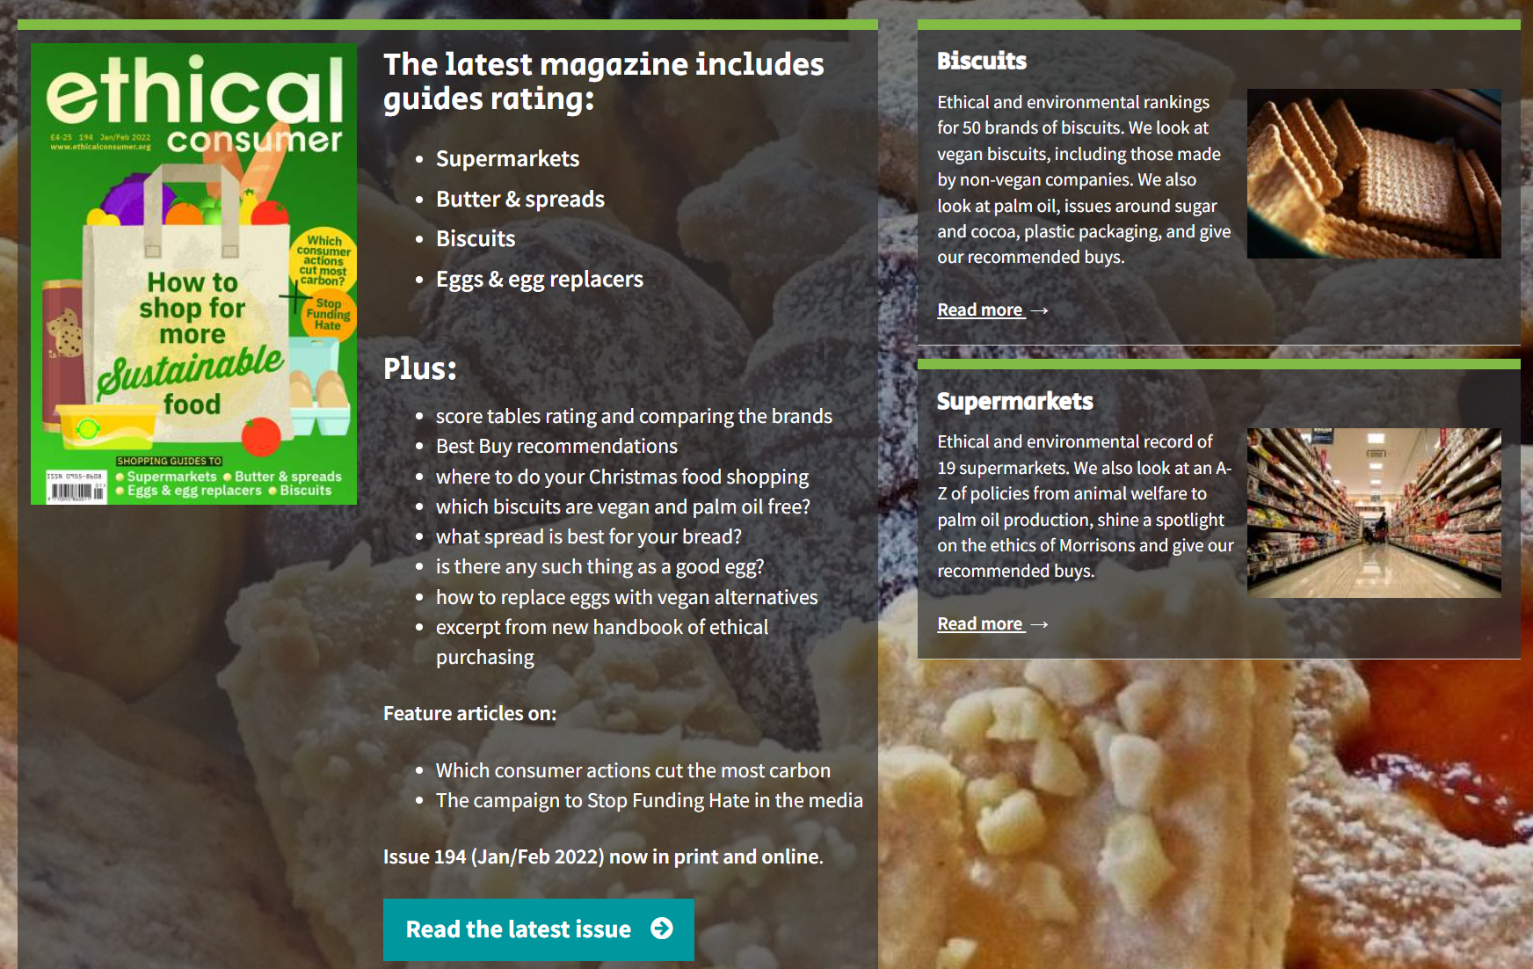
The contrast between the see though dark brown background and the background image is not great enough. Making it difficult to read the text. Additionally, the box sizing is inconsistent. The side images and the button design are inconsistent. This makes the website look untrustworthy and childish.
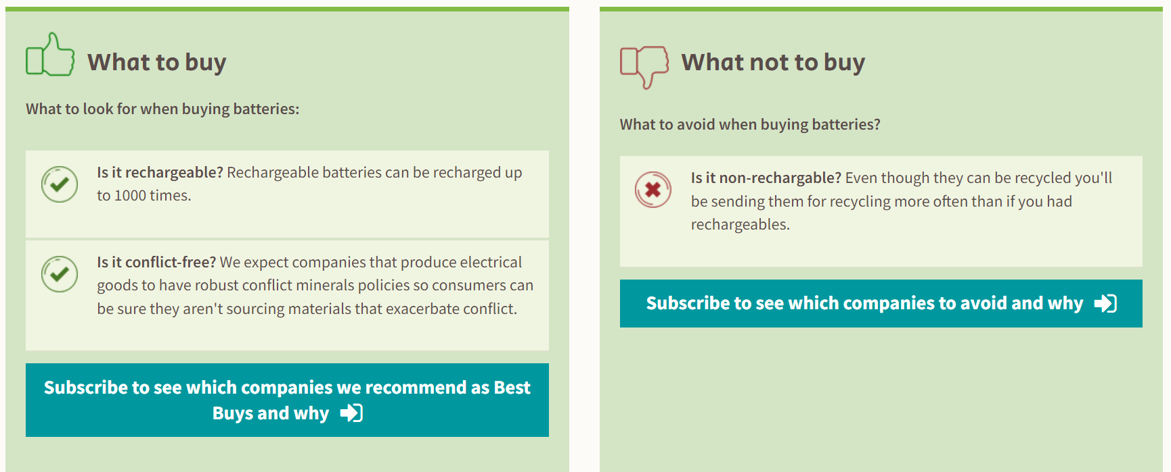
Listing a small summary on what to focus on and what to stay away from is a good idea for people who are skimming the page. At the same time, it makes it clear what criteria the website is focusing on.
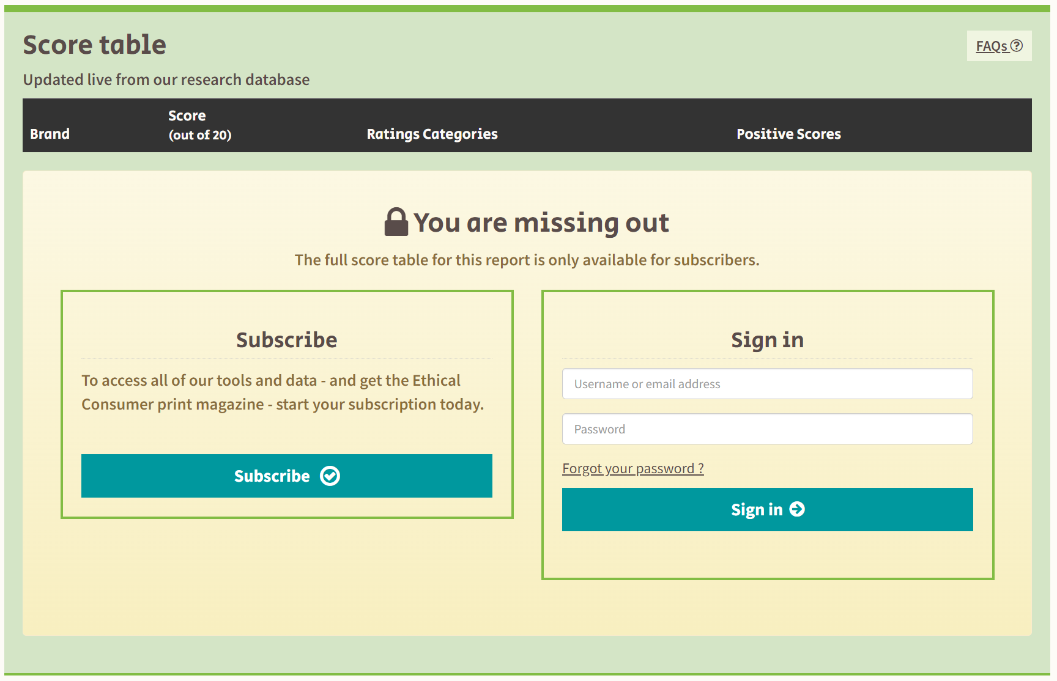
It can be a turn off is the website restricts information from the users.

Website: https://thegoodshoppingguide.com/energy-efficiency-in-the-home/
This website gives advice on products and appliances. When to change them and what specifications indicate that it is produced ethically and what to stay away from.
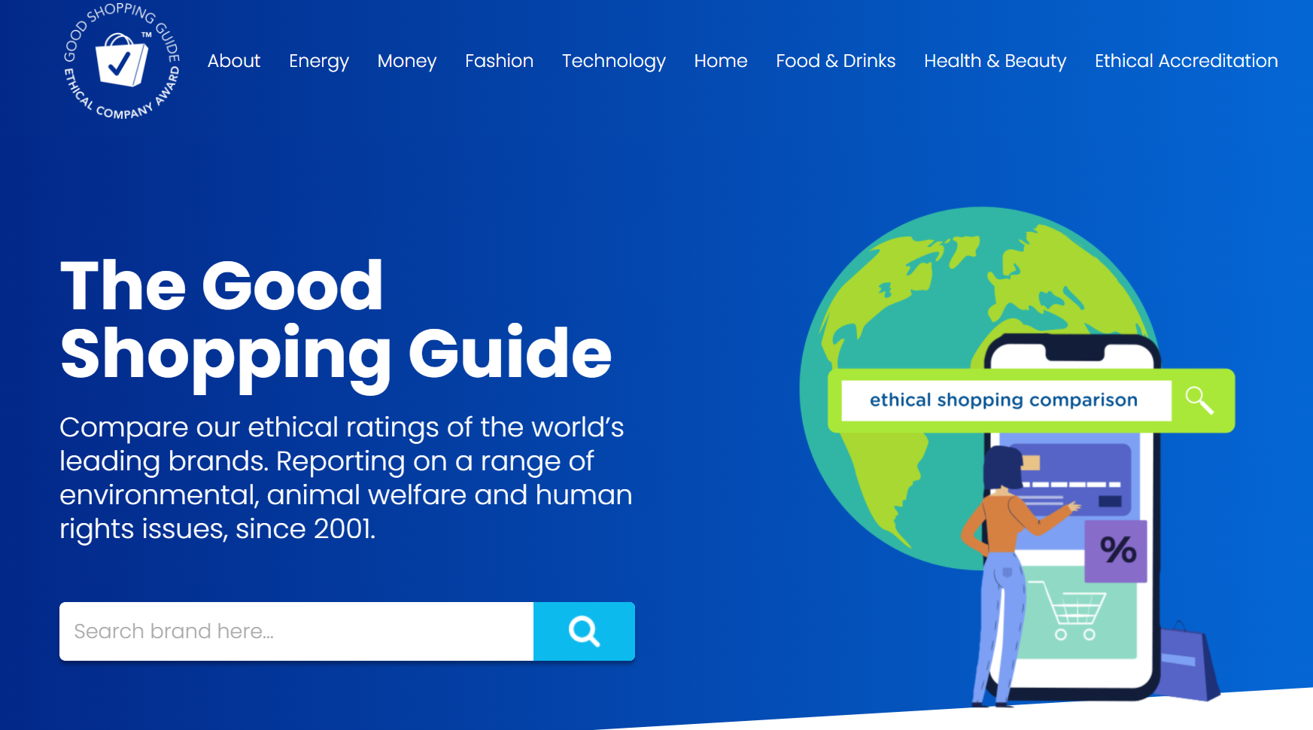
This website has a good color scheme. The text and the background color have a good contrast. However, I think the font weight in the navbar should be thicker. This would make it more readable.
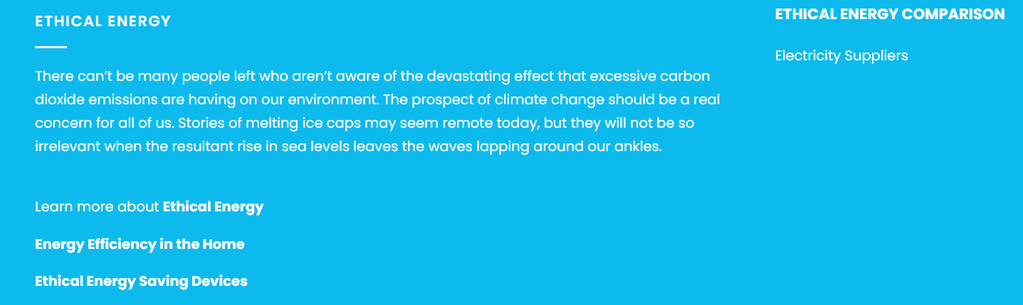
The sub-section in the navbar is too packed with information. Additionally, the information distribution look uneven.

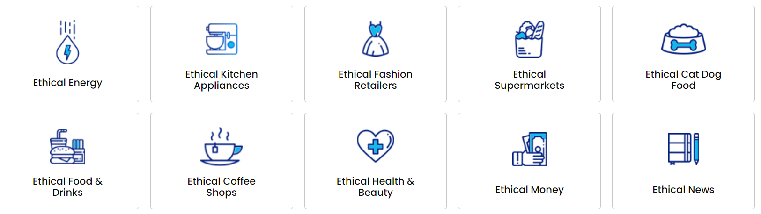
The highlighted subsections is a good idea. It is early on the website which makes it easy to find. The images make sense to the categories.
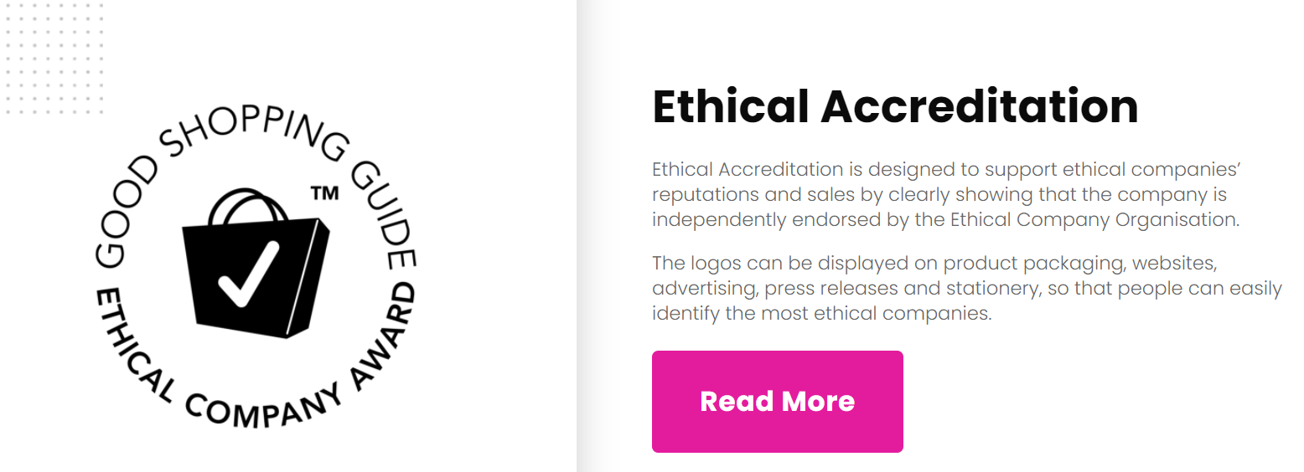

A summery of the main topics for each topic is well put together. The spacing between the logo and the text is nice and spacious. The text has a clear hierarchy. Additionally, they have not filled the space with so much text it becomes suffocating. The button has a clear contrast from the website. Which makes it eye-catching.

    - Interviews
This interview will consist of open-ended questions. These interviews will be conducted to gather functionalities and non-functionalities for a website that want to focus on guiding people to purchase clothes that are climate friendly, does not harm animals and focus workers’ rights.

After conducting the interviews, the consensus was that purchasing products that would lessen the damage the environment is a growing consideration among young adults. There seams to be few websites that give the same services that I would be giving. Few to no websites were known to the interviewee that produced the same services. Nonetheless, functionalities that would be important would be having a price index. This would be important because a lot of environmentally friendly products would be expensive. Additionally, where to purchase these products, online or in store. Lastly, having the option to divide the products into smaller categories. For example, if the product is vegan or if the animal wash treated ethically.
  - Requirements modelling
    - Functional requirements
- Information on how to find eco-friendly brands
- Login Page
- Navbar
- Nav-Subcategories
- Link to the store that sale the product
- Categories based on price and priorities
- Images for the brands
    - Non-functional requirements
These are requirements which if not met do not stop the application from working, but which mean that the application is not working as well as it should. They are usually based on issues such as:
- Usability
- CRUD functionality
- Easy navigation throughout the website
- Clear purpose of features
- Quality performance
- Performance
- Speedy
- Make it clear if something fails why it did not work
- Security
- Account Creation
- Locking the SQL server
- Delete not vital information
- Password generation (Creating a strong password. If not, make the user create a more secure one).

    - Use Case Diagrams
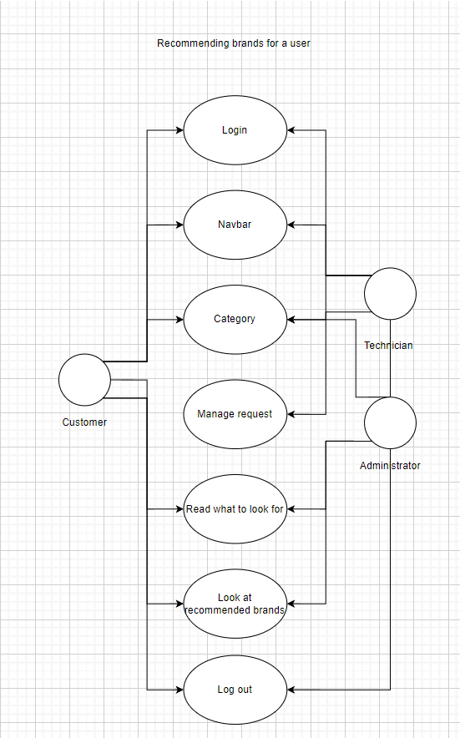

  - Feasibility
For this project I will be using the Laravel web framework, the PHPmyAdmin to handle administration of MySQL and the code editor Visual Studio Code.
It has been discovered that PhPMyAdmin4.6 has a compatibility issue with PHP 7.2. Using some of the functions like count(). Therefore, it will be important to make sure that I am using the newest version of PHP 8. There can also be an issue between Laravel and a later version of PHP 8. This issue for both opcach and xdebug. The opcach will be useful to increate the speed of the website.

