Web application Design
  - Layout
Describe the layout of your web application. Does this depend on a framework like bootstrap? Is it responsive?
I will be using the blade framework. It will have a mobile view and a desktop view. (Will be responsive.)
  - Interaction
What are the navigation elements, form elements. How does the user interact with the application?
- Navbar
- Articles
- Buttons
- Login
- Logo
- Categories
- Links to full article
  - Colour schemes
Describe the colour palette that you will use consistently across the web application
I want to use a shade of blue as my primary color. I want to build trust between the website and the user.
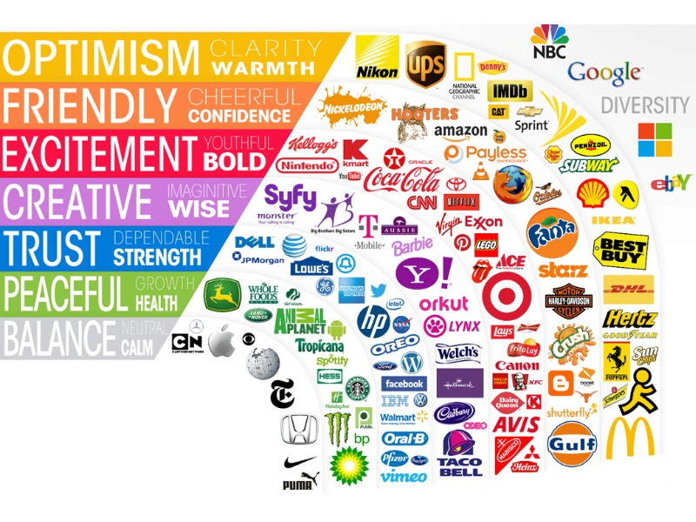
https://www.designwizard.com/blog/design-tips/color-theory

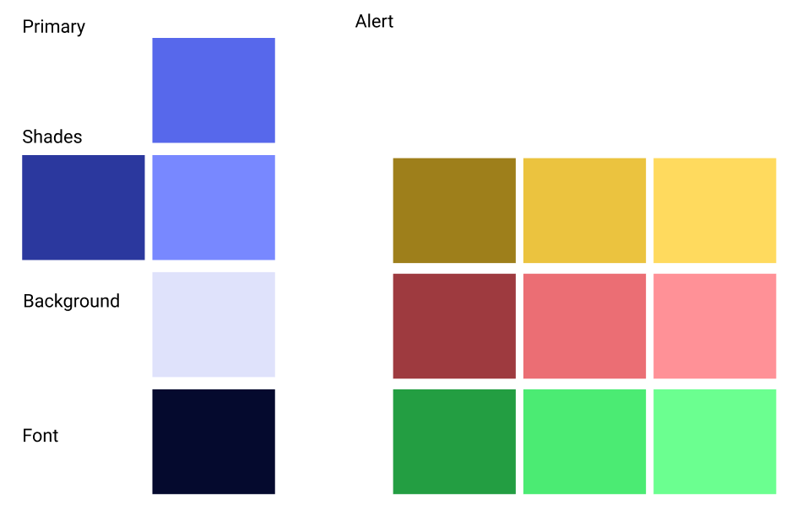
  - Font choices
Specify the fonts that you will use for different types of text. Include samples for paragraph text, headings and bold and italicised text.
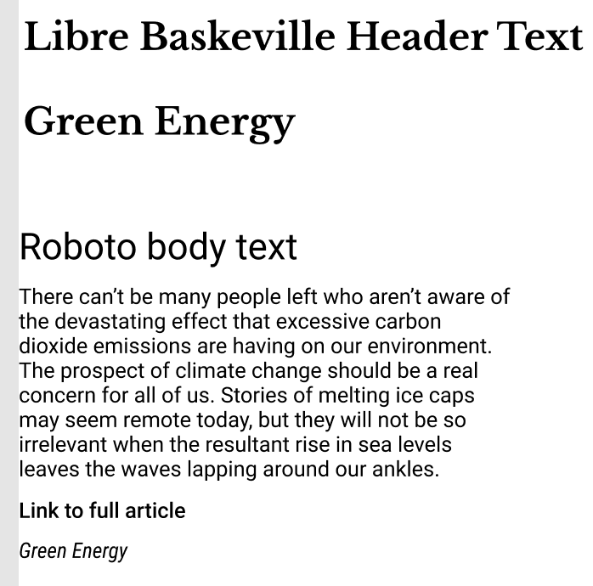

  - Wireframes
Describe how to navigate from one page to the next by adding an diagram of the different screens and what the main functionality is.

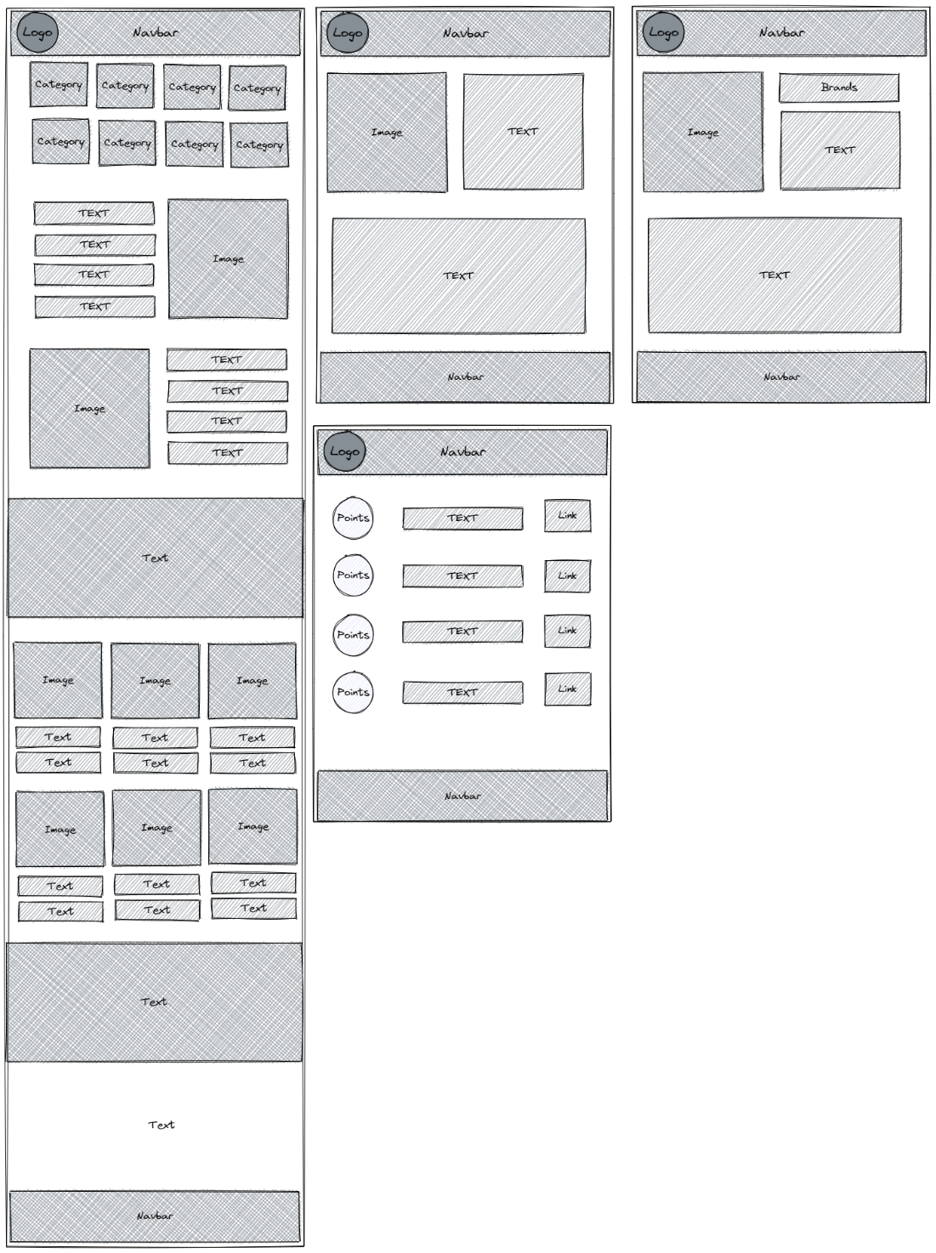
https://excalidraw.com/

