Project Management

Introduction

This chapter describes how the project was managed. It shows the phases of the project, going from the project idea through the requirements gathering, the specification for the project, the design, implementation and testing phases for the project. It also discusses GitHub as a tool which assist in project management

Project Phases

In this section, describe each of the following project phases. Explain any issues which arose for each of the phases.

Requirements
What are the essential aspects for this project? I wanted to create a website that would be informative. However, the issue was, how would I make it profitable? I solved this by adding subscriptions as an option.

Design
I needed to research the color scheme, fonts, and the layout for this project. The issue with the colors was that I need to make sure that they would attract users and the users feel like they could trust the information on my website. According to color theory, blue would be the best color for this. This is how I decided to make blue my primary color.

The wireframe needed to be simple, but not generic. I based a lot of the layout on a website that I though look very neat and organized.

Implementation
To be finished

Testing
To be done
Include a Gantt chart
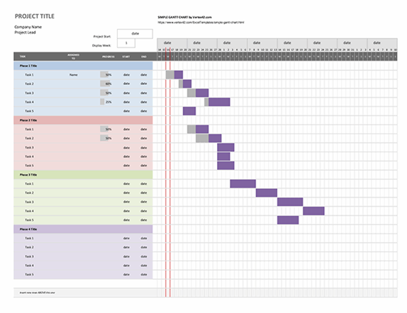

SCRUM Methodology (optional)

Sprints

Project Management Tools

Github Project
Description
Githug Project is a project management tool provided by github. Here I can create task and mention errors that need to be accomplished. I can declare tasks that I am working on and set the task as done, when I am finished.
Include screen shots

How it worked in practice
When working on the project or the report I divide the tasks into subtasks. Thereafter, the tasks I find the most important I would sett as in progress. When finished I would declare them as done. Then I do this prosses again.

GitHub
Description
GitHub is a web-based hosting service for Git repos(repositories). For any project, GitHub hosts the main repository, from which contributors can make copies for their own work.
How it is used
https://docs.microsoft.com/en-us/contribute/git-github-fundamentals
How it worked in practice
A long side git. Git is an open source control system. Which makes it possible to integrate streams of work done by multiple people over time, in one repo. This is essence, means that I can work on the project and have other people participate. Additionally, thanks to github I can clone the project repo on any computer and further develop the project.

