

Title of project

**Manu Jose**

**N00200555**

Software Project

CA 2 – Develop a PHP shopping cart website

Year 2 2021-22

DL836 BSc (Hons) in Creative Computing

Table of Contents

1 Introduction 4

2 Business Concept 5

2.1 Business Idea 6

2.2 Business model 6

2.3 Market Research 6

2.4 Marketing/Advertising 6

2.5 Suppliers 6

2.6 Competitors 6

2.7 Employees 6

2.8 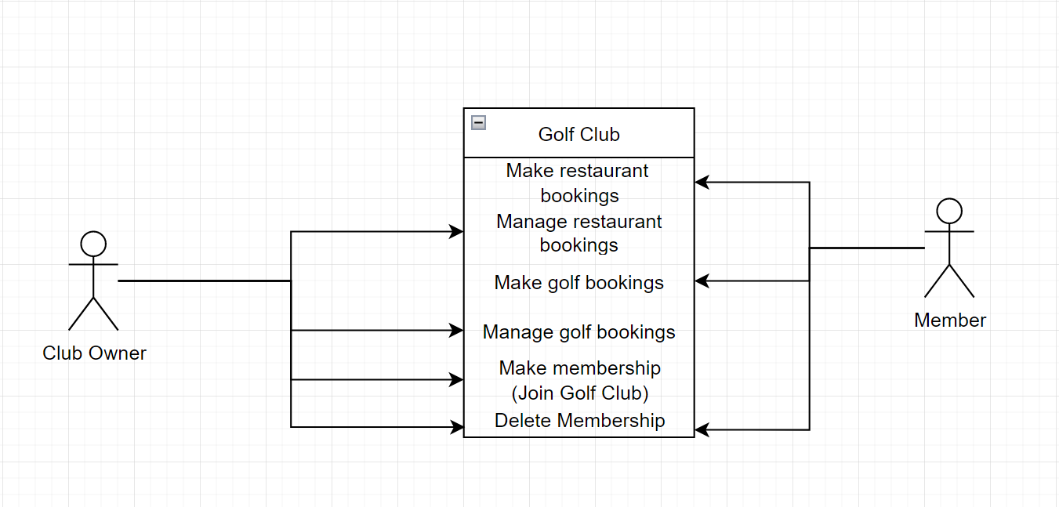Environmental Impact 6

3 Requirements 6

3.1 Introduction 7

3.2 Requirements gathering 7

3.2.1 Similar applications 7

3.2.2 Interviews 7

3.3 Requirements modelling 7

3.3.1 Functional requirements 7

3.3.2 Non-functional requirements 7

3.3.3 Use Case Diagrams 8

3.4 Feasibility 8

4 Web application Design 9

4.1 Layout 10

4.2 Interaction 10

4.3 Colour schemes 10

4.4 Font choices 10

4.5 Wireframes 10

5 Database Design 11

5.1 Description 11

5.2 Business Reporting Requirements 11

5.3 Textual Representation of Data-Set 11

5.4 Business Rules 12

5.5 Entity Relationship Diagram 12

5.6 Tables 13

5.7 Database Dictionary 14

6 System Design/ Architecture Overview 14

6.1 Introduction 15

6.2 Model View Controller 15

6.3 User Authenticaion 15

6.4 Routing 15

6.5 Templating 15

7 Testing 16

7.1 Introduction 16

7.2 Functional Testing 16

7.2.1 Login/Registration 17

7.2.2 Navigation 17

7.2.3 Calculation 17

7.2.4 CRUD 17

7.3 Discussion of Functional Testing Results 18

7.4 User Testing 18

7.5 Conclusion 18

8 Project Management 18

8.1 Introduction 19

8.2 Project Phases 19

8.2.1 Requirements 19

8.2.2 Design 19

8.2.3 Implementation 19

8.2.4 Testing 19

8.3 SCRUM Methodology 19

8.4 Project Management Tools 20

8.4.1 Github Project 20

8.4.2 GitHub 20

9 Reflection 20

9.1 Your views on the project 21

9.2 How could the project could be developed further? 21

9.3 Assessment of your learning. 21

9.4 Completing a large software development project 21

9.5 Technical skills 21

9.6 Further competencies and skills 21

10 References 22

# Introduction

The aim of my project is to create a website for a golf club that gives members of he club the ability to make bookings for playing golf and for the restaurant. The website will also contain information about the club and contact details for the club. It will also have a shop page where they can rent or buy equipment needed for golf such as golf clubs, balls, shoes and a golf buggy.

The technologies I will use for this project include PHP, HTML, CSS, Laravel, MySQL, and most likely Bootstrap but I will research other frameworks similar to Bootstrap.

The tools I will use are phpMyAdmin, XAMPP, Figma and Draw.io. I will also upload my project to GitHub with regular commits.

The concept for the business will be based off a selection of golf clubs in the greater Dublin area. It will have a clubhouse with facilities such as a bar and restaurant, changing rooms, a gym, a sauna, a shop where members can buy any equipment they need. I will need to create tables for all the members and their bookings for playing golf and reserving tables in the restaurant. I will also need to keep track of the employees working at the club.

# Business Concept

## Business Idea

A golf club with memberships and a booking service open to non-members as well. There will also be a restaurant and bar area available where people can book tables. This service will allow golfers to easily book a round of golf and it provides them with a place to eat and drink afterwards. Members will have access to changing rooms, a gym, a pool, a sauna, and games rooms with facilities such as snooker, darts and table tennis.

## Business model

The main source of income will be the club memberships. There will be different levels of membership plans to accommodate for all types of people, including full memberships, junior memberships and seasonal memberships. The restaurant and bar would also be a source of income.

## Market Research

The main demographic of customers for the golf club is mostly people who are doing well financially. They might be retired and so, they have plenty of time and money to go golfing. We’re also looking for people with families that they can bring to the restaurant.

## Marketing/Advertising

Advertising will be done mainly through social media pages for the club as well as some billboards and radio advertisements.

## Suppliers

## Competitors

Ireland has many established golf courses and clubs with decades of heritage including, Dun Laoghaire Golf Club, The K Club, Powerscourt Golf Club and the Royal Dublin Golf Club.

## Employees

## Environmental Impact

The club is very environmentally responsible. There are lakes and forests on the grounds of the club. The lakes allow the club to raise fish that can then be cooked and sold in the bar and restaurant as locally sourced produce. The grounds are also well looked after by the groundkeepers.

# Requirements

## Introduction

The main requirement of the application is to allow the club to easily take bookings from the members. Another function would be creating an online shop for the members to buy equipment from.

## Requirements gathering

I will need to create a table for the list of members currently at the golf club and make the functionality for new members to join. I will also need a table for all the bookings.

### Similar applications

Look at and document 2 similar applications. Be sure to include the following for each:

* Screen shots
* Descriptions
* Advantages
* Disadvantages

### Interviews

Conduct interviews with 2 or 3 users to find out what the important features for them for the app are. There may be various issues that arise in multiple interviews. These can be grouped together into a number of themes.

## Requirements modelling

### Functional requirements

Create a numbered list of what the application should be able to do. Start with the most important feature.

### Non-functional requirements

These are requirements which if not met do not stop the application from working, but which mean that the application is not working as well as it should. They are usually based on issues such as:

* Usability
* Performance
* Security

### Use Case Diagrams

Consists of actors and use cases. You should document each individual use case.

Delete the following diagram and insert your diagram. Use draw.io

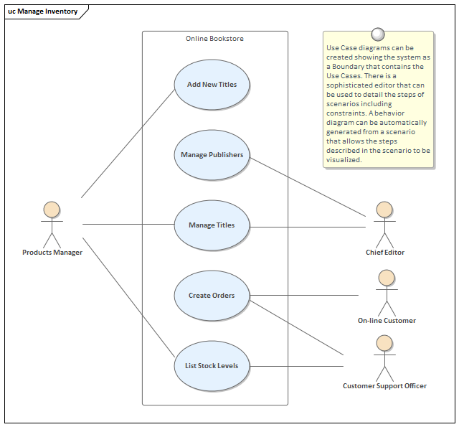

## Feasibility

This section describes which technologies are planned to be used in the development of the application. It then explains if there are any issues in terms of the technical feasibility of the project, for example, if there are two different types of software which may have compatibility issues.

# Web application Design

## Layout

Describe the layout of your web application. Does this depend on a framework like bootstrap? Is it repsonsive?

## Interaction

What are the navigation elements, form elements. How does the user interact with the application?

## Colour schemes

Describe the colour palette that you will use consistently across the web application

## Font choices

Specify the fonts that you will use for different types of text. Include samples for paragraph text, headings and bold and italicised text.

## Wireframes

Describe how to navigate from one page to the next by adding an diagram of the different screens and what the main functionality is.

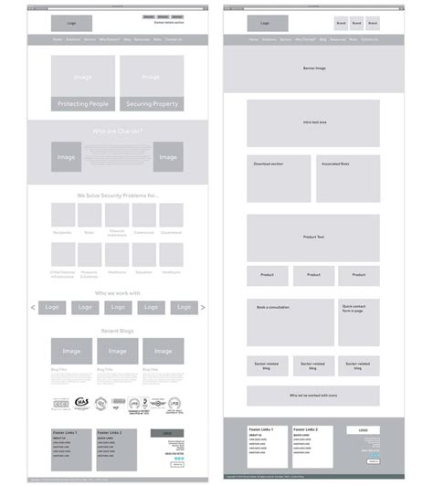

# Database Design

## Description

The Golf Club website can be used to make bookings for golf and the restaurant. They will need a database to manage the members and the golf and restaurant bookings. The members and club manager should be able to make and delete these bookings. The bookings themselves will need a date, time, number of people, and for the golf bookings, the number of holes being played and the course being used is also required. The members will have the members name, phone and email addresses. Members will input this information when registering a membership.

## Business Reporting Requirements

1. The manager needs to be able to create, read, update, and delete restaurant bookings, golf bookings, member information and golf course information.
2. Members will need to be able to find and view all of their own bookings.
3. The manager needs to be able to view all bookings.
4. The manager may need to be able to view and list all the employees where they’re working and their contact details.
5. Members need to be able to delete/cancel their membership.

## Textual Representation of Data-Set

Substitute in here the tables for your database

**MEMBER** (id, fname, lname, phone, email)

**GOLF_BOOKING** (id, date, time, course_id, golfer_amount)

**RESTAURANT_BOOKING** (id, date, time, guest_amount)

**COURSE** (id, length, difficulty)

**MEMBER_GOLF** (id, member_id, golf_booking_id)

**MEMBER_RESTAURANT** (id, member_id, restaurant_booking_id)

**EMPLOYEE** (id, name, phone, email)

## Business Rules

* A Member can have many Bookings
* A booking belongs to one member
* A booking has one course
* A course can be in many bookings

## Entity Relationship Diagram

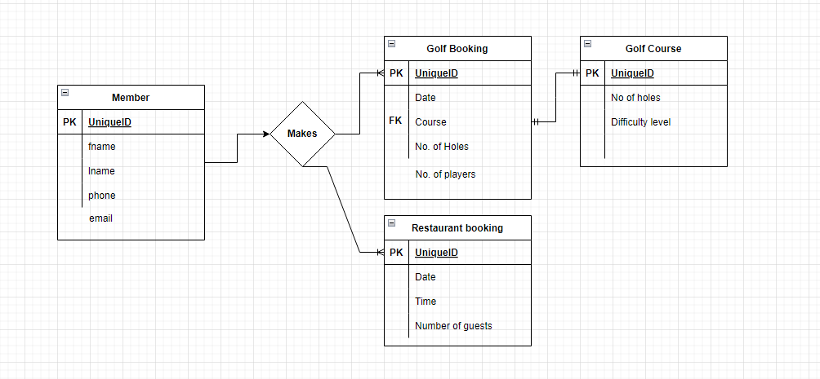

## Tables

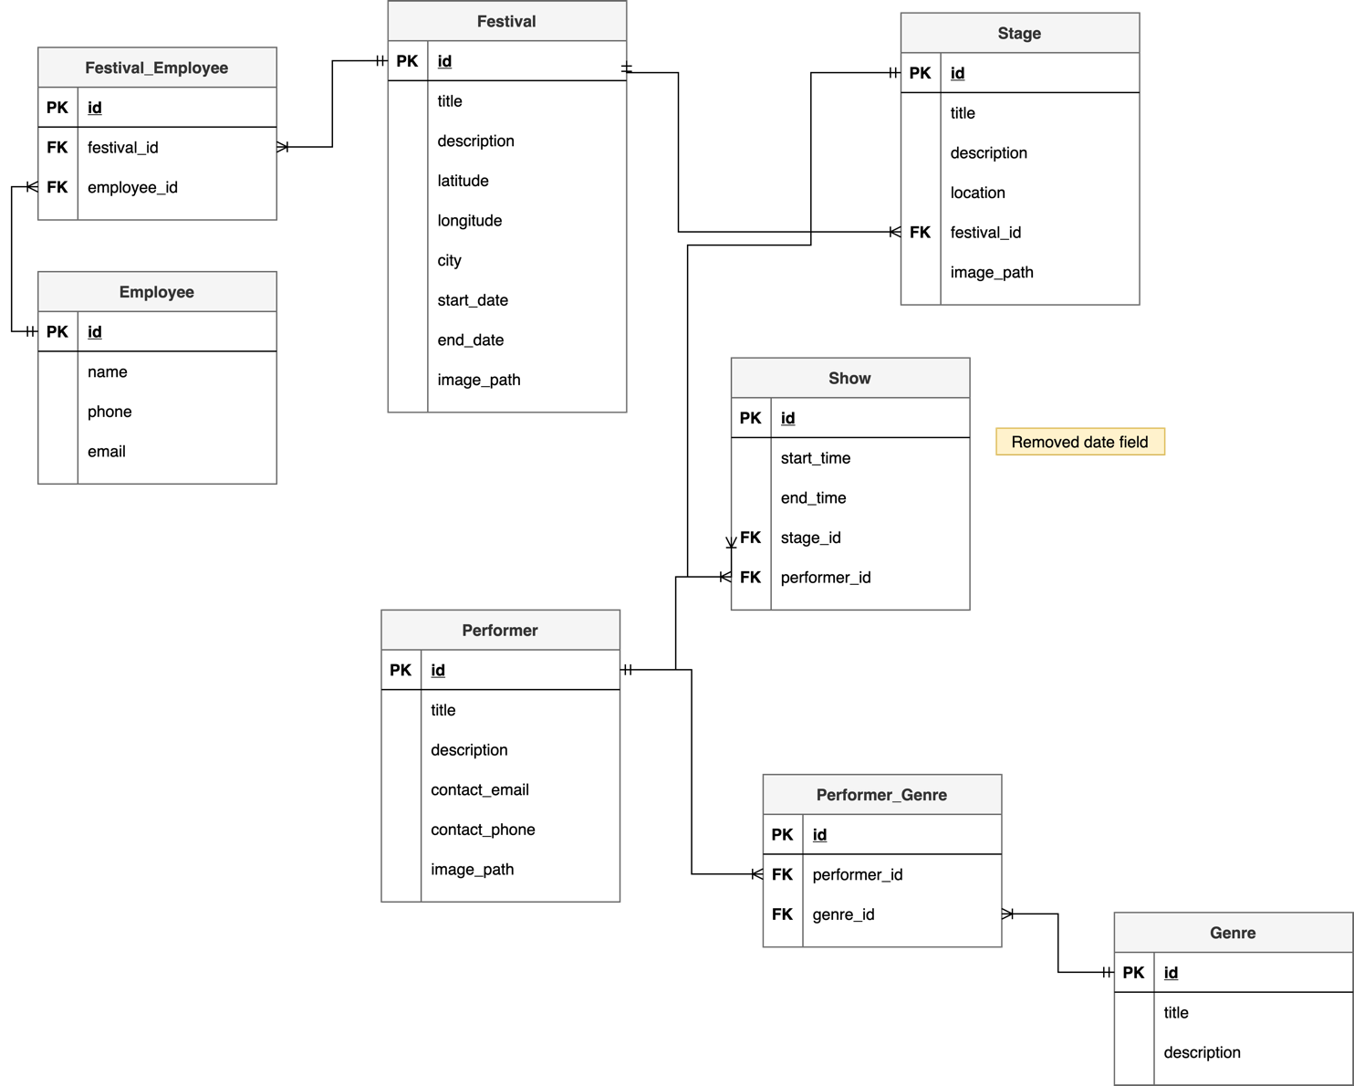

## Database Dictionary

|  |  |  |  |  |  |  |
| --- | --- | --- | --- | --- | --- | --- |
| Table | Attribute | Datatype | Range | Required | PK/FK | FK Ref Table |
|  |  |  |  |  |  |  |
|  |  |  |  |  |  |  |
|  |  |  |  |  |  |  |
|  |  |  |  |  |  |  |
|  |  |  |  |  |  |  |

# System Design/ Architecture Overview

* 1. Introduction

This section will describe the internal functionality of the web framework that you have chosed for the implementation. Add further sections if required by the specification of your web application

* 1. Model View Controller

Explain the follows a model-view-controller design pattern and how it is implemented in your web application.

* 1. User Authenticaion

Explain how user authentication is implemented in the web application framework.

* 1. Routing

Describe the routes that were defined in the web application

* 1. Templating

Describe the templating engine and how it was used to configure/ style the web application.

Add a sequence diagram in this section and other diagrams that illustrate the architecture clearly.

# Testing

* 1. Introduction

This chapter describes the testing that has been undertaken for the application. This chapter is presented in two sections:

1. Functional Testing
2. User Testing

Functional testing is a type of software testing whereby the system is tested against the functional requirements. The app is tested by looking to see if the actual output for a given input corresponds with the expected output. The tests should be based on the requirements for the app. The results of functional testing can indicate if a piece of software is functional and working, but not if the software is easy to use.

User testing looks to see if a piece of software is easy and intuitive for the user.

* 1. Functional Testing

This section describes the functional tests which were carried out on the app. These functional tests can be categorised as: (whatever is relevant to your app)

Login/Registration

Navigation

Calculation

CRUD

Functional testing generally uses a Black Box Testing technique which means that the internal logic of the system being tested is not of interest to the tester. The tester is only interested in whether the actual output agrees with the expected output.

* + 1. Login/Registration

|  |  |  |  |  |  |
| --- | --- | --- | --- | --- | --- |
| Test No | Description of test case | Input | Expected Output | Actual Output | Comment |
|  |  |  |  |  |  |
|  |  |  |  |  |  |
|  |  |  |  |  |  |

* + 1. Navigation

|  |  |  |  |  |  |
| --- | --- | --- | --- | --- | --- |
| Test No | Description of test case | Input | Expected Output | Actual Output | Comment |
|  |  |  |  |  |  |
|  |  |  |  |  |  |
|  |  |  |  |  |  |

* + 1. Calculation

|  |  |  |  |  |  |
| --- | --- | --- | --- | --- | --- |
| Test No | Description of test case | Input | Expected Output | Actual Output | Comment |
|  |  |  |  |  |  |
|  |  |  |  |  |  |
|  |  |  |  |  |  |

* + 1. CRUD

|  |  |  |  |  |  |
| --- | --- | --- | --- | --- | --- |
| Test No | Description of test case | Input | Expected Output | Actual Output | Comment |
|  |  |  |  |  |  |
|  |  |  |  |  |  |
|  |  |  |  |  |  |

## Discussion of Functional Testing Results

Describe the results from the tests. Address any functionality where unexpected behavior could not be debugged.

* 1. User Testing
  2. Conclusion

Discussion of test results.

# Project Management

## Introduction

This chapter describes how the project was managed. It shows the phases of the project, going from the project idea through the requirements gathering, the specification for the project, the design, implementation and testing phases for the project. It also discusses GitHub as a tool which assist in project management.

## Project Phases

In this section, describe each of the following project phases. Explain any issues which arose for each of the phases.

### Requirements

### Design

### Implementation

### Testing

## SCRUM Methodology

Sprints

## Project Management Tools

### Github Project

Description

Include screen shots

How it worked in practice

### GitHub

Description

How it is used

How it worked in practice

# Reflection

## Your views on the project

Describe how you feel the project went from your perspective.

## How could the project could be developed further?

## Assessment of your learning.

Critically assess your learning. List what skills and competencies you have learned developed in this Continuous Assessment.

List which part of the project would need further development and itemize where you feel you have not satisfactorily completed the continuous assessment.

## Completing a large software development project

Describe what you have learnt from the project, from the point of view of completing a large software development project.

## Technical skills

Describe what you have learnt from the project, from a technical skills viewpoint.

## Further competencies and skills

Describe any extra competencies and skills that would help you with your development in the work place.

# References

Add a list of references that you used to complete the project.

The Department of Technology and Psychology in IADT uses APA 7th referencing style.

Use alphabetical order for your references.

This site gives details about how to cite websites using APA:

https://www.wikihow.com/Cite-a-Website-in-APA

The following is a useful site for creating citations for APA for websites.

<http://www.citationmachine.net/apa/cite-a-website>

You can also use the Referencing tab within Microsoft Word to enter reference information manually. Word then creates an APA style reference.