# Web application Design

## Layout

The application will be fully responsive as I will be using bootstrap which makes it easy to manipulate elements on the page. The layout is simple I will use a lot of cards for the products and a lot of forms for things like logging in and buying products.

## Interaction

The user will use the buttons located at the top of the page to navigate through the application there will be clear indications on what page the user is on as it will be in the URL and I plan to implement a breadcrumb feature on each page

## Colour schemes

The website will have a dark theme with the background on most pages being black and the text being white. I will use a light blue to accent the page just to break it up a bit. For alert pop ups or messages, I will use red to make it stand out and most of the background on titles will have either a grey or white shade.

## Font choices

For the titles and headings, I will be using Garamond and for the text on the main body I will use Montserrat. I chose Garamond because it stands out as the thickness of the text is small and I chose Montserrat because it has a lot of styles which will help when italicizing or highlighting text.

## Wireframes

Figure 1This is the homepage

The user can login, sign up or browse the website from this page

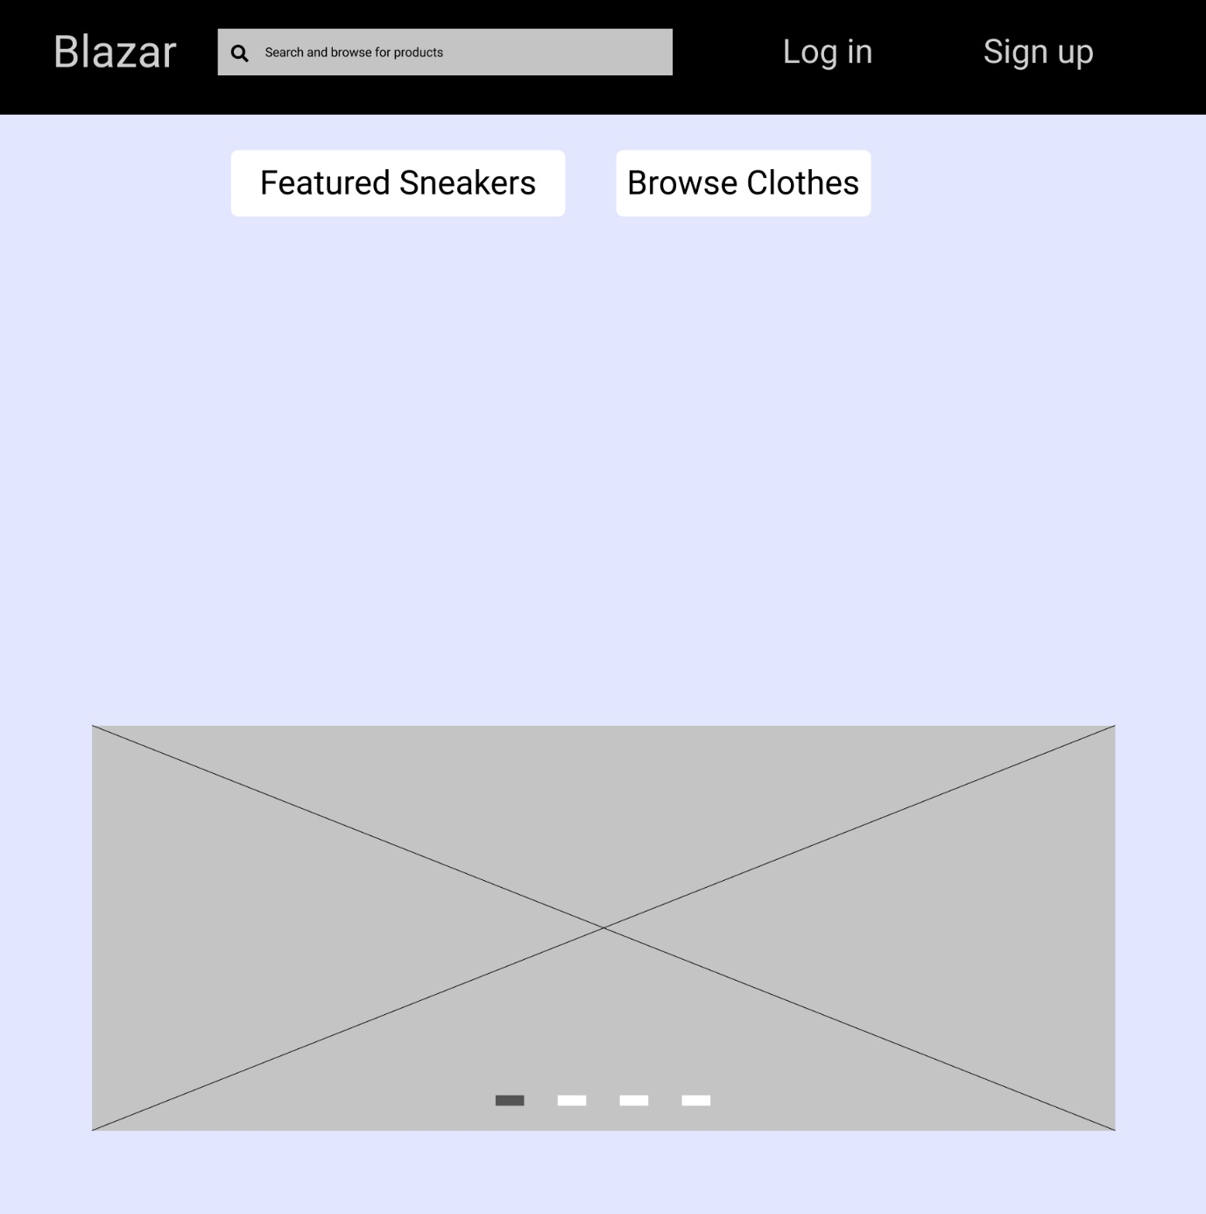

Figure 2 Page 2

This is essentially another homepage the user can see featured shoes and new shoes

Figure 3 This is the page the user can browse products on

The user gets here by clicking the browse shoes or browse clothes button they can also sort or filter through the products

Figure 4 Product view page

The user gets here by clicking a product on the browse page it shoes a description of the product and the buying options.