3 Requirements

3.1 Introduction

The user will be able to login when they use the application (they don’t have to), first they will need to register an account which will be stored in the database. The user will have to login using an email and password, they will also need to enter their shoe size and general clothing size.

There will be an admin for the application so for when they login they will have control over certain aspects of the application. They will have CRUD functionality so that it is easy to manipulate the contents of a certain page by altering the database.

The user will be able to browse products, filter and sort products and also bid on the products they desire. There is no cart, as far as purchase goes there will only be a successful bid pop up as a visual confirmation

3.2 Requirements gathering

3.2.1 Similar applications

o Screenshots

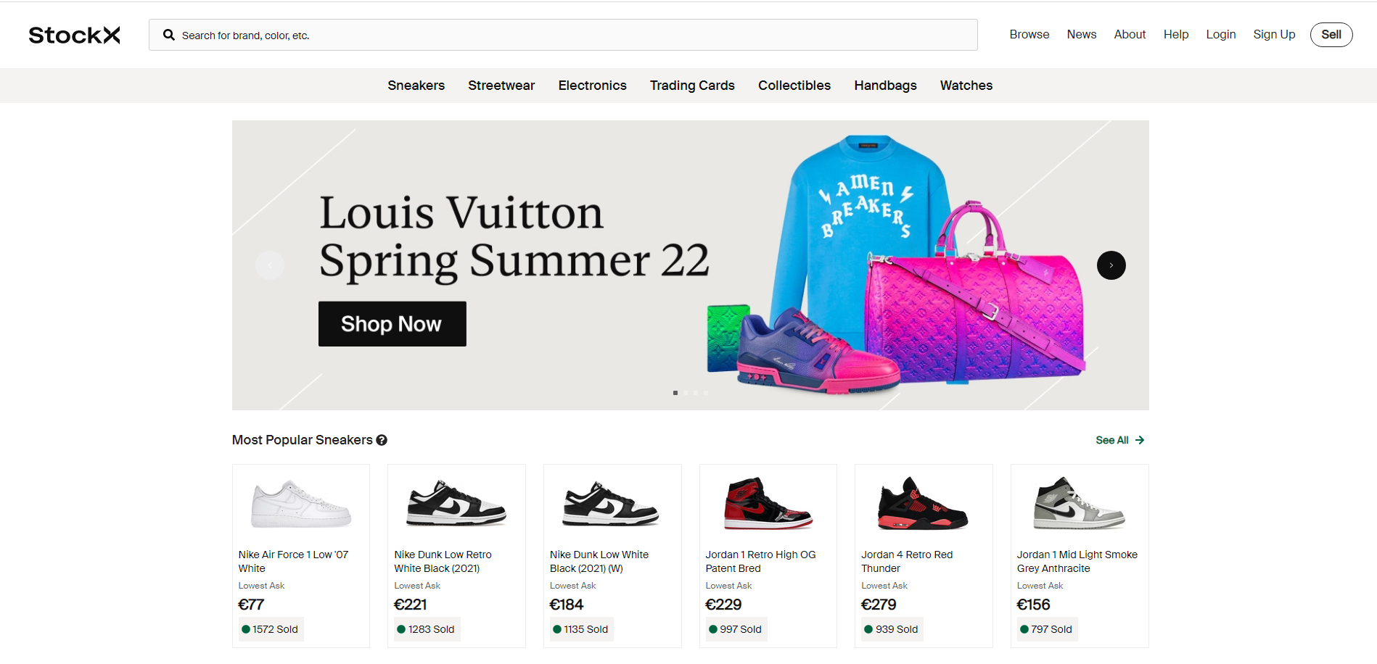

Figure The homepage of stockx

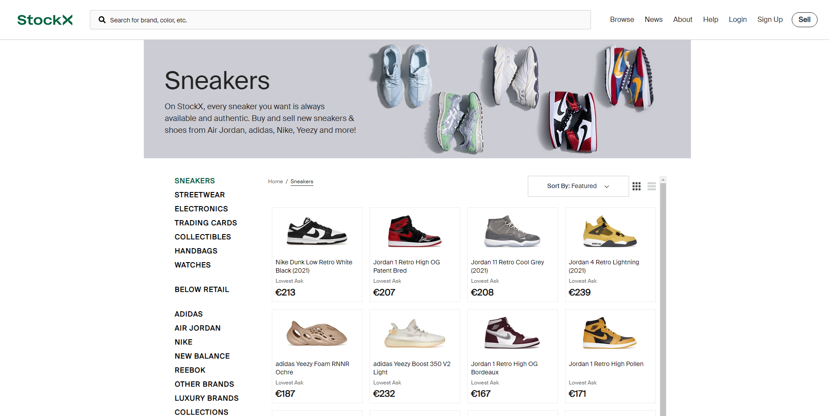

Figure The browse page for sneakers with some sort and filter options

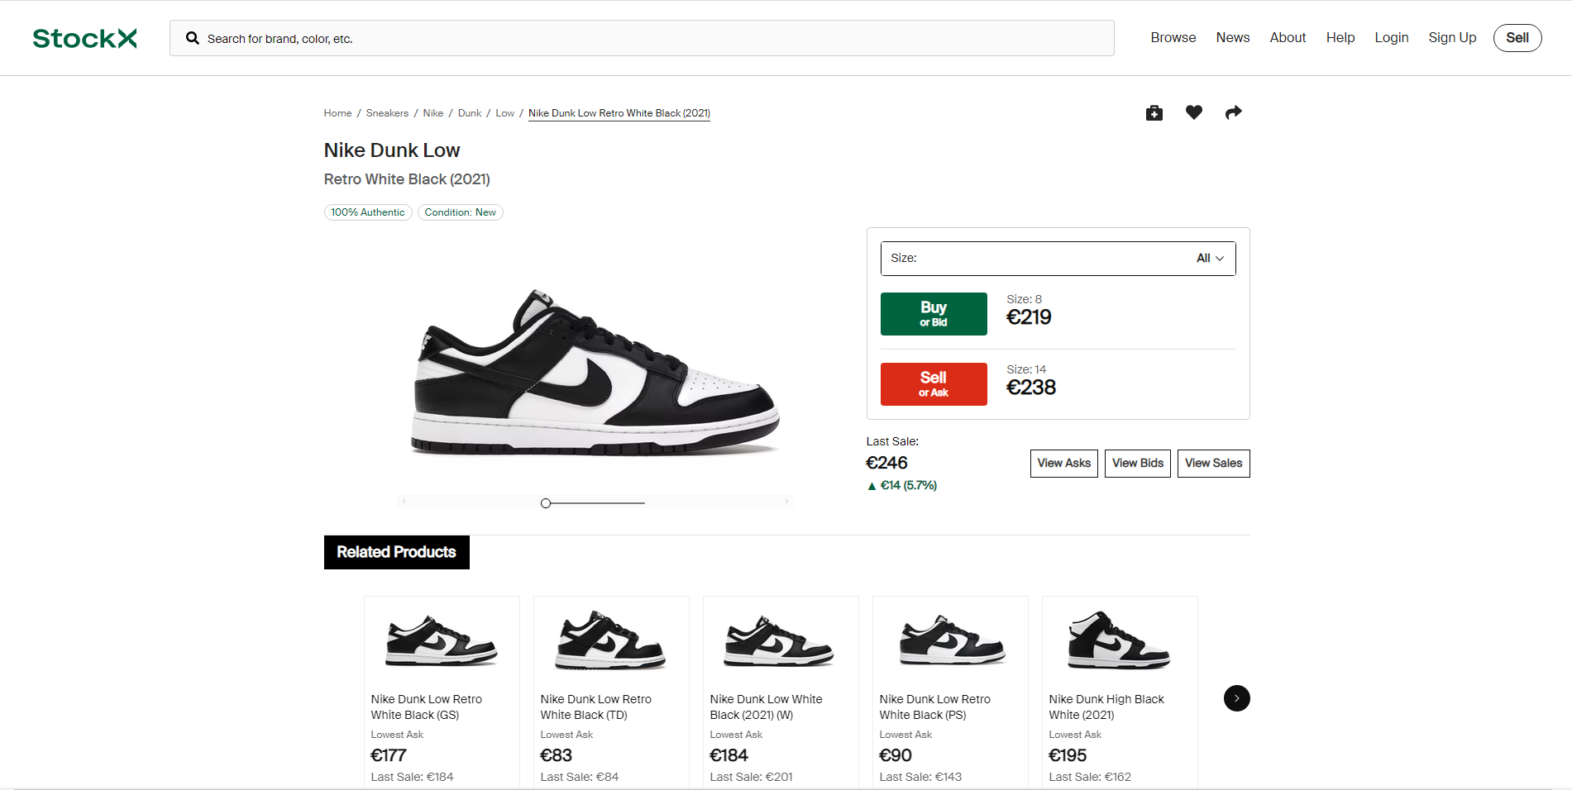

Figure The product view page with ability to bid

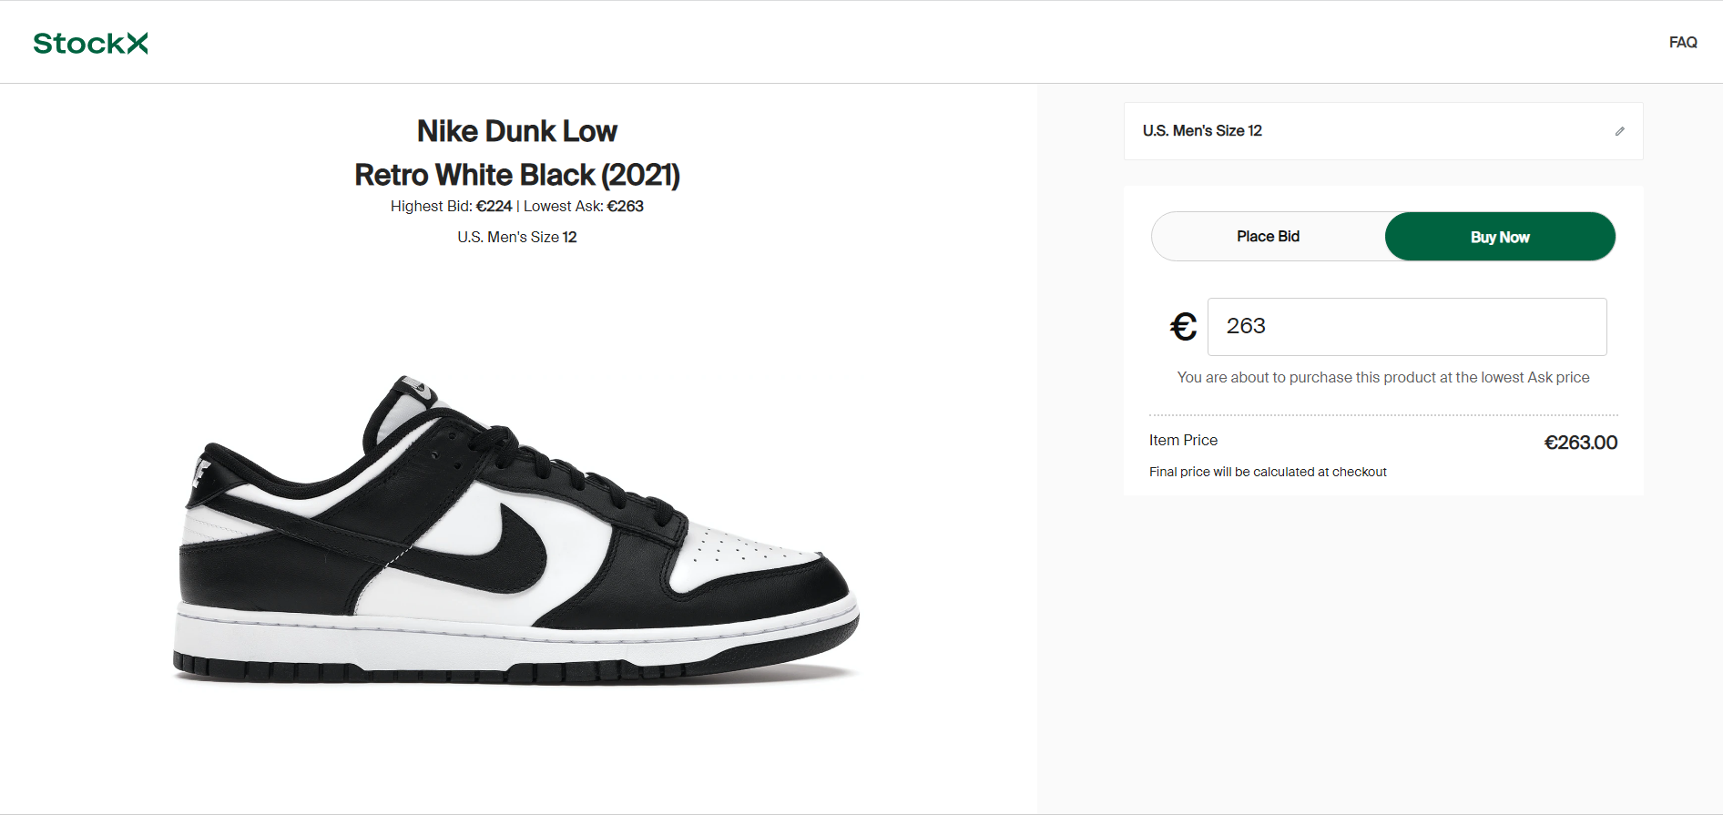

Figure The bidding and selling page for products

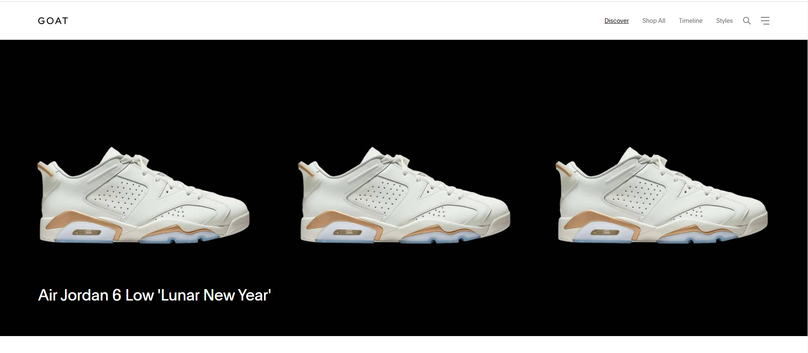

Figure GOAT homepage

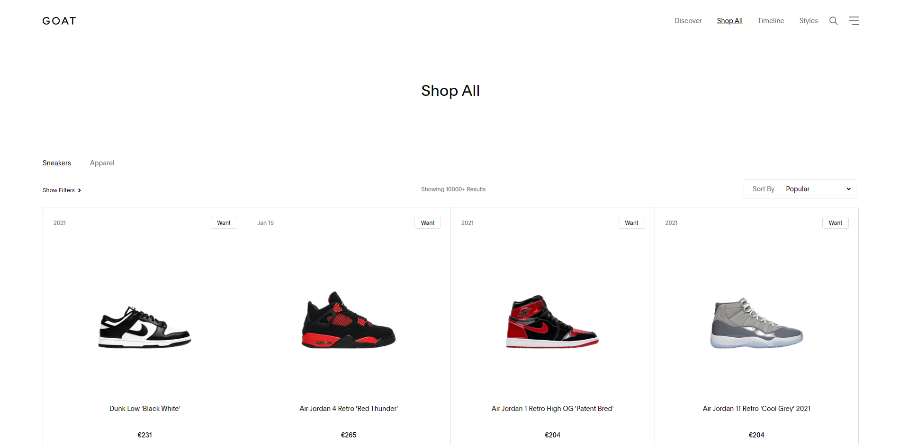

Figure The browse shoes page for GOAT

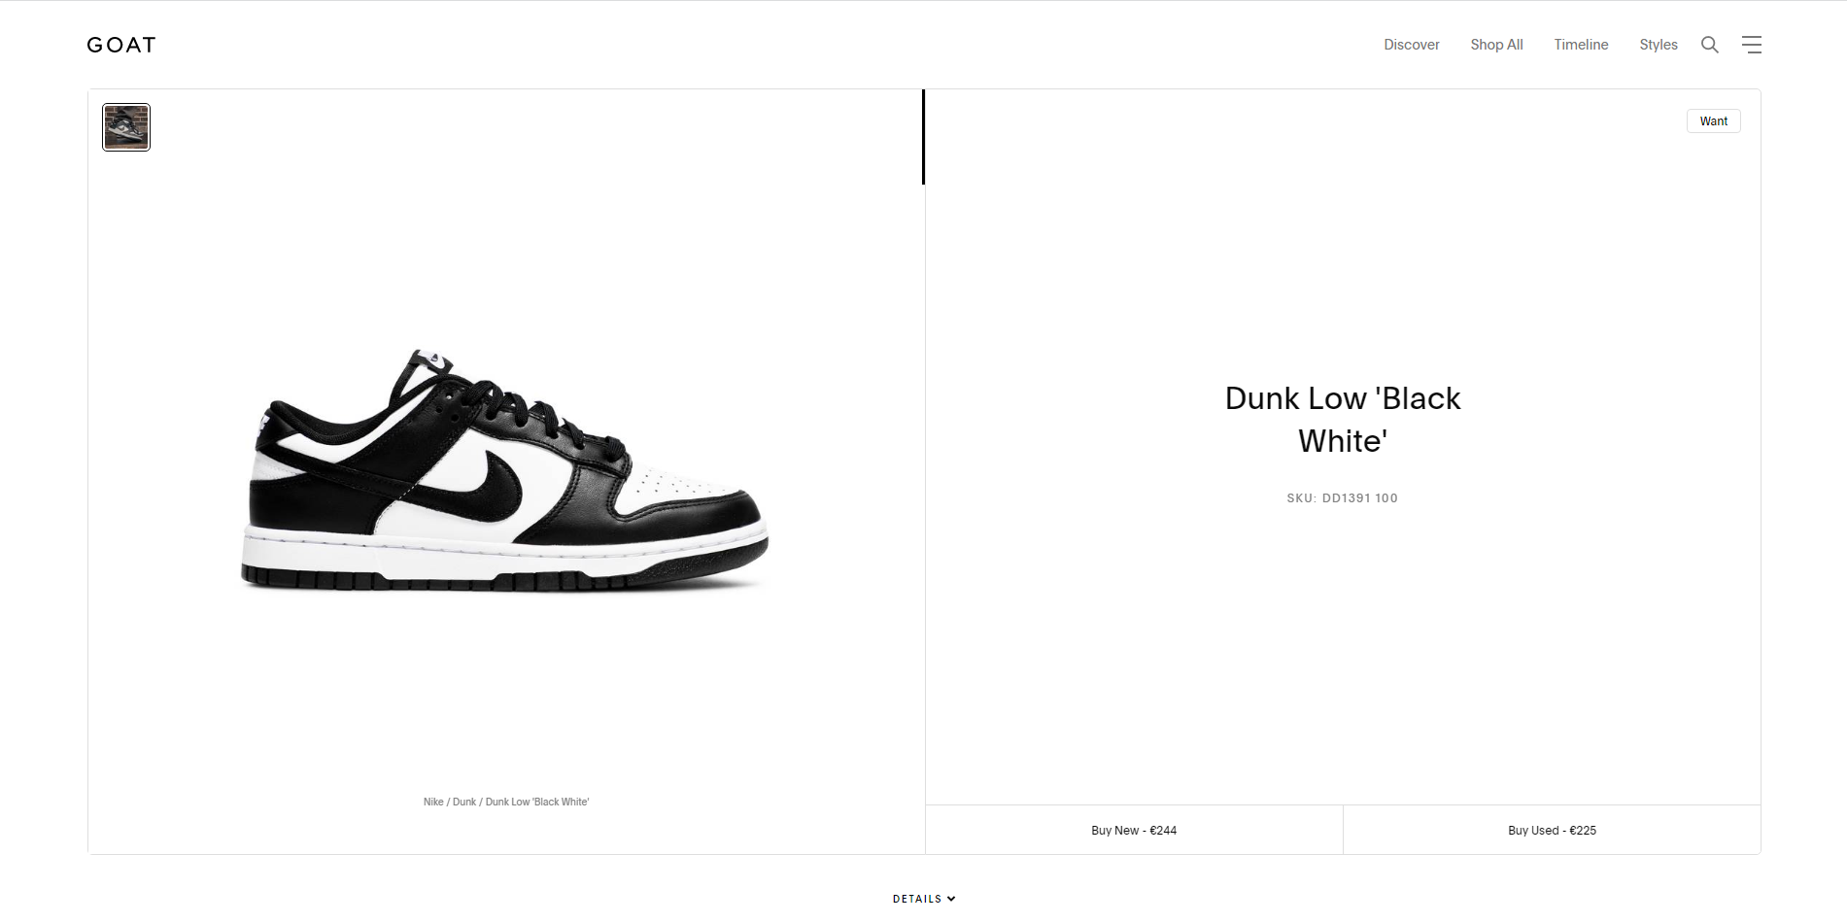

Figure The product view page with ability to bid

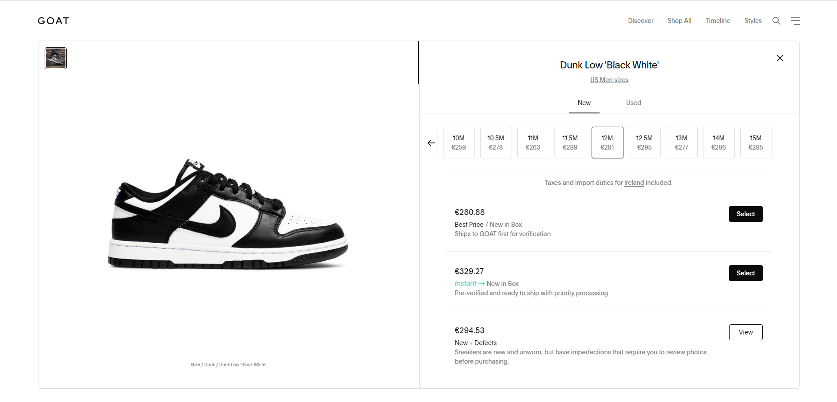

Figure The product view page with ability to bid

o Descriptions

The screen shots above are the basic flow for the process of buying a pair of shoes on both stockx and GOAT, it starts off on the browse page and it quickly allows you to buy or bid for a pair of shoes. I found that stockx was slightly easier to use and more clear.

o Advantages

Both sites have a quick way to find products as they both have search options.

Pictures of the products with clear descriptions.

Coloured buttons to differentiate between different services.

o Disadvantages

3.2.2 Interviews

Conduct interviews with 2 or 3 users to find out what the important features for them for the app are. There may be various issues that arise in multiple interviews. These can be grouped together into a number of themes.

3.3 Requirements modelling

3.3.1 Functional requirements

Create a numbered list of what the application should be able to do. Start with the most important feature.

3.3.2 Non-functional requirements

These are requirements which if not met do not stop the application from working, but which mean that the application is not working as well as it should. They are usually based on issues such as:

o Usability

o Performance

o Security

3.3.3 Use Case Diagrams

Consists of actors and use cases. You should document each individual use case.

Delete the following diagram and insert your diagram. Use draw.io

3.4 Feasibility

This section describes which technologies are planned to be used in the development of the application. It then explains if there are any issues in terms of the technical feasibility of the

project, for example, if there are two different types of software which may have compatibility issues.