**A Project Report on**

**Conversational AI chatbot using Python and Natural Language Processing**

submitted in partial fulfillment for the award of

**Bachelor of Technology**

in

**Computer Science & Engineering**

by

**P. Yani Grace (Y20ACS524) M. Harika (Y20ACS500)**

**G. Anjali (L21ACS409) K. Ajay(Y20ACS481)**



Under the guidance of

**Prof. Dr.P.S.V.Vachaspathi**

Department of Computer Science and Engineering

**Bapatla Engineering College**

(Autonomous)

(Affiliated to Acharya Nagarjuna University)

**BAPATLA – 522 102, Andhra Pradesh, INDIA**

**2023-2024**

**Department of**

**Computer Science & Engineering**



**CERTIFICATE**

This is to certify that the project report entitled **Conversational AI Chatbot using Python and Natural Language Processing**  that is being submitted by P.YaniGrace (Y20ACS524), M.Harika (Y20ACS500), G.Anjali (L21ACS409) and K.Ajay(Y20ACS481)in partial fulfillment for the award of the Degree of Bachelor of Technology in Computer Science & Engineering to the Acharya Nagarjuna University is a record of bonafide work carried out by them under our guidance and supervision.

Date:

**Signature of the Guide Signature of the HOD**

**Dr.P.S.V.Vachaspathi Dr. M. Rajesh Babu**

**Professor Prof. & Head**

**DECLARATION**

We declare that this project work is composed by ourselves, that the work contained herein is our own except where explicitly stated otherwise in the text, and that this work has not been submitted for any other degree or professional qualification except as specified.

**P. Yani Grace (Y20ACS524)**

**M. Harika (Y20ACS500)**

**G. Anjali (L21ACS409)**

**K. Ajay (Y20ACS481)**

**Acknowledgement**

We sincerely thank the following distinguished personalities who have given their advice and support for successful completion of the work.

We are deeply indebted to our most respected guide Dr.P.S.V.Vachaspathi **,Professor** Department of CSE, for his/her valuable and inspiring guidance, comments, suggestions and encouragement.

We extend our sincere thanks to **Dr. M. Rajesh Babu,** Prof. & Head of the Dept. for extending his cooperation and providing the required resources.

We would like to thank our beloved Principal **Dr. Sk. Nazeer** for providing the online resources and other facilities to carry out this work.

We would like to express our sincere thanks to our project coordinator **Dr. N. Sudhakar,** Prof. Dept. of CSE for his helpful suggestions in presenting this document.

We extend our sincere thanks to all other teaching faculty and non-teaching staff of the department, who helped directly or indirectly for their cooperation and encouragement.

**P. Yani Grace (Y20ACS524)**

**M. Harika (Y20ACS500)**

**G. Anjali (L21ACS409)**

**K. Ajay(Y20ACS481)**

Table of Contents

1 Introduction 1

1.1 Problem Statement 2

1.2 Objective 2

1.2.1 Knowledge Integration 3

1.2.2 Natural Language Understanding 3

1.2.3 Generative Response Generation 3

1.2.4 Knowledge Retrieval 3

1.2.5 Response Combination 3

1.2.6 User Experience Optimization 3

1.3 Python and Natural Language Processing 4

2 Literature Review 6

3 Proposed System 9

3.1 Introduction 9

3.2 Architecture 9

3.3 Input

3.3.1 Text Queries 11

3.3.2 Voice input 11

3.4 Output 11

3.4.1 Text Responses: 11

3.4.2 Generated Responses 11

3.4.3 Combined Responses 11

4 Design 12

4.1 UML Diagrams 12

4.1.1 Use Case Diagram 12

4.1.2 Activity Diagram 14

4.1.3 Class Diagram 16

4.1.4 Sequence Diagram 18

5 Requirements 20

5.1 Hardware Requirements 20

5.2 Software Requirements 21

5.3 Framework and Packages: 22

6 Implementation 24

6.1 Setup

7 Results 27

8 Conclusions 34

9 Future Work 36

**List Of Figures**

Figure 3.2.1 Gemini Pro Model 9

Figure 3.2.2 PYPDF2 Model 10

Figure 4.1.1.1 Use Case Diagram 13

Figure 4.1.2.1 Activity Diagram 15

Figure 4.1.3.1 Class Diagram 17

Figure 4.1.4.1 Sequence Diagram 19

Figure 7.1 Welcome Page 27

Figure 7.2 Chat With PDF Files 29

Figure 7.3 Chat With Assistant 30

Figure 7.4 Chat with PDF and Assistant 32

**Abstract**

The days of solely engaging with a service through a keyboard are over. Users interact with systems more and morethrough chatbots. A chatbot is an intelligent piece of software that can communicate and performing actions similar to human. This software is used to perform tasks such as quickly responding to users, informing them, helping to purchase products and providing better service to Customers.

At its core, a chatbot serves as a virtual assistant, capable of swiftly responding to user inquiries, providing information, facilitating purchases, and delivering enhanced customer service experiences. The versatility of chatbots makes them indispensable across various domains, from e-commerce platforms to customer support services.

One of the defining features of chatbots is their ability to continuously learn and evolve. Each interaction with a user provides valuable input, which the chatbot analyzes and stores for future reference. By accumulating a vast repository of user inputs and corresponding responses, the chatbot gradually enhances its understanding and accuracy. This iterative learning process is instrumental in refining the chatbot's capabilities over time, enabling it to deliver increasingly precise and personalized interactions.

Every time the chatbot gets input from the user, it saves input and response which helps chatbot with little initial knowledge to evolve using gathered responses. With increased responses, precision of the chatbot also gets increases. The ultimate goal of this project is to develop a chatbot that could answer student queries. The program selects the closest matching response from closest matching statement that matches input utilizing WordNet, it then chooses response from known selection of statements for that response. The well known chatbots currently are Apple's Siri, Amazon's Alexa, Microsoft's Cortana and Google Assistant.

# Introduction

A chatbot is an Artificial person or other creature which holds conversations with humans. This could be a text based(typed)conversations, a spoken conversation or even a non-Verbal conversation. Chatbot can run on local computers and phones though most of the time it is accessed through the internet. Chatbot appears everywhere from old ancient HTML pages to modern advanced social networking websites. There are some hybrid strategies and adaptive techniques that make increasingly complex techniques. A chatbot program that copies human discussions including content and communication picture and video processing, and voice analysis.

This chatbot system is an internet application that gives an answer to the broken-down queries of an user. Users simply need to choose the classification for inquiries and afterward ask the question to the bot that utilizes for noting it. Then the user can procure the fitting solutions to their inquiries. The creation and implementation of chatbot is still a developing area, heavily related to python so the provided solutions, while possessing obvious advantages have some important limitations in terms of functionalities and use cases. However, this is changing over time. As the knowledgebase used for the output generation is fixed and limited, chatbots can fail while dealing with an unsaved query.

But this chatbot cannot fail the user can the type the query if the query does not match with data so chatbot will message. Ido not understand your question. Analytics are often overlooked and underappreciated when it comes to chatbots. while chatbot analytics are unlikely to make or break the success of a chatbot they can provide valuable insight into opportunities for information about data allowing chatbot can help reply with text of users. The system answers to users queries with the assistance of effective Interfaces. There are many so popular chatbots in marketing for eg:Alexa it works in the voice bot that resulted in largest revenues in our chatbot reply with text form and quickly reply all information from the data.

## Problem Statement

There are many chatbots in use now-a-days. But most of the chatbots are bounded to single functionality. As technology gets updated users expect a chatbot to perform multiple functionalities. These days even the chatbots are multifunctional they cannot provide real-time information or they cannot take additional knowledge from the user

Developing a chatbot that efficiently incorporates user-uploaded knowledge from PDFs into its responses poses several challenges. Traditional chatbots may struggle to effectively utilize this additional information, leading to limited or inaccurate responses. Additionally, integrating Generative AI and Large Language Models (LLMs) presents technical complexities in ensuring seamless interaction and response generation. The problem lies in creating a chatbot capable of harnessing both user-provided knowledge and advanced AI techniques to deliver comprehensive and accurate responses to user queries.

## Objective

The project aims to create a versatile chatbot resembling ChatGPT, equipped with a conversational interface to elevate user experience and streamline information retrieval. Its core objectives encompass improving user interactions through natural language understanding, ensuring prompt and accurate responses through robust NLP and Generative AI algorithms, and facilitating a wide range of functionalities tailored to diverse user needs. A distinguishing feature of this chatbot lies in its capacity for knowledge augmentation via PDF uploads. This mechanism allows users to enrich the chatbot's knowledge base by providing relevant documents, thereby enhancing its proficiency and response accuracy over time.

### ****Knowledge Integration****

Incorporating knowledge extracted from user-uploaded PDFs into a chatbot's existing knowledge base requires a multi-faceted approach aimed at both effective extraction and seamless integration. Initially, the system must employ advanced Natural Language Processing (NLP) techniques to accurately extract information from the PDF documents. This extracted content should then undergo rigorous preprocessing, including entity recognition, summarization, and categorization, to ensure its relevance and coherence within the existing knowledge base.

Once processed, the extracted knowledge needs to be indexed and stored in a vector store database compatible with the chatbot's knowledge repository, facilitating easy retrieval during response generation. Integration of these mechanisms should prioritize maintaining the chatbot's conversational flow and ensuring timely access to pertinent information, ultimately enhancing the user experience by providing comprehensive and relevant responses. Regular updates and refinement based on user interactions will further optimize the system's ability to leverage user-uploaded PDFs effectively.

### ****Natural Language Understanding****

Implementing advanced Natural Language Processing (NLP) techniques involves accurately interpreting user queries, extracting relevant intents and entities essential for effective response generation. Initially, the system breaks down the input text into individual words or phrases, discerns the grammatical structure, identifies specific entities mentioned, and categorizes queries into predefined intent categories.

Additionally, sentiment analysis may gauge the emotional tone. Leveraging semantic similarity and knowledge retrieval techniques, the chatbot identifies appropriate responses from its knowledge base or external sources, ensuring coherence and relevance in its interactions with users. Overall, integrating these advanced techniques enhances the chatbot's ability to understand user queries and generate contextually appropriate responses, thereby improving the user experience.

### **Generative Response Generation**

Generating human-like responses to user queries, leveraging Generative AI and Large Language Models (LLMs) is essential. These sophisticated models are trained on vast amounts of text data and have the capability to understand context and language nuances. By employing Generative AI and LLMs, the chatbot can produce responses that not only reflect contextual relevance but also adhere to grammatical correctness.

These models enable the chatbot to comprehend the intricacies of user queries, capture underlying meanings, and generate responses that mimic natural human conversation. Through continuous learning and fine-tuning, the chatbot can further refine its language generation abilities, ensuring that it delivers high-quality, human-like responses consistently. By harnessing the power of Generative AI and LLMs, the chatbot can enhance the user experience by providing engaging and informative interactions that closely resemble human conversation.

### ****Knowledge Retrieval****

Leveraging a similarity search algorithm is instrumental in enabling the chatbot to efficiently retrieve relevant information from its knowledge base and user-uploaded PDFs. By employing techniques such as cosine similarity or Jaccard similarity, the chatbot can identify documents or passages that closely match the user's query, even in large datasets. This algorithm compares the similarity between the query and stored documents based on various features or embeddings, enabling the chatbot to access comprehensive information while formulating responses.

Through the utilization of similarity search, the chatbot can effectively navigate through both structured and unstructured data sources, ensuring that users receive accurate and contextually relevant answers. Regular optimization and tuning of the algorithm further enhance the chatbot's ability to retrieve information swiftly and accurately, ultimately enriching the user experience with valuable insights and knowledge.

### ****Response Combination****

Designing a mechanism to merge responses from the chatbot's AI models with information retrieved from its knowledge base and user-uploaded PDFs ensures accurate, informative, and comprehensive final responses. This integration combines real-time contextual understanding with structured and unstructured data sources, crafting tailored answers. Techniques like content fusion and context-aware response assembly play key roles in delivering valuable insights. Continuous refinement based on user feedback enhances the chatbot's ability to consistently provide high-quality responses, enriching the user experience.

### ****User Experience Optimization****

Focus on enhancing the user experience by providing prompt and relevant responses, minimizing response latency, and ensuring that the chatbot's interactions are natural and intuitive. By addressing these objectives, the project aims to develop a sophisticated chatbot capable of effectively utilizing user-uploaded knowledge from PDFs, while also leveraging advanced AI techniques to deliver informative and contextually relevant responses to user queries.

## Python and Natural Language Processing

Python is a high-level, interpreted programming language known for its simplicity and readability. It emphasizes code readability and ease of use, making it an excellent choice for beginners and professionals alike. Python supports multiple programming paradigms, including procedural, object-oriented, and functional programming styles. It has a vast standard library and a vibrant ecosystem of third-party packages, making it suitable for a wide range of applications, including web development, data analysis, scientific computing, artificial intelligence, and more.

Its clean syntax and dynamic typing contribute to its popularity and widespread adoption in various industries. Python's clean and readable syntaxmakes it easy to write and maintain code, which is crucial for developing and updating complex chatbot systems.Python has numerous libraries and frameworks specifically designed for natural language processing (NLP) and building chatbots. Libraries such as NLTK (NaturalLanguage Toolkit), spaCy, and TensorFlow enable developers to implement advanced NLP capabilities with ease.

Natural Language Processing (NLP) is integral to the development of chatbots due to its role in enabling these AI systems to understand and interpret human language. Through NLP, chatbots can effectively analyze the structure, semantics, and context of user messages, allowing them to accurately recognize user intents and extract important entities. This capability not only facilitates the generation of relevant and meaningful responses but also enables chatbots to maintain context throughout a conversation, resulting in more coherent interactions.

Furthermore, NLP enables chatbots to personalize responses based on user preferences, learn from past interactions to improve over time, and support multilingual communication, making them versatile tools for engaging with diverse user populations across various domains and industries. Ultimately, NLP empowers chatbots to provide intelligent, natural, and user-friendly conversational experiences, driving enhanced customer satisfaction and engagement.

In conclusion, Python's simplicity, extensive ecosystem of NLP libraries, community support, and scalability make it a prime candidate for developing conversational AI chatbots. Leveraging Python and NLP, developers can create intelligent chatbots capable of delivering personalized and engaging user experiences across diverse platforms and systems.

# Literature Review

The study conducted [1] in H. Behavior, along with undefined, published in 2015, delves into the realm of human-chatbot interactions by comparing them with human-human online conversations. This research explores the dynamics and nuances of real conversations with artificial intelligence, shedding light on the similarities, differences, and potential implications for human-computer interaction. By analyzing the intricacies of these interactions, the study offers valuable insights into the evolving landscape of conversational AI and its impact on communication paradigms in the digital age.

The comprehensive survey [2] on chatbot design techniques within speech conversation systems, published in the International Journal of Advanced Computer Science and Applications in 2015. This study investigates various methodologies and strategies employed in the design and development of chatbots tailored for speech-based interactions.

By examining existing literature and case studies, the authors elucidate key design principles, challenges, and advancements in the field of speech-based chatbot systems. This research serves as a valuable resource for understanding the evolving landscape of chatbot and interaction efficiency in speech-based conversational systems.

The study [3] on the implementation of a chatbot using Natural Language Processing (NLP), which was published in the proceedings of the 9th International Conference on Recent Developments in Engineering, Science, Humanities, and Management in 2017. This research focuses on the practical application of NLP techniques in developing a functional chatbot system capable of processing and responding to user queries and discussing the challenges and insights gained, the authors provide valuable contributions to the field of chatbot development and NLP integration. Their work serves as a reference point for understanding the technical intricacies involved in building effective chatbot systems and AI capabilities.

The study [4], published in 2018 provides a comprehensive guide to developing chatbots using Python programming language. This book offers insights into the practical application of Natural Language Processing (NLP) and Machine Learning techniques in building chatbot systems.

Through step-by-step tutorials and hands-on examples, the author demonstrates how to implement various NLP algorithms and machine learning models to create intelligent conversational agents capable of understanding and responding to user queries. By bridging the gap between theory and practice, Raj's book serves as an invaluable resource for developers and researchers interested in exploring the capabilities of chatbot technology and leveraging Python's rich ecosystem for NLP and ML development.

The study [5]., published in the International Journal of Engineering Research in 2017, presents research on the development of an intelligent chatbot utilizing Natural Language Processing (NLP). This research delves into the implementation of NLP techniques to empower the chatbot with the ability to comprehend and respond to user queries in natural language.

Through experimentation and analysis, the authors explore the effectiveness of various NLP algorithms and methodologies in enhancing the chatbot's conversational capabilities. By providing insights into the design and functionality of the intelligent chatbot, this study contributes to the advancement of NLP-driven conversational AI systems and sheds light on potential applications in diverse domains.

The review article [6] published in the International Journal of Research in Engineering and Applied Sciences in 2016, provides an overview of Natural Language Processing (NLP) technologies. Through a comprehensive review of existing literature and research advancements, the authors explore the fundamentals, methodologies, and applications of NLP in diverse domains.

By synthesizing insights from various studies, the review article offers a holistic perspective on the state-of-the-art in NLP, including key challenges, trends, and future directions. This work serves as a valuable resource for researchers, practitioners, and enthusiasts seeking to deepen their understanding of NLP and its implications for advancing human-computer interaction, information retrieval, and language understanding.

The paper [7] published in the International Journal of Engineering Research and Technology. This work delves into the design and implementation of a voice-based chatbot named Alexis. It explores how Natural Language Processing (NLP) is employed to create an intelligent conversational agent capable of understanding and responding to human voice commands.

The research likely discusses the underlying technologies, architecture, and challenges associated with building such a chatbot. Additionally, it might offer insights into the practical applications of voice-based chatbots, their benefits, and the advancements in conversational AI. This study contributes to the growing body of knowledge on chatbots and their role in enhancing user interaction through voice-based technology

# Proposed System

The proposed system defines the recommended solution or system to address identified challenges or meet specified objectives. This section succinctly outlines the proposed system objectives, scope, and key functionalities, providing detailed specifications regarding its architecture, requirements, and design

## Introduction

This chatbot is created by using Python, Natural Language Processing, Generative AI model, and various APIs. When a user asks a query, the chatbot is able to retrieve information from the pre-trained model and from the additional knowledge. It also enables the user to interact and ask queries through voice.

## Architecture

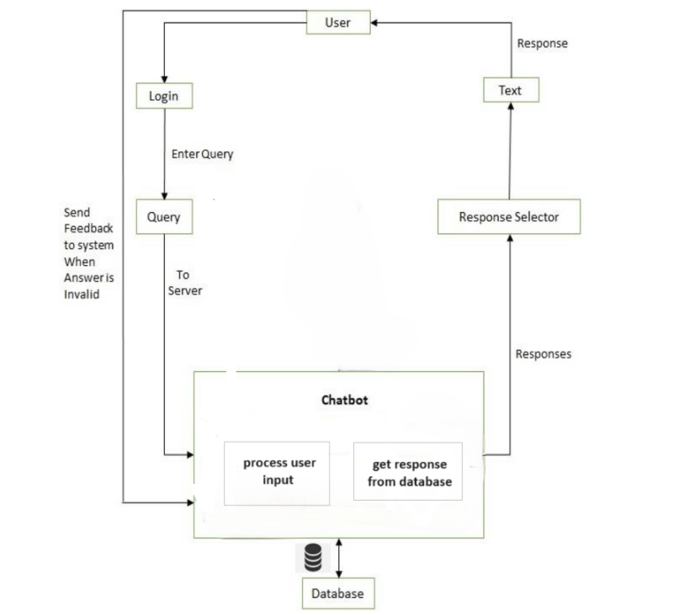

Figure 3.2.1 Gemini Pro Model

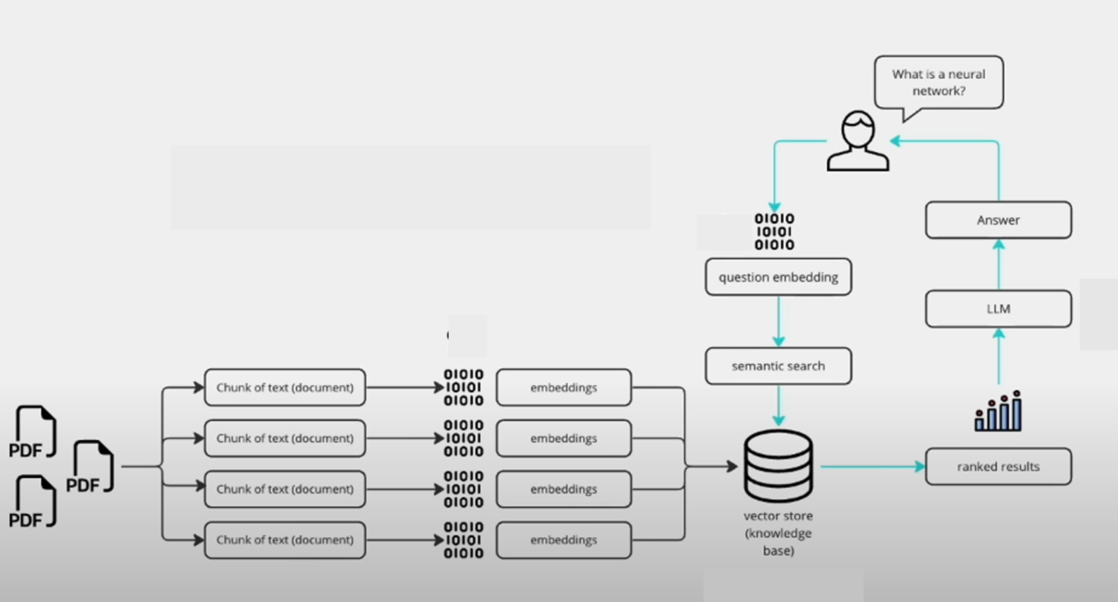

Figure 3.2.2 PYPDF2 Model

In the proposed system architecture, user interaction begins with opening the application, offering the option to augment the knowledge base by uploading PDF documents. After uploading, users can query the chatbot. The chatbot then processes the query, initiating a search through the extensive knowledge base for relevant responses. Using similarity search algorithms, the chatbot identifies pertinent responses from the database.

Simultaneously, uploaded PDFs undergo processing, transformed into embeddings, and stored in a vector store for efficient retrieval. When a user poses a query, it's also converted into embeddings, and semantic search techniques match these embeddings with the stored data. Leveraging Large Language Models (LLMs), the system selects highly matched or ranked data as a response. Finally, the responses generated by both processes are merged and presented to the user, ensuring a comprehensive and relevant reply to their query.

## Input

The chatbot is capable of accepting input in either voice or text format. When users interact with the chatbot, whether through text or voice, their queries are processed and searched across the Knowledge Base and vector store for a response. This search is facilitated using Generative AI techniques, which enable the chatbot to generate responses based on the input query. Additionally, the chatbot utilizes PyPDF2 to access and extract information from PDF documents uploaded by users. By combining Generative AI with PyPDF2, the chatbot ensures a robust and comprehensive search process, enabling it to provide accurate and relevant responses to user queries, regardless of the input method

### Text Queries

In the realm of text queries, users are empowered to directly input their questions or inquiries into the chatbot interface. This functionality spans a wide spectrum, accommodating everything from straightforward inquiries to more intricate requests for specific information. Whether users seek quick responses to general queries or delve into deeper topics, the chatbot serves as a versatile tool, adept at providing comprehensive assistance and facilitating seamless interaction.

### Voice input

Optionally, users are granted the flexibility to provide input through voice commands. Leveraging speech-to-text technology, the chatbot seamlessly transcribes these spoken inputs into text, ready for processing. This feature enhances accessibility and convenience, catering to users who prefer vocal interaction over traditional text input methods. By accommodating voice commands, the chatbot ensures a versatile and inclusive user experience, further enriching its capabilities for effortless communication and information retrieval

## Output

Upon querying the Knowledge Base and vector store, if an appropriate response aligning with the user's input is identified, it is promptly returned by the Generative AI model. However, in cases where no suitable response is found, the chatbot seamlessly resorts to providing a predefined response. This predetermined response, decoded and presented in text format, ensures that users receive a prompt and relevant reply to their queries, maintaining a smooth and engaging interaction experience.

### Text Responses:

The chatbot operates by generating text responses tailored to user queries, offering answers, explanations, or suggestions derived from the information stored within its knowledge base and any user-uploaded PDF documents. Leveraging this wealth of information, the chatbot endeavour to furnish comprehensive and informative responses, catering to a diverse array of user needs and inquiries. Whether users seek clarification, guidance, or recommendations, the chatbot aims to deliver relevant and helpful content, enhancing the overall user experience and facilitating seamless interaction.

### Generated Responses

By harnessing the power of Generative AI and Large Language Models (LLMs), the chatbot adeptly crafts human-like responses characterized by grammatical accuracy and contextual coherence. This integration of advanced AI technologies enables the chatbot to generate responses that closely resemble natural human conversation, elevating the overall conversational experience for users. With the ability to produce contextually relevant and linguistically refined responses, the chatbot fosters engaging and meaningful interactions, fostering a sense of fluidity and authenticity in dialogue exchanges with users.

### Combined Responses

The chatbot integrates insights from its NLP processing, knowledge base, and Generative AI models to generate comprehensive responses. These responses incorporate both existing knowledge and user-uploaded information from PDF documents, ensuring accuracy and relevance in addressing user queries.

# Design

## UML Diagrams

UML stands for Unified Modeling Language. UML is a standardized general-purpose modeling language in the field of object-oriented software engineering. The standard is managed, and was created by, the Object Management Group. The goal is for UML to become a common language for creating models of object oriented computer software.

In its current form UML is comprised of two major components: a Meta-model and a notation. In the future, some form of method or process may also be added to; or associated with, UML. The Unified Modeling Language is a standard language for specifying, Visualization, Constructing and documenting the artifacts of software system, as well as for business modeling and other non-software systems.

The UML represents a collection of best engineering practices that have proven successful in the modeling of large and complex systems. The UML is a very important part of developing objects oriented software development process. The UML uses mostly graphical notations to express the design of software projects.

### Use Case Diagram

A use case diagram in the Unified Modeling Language (UML) serves as a pivotal tool derived from Use-case analysis, aiming to provide a comprehensive graphical representation of a system's functionality. By visualizing the interactions between actors and the system, it offers insights into how users (actors) interact with the system to achieve specific goals (use cases). Each actor represents a role played by a user or an external system, while use cases illustrate the functionalities or tasks performed by the system to fulfill the actors' objectives.

Moreover, use case diagrams elucidate any dependencies or relationships between these use cases, offering a clear overview of the system's behaviour and structure. Ultimately, the primary purpose of a use case diagram is to facilitate understanding by showcasing which system functions are performed for which actors, thus aiding in system design and development.

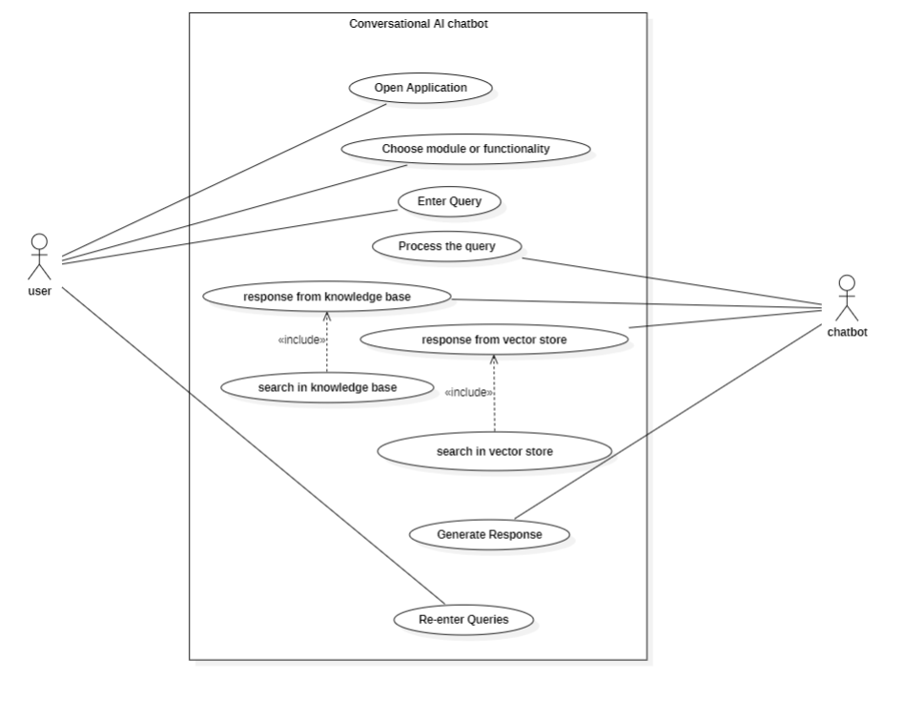

Figure 4.1.1.1 Use Case Diagram

In the above Fig (4.1.1.1), The User and Chatbot Application are the actors . The User opens Chatbot application and posts his Query which is processed by chatbot . After that the Chatbot Application uses Generative AI model to find suitable response from knowledgebase and vector store ,then it will reply the user by combing both the responses.

### Activity Diagram

An activity diagram is another crucial diagram within UML that elucidates the dynamic aspects of a system. Essentially, it serves as a flowchart depicting the transition from one activity to another. Here, an activity refers to an operation performed by the system. The key elements of an activity diagram include:

**Activities:**

In the realm of activity diagrams in UML, "Activities" embody the specific actions executed within the system. These actions, akin to verbs like "Ask Query" or "Get Response," denote distinct operations performed by the system. Each activity encapsulates a set of tasks or steps necessary to accomplish a particular functionality or goal within the system. By delineating the system's behaviour into discrete activities, the activity diagram offers a structured and comprehensible visualization of the system's dynamic workflow. This breakdown facilitates a detailed analysis of operational processes, aiding in system design and optimization.

**Flow:**

In activity diagrams within the UML framework, "Flow" is represented by arrows connecting activities, illustrating the sequence in which they are executed. This flow can take on various forms: it may follow a simple linear progression, where one step follows another in a sequential manner, or it can branch out to depict different paths based on conditions or decisions within the system.

For instance, the flow might diverge to show alternative outcomes, such as the success or failure of a payment transaction, leading to different subsequent activities. By visually delineating the flow of activities and potential decision points, the activity diagram provides a clear depiction of the dynamic behaviour of the system, aiding in understanding and analysis of its operational processes.

**Decisions:**

In process flow diagrams, diamond symbols mark pivotal points where the flow can split based on criteria. These decision nodes determine different paths based on conditions. For example, in an order fulfillment system, an order may proceed to shipping with adequate stock, or be held if inventory is low. Decision diamonds are vital in guiding task progression based on predefined rules.

**Swimlanes (Optional):**

Swimlanes organize activities based on who or what performs them. For instance, one lane might represent customer actions, like placing orders, while another shows system actions, such as inventory management. This segmentation clarifies roles and responsibilities, providing a clear view of the workflow.

**Start and End Nodes:**

Activity diagrams serve as visual representations that define the initiation and conclusion of a process. They conform to a standardized notation within the Unified Modeling Language (UML), mirroring the structure used in class diagrams. The utilization of activity diagrams offers several notable benefits:

Clear Visualization of Workflows provides a step-by-step view of a process, making it easier to understand and communicate. Identification of Potential Issues includesvisualizing the flow, bottlenecks or areas for improvement so they can be identified early on. Documentationserves as a clear reference for how a system should function. Overall, activity diagrams are a powerful tool for modeling and understanding the dynamic behavior of a system.

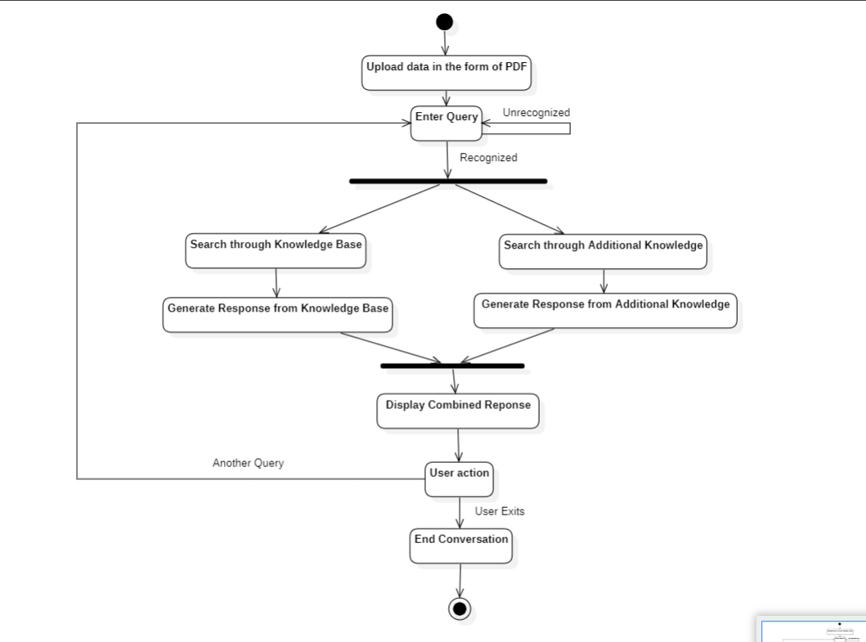

Figure 4.1.2.1 Activity Diagram

In the above Fig.(4.1.2.1) User gives additional knowledge by uploading PDF’s and gives his query to chatbot then chatbot tries to find an appropriate response in Knowledge Base and additional knowledge by searching and generating the response. Then it will combine both the responses and then display to the user. If user wants to continue conversation he can re-enter query or else he can end the conversation by exiting.

### Class Diagram

A class diagram serves as a foundational blueprint in software engineering, providing a visual depiction of a system's structure. Analogous to a map, it illustrates the essential building blocks and their interconnections, offering a comprehensive overview of the system's architecture. Typically, a class diagram showcases:

**Classes:**

Classes serve as the foundational actors within a system, embodying real-world entities or abstract concepts. Visualize them as nouns, such as "Customer" or "Product," encapsulating the essential components and behaviours of the system. As the building blocks of object-oriented design, classes define the attributes and methods shared by instances of the same type, facilitating the modeling and implementation of complex systems

**Attributes:**

Attributes are the defining properties of a class, representing data specific to instances like a customer's name and email or a product's price and description. They characterize each class by encapsulating its distinct features, facilitating data representation and manipulation within the system.

**Operations (Methods):**

Operations, or methods, are the dynamic functionalities of classes within a software system, defining behaviors like a customer placing an order or a product being added to a cart. They encapsulate essential processes, enabling specific tasks to be carried out effectively. Operations play a pivotal role in defining class functionality and behavior, facilitating system implementation by delineating actions and interactions within the software application.

**Relationships:**

These show how the classes are connected and interact with each other. This could be a simple association, like an order belonging to a customer, or a more complex inheritance, where one class inherits properties and behaviors from another. Class diagrams use a standardized notation, often with rectangles representing classes and lines showing the relationships. They are part of the Unified Modeling Language (UML), a common way to design software systems.

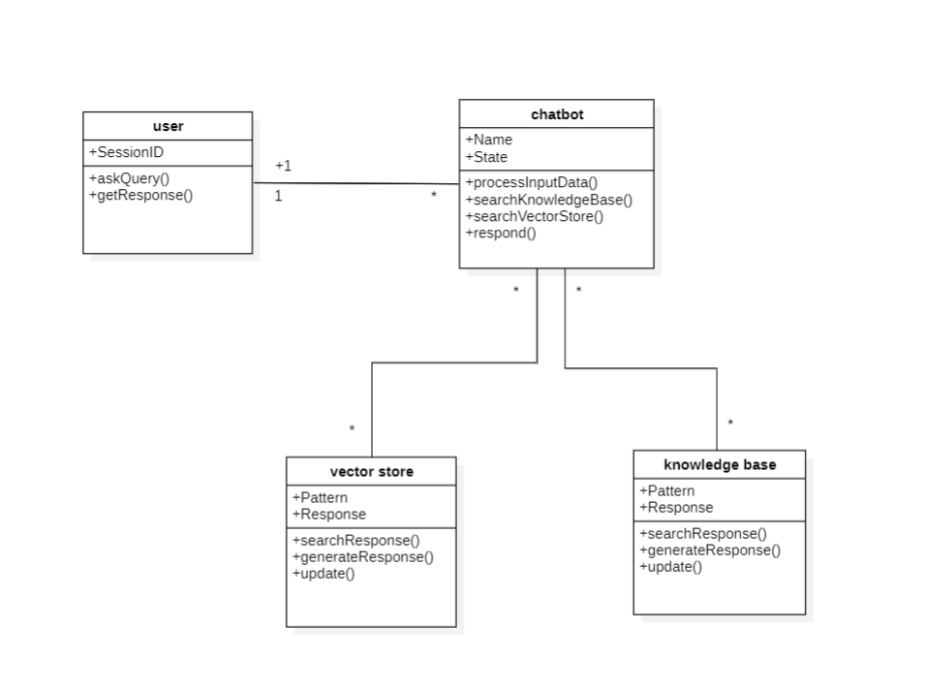

Figure 4.1.3.1 Class Diagram

In the depicted figure (4.1.3.1), four entities are discernible: the user, chatbot, vector store, and knowledge base. Each entity is engaged in executing specific operations crucial to the system's functionality. These operations, such as askQuery(), getResponse(), processInputData(), respond(), and searchResponse(), enable the system to function seamlessly. The user initiates interactions, while the chatbot processes input data, understands queries, and generates responses.

The vector store likely manages vector representations of data, aiding in semantic understanding, while the knowledge base serves as a repository of structured information for the chatbot to draw upon. Together, these entities and operations facilitate effective communication and interaction within the system, ensuring accurate and informative responses to user queries.

### Sequence Diagram

A sequence diagram, a crucial component of UML's interaction diagrams, serves as a detailed depiction of how objects interact within a specific scenario of a system. It meticulously charts the flow of messages, events, or actions exchanged between objects or components, providing a comprehensive view of the system's dynamic behavior and intricate communication pathways.

**Objects/Participants**: In a sequence diagram, participants are depicted as boxes, known as lifelines, positioned across the top. Each box represents an entity, such as an object or actor, involved in the scenario. These lifelines offer a structured visualization of the key players within the system, facilitating comprehension of their roles and interactions throughout the depicted sequence of events.

1. **Messages**: In sequence diagrams, interactions among objects are symbolized by arrows or lines connecting the lifelines, illustrating the flow of communication. These visual elements represent the exchange of messages between the objects, which can denote method calls, signals, or any other form of communication facilitating interactions within the system.
2. **Activation**: In sequence diagrams, vertical lines known as activations or execution occurrences signify when an object is actively processing a message or performing an action. They represent the duration of an object's engagement in executing a specific operation, aiding in visualizing the timing of interactions and object activities within the scenario.
3. **Parallel Execution**: In system modeling, parallel execution allows objects to perform operations simultaneously, depicted by multiple activations occurring concurrently in diagrams. Each activation represents an instance of an object actively engaged in executing a specific operation. This visualization communicates the system's concurrent behavior, revealing opportunities for optimization or synchronization.

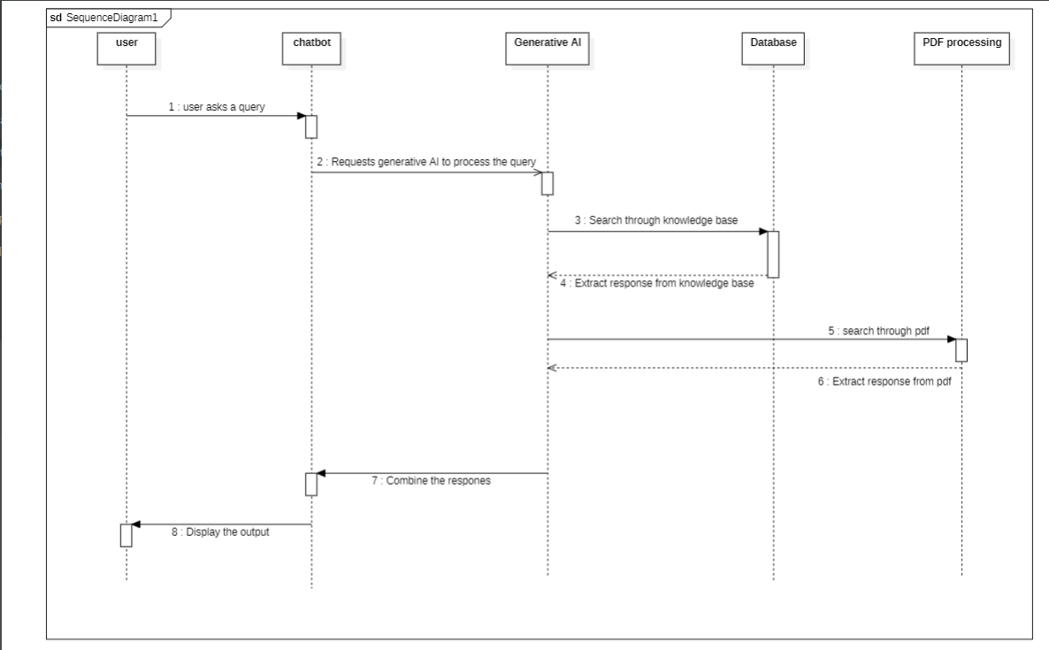

Figure 4.1.4.1 Sequence Diagram

The interaction begins as the user initiates communication by sending a message to the Chatbot. The Chatbot, acting as an intermediary, relays the user's query to the Generative AI component. Concurrently, the Generative AI performs two parallel tasks: it searches the Database (knowledge base) for a relevant answer and simultaneously conducts PDF Processing within the vector store to extract pertinent information. Upon completion of these tasks, the Generative AI receives results from either or both sources. Subsequently, it utilizes the retrieved data to formulate a response tailored to the user's query. Finally, the Chatbot delivers this response back to the user, thereby completing the interaction loop

# Requirements

Requirements are critical to the success of a project. By meeting these requirements, you can ensure that the project's software runs smoothly, reduces the risk of compatibility issues, and ensures that all stakeholders can access and use the project's software. By ignoring these requirements, you risk encountering compatibility issues, errors, and crashes, which can negatively impact the project's success.

## Hardware Requirements

Hardware requirements are essential to ensure that the project's software can run efficiently and effectively. These requirements include the minimum specifications for the CPU, RAM, storage, and other hardware components. By meeting these requirements, the project's software can run smoothly, reducing the risk of crashes, errors, and other issues.

**RAM**:

Adequate RAM is crucial for handling the concurrent processing and storage of data in memory. The amount of RAM required depends on the size of your knowledge base, the number of concurrent users, and the memory footprint of your backend services and AI models. Generally, a minimum of 8 GB of RAM is recommended, but higher capacities may be needed for more demanding workloads.

**Hard Disk**:

Utilizing a solid-state drive (SSD) with ample storage is advisable for storing user-uploaded PDF documents, metadata, and the chatbot's knowledge base, as SSDs offer faster read/write speeds compared to traditional hard disk drives (HDDs), enhancing overall system performance and responsiveness. This upgrade ensures smoother operation and quicker access to stored data, improving the user experience and efficiency of data retrieval processes.

**CPU**:

A multi-core CPU with sufficient processing power is essential for running the backend components of your chatbot, including NLP processing, AI model inference, PDF parsing, and database operations. The specific CPU requirements will depend on the complexity and volume of data processing tasks.

**X64 based Processor**:

An X64 based processor is a 64-bit architecture commonly found in modern CPUs. Ensure your server or computer has a 64-bit processor for installing and running 64-bit software and operating systems efficiently. This architecture allows for better performance and compatibility with modern applications. Verify compatibility before installing 64-bit software or operating systems.

**64-bit operating system**:

A 64-bit operating system efficiently handles more RAM and boosts application performance. It supports larger memory capacities than a 32-bit OS, enabling smoother multitasking and better handling of large datasets. Optimized for this architecture, 64-bit applications can efficiently utilize memory and perform tasks with greater speed, making a 64-bit OS essential for demanding computing tasks.

## Software Requirements

Software requirements are crucial for project success, detailing specific versions of software and operating systems compatible with the project. Compatibility ensures smooth functionality, reducing risks of malfunctions, errors, and system crashes. By aligning software accordingly, optimal performance is maintained, contributing significantly to project success. Thorough validation and adherence to software requirements are essential steps in project planning and execution to ensure reliability, security, and maintainability.

**Python 3.11 or high version**:

Python is a versatile and widely-used programming language known for its simplicity and readability. Python 3.11 (or a higher version) provides numerous features and enhancements that improve developer productivity and code maintainability. In your project, Python serves as the primary programming language for implementing the chatbot's logic, handling data processing tasks, integrating AI models, and building the web application interface.

**IDE: Visual Studio Code** :

Visual Studio Code (VS Code) is a lightweight, open-source code editor developed by Microsoft. It offers a rich set of features, including syntax highlighting, code completion, debugging support, and extension ecosystem. As your chosen IDE, VS Code provides a user-friendly and customizable environment for writing, testing, and debugging Python code. Its built-in support for Git and various extensions enhances collaboration and productivity during development.

## Framework and Packages:

In the realm of conversational AI, frameworks and packages play a pivotal role in streamlining the development of chatbot applications. These tools offer developers a comprehensive set of features, libraries, and utilities to expedite the creation, deployment, and management of conversational interfaces. By leveraging such frameworks and packages, developers can focus more on crafting engaging conversational experiences rather than reinventing the wheel.

**os:**

The os module in Python's standard library serves as a powerful toolset for developers, providing a plethora of functions for interacting with the operating system. Beyond basic file operations, directory manipulation, and environment variable management, you can also utilize it for tasks like process management, system information retrieval, and file permission handling within your chatbot application.

**langchain:**

Assuming **langchain** is a custom or third-party package, it likely provides functionality related to natural language processing (NLP) or language understanding. You'll use this package to process and analyze user input, extract intents and entities, and facilitate conversation flow within your chatbot.

**generativeai:**

This package likely provides access to Generative AI models or APIs for generating human-like responses to user queries. You'll leverage Generative AI capabilities to generate contextually relevant and grammatically correct responses, enhancing the conversational experience of your chatbot.

**PyPDF2:**

This package likely provides access to Generative AI models or APIs for generating human-like responses to user queries. You'll leverage Generative AI capabilities to generate contextually relevant and grammatically correct responses, enhancing the conversational experience of your chatbot.

**streamlit:**

Streamlit is a popular Python framework for building interactive web applications. You'll use Streamlit to create the user interface for your chatbot, allowing users to interact with the chatbot, upload PDF documents, and receive responses in a web browser. Streamlit's simplicity and ease of use make it ideal for rapid prototyping and deployment of data-driven applications.

**dotenv:**

The **dotenv** package allows you to load environment variables from a **.env** file into your Python application. You'll use dotenv to manage sensitive information such as API keys, database credentials, or configuration settings securely. This helps maintain separation of concerns and improves the security of your chatbot application.

# Implementation

The implementation process of a chatbot project with user-uploaded knowledge integration involves configuring the development environment, planning, and analysis, designing a robust architecture, integrating features, rigorous testing, user-uploaded knowledge integration, deployment, and ongoing monitoring. These steps collectively ensure the chatbot's functionality, reliability, and optimal performance, marking the culmination of a comprehensive implementation journey. The successful completion of this journey empowers the chatbot to provide users with seamless interactions and access to valuable knowledge, enriching their overall experience.

**Setting Up Development Environment:**

1. Install Python 3.11 or a higher version on the developer's machine.
2. Set up Visual Studio Code (VS Code) as the Integrated Development Environment (IDE) for Python development.
3. Create a new Python virtual environment for the project to manage dependencies.

**Installing Required Packages:**

1. Write all the required libraries in requirements.txt file
2. Download and install pip for the device to install python packages afterwards
3. Use pip, the Python package manager, to install the necessary packages:

**Defining Project Structure:**

1. Organize project files and directories in a structured manner:
2. Create directories for backend logic, frontend templates, and configuration files.
3. Define Python scripts for backend processing and Streamlit web application.

**Implementing Backend Logic:**

1. Write Python scripts to handle backend logic:
2. Use the **os** module for file operations and environment variables management.
3. Implement NLP processing with the **langchain** package for user input analysis.
4. Utilize the **PyPDF2** library to parse and extract text from the user-uploaded
   1. PDF documents.
5. Integrate Generative AI models for response generation.

**Building Streamlit Web Application:**

1. Develop the user interface using Streamlit.
2. Create Python scripts defining Streamlit app layout and components.
3. Implement functionality for user input, PDF upload, and response display.
4. Use Streamlit's widgets and elements to enhance interactivity and user experience.

**Integrating Environment Variables:**

1. Configure environment variables using the **dotenv** package:
2. Create a **.env** file to store sensitive information such as API keys or model configurations.
3. Load environment variables from the **.env** file in Python scripts for secure access.

## Setup

1. First a virtual environment for the project is need to be created.
   * 1. python –m venv venv_name
2. Then activate the virtual environment.
   * 1. venv_name\Scripts\activate
3. Next specify all the required modules in requirements.txt file and install them.
   * 1. pip install –r requirements.txt
4. Now run the streamlit command to host the project as web application.
   * 1. streamlit run app.py

# Results

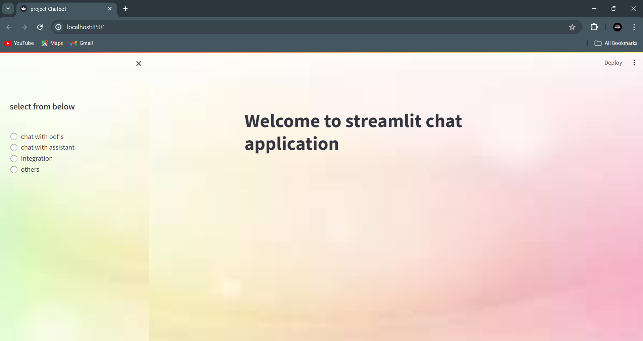

Figure 7.1 Welcome Page

Upon entry, users encounter a meticulously crafted welcoming screen designed for seamless interaction with the system. This central hub offers various engagement options, from intuitive navigation menus to inviting interactive buttons, ensuring an enjoyable user experience. This encourages exploration of the system's functionalities in a manner aligned with user preferences, fostering meaningful interactions.

**Chat with PDFs**:

This functionality allows users to upload PDFs and then engage in a conversation about the information contained within. The chatbot employs a combination of Natural Language Processing (NLP) and information retrieval techniques to pinpoint the answer within the uploaded documents.

**Chat with Assistant**:

This option empowers users to ask general questions in a conversational manner. The chatbot leverages a large language model (LLM) like Gemini-Pro to search its extensive knowledge base, encompassing text from the internet, books, and various other sources, to find an answer.

**Integration**:

This powerful feature allows for a more comprehensive information retrieval experience. When enabled, a user's query will be directed towards both the uploaded PDFs and the chatbot's assistant function. The responses generated from both sources are then meticulously combined and presented to the user. This integration provides a more holistic perspective, potentially offering a richer and more informative answer.

**Others**:

This category is designed with future prospects and expansion in mind. The developers are constantly working to introduce new functionalities that will further enhance the user experience. These potential additions could include:

1. Support for additional file formats beyond PDFs
2. Integration with external data sources and applications
3. Advanced features like sentiment analysis or topic modeling etc.

In essence, this chatbot serves as a dynamic and versatile interface, empowering users to seamlessly interact with and retrieve information from a myriad of sources, all through a convenient chat interface. The system's commitment to innovation and evolution ensures that it remains at the forefront of technological advancements, continuously evolving to meet the ever-changing needs and expectations of its users. With exciting new features planned for the future, users can anticipate a richer and more immersive experience, further cementing the chatbot's position as a valuable tool for information retrieval and interaction.

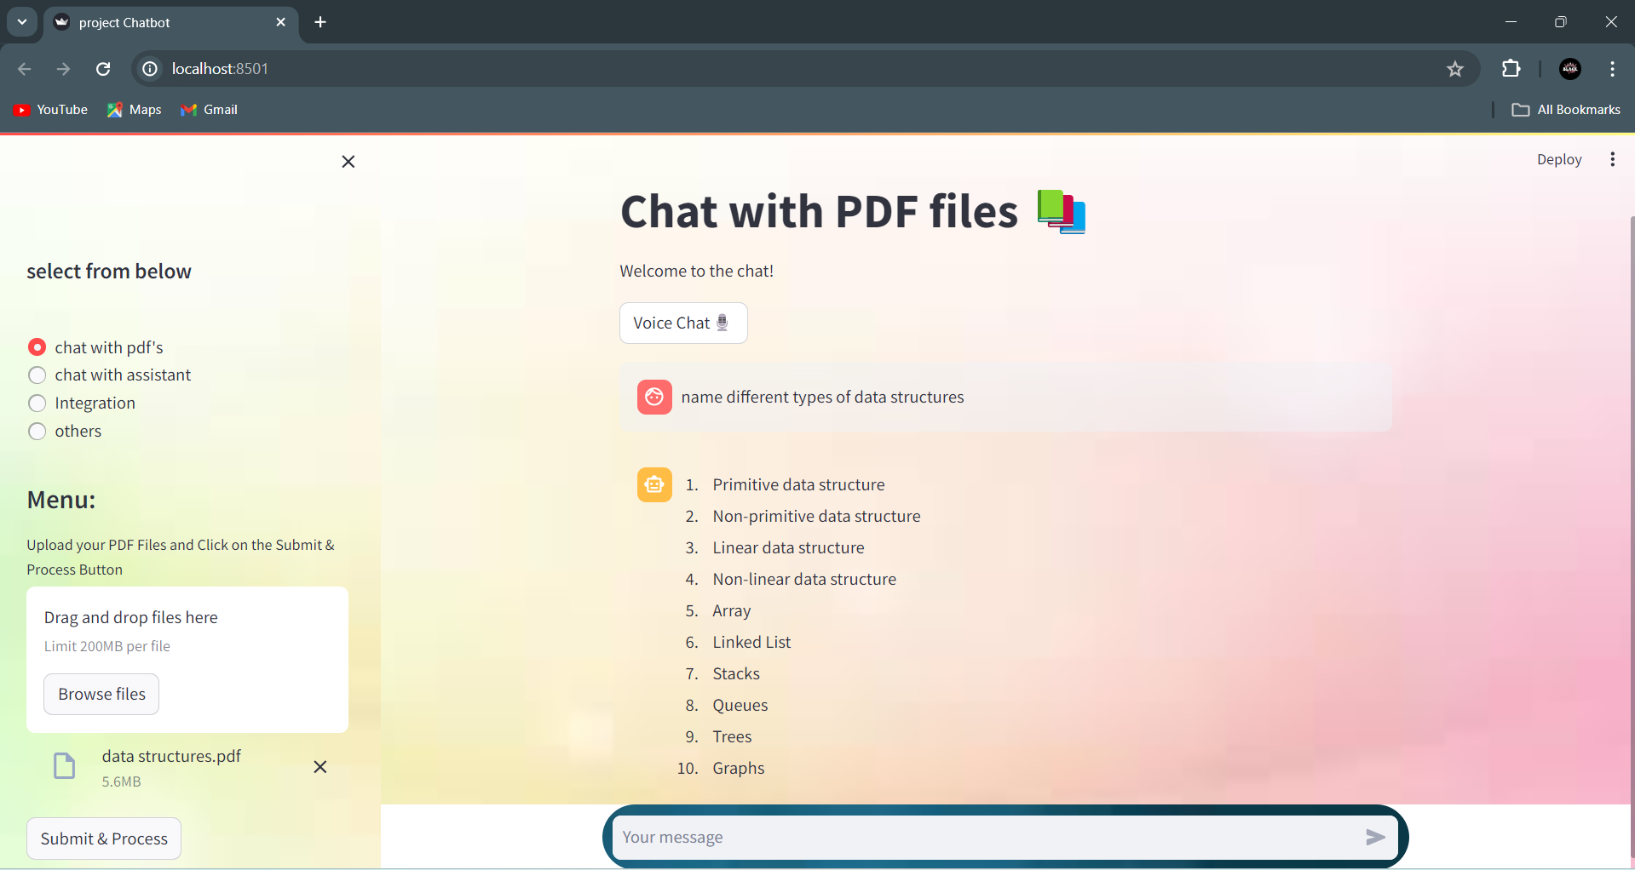

Figure 7.2 Chat With PDF Files

The user encounters a screen introducing the "Chat with PDFs" functionality, a cutting-edge feature designed to transform uploaded PDFs into interactive knowledge sources. This innovative capability revolutionizes the way users interact with documents, offering a seamless and intuitive experience. Here's the process breakdown:

**Uploading Knowledge**:

Users are provided with the ability to upload PDFs containing valuable information they wish to access seamlessly through conversation. This feature streamlines the process of incorporating external knowledge sources into the chatbot's repository, empowering users to leverage a diverse range of content during interactions. Through this functionality, users can easily share and access pertinent information

**Conversational Search Preparation**:

Following the upload, the system employs state-of-the-art Natural Language Processing (NLP) techniques to process and comprehend the content within the PDFs. This processed information is then meticulously stored in a vector store, a specialized database optimized for a powerful search method known as semantic search.

**Engaging in Conversation**:

Once PDFs are uploaded and indexed, users seamlessly engage in conversation with the chatbot, freely asking questions about the information contained within the documents. This interactive feature simplifies information retrieval and fosters dynamic exchanges, empowering users to interact intuitively within the familiar chat interface.

**Semantic Search in Action**:

When a user poses a question, the chatbot leverages semantic search. This innovative technique goes beyond a simple keyword matching approach, aiming to grasp the deeper meaning behind the user's inquiry. It meticulously searches the vector store, pinpointing the most relevant passages from the uploaded PDFs that hold the answer the user seeks.

**Conversational Response**:

In the final stage, the chatbot seamlessly translates the retrieved information into clear and concise responses, which are presented directly within the chat interface. This streamlined process ensures that users receive accurate and relevant information in real-time, enhancing the overall user experience. With the chatbot's ability to distill complex information into digestible responses, users can easily access the knowledge they seek without any additional complexity or friction.

In essence, "Chat with PDFs" empowers users to breathe new life into their static PDFs, transforming them into dynamic knowledge resources that can be readily accessed through conversation. Users can ask questions, and the chatbot will delve into their uploaded documents, surfacing the information they need in a conversational format. This innovative feature revolutionizes the way users interact with their documents, offering a seamless and intuitive experience that enhances knowledge accessibility and fosters efficient communication.

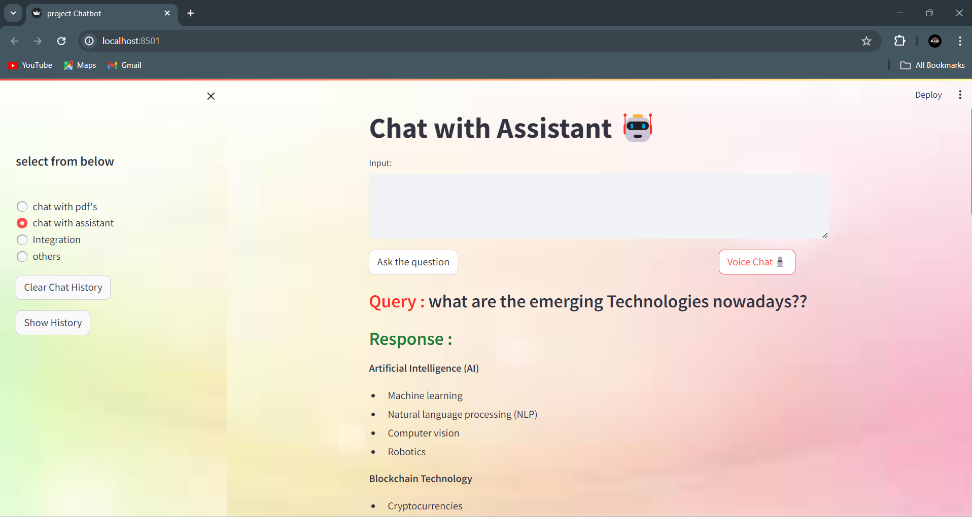

Figure 7.3 Chat With Assistant

Upon accessing the "Chat with Assistant" functionality, users are greeted with a specially crafted screen tailored to facilitate seamless interaction. This innovative feature harnesses the formidable capabilities of the Gemini-Pro large language model (LLM) to address user queries effectively. Here's how it works:

**User Inquiry**:

Users are offered an intuitive interface enabling them to input questions into the designated "Query" field, fostering natural and conversational interaction akin to conversing with a human assistant. This user-friendly feature empowers users to pose inquiries with ease, ensuring a seamless and engaging experience throughout their interaction with the chatbot.

**Gemini-Pro in Action**:

Once the user submits their question, the system activates the Gemini-Pro LLM. This powerful model boasts a vast knowledge base, meticulously compiled from text gleaned from the internet, books, and a multitude of other sources. Gemini-Pro meticulously searches this knowledge base to find the most relevant information that addresses the user's query.

**Conversational Response**:

Following its search, Gemini-Pro translates the retrieved information into a clear and concise response, presented directly within the chat interface for the user to view. In essence, "Chat with Assistant" empowers users to interact with a virtual assistant powered by Gemini-Pro. Ask your questions in a conversational tone, and Gemini-Pro will delve into its vast knowledge base, surfacing the information you seek and presenting it in a clear and user-friendly format.

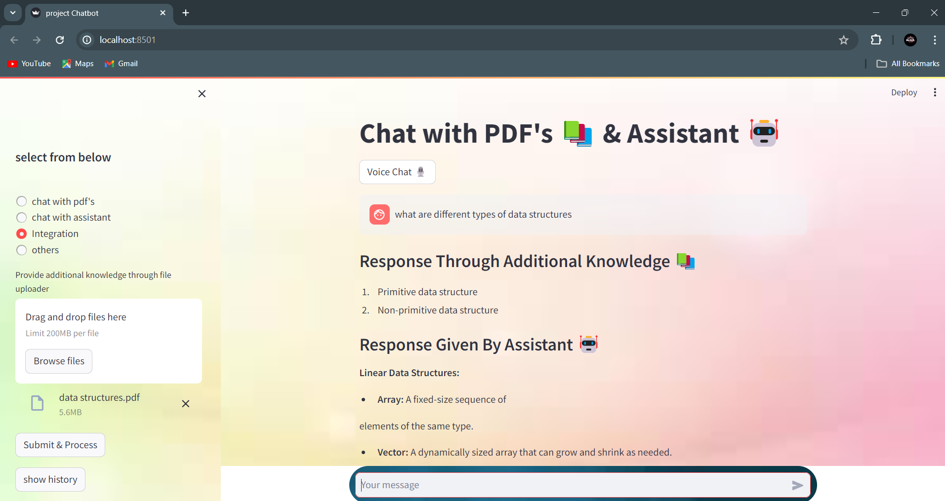

Figure 7.4 Chat with PDF and Assistant

This functionality harnesses the power of the Gemini-Pro generative AI model to generate human-like responses to user queries. Gemini-Pro is a state-of-the-art generative AI model trained on a vast corpus of text data, capable of understanding and generating natural language responses. When a user submits a question to the system It will perform three types of functionalities.

**Functionality 1 :**

It utilizes the Gemini-Pro model to generate a response based on the input query. The model analyzes the query's context, semantics, and intent to produce a coherent and contextually relevant answer. Gemini-Pro has been trained on diverse textual data sources, enabling it to provide informative and accurate responses across a wide range of topics and domains.

**Functionality 2** :

This functionality focuses on processing and analyzing user-uploaded documents, particularly PDF files, to extract additional knowledge relevant to the user's query. It employs techniques for parsing, indexing, and understanding the content within documents.Upon receiving a user query, Functionality 2 searches through a repository of user-uploaded PDF documents or allows users to upload new documents. It extracts text and metadata from these documents, identifying key concepts, keywords, or phrases related to the query. The documents processed may include research papers, reports, manuals, or any other documents that contain valuable information pertinent to the user's query.

**Integration of Functionalities**:

Upon receiving a user's question, both functionalities work collaboratively to gather information and generate a comprehensive response. Functionality 1 generates an initial response using the Gemini-Pro model, leveraging its vast knowledge base and language understanding capabilities. Meanwhile, Functionality 2 searches for additional information within user-uploaded documents, ensuring that the response is thorough and relevant. This collaborative approach ensures that users receive comprehensive and accurate responses to their inquiries, enhancing the overall effectiveness of the chatbot.

# Conclusions

The development of the chatbot project with user-uploaded knowledge integration marks a significant stride forward in the realm of conversational AI applications. By harnessing the power of Python programming, advanced Natural Language Processing (NLP) techniques, Generative AI models, and the versatile Streamlit framework, this project endeavors to deliver a holistic and enriching experience for users seeking information and assistance.

At its core, the project revolves around the seamless integration of user-uploaded PDF documents into the chatbot's knowledge base. This integration serves as a pivotal mechanism for augmenting the chatbot's understanding and proficiency by tapping into a vast reservoir of additional knowledge resources contributed directly by users. Through this collaborative approach, the chatbot evolves from a static repository of information to a dynamic, ever-expanding reservoir of knowledge, continuously enriched by the collective input of its users.

The synergy between Natural Language Processing (NLP) techniques and Generative AI models lies at the heart of the chatbot's ability to understand and respond to user queries effectively. Leveraging sophisticated algorithms, the chatbot analyzes user input, discerns underlying intents, and extracts relevant entities to craft contextually relevant responses. The integration of Generative AI models further elevates the conversational experience, enabling the chatbot to generate responses that resonate with the nuances of human communication, fostering a sense of natural interaction and engagement.

The user interface, crafted using the Streamlit framework, serves as the gateway to the chatbot's capabilities, providing users with an intuitive and immersive platform for interaction. Through the Streamlit web application interface, users can effortlessly input queries, upload PDF documents, and receive responses in a seamless and user-friendly manner. The interface acts as a conduit for facilitating meaningful dialogue between users and the chatbot, empowering users to navigate through vast repositories of knowledge with ease and convenience.

The deployment of the chatbot application to a hosting platform marks the culmination of the development journey, bringing the fruits of labor to fruition and making the chatbot accessible to a wide audience. Whether deployed on cloud infrastructure or hosted on a dedicated server, the availability of the chatbot across various devices and geographical locations ensures universal access, democratizing the dissemination of knowledge and information. This pivotal step not only expands the reach of the chatbot but also fosters inclusivity, enabling individuals from diverse backgrounds and regions to benefit from its capabilities, thereby contributing to the democratization of access to information.

In conclusion, the chatbot project with user-uploaded knowledge integration epitomizes the transformative potential of AI-driven solutions in revolutionizing information retrieval and communication. With its collaborative approach, sophisticated algorithms, intuitive interface, and widespread accessibility, the project embodies a paradigm shift in the way users engage with and harness the power of technology to navigate the ever-expanding landscape of knowledge and information.

As the project evolves and matures, driven by continuous improvement and user-centric innovation, it holds the promise of empowering users worldwide with an unparalleled tool for unlocking the boundless realms of knowledge and expertise. With each iteration, the project strives to enhance user experience, expand functionality, and cater to the evolving needs of a diverse user base. Through ongoing refinement and adaptation, the project aims to establish itself as a cornerstone resource, facilitating seamless access to information and fostering collaborative learning and discovery on a global scale

# Future Work

The future scope for the chatbot project with user-uploaded knowledge integration is promising, opening avenues for further development and enhancement. Areas for future improvement could include advancing natural language understanding to recognize complex queries, expanding the range of user-uploaded knowledge for more dynamic responses, and refining voice recognition accuracy for smoother interactions. Additionally, introducing multi-lingual support and using more robust generative AI models could further personalize responses, leading to improved user engagement and satisfaction

**Advanced NLP Techniques**:

Incorporating more advanced NLP techniques, such as sentiment analysis, entity recognition, and context-aware processing, can enhance the chatbot's understanding of user queries and enable more nuanced responses. Integrating state-of-the-art NLP models like BERT or GPT (Generative Pre-trained Transformer) can further improve the chatbot's conversational abilities.

**Personalization and User Profiling**:

Implementing mechanisms for user profiling and personalization can tailor the chatbot's responses to individual user preferences, behavior, and historical interactions. By leveraging user data and feedback, the chatbot can deliver more relevant and personalized recommendations, suggestions, and responses.

**Multimodal Capabilities**:

Expanding the chatbot's capabilities to support multimodal interactions, including text, speech, and visual inputs, can enhance user engagement and accessibility. Integrating speech recognition, image recognition, and natural language understanding can enable users to interact with the chatbot through diverse modalities.

**Knowledge Graph Integration**:

Incorporating knowledge graph technologies can enhance the chatbot's understanding of complex relationships and concepts, enabling more accurate and insightful responses. By building a knowledge graph from user-uploaded documents and external sources, the chatbot can provide richer context and facilitate deeper exploration of topics.

**Continuous Learning and Adaptation**:

Implementing mechanisms for continuous learning and adaptation allows the chatbot to evolve and improve over time. By analyzing user interactions, feedback, and new data sources, the chatbot can refine its knowledge base, update its models, and adapt its responses to changing user needs and preferences.

**Integration with External APIs and Services**:

Integrating with external APIs and services, such as databases, search engines, or third-party applications, can extend the chatbot's functionality and access to information. By leveraging external data sources and services, the chatbot can provide more comprehensive and up-to-date responses to user queries.

**Enhanced User Experience**:

Improving the user experience through intuitive interfaces, interactive elements, and natural language understanding can increase user satisfaction and engagement. Incorporating features like proactive suggestions, conversational UX design, and multimedia content presentation can enhance the overall user experience.

**Domain-Specific Applications**:

Customizing the chatbot for specific domains or industries, such as healthcare, education, finance, or customer service, can address domain-specific needs and requirements. By tailoring the chatbot's knowledge base, language models, and functionalities to specific use cases, organizations can unlock new opportunities for automation, efficiency, and innovation.

# References

**[**1] J. Hill, W. Ford, I. F.-C. in H. Behavior, and undefined 2015, “Real conversations with artificial intelligence: A comparison between human–human online conversations and human–chatbot conversations,” Elsevier

[2] Sameera A. Abdul-Kader, Dr. John Woods, "Survey on Chatbot Design Techniques in Speech Conversation Systems", International Journal of Advanced Computer Science and Applications, Vol. 6, No. 7, 2015, pp. 72-80.

[3] N. Dandekar and S. Ghodey, “Implementation of a Chatbot using Natural Language Processing,” 9th Int. Conf. Recent Dev. Eng. Sci. Humanit. Manag., pp. 99–105, 2017.

[4] S. Raj, Building Chatbots with Python_ Using Natural Language Processing and Machine Learning-Apress. 2018.

[5] Rishabh Shah Et al., “An Intelligent Chatbot using Natural Language Processing”, International Journal of Engineering Research, 2017.

[6] Sethunya R Joseph Et al., “Natural Language Processing; a Review”, International Journal of Research in Engineering and Applied Sciences, 2016.

[7] Meet Popat Et al., “Alexis: A Voicebased Chatbot using Natural Language Processing”, International Journal of Engineering Research and Technology, 2022.

[8] Mohammed Benhmed Et al., “A Smart Chatbot Architecture based NLP and Machine Learning for Health Care Assistance”, International Journal of Advanced Computer Science and Applications, 2015.

[9] Tarun Lalwani Et al., “Implementation of a Chat Bot using Natural Language Processing”, International Journal of Innovative Research in Computer Science and Technology, 2018.

[10] Patrick Lewis Et al.,“Retrieval-Augmented Generation for Knowledge-Intensive NLP Tasks”, Cornell University, 2020

[11] Dinesh Kalla Et al., “Study and Analysis of Chat GPT and its Impact on Different Fields of Study”, International Journal of Innovative Science and Research, 2023.