**Assignment 3**

**Yifei Gu**

**260906596**

**Q1**

**a)**

Our original ‘non-model’ is:

z - z0 = a( (x - x0)2 + (y - y0)2 )

We can rewrite our new linear model as:

z = A0 (x2 + y2) + A1 x + A2 y + A3

The relation between new parameters and old parameters:

A0 = a

A1 = -ax0

A2 = -ay0

A3 = ax02+ay02+z0

**b) & c)**

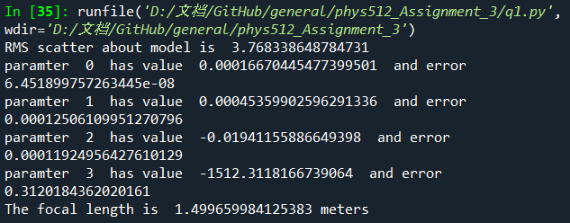

The **RMS** scatter about model is **3.768338648784731.**

With SVD, I got my **parameters** and their **errors**:

A0 = 1.66704455e-04 +/- 6.451899757263445e-08

A1 = 4.53599026e-04 +/- 0.00012506109951270796

A2 = -1.94115589e-02 +/- 0.00011924956427610129

A3 = -1.51231182e+03 +/- 0.3120184362020161

So the **uncertainty** in **a** is 6.451899757263445e-08. The focal length I got is **1.499659984125383**

**Q2**

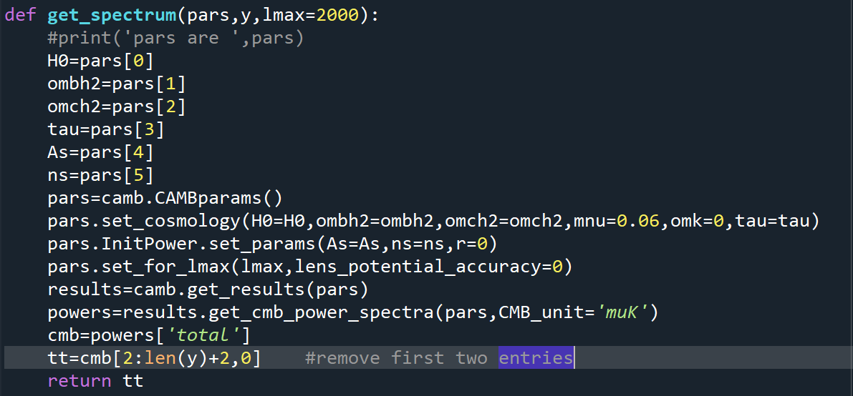

The **first two entries of CAMB returns were manually remove**. The columns of data text file were loaded in correctly. The chi square I got from this step is as expected, **1588.237653293156**

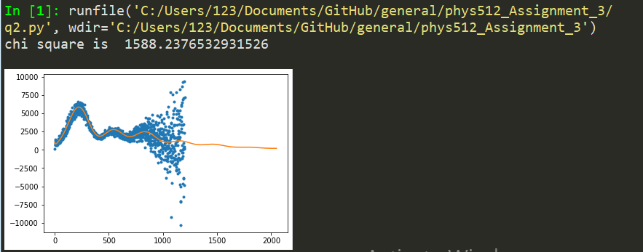

**Q3**

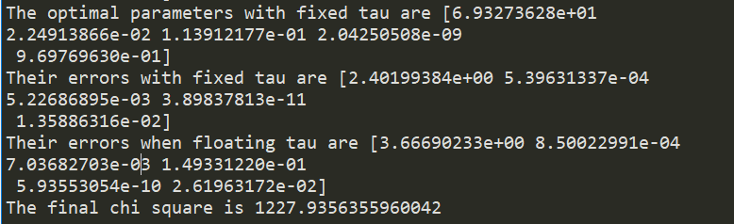

It looks like it is doing a good job. Luckily, with Newton’s method, the final **chi square is improved and down to 1227.9356355960042.**

**The optimal parameters with fixed tau are:**

6.93273674e+01

2.24913878e-02

0.05

1.13912169e-01

2.04250500e-09

9.69769637e-01

**Their errors with fixed tau are:** **Their errors when floating tau are:**

2.40199240e+00 3.66690095e+00

5.39627332e-04 8.50018389e-04

5.22687090e-03 7.03682738e-03

3.89839951e-11 1.49331227e-01

1.35886726e-02 5.93553400e-10

1.49331227e-01 2.61963951e-02

It seems that the errors of other parameters **increase** when floating the tau.

**Q4**

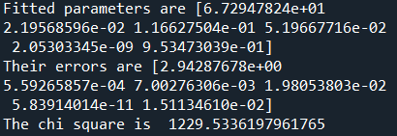

**Fitted parameters are:**

6.72947824e+01

2.19568596e-02

1.16627504e-01

5.19667716e-02

2.05303345e-09

9.53473039e-01

**Their errors are:**

2.94287678e+00

5.59265857e-04

7.00276306e-03

1.98053803e-02

5.83914014e-11

1.51134610e-02

**The chi square is 1229.5336197961765**

To ensure my parameters are converged, I plot the **autocorrelation plot** for each of my parameter. **Them seem all converged**.

I also plot the **corner plot** for all 6 parameters but with **contour option** on. It does not look pretty. I think I have some setting not right when I call the corner plot function.

**Q5)**