**Assignment 4**

**Yifei Gu**

**260906596**

**Q1)**

Here is my defined function and choice of gaussian function:

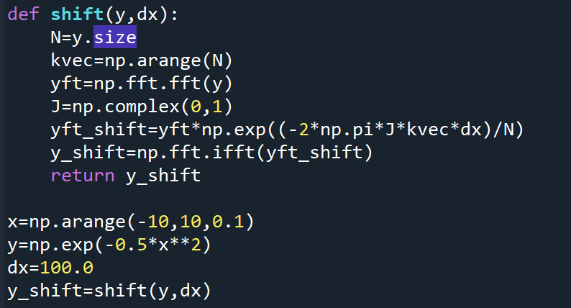

The gaussian is shifted by half of the array length.

**Q2)**

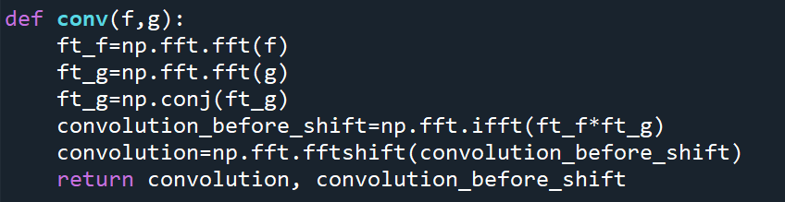

The result from **np.fft.fft** is not centered. Considering the periodicity, I used **np.fft.fftshift** to **move** the convolution **to the center**. Here I showed both plots.

The gaussian I chose is **y= exp(-0.5*x**2)**. This plot is not easy to interpret. However, when shift the convolution, which is a gaussian, to the center, it makes much more sense now. A **fat gaussian** becomes a **skinny gaussian** after Fourier Transform.

**Q3)**

Again, I used **np.fft.fftshift** to move the convolution to the center. Comparing with the convolution curve with guassian itself, the convolution curve between gaussian and its shifted gaussian **moves** towards the shifted gaussian.

**Q4)**

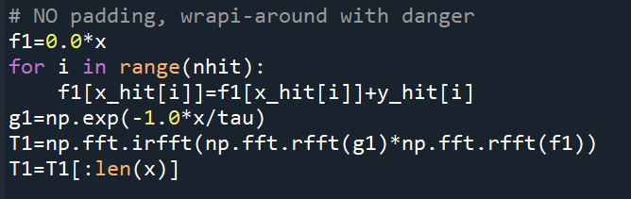

Here I used the example showed in class. Doing convolution with no padding might cause the problem of wrap-around, which is due to the periodicity of Fourier transfer. As you can see from the plot, the curve without padding is trying to connect the starting point and ending point. **Padding the data with some zeros and chopping them off in the end will solve this problem.**

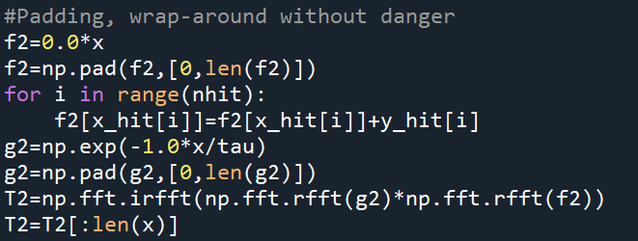

**Q5）**

**a)**

Let $α=exp(-2πik/N)$,

$$\sum_{x=0}^{N-1}{exp(-2πikx/N)}=\sum_{x=0}^{N-1}{α^{x}=S=1+α+α^{2}+…+α^{N-1}}$$

$$S*α= α+α^{2}+…+α^{N}$$

$$S-S*α= 1-α^{N}$$

$$S*\left(1-α\right)= 1-α^{N}$$

$$S= \frac{1-α^{N}}{(1-α)}$$

Bring $α=exp(-2πik/N)$ back to the equation:

$$\sum_{x=0}^{N-1}{exp(-2πikx/N)}= \frac{1-{exp(-2πik/N)}^{N}}{1-exp(-2πik/N)}$$

$$= \frac{1-exp(-2πik)}{1-exp(-2πik/N)}$$

**b)**

According to *L'Hôpital*’s rule, when k🡪0:

$$\lim_{k→0}{\sum_{x=0}^{N-1}{exp(-2πikx/N)}= \lim_{k→0}{\frac{1-exp(-2πik)}{1-exp(-2πik/N)}}}$$

$$= \lim_{k→0}\frac{{(1-exp\left(-2πik\right))}^{'}}{{1-exp(-2πik/N)}^{'}}$$

$$= \lim_{k→0}\frac{2πi*exp\left(-2πik\right)}{(2πi/N)*exp(-2πik/N)}$$

$$= \lim_{k→0}{\frac{exp\left(-2πik\right)}{\exp\left(-\frac{2πik}{N}\right)}N} \\ =\frac{exp\left(0\right)}{\exp\left(0\right)}N$$

$$=N$$

When integer k is not a multiple of N, k/N will not be an integer. $exp\left(-2πik\right)=1$, but $\exp\left(-\frac{2πik}{N}\right)≠1$. $\frac{1-exp\left(-2πik\right) →0}{1-exp\left(-\frac{2πik}{N}\right) →≠0}$ = 0.

**c)**

According to **Euler's formula**:

$$F(k')=\sum_{x=0}^{N-1}{\sin\left(\frac{2πikx}{N}\right)*exp⁡(-2πik'x/N)}$$

$$=\sum_{x=0}^{N-1}{\frac{\exp\left(\frac{-2πikx}{N}\right)-\exp\left(\frac{2πikx}{N}\right)}{2i}*exp⁡(-2πik'x/N)}$$

$$=\sum_{x=0}^{N-1}{\frac{\exp\left(\frac{-2πi(k^{'}+k)x}{N}\right)}{2i}-\frac{\exp\left(\frac{-2πi(k^{'}-k)x}{N}\right)}{2i}}$$

With this **analytic estimate of the DFT**, I wrote my DFT function as below:

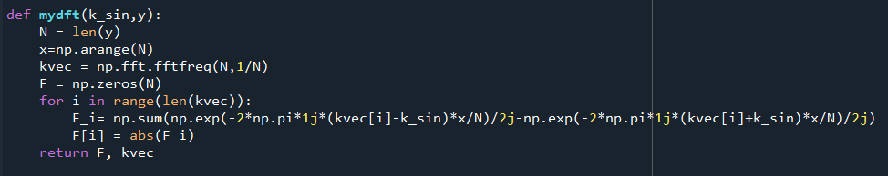

I chose **a non-integer k =15.4**, which will reflect as **a peak** in the Fourier Transform of the sine wave near **k’=15**. Due to aliasing, there be **another peak** **near k’=1009**, which is the **mirror image** about **N/2** of **k’=15**. **This is also consistent with the analytic estimate of DFT.** When **k’=k** or **k’=-k**, $\exp\left(\frac{-2πi(k^{'}+k)x}{N}\right)$ and $\exp\left(\frac{-2πi(k^{'}-k)x}{N}\right)$ are not zero and **all the other k’ will have a DFT equal to zero.** Here is how I defined my **delta function**:

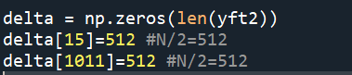

As you can see, the **numpy fft**(blue) is **overlapping** with “**my dft**”, but both have some **spectral leakage** from the delta function. The error **between my written DFT and numpy FFT** is close to the **machine precision**, and the error **between my written DFT and delta** function is **huge**:



**d)**

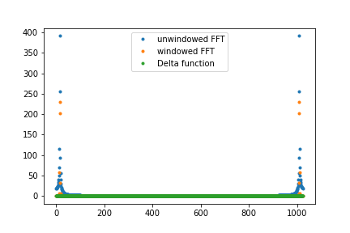

**With windowing** (Orange dots), the **spectral leakage** effects are **reduced**. The **error** between FFT and delta function also **dropped**.



**e)**

$$F(k')=\sum_{x=0}^{N-1}{(0.5-0.5cos\left(2πx/N\right))*exp⁡(-2πik'x/N)}$$

$$F(k')=\sum_{x=0}^{N-1}{(0.5-0.5\frac{\exp\left(\frac{2πix}{N}\right)+\exp\left(-\frac{2πix}{N}\right)}{2})*exp⁡(-2πik'x/N)}$$

$$F(k')=\sum_{x=0}^{N-1}{0.5\exp\left(-\frac{2πik^{'}x}{N}\right)-0.5\frac{\exp\left(\frac{2πix(k^{'}-1)}{N}\right)}{2}-}0.5\frac{\exp\left(-\frac{2πix(k^{'}+1)}{N}\right)}{2}$$

When k’=0, F(0)=N/2,

When k’=1, F(0)=-N/4,

When k’=-1, F(0)=-N/4,

All the other k’ will give a zero for DFT. The Fourier Transform of the window is [N/2, -N/4,0,0……0,-N/4].

$$F\left(f*window\right)=F\left(f\right)F(window)$$