8

Functions

Chapter Outline

Introduction.
Advantages of functions.
Types of functions.
Predefined functions
User-defined functions.
parameter passing mechanisms
Scope and extent of variables.
Storage classes

Recursion.
Conclusion.

“The function of prayer is not to influence God, but rather to change the nature of the one who prays.” -Soren Kierkegaard

“The most important function of education at any level is to develop the personality of the individual and the significance of his life to himself and to others” -Grayson Kirk

“The function of genius is not to give new answers, but to pose new questions - which time and mediocrity can solve.” -Hugh Trevor-Roper

8.1. Introduction
A function is a named, independent section of C code that performs a specific task and optionally returns a value to the calling program.

This definition has the following parts:
- A function is named. Each function has a unique name. By using that name in another part of the program, we can execute the statements contained in the function. This is known as calling the function. A function can be called from within another function.
- A function is independent. A function can perform its task without interference from or interfering with other parts of the program.
- A function performs a specific task. This is the easy part of the definition. A task is a discrete job that a program must perform as part of its overall operation, such as sending a line of text to a printer, sorting an array into numerical order, or calculating a cube root.
- A function can return a value to the calling program. When our program calls a function, the statements it contains are executed. If we want them to, these statements can pass information back to the calling program.
( OR )
A Function is a self-contained block of code that performs a coherent task.

In other words, a function is an independent, special and named collection of instructions that is used to achieve the desired result. E.g., sqrt() is function which has the purpose of returning the square root of a number.

Every C program can be thought of as a collection of these functions. Any C program contains at least one function. If a C program contains functions, then these are recognized easily as a string (or name) followed by parentheses. E.g., main() is a function. If a program contains only one function, it must be main( ). If a C program contains more than one function, then one of these functions must be main( ), Typically, C program execution always begins with main( ). There is no limit on the number of functions that might be present in a C program.
8.2. Advantages of functions
- Supports structured programming: By using functions in our C programs, we can practice structured programming, in which individual program tasks are performed by independent sections of program code. It's easier to write a structured program, because complex programming problems are broken into a number of smaller, simpler tasks. Each task is performed by a function. It's easier to debug a structured program.

- Reusability: Writing functions avoids rewriting the same code over and over. Suppose we have a section of code in our program that calculates area of a triangle. If later in the program we want to calculate the area of a different triangle, we won’t like it if we are required to write the same instructions all over again. Instead, we would prefer to jump to a ‘section of code’ that calculates area and then jumps back to the place from where we left off. This section of code is nothing but a function.

8.3. Types of functions
There are basically two kinds of functions: Pre-defined functions and user-defined functions. Pre-defined functions are the functions that were developed by the C Language developers. User-defined functions are the functions that will be developed by the user.

8.3.1. Pre-defined functions:
- These are the functions that were developed earlier by the C language developers.
- All related pre-defined functions are grouped together into header files, a file that has extension “.h”. E.g., all the mathematical functions are grouped together into the header file “math.h”. So, whenever a pre-defined function is used, the header file that contains the pre-defined function definition should be included. # include statement helps us in this context.
- Some of the pre-defined functions require data to be submitted as an input and these may return the result by processing the input data. E.g., sqrt(x) function takes a double value “x” as an input and returns square root of number as a double value. The value that is being input to function is called as an “argument” or “parameter” and the result that the function returns is called as “return value”.
Program #1
Write a program to calculate x^{y} using predefined function
/*program to calculate x^y using pre-defined function*/
# include<stdio.h>
#include<math.h>
main()
{
double x,y,ans;
printf(“\n Enter any two numbers:”);
scanf(“%lf%lf”,&x,&y);
ans=pow(x,y);
printf(“\n power of x raised to y=%lf”,ans);
}

Output:
Enter any two numbers: 2
5
power of x raised to y=32.000000

In this program, we observe that:
- main(), printf(), scanf() and pow() are functions. main() is the only one user-defined function and others are pre-defined functions. The definitions of printf() and scanf() are available in the header file “stdio.h” and definition of pow() is available in “math.h”. Hence these are included with the help of pre-processor directive #include.
- Each function has its own “function prototype” that specifies the data types of arguments, number of arguments and type of value that is being returned. Based on this only, the arguments will be submitted to the function and the returned value will be hold. E.g., the prototype of pow(x,y) is “double pow(double,double);”. Based on this prototype only, we submitted two arguments of type “double” and we used a double variable for holding the return value.
- As we know that the thing that is in between two parentheses is an argument, the first printf() took one argument where as the last printf() took two arguments, scanf() took one argument and pow() took two arguments. There is no limit in the number of arguments taken for printf() and scanf(). But pow() should take only two arguments. From this, we can say that some pre-defined functions may have fixed number of arguments and some others may have variable number of arguments.
- As the pow() returns the result, that result should be assigned to a variable for further reference. Hence, we can say that there should be a holder (variable or pointer) for holding the value returned by the function.
- All the statements that are included with in pair of curly braces are collectively called as the definition of function. There are 5 statements in between { and } after main(). These statements are collectively called as “main() function definition”. For pre-defined functions, their corresponding definitions are available in their corresponding header files. For user-defined functions, their function definitions will be given by the user.
- The program execution begins with main() and all other functions get executed (or called) in the order specified with in the main(). In this program, main() is called as “calling function” and printf(), scanf() and pow() are called as “called functions”. When a function calls another function, the control transfers to called function’s definition. After the total execution of definition is completed, the control comes back to the calling function along with return value, if any.

Commonly used header files in C:
Header file name | Purpose
<ctype.h> | Contains functions used to classify characters by their types or to convert between upper and lower case in a way that is independent of the used character set
<graphics.h> | Contains functions used to draw different objects such as rectangle, circle …etc.
<math.h> | For computing common mathematical functions.
<stdio.h> | Provides the core input and output capabilities of the C language. This file includes the venerable printf and scanf functions.
<conio.h> | Provides the console input and output capabilities of the C language. However, it is used in old MS-DOS compilers to create text user interfaces.
<stdlib.h> | For performing a variety of operations, including conversion, pseudo-random numbers, memory allocation, process control, environment, signalling, searching, and sorting.
<time.h> | For converting between various time and date formats.
<string.h> | For manipulating various types of strings.

Mathematical Functions (Prototypes) <math.h>
long double pow(long double base, long double exponent);
---Returns base raised to the power exponent: base^{exponent}
Ex: long double x=pow(32.01,1.54); x=208.036691
long double sqrt(long double x);
---Returns square root of x
Ex: long double x=sqrt(1024); x=32.000000
long double exp(long double x);
--- Returns the base-e exponential function of x, which is the e number raised to the power x.
Ex: long double x=exp(5); x= 148. 413159
long double log(long double x);
--- Returns the natural logarithm of x
Ex: long double x=log(5.5); x= 1.704748
long double log10(long double x);
--- Returns the common logarithm (base 10) of x
Ex: long double x=log10(1000); x= 3.000000
long double ceil(long double x);
--- Returns the smallest integral value that is not less than x.
Ex: long double x=ceil(3.8); x= 4.000000
long double floor(long double x);
--- Returns the largest integral value that is not greater than x.
Ex: long double x=floor(3.8); x= 3.000000
long abs(long x);
--- Returns the absolute value of x.
Ex: long x=abs(-23); x= 23
long double sin(long double x);
long double cos(long double x);
long double tan(long double x);
long double asin(long double x);
long double acos(long double x);
long double atan(long double x);
long double sinh(long double x);
long double cosh(long double x);
long double tanh(long double x);
---Returns the values of different trigonometric functions
Ex: long double x=sin(30*3.1412/180); x=0.500000
long double x=cos(60*3.1412/180); x=0.500000
long double x=tan(45*3.1412/180); x=1.000000
long double x=asin(0.5*180/3.1412); x=30.000000
long double x=acos(0.5*180/3.1412); x=60.000000
long double x=atan(1.0*180/3.1412); x=45.000000

8.3.2. User-defined functions:
  - These are the functions defined by the user for fulfilling his desired objective. Usually, these are self-contained blocks of code that perform coherent tasks that are same as pre-defined functions.
  - Whenever the user wants to define a function he should keep these things in mind:
- First, he should decide the objective of the function. In other words, he should decide the purpose of function for which it is being developed.
- Second, he should develop the function prototype that tells the compiler the name of the function, types of arguments to that function and return type of that function. Usually, it has the following form:
<return_type> <function_name>(<data type1>,<datatype2>….<datatypeN>);

In this syntax,
<return_type> and <data type1><data type2>…<datatypeN> are any one of valid pre-defined data types such as int, float, double, char and void (or) any derived data types such as long int, short int…etc (or) any user defined data types such as array (not used as return type), pointer, struct…etc.
<function_name> is any valid identifier. Usually, it is named based on the purpose of function.
Ex: The user wants to calculate a number rose to power of another number. In other words, if x and y are two numbers, then he wants to find x^{y} using functions. Then his function prototype may be as one of these:
int powXY(int,int); /*function with arguments and return value*/
int powXY(void); /*function without arguments but with return value*/
void powXY(int,int); /*function with arguments and without return value*/
void powXY(void); /*function without arguments and without return value*/

- Third, he should develop the function definition that is a collection of statements or block of code based on the function prototype. Usually, the function definition has the following form:
<return_type> function_name(<datatype1> <arg1>,<datatype2> <arg2>, …<datatypeN> <argN>)
{
Statement(s);
}

A function definition describes what a function does. It consists of a function header and a function body.
a) The function header consists of:
  - <return_type> specifies the data type of the value returned by the function. It may be of any data type other than array and function types. If <return type> is omitted, the value returned is assumed to be an int type by default. The data type void is specified in the place of <return_type> if the function returns no value.
  - function_name is any valid identifier. But, it should not used as name for a variable, a constant or any other program element.
  - <arg1>,<arg2>…<argn> are known as formal arguments or formal parameters. Each parameter must be preceded by its data type. If there is more than one parameter, then those should be separated with commas. For parameterless functions, the keyword void is placed within the parentheses following function_name.
b) The function body is also known as a compound statement or a block. All valid C statements can take part in this function body. In addition to these, two more statements may take part: function calls and return statement.
- A return Statement is a statement that is used to transfer control to the calling function along with returned value, if any. This statement should be used in the definition of function, if the function returns value to the calling function. This statement consists of the keyword return followed by an expression (or) a value with in optional parentheses.
Ex: These are valid return statements
return; /*Transfers only control to the calling function*/
return 10; /*Transfers control as well as 10 to the calling function*/
return (a+b*c-d); /*the expression is evaluated and the result gets transferred along with control to the calling function*/
Note:
1) Multiple return statements can be used.
/* conversion of upper case letter to lower case letter*/
if ( ch >= 65 && ch <= 90 )
return ( ch ) ;
else
return ( ch + 32 ) ;

2) A function can return only one value at a time. Thus, the following statements are invalid.
return ( a, b ) ;
return ( x, 12 ) ;

3) The return value should match with the <return_type> as in function header. Otherwise, the value will be converted according to the <return_type> and the converted value gets returned to the calling function.
Ex: Possible function definitions for the function powXY()
With arguments and with return value | Without arguments and with return value
int powXY(int x,int y)  {  int i,product;  product=1;  for(i=1;i<=y;i++)  product=product*x;  return (product);  } | int powXY(void)  {  int x,y,i,product;  printf(“Enter x,y values:”);  scanf(“%d%d”,&x,&y);  product=1;  for(i=1;i<=y;i++)  product=product*x;  return (product);  }
With arguments and without return value | Without arguments and with out return value
void powXY(int x,int y)  {  int i,product;  product=1;  for(i=1;i<=y;i++)  product=product*x;  printf(“Answer=%d”,product);  } | void powXY(void)  {  int x,y,i,product;  printf(“Enter x,y values:”);  scanf(“%d%d”,&x,&y);  product=1;  for(i=1;i<=y;i++)  product=product*x;  printf(“Answer=%d”,product);  }

- Finally, he should utilize the defined function by calling it from another function or in it. For this purpose, function call statement (callable statement) is helpful.
A function call is a statement that is used to invoke (or call) a function that is defined by the user or pre-defined function. A function can call itself or can be called from any other function. It can be called many times. Even, main() can be called from other functions. A function call has the following form:
<function_name>(<e1>,<e2>,<e3>…<eN>);

In this syntax,
<function_name> is any existing name of the function that needs to be called.
<e1>,<e2>…<eN> are called as actual arguments or actual parameters.
If there are no arguments, then the parentheses should be left as empty. If there is any return value that a function returns, then that value will be hold by a variable using assignment statement (or) that function call can be used as a part of expression as an operand.

Ex: Possible function calls for the function powXY() from main()
With arguments and with return value | Without arguments and with return value
#include<stdio.h>  main()  {  int a,b,ans;  printf(“\n Enter any two values:”);  scanf(“%d%d”,&a,&b);  ans=powXY(a,b); /*function call*/  printf(“\n Answer=%d”,ans);  } | #include<stdio.h>  main()  {  int ans;  ans=powXY(); /*function call*/  printf(“\n Answer=%d”,ans);  }
With arguments and without return value | Without arguments and with out return value
#include<stdio.h>  main()  {  int a,b;  printf(“\n Enter any two values:”);  scanf(“%d%d”,&a,&b);  powXY(a,b); /*function call*/  } | #include<stdio.h>  main()  {  powXY(); /*function call*/  }

Hence, we can say that a user can define and utilize a function to achieve his desired objective in any one of the following ways:

With arguments and with return value | Without arguments and with return value | With arguments and without return value | Without arguments and without return value
#include<stdio.h>  int powXY(int,int);  main()  {  int a,b,ans;  printf(“\n Enter any two values:”);  scanf(“%d%d”,&a,&b);  ans=powXY(a,b); /*function call*/  printf(“\n Answer=%d”,ans);  }  int powXY(int x,int y)  {  int i,product;  product=1;  for(i=1;i<=y;i++)  product=product*x;  return (product);  }  Output:  Enter any two values:  2  5  Answer=32 | #include<stdio.h>  int powXY(void);  main()  {  int ans;  ans=powXY(); /*function call*/  printf(“\n Answer=%d”,ans);  }  int powXY(void)  {  int x,y,i,product;  printf(“Enter x,y values:”);  scanf(“%d%d”,&x,&y);  product=1;  for(i=1;i<=y;i++)  product=product*x;  return (product);  }  Output:  Enter x,y values:  2  5  Answer=32 | #include<stdio.h>  void powXY(int,int);  main()  {  int a,b;  printf(“\n Enter any two values:”);  scanf(“%d%d”,&a,&b);  powXY(a,b); /*function call*/  }  void powXY(int x,int y)  {  int i,product;  product=1;  for(i=1;i<=y;i++)  product=product*x;  printf(“Answer=%d”,product);  }  Output:  Enter any two values:  2  5  Answer=32 | #include<stdio.h>  void powXY();  main()  {  powXY(); /*function call*/  }  void powXY(void)  {  int x,y,i,product;  printf(“Enter x,y values:”);  scanf(“%d%d”,&x,&y);  product=1;  for(i=1;i<=y;i++)  product=product*x;  printf(“Answer=%d”,product);  }  Output:  Enter x,y values:  2  5  Answer=32
Points to ponder: 1) A function can be called multiple times. Even, the function main() can also be called from other functions.
2) A function’s definition can never be placed in another function’s definition.
3) A function can return only one value at a time to the calling function.
Few points about main(): 1) main() is the user-defined function.

2) main() is invoked or called by operating system and the return value from is returned to operating system.

3) By default, main() function as well as other user-defined functions return an integer value.
From the above example, it is clear that there are four types of user-defined functions:
- Function with arguments and with return value.
- Function with arguments and without return value.
- Function without arguments and with return value.
- Function without arguments and without return value.

Function with arguments and with return value
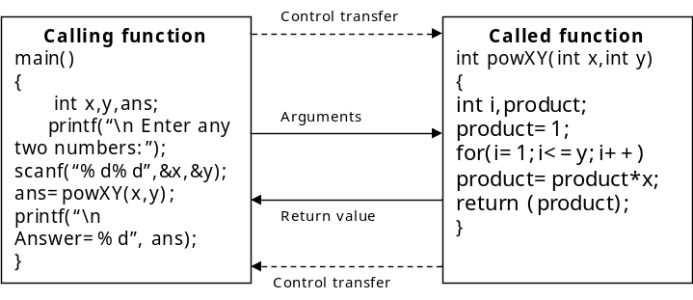
Function with arguments and without return value
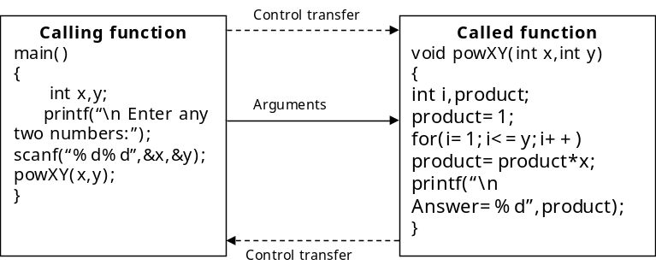

Function without arguments and with return value
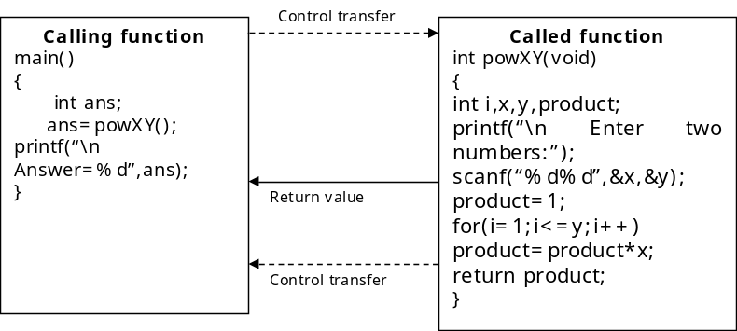
Function without arguments and without return value
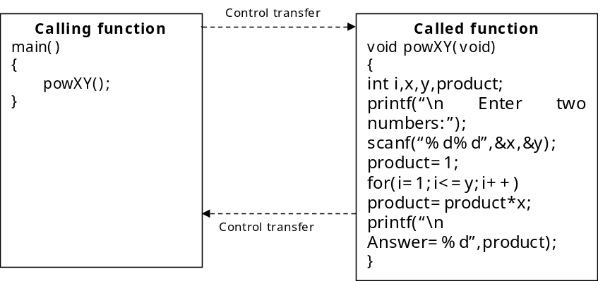

Example programs:
/* Program to find the roots of a quadratic equation*/  #include<stdio.h>  void quadroots(int,int,int);/function prototype  main()  {  int a,b,c;  printf(“\n Enter values of a,b,c”);  scanf(“%d%d%d”,&a,&b,&c);  quadroots(a,b,c); //function call  }  //function definition  void quadroots(int a,int b,int c)  {  int desc;  float root1,root2,r1,r2;  if(a==0)  {  printf(“\n given equation is not quadratic”);  root1=-c/b;  printf(“\n Root1=%f”,root1);  }  else  {  desc=b*b-4*a*c;  if(desc==0)  {  printf(“\n roots are real and equal”);  root1=root2=-b/(float)2*a;  printf(“root1=%f\nroot2=%f”,root1,root2);  }  else if(desc>0)  {  printf(“\n roots are real and unequal”);  root1=(-b+sqrt(desc))/(2*a);  root2=(-b-sqrt(desc))/(2*a);  printf(“root1=%f\nroot2=%f”,root1,root2);  }  else  {  printf(“\n roots are complex”);  r1=-b/(float)(2*a);  r2=sqrt(-desc)/(2*a);  printf(“root1=%.2f+i%.2f”,r1,r2);  printf(“root2=%.2f-i%.2f”,r1,r2);  }  }  } | /*program to print prime factors of a number*/  #include<stdio.h>  int isPrime(int);  void factors(int);  main()  {  int n;  printf(“\n Enter any number:”);  scanf(“%d”,&n);  factors(n);  }  void factors(int n)  {  int i,r;  printf(“\n Prime factors:”);  for(i=1;i<=n;i++)  {  if(n%i==0)  r=isPrime(i);  if(r==1)  printf(“\n%d”,i);  }  }  int isPrime(int n)  {  int i,fcount;  fcount=0;  for(i=1;i<=n;i++)  {  if(n%i==0)  fcount++;  }  if(fcount==2)  return 1;  else  return 0;  }

8.4. Parameter passing mechanisms (or) passing arguments to a function
A function can be called by passing arguments (or inputs or parameters) to it from another function. This process is called as parameter passing mechanism.
There are two parameter passing mechanisms:
- call by value (or) pass by value
- call by reference / address (or) pass by reference / address
In call by value method, the arguments are normal values. In call by reference method, the arguments are the addresses or references.

To pass arguments to a function, we list them in parentheses following the function name. The number of arguments and the type of each argument must match the parameters in the function header and prototype. For example, if a function is defined to take two type int arguments, we must pass it exactly two int arguments—no more, no less--and no other type. If we try to pass a function an incorrect number and/or type of argument, the compiler will detect it, based on the information in the function prototype.

If the function takes multiple arguments, the arguments listed in the function call are assigned to the function parameters in order: the first argument to the first parameter, the second argument to the second parameter, and so on. Each argument can be any valid C expression: a constant, a variable, a mathematical or logical expression, or even another function (one with a return value). For example, if half(), square(), and third() are all functions with return values, we could write

x = half(third(square(half(y))));

The program first calls half(), passing it y as an argument. When execution returns from half(), the program calls square(), passing half()'s return value as an argument. Next, third() is called with square()'s return value as the argument. Then, half() is called again, this time with third()'s return value as an argument. Finally, half()'s return value is assigned to the variable x. The following is an equivalent piece of code:
a = half(y);
b = square(a);
c = third(b);
x = half(c);
While passing arguments, we can observe that there are basically two types of functions: calling function, called function.
Calling function: It is a function that calls another function or itself.
Called function: It is a function that is being called from another function.
8.4.1. Call by value
In this method, the values will be passed to called function from calling function. The values passed are called as “actual arguments”. In the header of called function definition, there will be arguments that hold the passed values. These arguments are called as “formal arguments”. Whenever a function is called from another function using call by value method, the actual arguments are copied into formal arguments. Then the called function gets executed with those copied values. After completion, the control returns to calling function with return value, if any.
Ex: The following program demonstrates the call by value method.
/*program to convert lowercase to uppercase*/
#include<stdio.h>
char toUpperCase(char);
main()
{
char alphabet,upper;
printf(“\n Enter any lowercase alphabet:”);
scanf(“\n%c”,&alphabet);
upper=toUpperCase(alphabet); /*call by value – actual argument: alphabet*/
printf(“\n Uppercase alphabet:%c”,upper);
}
char toUpperCase(char ch) /*formal argument: ch*/
{
if(ch>=’a’ && ch<=’z’)
ch=ch-32;
return ch;
}

In this program, main() is the calling function and toUpperCase() is called function. The toUpperCase() function is called with one actual argument from main(). The actual argument is copied into formal argument. The conversion process is carried out with copied value. After then, the converted character is returned to main(), the calling function. The main(), the calling function, holds the value and prints that value.
8.4.2. Call by reference
In this method, the addresses will be passed to called function from calling function. Hence, the actual arguments are addresses. That is, the variables that are preceded by reference operator (&). The formal arguments in function header are pointers. That is, the variables that are preceded by de-reference operator (*). This method is very useful in such a situation where the called function wants to change the calling function’s arguments.

The following program demonstrates call by reference method.
/*progam to swap two numbers using call by value method*/  #include<stdio.h>  void swap(int,int);  main()  {  int a,b;  printf(“\n Enter any two numbers:”);  scanf(“%d%d”,&a,&b);  printf(“\n Before swap a=%d \t b=%d”,a,b);  swap(a,b);  printf(“\n After swap a=%d \t b=%d”,a,b);  }  void swap(int x,int y)  {  int temp;  temp=x;  x=y;  y=temp;  }  Output: Enter any two numbers: 10 20  Before swap a=10 b=20  After swap a=10 b=20 | /*progam to swap two numbers using call by reference method*/  #include<stdio.h>  void swap(int*,int*);  main()  {  int a,b;  printf(“\n Enter any two numbers:”);  scanf(“%d%d”,&a,&b);  printf(“\n Before swap a=%d \t b=%d”,a,b);  swap(&a,&b);  printf(“\n After swap a=%d \t b=%d”,a,b);  }  void swap(int *x,int *y)  {  int temp;  temp=*x;  *x=*y;  *y=temp;  }  Output: Enter any two numbers: 10 20  Before swap a=10 b=20  After swap a=20 b=10
Actual arguments: Normal values  Formal arguments: Normal variables | Actual arguments: addresses  Formal arguments: pointers
The changes in formal arguments are not reflected in actual arguments. | The changes in formal arguments are reflected in actual arguments.

8.5. Scope and extent of variables
The scope of a variable is the portion of a program in which the variable may be visible or available. There are 3 types of scopes in which a variable can fall:
- Block scope
- Function scope or local scope
- Global scope or file scope

The longevity or lifetime or extent of a variable refers to the duration for which the variable retains a given value during the execution of a program.

The same variable name may appear in different scopes. It is the duty of the compiler to decide whether the different occurrences of the variable refer to the same variable or not.
Block Scope: A variable is said to have block scope, if it is recognised only with in the block where it is declared.
The following example demonstrates this concept:
#include<stdio.h>
main()
{
{/*Block-1*/
int a;
a=10;
printf("%d\t%d",a,b);
}
{/*Block-2*/
int b;
b=20;
printf("%d\t%d",a,b);
}
}
Whenever we execute this program, we get an error because we are trying to utilize the variables that are out of block scope. In this program, we observe that there are two blocks. In block-1, the variable ‘a’ is declared and initialized. In block-2, the variable ‘b’ is declared and initialized. In block-1, undoubtedly, we can access the value of ‘a’. But, we can’t access the value of ‘b’ that is declared in block-2. Since, b is not declared and initialized in block-1, b is out of scope. The variable ‘b’ is available only in the block-2. Hence, we get an error like ‘b undeclared’. The same happens with the variable ‘a’ in block-2.

Local Scope: A variable is said to have local scope or function scope, if it is recognised only with in the function where it is declared. The following example demonstrates this concept:
#include<stdio.h>
void fun(void);
main() //function-1
{
int a;
a=10;
printf("a=%d\tb=%d",a,b);
fun();
}
void fun() //function-2
{
int b;
b=20;
printf("a=%d\tb=%d",a,b);
}
Whenever we execute this program, we get an error because we are trying to utilize the variables that are out of function scope. In this program, we observe that there are two functions. In function-1, the variable ‘a’ is declared and initialized. In function-2, the variable ‘b’ is declared and initialized. In function-1, undoubtedly, we can access the value of ‘a’. But, we can’t access the value of ‘b’ that is declared in function-2. Since, b is not declared and initialized in function-1, b is out of scope. The variable ‘b’ is available only in the function-2. Hence, we get an error like ‘b undeclared’. The same happens with the variable ‘a’ in function-2.
Global Scope: A variable is said to have global scope or file scope, if it is recognised with in blocks and all the functions defined in a program. A global variable can be declared outside of all functions with in a file. The following example demonstrates the concept of global variable:
#include<stdio.h>
void fun(void);
int c=30; //global variable
int d; //global variable
main()
{
int a;
a=10;
d=40;
printf("\n With in main()");
printf("\n Local variable a=%d",a);
printf("\n Global variables c=%d\td=%d",c,d);
fun();
}
void fun()
{
int b;
b=20;
d=60;
printf("\n With in fun()");
printf("\n Local variable b=%d",b);
printf("\n Global variables c=%d\td=%d",c,d);
}
In this example, the variables ‘c’ and ‘d’ are global variables. These variables can be available in both functions. We can assign different values to same global variable in different functions. The value that is assigned locally in the function only gets accessed.

The life time of a variable is best demonstrated with the following example:
#include<stdio.h>
main()
{
int i;
for(i=1;i<=4;i++)
{
int y=20;
printf("\ny is %d",y);
y=100;
printf("\ny is now %d",y);
}
}

In this program, it is clear that the variable y in loop is alive until the iteration is completed. In the first iteration, the variable y is initialized with the value 20. Later it is changed to 100. After completion of first iteration, agian the value of y gets initialized with 20. Hence, the old value is unchanged until first iteration is completed. Hence, the life time of variable y is upto the iteration only.
8.5.1. Storage classes
Variables in C differ in behavior. The behavior depends on the storage class a variable may assume. From C compiler’s point of view, a variable name identifies some physical location within the computer where the string of bits representing the variable’s value is stored. There are basically two kinds of locations in a computer where such a value may be kept— Memory and CPU registers. It is the variable’s storage class that determines in which of these two locations the value is stored.
Moreover, a variable’s storage class tells us:
- Where the variable would be stored.
- What will be the initial value of the variable, if initial value is not specifically assigned? (i.e. the default initial value).
- What is the scope of the variable; i.e. in which functions the value of the variable would be available.
- What is the life of the variable; i.e. how long would the variable along with its values exist.

There are four storage classes in C:
- (a) Automatic storage class
- (b) Register storage class
- (c) Static storage class
- (d) External storage class
These storage classes are identified by the keywords: auto, register, static and extern respectively.
1) Automatic Storage Class
The features of a variable defined to have an automatic storage class are as under:

Storage | Memory.
Default initial value | An unpredictable value, which is often called a garbage value.
Scope | Local to the block in which the variable is defined.
Life | Till the control remains within the block in which the variable is defined.

Following program shows how an automatic storage class variable is declared, and the fact that if the variable is not initialized it contains a garbage value.
main( )
{
auto int i, j ;
printf ( "\n%d %d", i, j ) ;
}
When you run this program you may get different values, since garbage values are unpredictable. So always make it a point that you initialize the automatic variables properly, otherwise you are likely to get unexpected results. Scope and life of an automatic variable is illustrated in the following program.
main( )
{
auto int i = 1 ;
{
auto int i = 2 ;
{
auto int i = 3 ;
printf ( "\n%d ", i ) ;
}
printf ( "%d ", i ) ;
}
printf ( "%d", i ) ;
}
Note that the Compiler treats the three i’s as totally different variables, since they are defined in different blocks. It means the scope of i is local to the block in which it is defined. The moment the control comes out of the block in which the variable is defined, the variable and its value is irretrievably lost. Once the control comes out of the innermost block the variable i with value 3 is lost, and hence the i in the second printf( ) refers to i with value 2. Similarly, when the control comes out of the next innermost block, the third printf( ) refers to the i with value 1.
2) Register Storage Class
The features of a variable defined to be of register storage class are as under:

Storage | CPU Registers
Default initial value | An unpredictable value, which is often called a garbage value.
Scope | Local to the block in which the variable is defined.
Life | Till the control remains within the block in which the variable is defined.

A value stored in a CPU register can always be accessed faster than the one that is stored in memory. Therefore, if a variable is used at many places in a program it is better to declare its storage class as register. A good example of frequently used variables is loop counters. We can name their storage class as register.
main( )
{
register int i ;
for ( i = 1 ; i <= 10 ; i++ )
printf ( "\n%d", i ) ;
}
Here, even though we have declared the storage class of i as register, we cannot say for sure that the value of i would be stored in a CPU register. Why? Because the number of CPU registers are limited, and they may be busy doing some other task. What happens in such an event is the variable works as if its storage class is auto.
Not every type of variable can be stored in a CPU register.
For example, if the microprocessor has 16-bit registers then they cannot hold a float value or a double value, which require 4 and 8 bytes respectively. However, if you use the register storage class for a float or a double variable you won’t get any error messages. All that would happen is that the compiler would treat the variables to be of auto storage class.
3) Static Storage Class
The features of a variable defined to have a static storage class are as under:
Storage | Memory.
Default initial value | Zero.
Scope | Local to the block in which the variable is defined.
Life | Value of the variable persists between different function calls

The following program demonstrates the details of static storage class:
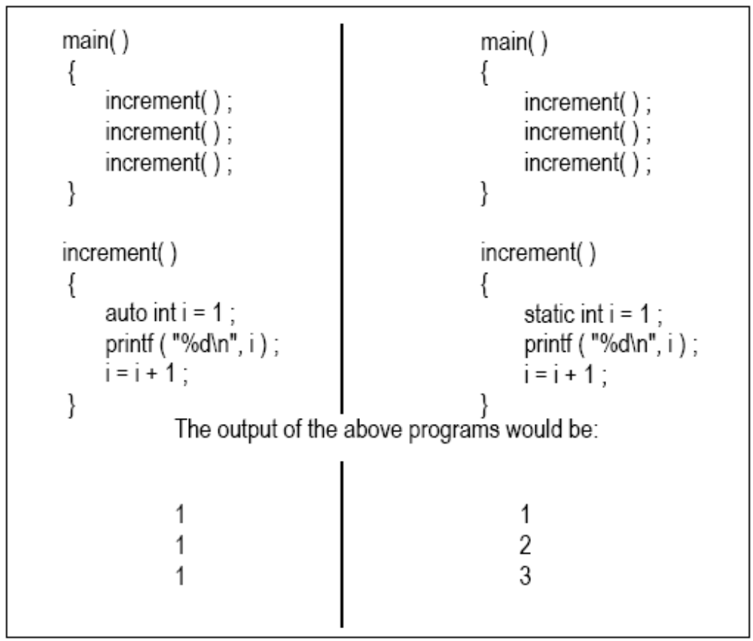
The programs above consist of two functions main( ) and increment( ). The function increment( ) gets called from main( ) thrice. Each time it increments the value of i and prints it. The only difference in the two programs is that one uses an auto storage class for variable i, whereas the other uses static storage class.
Like auto variables, static variables are also local to the block in which they are declared. The difference between them is that static variables don’t disappear when the function is no longer active. Their values persist. If the control comes back to the same function again the static variables have the same values they had last time around.
In the above example, when variable i is auto, each time increment( ) is called it is re-initialized to one. When the function terminates, i vanishes and its new value of 2 is lost. The result: no matter how many times we call increment( ), i is initialized to 1 every time.
On the other hand, if i is static, it is initialized to 1 only once. It is never initialized again. During the first call to increment( ), i is incremented to 2. Because i is static, this value persists. The next time increment( ) is called, i is not re-initialized to 1; on the contrary its old value 2 is still available. This current value of i (i.e. 2) gets printed and then i = i + 1 adds 1 to i to get a value of 3. When increment( ) is called the third time, the current value of i (i.e. 3) gets printed and once again i is incremented. In short, if the storage class is static then the statement static int i = 1 is executed only once, irrespective of how many times the same function is called.
4) External Storage Class
The features of a variable whose storage class has been defined as external are as follows:
Storage | Memory.
Default initial value | Zero.
Scope | Global.
Life | As long as the program execution does not come to end.
External variables differ from those we have already discussed in that their scope is global, not local. External variables are declared outside all functions, yet are available to all functions that care to use them. Here is an example to illustrate this fact.
int i ;
main( )
{
printf ( "\ni = %d", i ) ;
increment( ) ;
increment( ) ;
decrement( ) ;
decrement( ) ;
}
increment( )
{
i = i + 1 ;
printf ( "\non incrementing i = %d", i ) ;
}
decrement( )
{
i = i - 1 ;
printf ( "\non decrementing i = %d", i ) ;
}
The output would be:
i = 0
on incrementing i = 1
on incrementing i = 2
on decrementing i = 1
on decrementing i = 0
As is obvious from the above output, the value of i is available to the functions increment( ) and decrement( ) since i has been declared outside all functions.
Look at the following program.
int x = 21 ;
main( )
{
extern int y ;
printf ( "\n%d %d", x, y ) ;
}
int y = 31 ;
Here, x and y both are global variables. Since both of them have been defined outside all the functions both enjoy external storage class. Note the difference between the following:
extern int y ;
int y = 31 ;
Here the first statement is a declaration, whereas the second is the definition. When we declare a variable no space is reserved for it, whereas, when we define it space gets reserved for it in memory. We had to declare y since it is being used in printf( ) before it’s definition is encountered. There was no need to declare x since its definition is done before its usage. Also remember that a variable can be declared several times but can be defined only once.
Another small issue—what will be the output of the following program?
int x = 10 ;
main( )
{
int x = 20 ;
printf ( "\n%d", x ) ;
As is obvious from the above output, the value of i is available to the functions increment( ) and decrement( ) since i has been declared outside all functions.
Look at the following program.
int x = 21 ;
main( )
{
extern int y ;
printf ( "\n%d %d", x, y ) ;
}
int y = 31 ;
Here, x and y both are global variables. Since both of them have been defined outside all the functions both enjoy external storage class. Note the difference between the following:
extern int y ;
int y = 31 ;
Here the first statement is a declaration, whereas the second is the definition. When we declare a variable no space is reserved for it, whereas, when we define it space gets reserved for it in memory. We had to declare y since it is being used in printf( ) before it’s definition is encountered. There was no need to declare x since its definition is done before its usage. Also remember that a variable can be declared several times but can be defined only once.
Another small issue—what will be the output of the following program?
int x = 10 ;
main( )
{
int x = 20 ;
printf ( "\n%d", x ) ;
display( ) ;
}
display( )
{
printf ( "\n%d", x ) ;
}
Here x is defined at two places, once outside main( ) and once inside it. When the control reaches the printf( ) in main( ) which x gets printed? Whenever such a conflict arises, it’s the local variable that gets preference over the global variable. Hence the printf( ) outputs 20. When display( ) is called and control reaches the printf( ) there is no such conflict. Hence this time the value of the global x, i.e. 10 gets printed.
One last thing—a static variable can also be declared outside all the functions. For all practical purposes it will be treated as an extern variable. However, the scope of this variable is limited to the same file in which it is declared. This means that the variable would not be available to any function that is defined in a file other than the file in which the variable is defined.
Which to Use When
Dennis Ritchie has made available to the C programmer a number of storage classes with varying features, believing that the programmer is in a best position to decide which one of these storage classes is to be used when. We can make a few ground rules for usage of different storage classes in different programming situations with a view to:
- (a) economise the memory space consumed by the variables
- (b) improve the speed of execution of the program

The rules are as under:
- Use static storage class only if you want the value of a variable to persist between different function calls.
- Use register storage class for only those variables that are being used very often in a program. Reason is, there are very few CPU registers at our disposal and many of them might be busy doing something else. Make careful utilization of the scarce resources. A typical application of register storage class is loop counters, which get used a number of times in a program.
- Use extern storage class for only those variables that are being used by almost all the functions in the program. This would avoid unnecessary passing of these variables as arguments when making a function call. Declaring all the variables as extern would amount to a lot of wastage of memory space because these variables would remain active throughout the life of the program.
- If we don’t have any of the express needs mentioned above, then use the auto storage class. In fact most of the times we end up using the auto variables, because often it so happens that once we have used the variables in a function we don’t mind loosing them.

8.6. Recursion
Recursion is a process by which a function calls itself repeatedly, until some specified condition has been satisfied.

A function is recursive if it can call itself; either directly:
void f()
{
f();
}
or indirectly:
void f()
{
g();
}

void g()
{
f();
}

Recursion is just a loop; however, it has one difference from other loops. With recursion, each time a recursive function is called, a new set of variables is created. This is not true of the other loops

When a function calls itself, a new set of local variables and parameters are allocated storage on the stack, and the function code is executed from the top with these new variables. A recursive call does not make a new copy of the function. Only the values being operated upon are new. As each recursive call returns, the old local variables and parameters are removed from the stack, and execution resumes immediately after the recursive call inside the function.
The main advantage to recursive functions is that we can use them to create clearer and simpler versions of several programs.
When writing a recursive function, we should follow these rules:

Recursion rule #1: Every recursive method must have a base case -- a condition under which no recursive call is made -- to prevent infinite recursion.

When writing recursive functions, we must have a conditional statement, such as an if, somewhere to force the function to return without the recursive call being executed. If we don't, the function will never return once we call it. Omitting the conditional statement is a common error when writing recursive functions.
Recursion rule #2: Every recursive method must make progress toward the base case to prevent infinite recursion.

When writing recursive functions, we must write a recursive case in which there should be a call to same function.
Ex: Suppose we want to calculate the factorial value of an integer. As we know, the factorial of a number is the product of all the integers between 1 and that number. For example, 4 factorial is 4 * 3 * 2 * 1. This can also be expressed as 4! = 4 * 3!, where ‘!’ stands for factorial. Thus factorial of a number can be expressed in the form of itself. Hence this can be programmed using recursion.
Program #2
Write a program to calculate factorial of a number
/* program to calculate factorial of a number in iterative approach*/  #include<stdio.h>  main()  {  int n,fact,i;  printf(“\n Enter any number:”);  scanf(“%d”,&n);  for(i=1,fact=1;i<=n;i++)  fact=fact*i;  printf(“\n Factorial of %d is %d”,n,fact);  } | /* program to calculate factorial of a number using recursion*/  #include<stdio.h>  int fact(int);  main()  {  int n,f;  printf(“\n Enter any number:”);  scanf(“%d”,&n);  f=fact(n);  printf(“\n Factorial of %d is %d”,n,f);  }  int fact(int n)  {  int f;  if(n==0||n==1) //base case  f=1;  else  f=n*fact(n-1); //recursive case  return f;  }
Output:
Enter any number: 5
Factorial of 5 is 120

Let us see how the recursion works. Assume n=5. since the value of n is not 1 or 0, the statement will be executed with n=5. That is,
f=5*fact(4);
will be evaluated. The expression on the right hand side includes the call to fact() with n=4. This call, fact(4), will return this value: 4*fact(3). Like this, the sequence of operations can be summarized as follows:
f=5*fact(4);
=5*4*fact(3);
=5*4*3*fact(2);
=5*4*3*2*fact(1);
=5*4*3*2*1
=120

When this recursive program is executed, the recursive function calls are not executed immediately. Rather, these are placed on a stack until the condition terminates the recursion is encountered. The function calls are then executed in reverse order, as they are deleted from the stack. Thus, when evaluating a factorial recursively, the function calls will proceed in the following order:
fact(1)
2*fact(1)
3*fact(2)
4*fact(3)
5*fact(4)

The actual values will then be returned in the following order:
fact(1)=1
2*fact(1)=2*1=2
3*fact(2)=3*2=6
4*fact(3)=4*6=24
5*fact(4)=24*5=120

/*A program to calculate sum of n natural numbers using iterative approach*/  #include<stdio.h>  main()  {  int n,sum,i;  printf(“\n Enter n value:”);  scanf(“%d”,&n);  for(i=1,sum=0;i<=n;i++)  sum=sum+i;  printf(“\n Sum of %d numbers=%d”,n,sum);  } | /*A program to calculate sum of n natural numbers using recursive approach*/  #include<stdio.h>  int sumNatural(int);  main()  {  int n,s;  printf(“\n Enter n value:”);  scanf(“%d”,&n);  s=sumNatural(n);  printf(“\n Sum of %d numbers=%d”,n,s);  }  int sumNatural(int n)  {  int sum;  if(n==0)  sum=0; //base case  else  sum=sum+sumNatural(n-1); //recursive case  return sum;  }
/*A program to calculate sum of digits of a number using iterative approach*/  #include<stdio.h>  main()  {  int num,sum,r;  printf(“\n Enter any number:”);  scanf(“%d”,&num);  sum=0;  while(num>0)  {  r=num%10;  sum=sum+r;  num=num/10;  }  printf(“\n Sum of digits=%d”,sum);  } | /*A program to calculate sum of digits of a number using recursive approach*/  #include<stdio.h>  int sumDigits(int);  main()  {  int num,s;  printf("\n Enter any number:");  scanf("%d",&num);  s=sumDigits(num);  printf("\n Sum of digits=%d",s);  }  int sumDigits(int n)  {  if(n==0)  return 0;  else  return (n%10)+sumDigits(n/10);  }

/*A program to calculate GCD of two numbers using iterative approach*/  #include<stdio.h>  int gcd(int,int);  main()  {  int a,b;  printf("\n Enter any two numbersx:");  scanf("%d%d",&a,&b);  printf("\n GCD=%d",gcd(a,b));  }  int gcd(int a,int b)  {  int t;  if(a<b)  {  t=a;  a=b;  b=t;  }  while(1)  {  t=a%b;  if(t==0)  return b;  a=b;  }  } | /*A program to calculate GCD of two numbers using recursive approach*/  #include<stdio.h>  int gcd(int,int);  main()  {  int a,b;  printf("\n Enter any two numbers:");  scanf("%d%d",&a,&b);  printf("\nGCD=%d",gcd(a,b));  }  int gcd(int a,int b)  {  if(b==0) //base case  return a;  else  return gcd(b,a%b); //recursive case  }
/*A program print Fibonacci series using iterative approach*/  #include<stdio.h>  int main()  {  int n,a,b,c,i;  printf("\n Enter how many numbers:");  scanf("%d",&n);  a=0;  b=1;  printf("%d\t%d",a,b);  for(i=3;i<=n;i++)  {  c=a+b;  printf("\t%d",c);  a=b;  b=c;  }  return 0;  } | /*A program to calculate sum of digits of a number using recursive approach*/  #include<stdio.h>  int fibrec(int);  int main()  {  int n,i;  printf("\n Enter how many numbers:");  scanf("%d",&n);  printf("%d\t%d",0,1);  for(i=1;i<n-1;i++)  printf("\t%d",fibrec(i));  return 0;  }  int fibrec(int n)  {  int fib;  if(n==0||n==1)  fib=1;  else  fib=fibrec(n-1)+fibrec(n-2);  return fib;  }
Recursion vs Iteration
Similarities:
- Both iteration and recursion are based on a control structure: Iteration uses a repetition structure; recursion uses a selection structure.
- Both iteration and recursion involve repetition: Iteration explicitly uses a repetition structure; recursion achieves repetition through repeated function calls.
- Iteration and recursion each involve a termination test: Iteration terminates when the loop-continuation condition fails; recursion terminates when a base case is recognized.
- Iteration and recursion can occur infinitely: An infinite loop occurs with iteration if the loop-continuation test never becomes false; infinite recursion occurs if the recursion step does not reduce the problem in a manner that converges on the base case.
Differences:

- Recursive version of a program is slower than iterative version of a program due to overhead of maintaining stack.
- Recursive version of a program uses more memory (for the stack) than iterative version of a program.
- Some times, recursive version of a program is simpler to understand than iterative version of a program.

  OBSERVABLE  O  U  T  P  U  T | 1)#include<stdio.h>  void foo(void);  main()  {  int a=10,b=20;  goto here;  }  void foo()  {  here: printf(“%d%d”,a,b);  }  4) #include<stdio.h>  main()  {  int c;  printf("\n before call c=%d",c);  c=message();  printf("\n after call c=%d",c);  }  message()  {  printf("\n Live and let live");  }  7) #include<stdio.h>  main()  {  int i;  printf(“\n Helloooooo”);  for(i=1;i<=10;i++)  main();  }  8) #include<stdio.h>  main()  {  if(printf(“Hello”))  main();  }  2)#include<stdio.h>  main()  {  int i=45;  float c;  c=check(i);  printf("\nc=%f",c);  }  check(ch)  int ch;  {  float x;  (ch>=45)? (x=35.4):(x=34.2);  return x;  }  5) #include<stdio.h>  main()  {  C()  {  c()  {  printf("\n C is a sea");  }  printf("....and.......");  }  printf("\n Next what?");  }  9) #include<stdio.h>  main()  {  printf(“\n Mama”);  message();  }  message()  {  printf(“\n Chandamama”);  main();  }  3)#include<stdio.h>  main()  {  int area;  float radius=2.0;  area=areacircle(radius);  printf("area=%d",area);  }  areacircle(r)  float r;  {  float a;  a=3.14*r*r;  printf("\na=%f",a);  return (a);  }  6) #include<stdio.h>  main()  {  int i=135,a=135,k;  k=fun(!++i,!a++);  printf("i=%d a=%d k=%d",i,a,k);  }  fun(j,b)  int j,b;  {  int c;  c=j+b;  return c;  }  10) #include<stdio.h>  main()  {  int k=35,z;  k=fun1(k=fun1(k=fun1(k)));  printf("k=%d",k);  }  fun1(k)  int k;  {  k++;  return k;  }  11) #include<stdio.h>  main()  {  int z=4;  printf(“%d”,printf(“%dHello”,z));  }  13) #include<stdio.h>  #include<stdio.h>  main()  { int k=35,z;  z=fun1(k);  printf("%d",z);}  fun1(int k)  { int p=k++;  return k;  return 90;}  12) #include<stdio.h>  main()  {  int z;  printf(“%d”,scanf(“%d”,&z);  }

