CA1 Project

Project Title: Smart Docklands Parking Space Manager
Author: Rostyslav Kuznets
Student ID: 24326776
Module: Data Structures & Algorithms
https://github.com/y2hiro/Data-Structures-and-Algorithms

The Smart Docklands theme chosen for this project is Mobility Innovation. Mobility is an important problem in the docklands since the area has a huge traffic going through out the day as it is one of the main areas for offices, tourism, student and residential life in Dublin representing reputation of our city. Common problem in busy urban areas like Docklands is the inefficiency of use of parking spaces, which causes people to waste time and makes access more stressful and difficult. This was a foundation to my Java application called Smart Docklands Parking Space Manager to help support parking booking and vehicle queue management.
The idea of the application is to manage active parking bookings, waiting vehicles, and cancelled bookings in one system. The user is able to enter details using a Swing GUI built in NetBeans. The application stores each vehicle as an object containing information such as registration number, owner name, zone, and vehicle type. Two types of vehicles are used, Car and Van, which also demonstrates inheritance and polymorphism in the solution.
The application uses three abstract data types learnt in class. A Singly Linked List is used for active parking bookings, because it allows vehicles to be added, searched, updated, displayed, and removed in a structured way. A queue is used for waiting vehicles, because its based on first-come, first-served process for assigning parking spaces. A stack is used for cancelled bookings, allowing the most recently cancelled items to be stored and reviewed. These structures are suitable for the problem because they help with different parking management tasks clearly and practically.
The system also uses CRUD operations on the stored vehicle data. Users can create new bookings, search and view bookings, update the parking zone for a vehicle, and delete a booking by cancelling it. Additional methods allow vehicles to be moved from the waiting queue into the active booking list and display all data currently stored in each ADT.
In my opinion this project fits the Mobility Innovation theme because it focuses on improving the organisation and flow of parking access in a busy city environment. While the application is only a simplified prototype, it represents how software and data structures can support smarter movement and better management of transport-related resources in the Docklands. Project could also help with the Smart Docklands goal of using digital solutions to improve urban life through practical, scalable ideas.

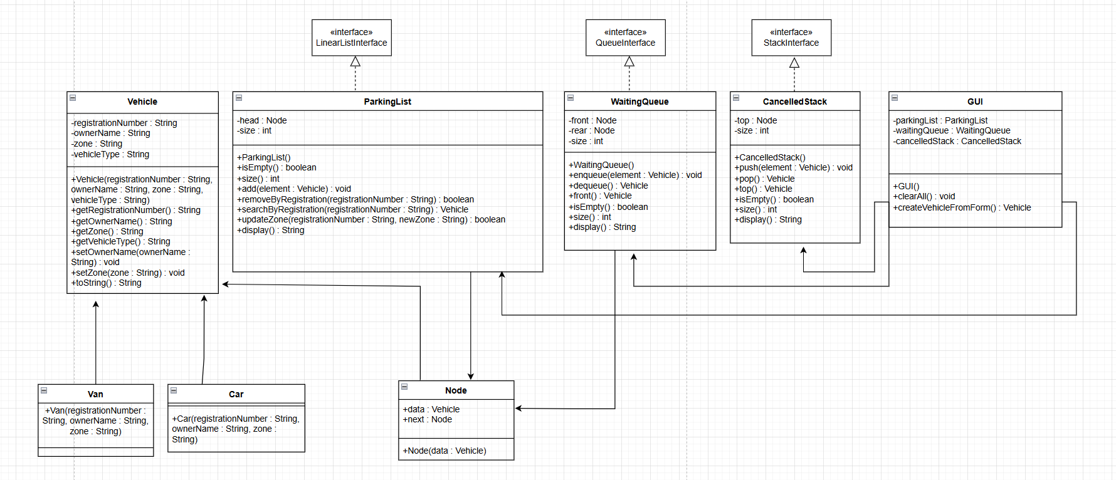
References:
Smart Docklands Call for Pilots 2025 (https://smartdocklands.ie/smart-docklands-call-for-pilots-2025-call-now-open/)
Oracle. Interfaces and inheritance (https://docs.oracle.com/javase/tutorial/java/IandI/index.html)

AI Use Declaration
I used AI as a support tool during planning, debugging and reviewing the structure of the project. It has been used to help explain Java concepts, suggest class and method organisation and support troubleshooting during development. All final code was reviewed, edited, tested and integrated by me in NetBeans, and I take responsibility for submitted work.

