Title Slide

"Enhancing Cybersecurity Through Analyst Expertise with Incribo's Synthetic Cyber Dataset"

---

Scenario

- **About the Company:**

Incribo offers cutting-edge synthetic data generation tailored for cybersecurity needs.

- **Problem Statement:**

Addressing the need for precise and actionable insights to enhance cybersecurity posture.

---

Proposed Solution

- **Strategy:**

Utilize the synthetic dataset to extract actionable insights and support strategic cybersecurity decisions.

- **Deliverables:**

1. **Business Task Statement:** Clearly define the cybersecurity objectives and tasks.

2. **Data Sources Description:** Outline the sources and relevance of data used.

3. **Data Cleaning Documentation:** Detail the cleaning processes to ensure data integrity.

4. **Analysis Summary:** Present the analysis methods and findings.

5. **Visualizations and Key Findings:** Highlight critical insights through visual data representation.

6. **Top Recommendations:** Provide prioritized recommendations based on the analysis.

---

- **Task:**

Explicitly state the importance of Incribo's synthetic cyber dataset in identifying and mitigating cybersecurity threats, demonstrating the analyst's expertise in data interpretation and strategy formulation.

---

Prepare

- **Data Sources:**

Data requires rigorous cleaning and adheres to ROCCC (Relevant, Original, Comprehensive, Consistent, and Correct) standards, ensuring high-quality input for analysis.

- **Data Cleaning:**

Utilized Python in Jupyter Notebook for efficient data cleaning and manipulation. Documented each step meticulously to ensure reproducibility and transparency, showcasing the analyst’s technical proficiency.

By refining the presentation to emphasize the value added by analysts, this document aims to reinforce their importance in the cybersecurity landscape.

1. Network Traffic Volume Over Time

   - Objective: Monitor fluctuations in network traffic to identify abnormal patterns that may indicate potential threats or breaches.

   - Value: Helps in proactive detection and response planning based on traffic volume trends.

   - Example: Line plot showcasing hourly or daily traffic volumes over a specified period.

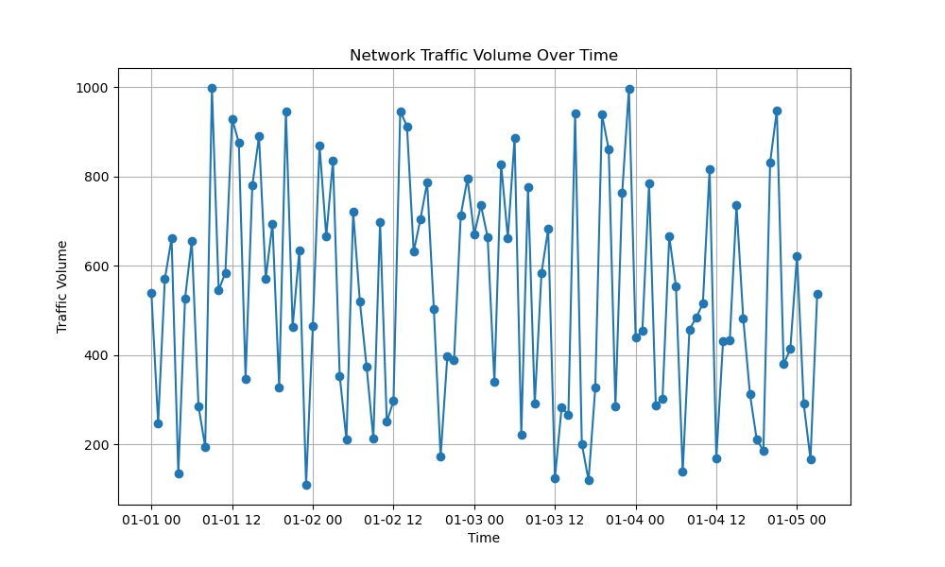

2. Top Sources of Malicious Traffic

   - Objective: Identify IP addresses responsible for the highest number of malicious requests.

   - Value: Pinpoints potential attackers and facilitates targeted mitigation strategies.

   - Example: Bar chart illustrating the number of malicious requests per IP address.

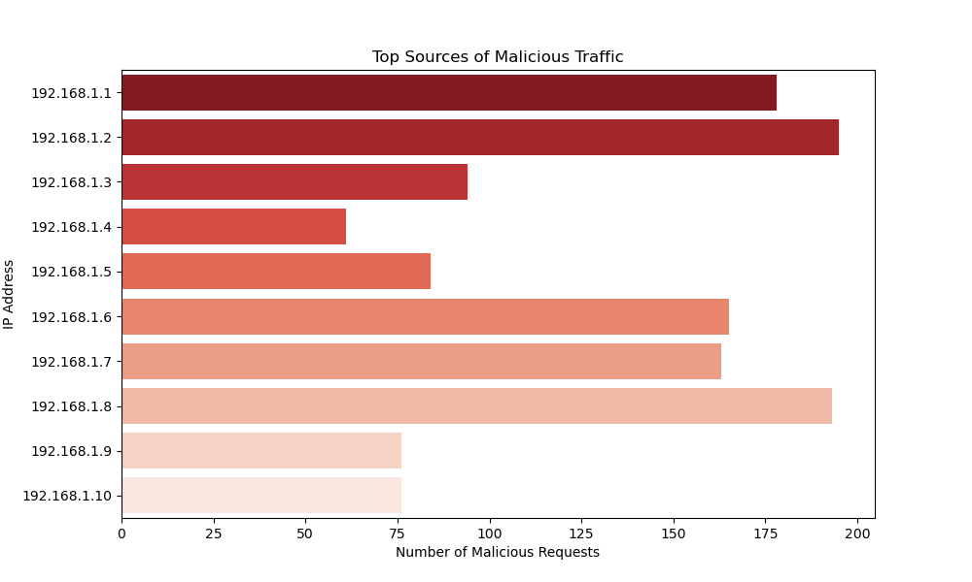

3. Types of Detected Threats

   - Objective: Understand the distribution of detected threats (e.g., malware, phishing, DoS) within the network.

   - Value: Prioritizes threat response efforts based on prevalence and severity.

   - Example: Pie chart displaying the percentage breakdown of different threat types.

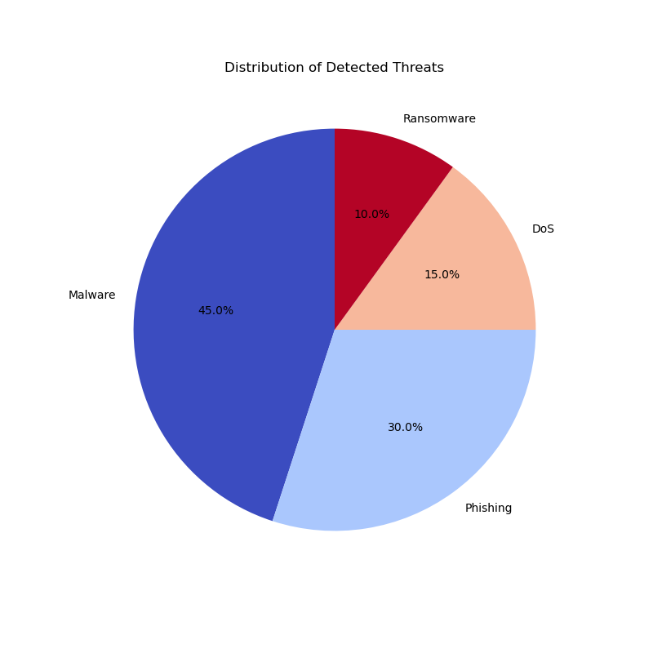

4. Incident Trends Over Time

   - Objective: Track the frequency and severity of security incidents over time.

   - Value: Enables trend analysis and prediction of potential escalation points.

   - Example: Line graph depicting the number of security incidents recorded daily or monthly.

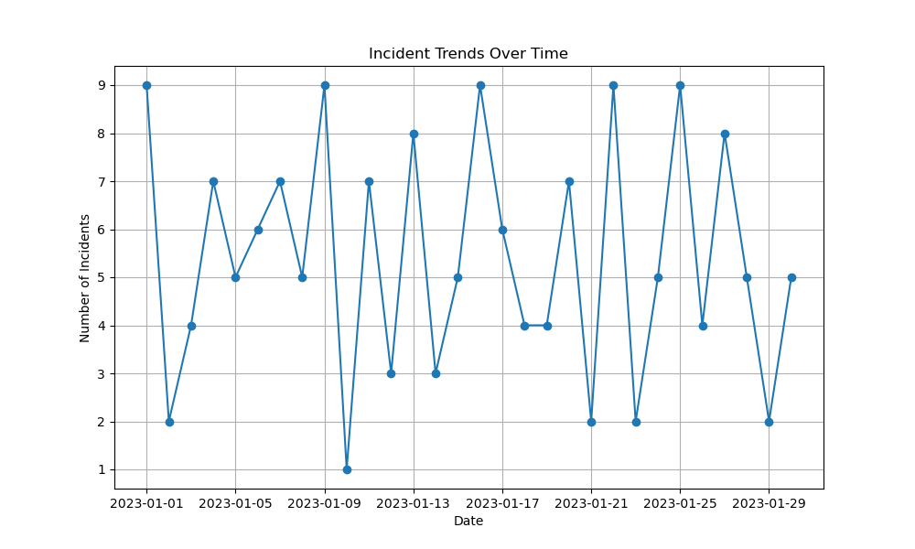

5. User Authentication Attempts

   - Objective: Analyze patterns in user authentication attempts across days and hours.

   - Value: Detects anomalous authentication patterns indicative of unauthorized access attempts.

   - Example: Heatmap illustrating authentication attempts by day of the week and hour of the day.

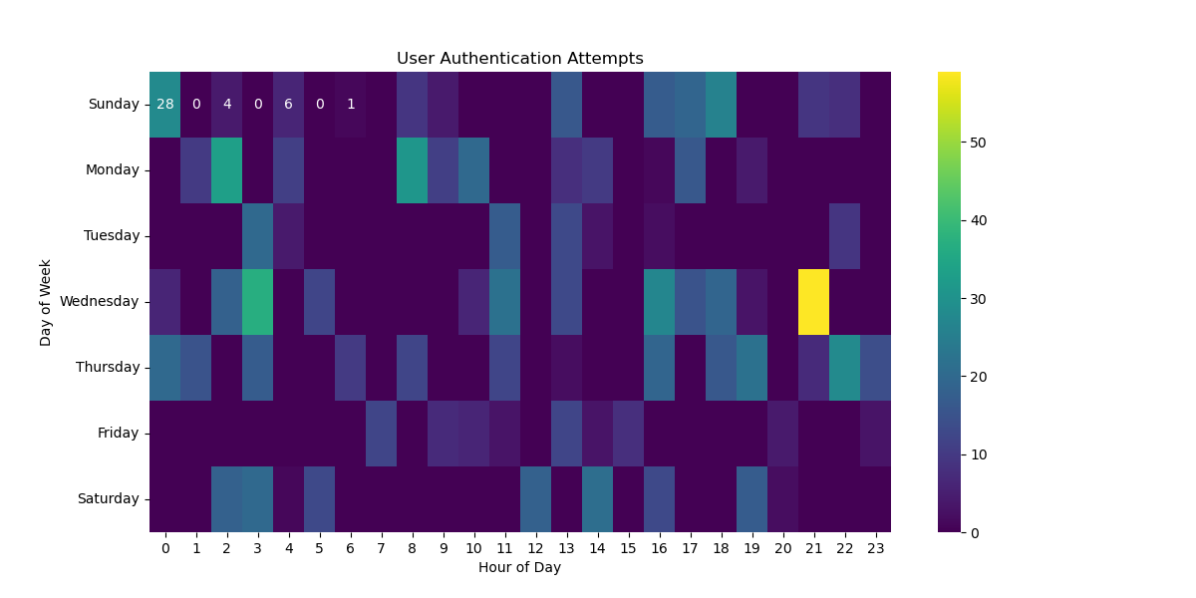

6. Vulnerability Status by System and Severity

   - Objective: Assess vulnerabilities across different systems categorized by severity levels (e.g., critical, high, medium, low).

   - Value: Guides prioritization of patching and mitigation efforts based on system criticality and vulnerability severity.

   - Example: Stacked bar chart showing the number of vulnerabilities per system by severity.

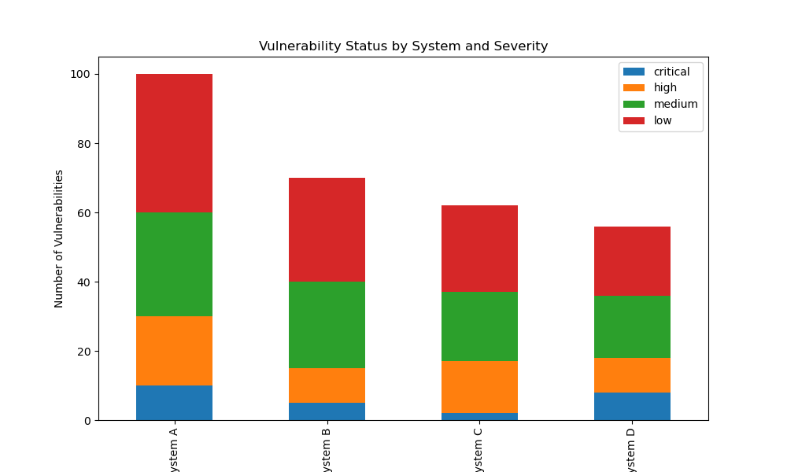

---

Process

- **Data Analysis:**

- **Detection and Response Planning:** Analyze traffic volume trends to identify potential threats.

- **Targeted Mitigation:** Focus on potential attackers and prioritize threat response efforts.

- **Trend Analysis:** Predict potential escalation points and anomalous authentication patterns to enhance patching and mitigation strategies.

- **Analyst’s Role:**

Highlight the analyst’s role in identifying critical patterns and providing actionable insights for proactive threat management.

---

Share

• **DDoS Attack Detection:**

* Recognize patterns of high traffic volume and specific packet characteristics indicative of DDoS attacks.
* Response: Activate DDoS mitigation tools, alert IT security teams.

• **Credential Stuffing:**

* Identify patterns of multiple login attempts from different IP addresses within short time frames.
* Response: Implement multi-factor authentication (MFA), lock accounts after several failed attempts.

• **Insider Threats:**

* Detect unusual access patterns to sensitive data by internal employees.
* Response: Conduct thorough investigations, enforce least privilege access controls.

---

Act

- **Recommendations:**

- **Regular Monitoring:** Continuous monitoring and updating of visualizations to adapt to changing network behaviors.

- **Collaborative Analysis:** Encourage teamwork between analysts and other stakeholders for comprehensive threat interpretation and response.

- **Adaptive Strategies:** Develop and implement adaptive strategies based on evolving threats and insights derived from visual data analysis.

---

Understanding Patterns

- **Pattern Recognition:**

- **Threat Detection:** Identifying patterns indicative of potential threats.

- **Targeted Strategies:** Develop targeted strategies for vulnerability management and incident response.

- **Outcome Improvement:**

Demonstrate how understanding these patterns enhances incident response and overall cybersecurity outcomes, reinforcing the value of the analyst’s expertise.

---

Recommendations

- Regular Monitoring: Continuously monitor and update visualizations to capture real-time changes in network behavior and threat landscape.

- Collaborative Analysis: Foster collaboration between analysts and stakeholders to interpret visual insights and implement effective security measures.

- Adaptive Strategies: Develop adaptive strategies based on evolving threat trends and insights derived from visualizations.