**POSTER**

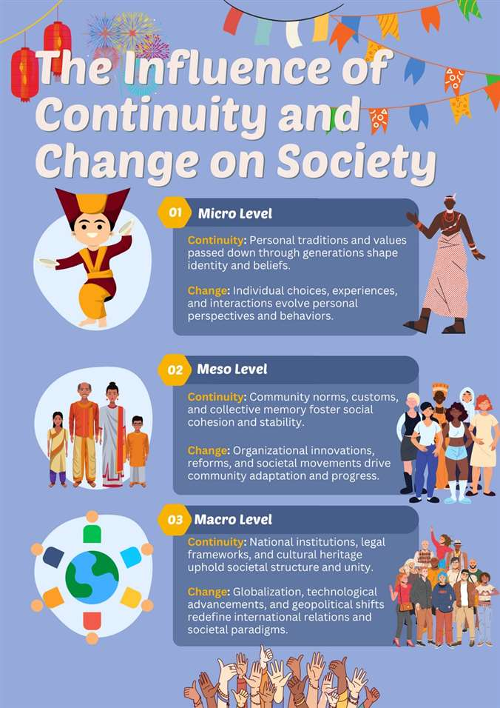

#### YASIRU PRABODHA CL/OTHMFL3/11/90



DYNAMICS

**OF MODERN SOCIETY**

Written By

**Yasiru Prabodha**

**ID : cl/othmfl3/11/90**

**ACKNOWLEDGEMENT**

I would like to express my sincere gratitude to Ms. Malithi for her invaluable guidance and support throughout the preparation of this analysis. Her insightful feedback and encouragement have been instrumental in shaping the direction of this work.

I would also like to acknowledge the contributions of J.K. Rowling, whose creation of the Harry Potter series has provided a rich subject for examining the impact of modernization on social and cultural change.

Lastly, I extend my thanks to all those who have supported me during this research, including my family and friends, whose encouragement has been a constant source of motivation.

Thankyou. Yasiru Prabodha

**INTRODUCTION**

The global phenomenon of Harry Potter, created by J.K. Rowling, serves as a remarkable case study to explore the intricate dynamics of social and cultural change in the modern era. Since its debut, the Harry Potter series has transcended the boundaries of traditional literature, profoundly influencing popular culture worldwide. This impact extends far beyond the realm of books, permeating various facets of media and entertainment, including television, merchandise, and even the naming of celestial bodies. The cultural significance of Harry Potter is a testament to the pervasive reach of modernization and the ways in which it fosters social and cultural transformations.

In this analysis, we will delve into the effects of modernization on social and cultural change, applying relevant theories to evaluate these shifts and their associated paradigms. Additionally, we will examine the nature of popular culture through the lens of Harry Potter, highlighting its distinguishing characteristics and the current trends it embodies. Finally, we will assess the probable future directions and the ongoing importance of popular culture, particularly the Harry Potter phenomenon, in shaping societal values and behaviors. Through this exploration, we aim to understand how a single literary work has managed to captivate and influence a global audience, becoming a cultural touchstone in the process.

**THEORIES OF SOCIAL CHANGE**

01

**TABLE OF CONTENTS**

01

**WHAT IS MODERNIZATION ?**

02

02

**INFLUENCE OF CONTINUITY AND CHANGE**

**ON SOCIETY**

05

03

07

**DISTINGUISHING CHARACTERISTICS AND NATURE**

04

09

**TRENDS AND PROBABLE FUTURE DIRECTIONS**

05

11

**IMPORTANCE FOR SOCIETY BOTH NOW AND IN THE FUTURE**

06

13

**REFERENCE**

07

15

02

# WHAT IS MODERNIZATION ?

Around the world, modernization—the process of social change brought about by the adoption of new concepts, tools, and lifestyles—has had a significant influence on changes in culture and society. One powerful example of how modernization has aided in the global dissemination and impact of cultural phenomena is the case of Harry Potter and author J.K. Rowling. Using Harry Potter as a focal point, we may explore here the different aspects of modernization and its consequences for social and cultural transformation.

#### TECHNOLOGICAL ADVANCEMENTS

The internet and the development of digital technologies have completely changed how people access and use information. The internet was taking off at the same time that Harry Potter became well-known, enabling fans all over the world to interact, share, and create communities. A worldwide Harry Potter community was formed as a result of the conversations, fan fiction, and theories that centered around websites, forums, and social media platforms. This unprecedented level of technical connectivity is an example of how modernization has dissolved geographical borders and fostered a common cultural experience. (Inglehart, 1997)

#### GLOBALIZATION

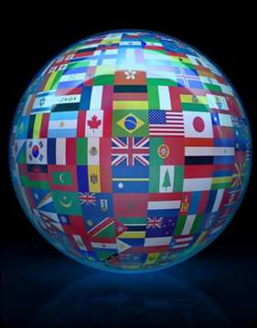Globalization, the movement of enterprises, ideas, and cultures around the world, is strongly related to modernization. With 64 translations, the Harry Potter series is a prime example of how a single cultural product can cross linguistic and cultural barriers to become an international sensation. Harry Potter is now accessible to a wide range of people and has been incorporated into numerous cultures because to globalization, which has made it possible for books, movies, and merchandise to be distributed globally. Local customs are enhanced by this cross-cultural interaction, which also unifies world culture.

03

#### ECONOMIC IMPACTS

The commercial success of Harry Potter demonstrates the economic aspects of modernization. The brand has brought in billions of revenue via theme parks, movies, books, and merchandise. This economic impact demonstrates how media and entertainment are essential to modern consumer culture. The widespread shift in consumption patterns brought about by modernization where cultural commodities are mass-marketed and consumed is reflected in the desire for Harry Potter-related products.



#### CULTURAL INTEGRATION AND HYBRIDIZATION

Cultural integration and hybridization, in which components from several cultures meld to create new cultural expressions, are frequently the results of modernization. The universal themes of friendship, bravery, and the conflict between good and evil are all present in Harry Potter, a book with roots in British folklore and literary traditions. These universal themes enable readers from a wide range of cultural backgrounds to relate to the characters and plots. Harry Potter's assimilation into many cultural contexts serves as an example of how modernization promotes the merging of local and global cultures.

#### INFLUENCE ON MEDIA AND ENTERTAINMENT

Harry Potter's impact can be seen in television, movies, and other media in addition to literature. With the release of the Harry Potter films, behind-the- scenes specials, and talk show appearances, media has become more widely available and influential due to modernization. This multi-media presence highlights how modernity has changed the entertainment sector by enabling a single cultural offering to rule several media platforms and shape public opinion. (Lee & Ma, 2012)

04

#### SOCIAL IMPACT

Significant societal effects have also been caused by the Harry Potter phenomenon. It has sparked a passion of narrative, promoted literacy, and inspired a generation of readers. The books tackle significant societal themes that strike a chord with readers and ignite conversations about social concerns, such racism, the worth of education, and the significance of choices. Modernization shapes attitudes and values by facilitating broad access to such influential literature, which in turn affects social transformation.

#### SPACE AND BEYOND

An asteroid named for J.K. Rowling serves as a metaphor for the profound effects of modernization on culture. It serves as an example of how cultural icons can become well-known everywhere, even outside of our planet. This heavenly recognition illustrates how much contemporary society affects all facets of existence, even science.



Modernization has significantly influenced social and cultural change, as illustrated by the global impact of the Harry Potter phenomenon. Through technological advancements, globalization, economic changes, cultural integration, media influence, and social impacts, modernization has enabled cultural products to transcend boundaries and shape global culture. The story of Harry Potter is a testament to the power of modernization in creating shared cultural experiences and driving social change on a worldwide scale. (Schmid & Klimmt, 2011)

## INFLUENCE OF CONTINUITY AND CHANGE ON SOCIETY

05

The influence of continuity and change on society can be analyzed through various dimensions, particularly how they manifest at the micro, meso, and macro levels.

**MICRO LEVEL**

##### CONTINUITY :

##### [ INDIVIDUAL AND PERSONAL CHANGES ]

**Reading Habits:** The Harry Potter series maintained and revived a culture of reading among children and adults, which is a continuity of traditional literary engagement.

**Moral Lessons:** The themes in Harry Potter, such as bravery, friendship, and the fight against evil, provided continuity in the transmission of moral values and life lessons through storytelling.

##### CHANGE:

 **Behavioral Shifts:** Many children and young adults shifted their leisure activities from video games and television to reading, which can improve cognitive skills and imagination.

 **Identity Formation:** Fans, often referred to as "Potterheads," identify strongly with the characters and values in the series, influencing their personal development and sense of self.



06

**MESO LEVEL [ COMMUNITY AND ORGANIZATIONAL CHANGES ]**

##### CONTINUITY :

 **Community Engagement:** Book clubs, fan groups, and online communities formed around the series, continuing the tradition of communal literary discussion and engagement.

 **Educational Integration:** Schools and educational institutions incorporated the books into their curricula, using them as tools for teaching literature, ethics, and critical thinking.

##### CHANGE:

 **Media and Entertainment Industries:** The success of Harry Potter led to significant changes in these industries, including the production of blockbuster movies, theme parks, and a wide range of merchandise.

 **Cultural Events:** Events such as book launches, movie premieres, and fan conventions became significant cultural phenomena, contributing to changes in how literary works are celebrated and marketed.

**MACRO LEVEL [ SOCIETAL AND GLOBAL CHANGES ]**

##### CONTINUITY :

 **Cultural Narratives:** The series draws on timeless themes and archetypes (the hero’s journey, the battle between good and evil) that have been central to human storytelling across cultures and eras.

 **Literary Traditions:** Harry Potter continues the tradition of fantasy literature, joining the ranks of works by authors like J.R.R. Tolkien and C.S. Lewis in influencing global culture.

##### CHANGE:

 **Globalization:** The translation of the books into 64 languages and their global popularity reflect and contribute to the process of cultural globalization, making Harry Potter a unifying cultural phenomenon across diverse societies.

 **Economic Impact:** The series' commercial success has had a substantial economic impact, influencing global markets through book sales, movies, merchandise, and related tourism (e.g., visits to filming locations and theme parks).

07

## THEORIES OF SOCIAL CHANGE

The phenomenon of Harry Potter and its impact on global culture can be analyzed through various theories of social change and associated paradigms. Here are a few perspectives to consider

#### CULTURAL HEGEMONY (ANTONIO GRAMSCI)

According to Antonio Gramsci's theory of cultural hegemony, cultural practices and institutions help dominant groups in society hold onto their positions of authority. There are various ways in which Harry Potter challenges established hegemonic cultural norms

L**iteracy and Reading Habits:** Harry Potter revitalized reading habits globally, particularly among young people who were increasingly engaged with digital media. It promoted literacy as a popular cultural activity.

**Cultural Universalism:** The translation of Harry Potter into 64 languages exemplifies cultural universalism, where a single cultural product becomes widely accepted and understood across diverse linguistic and cultural contexts. This challenges linguistic and cultural boundaries. (Eerkens, 2003)

#### CULTURAL DIFFUSION (EVERETT ROGERS)

Everett Rogers' theory of diffusion of innovations examines how new ideas or products spread through societies. Harry Potter demonstrates several aspects of successful diffusion

 **Global Reach:** The series rapidly spread across the globe, becoming a cultural phenomenon in diverse countries and regions.

 **Adoption and Imitation:** The popularity of Harry Potter spawned a wide range of adaptations, from films to merchandise, enriching the cultural landscape and reaching audiences beyond traditional literary circles.



08

#### GLOBALIZATION AND CULTURAL HOMOGENIZATION

Roland Robertson's theory focuses on globalization's role in creating a more interconnected world with shared cultural elements. Harry Potter exemplifies aspects of cultural homogenization (Wolosky, 2012)

 **Cultural Hybridity:** While rooted in British culture, Harry Potter incorporates diverse mythological elements and values that resonate globally, appealing to a wide audience.

 **Global Reception:** The series' translation into numerous languages and its adaptation into films and merchandise illustrate how global audiences adopt and reinterpret cultural products in their own contexts.

#### MEDIA AND CULTURAL INDUSTRIES (HERBERT SCHILLER)

Herbert Schiller's perspective emphasizes the role of media and cultural industries in shaping cultural norms and values. Harry Potter's impact can be viewed through

 **Media Convergence:** The series' adaptation into films and subsequent multimedia expansion (games, theme parks) demonstrates the convergence of media platforms to enhance cultural diffusion and engagement.

 **Cultural Commodification:** The extensive merchandise associated with Harry Potter illustrates how cultural products are commodified and marketed globally, contributing to its sustained popularity and economic impact.

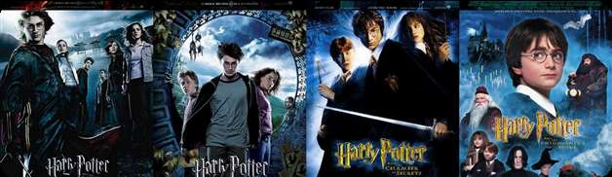

In conclusion, Harry Potter represents a significant case study in how a cultural phenomenon can transcend national boundaries, influence reading habits, challenge traditional cultural norms, and contribute to global cultural homogenization through its widespread adoption and adaptation. It exemplifies the complex interplay between media, globalization, and cultural change in contemporary society.

09

## DISTINGUISHING CHARACTERISTICS AND NATURE

Popular culture is characterized by its widespread impact on societies, influencing attitudes, actions, and preferences worldwide. The Harry Potter craze is an excellent example of a number of distinctive elements of popular culture.

#### GLOBAL REACH

Popular culture transcends geographical boundaries, appealing to diverse audiences worldwide. The translation of Harry Potter into 64 languages underscores its universal appeal, making it accessible and understandable across cultures. This global accessibility contributed to its widespread adoption and influence.

#### MULTIMEDIA INTEGRATION

Popular culture frequently incorporates elements of other media, such as books, movies, television, and products. Beyond the books, Harry Potter's popularity spread to big-budget movies, TV shows, souvenirs, and appearances by the author and actors on talk shows. The franchise's cultural influence was strengthened by this multiplatform strategy, which made sure it was widely represented in popular media.

#### CULTURAL ICONS AND SYMBOLS

Long-lasting icons and symbols that audiences can relate to are produced by popular culture. Characters that were immediately recognizable and frequently mentioned in popular culture, such as Harry Potter, Hermione Granger, and Severus Snape, evolved into cultural icons. Popular narratives and the public imagination were enhanced by the inclusion of these individuals and their stories in a wider cultural discourse. (Karjala, 2006)

**10**

#### CULTURAL INFLUENCE AND ADAPTATION

The norms, practices, and tendencies of society are influenced by popular culture. In addition to sparking a resurgence of interest in fantasy literature and storytelling, the Harry Potter series brought back reading interest in both adults and children. Inspiring fan networks, fan writing, fan art, and fan conferences, it promoted a culture of participation that actively interacts with and adds to the storyworld.

#### COMMERCIALIZATION AND MERCHANDISING

Opportunities for merchandising and commercialization are vital to popular culture. The wide variety of Harry Potter memorabilia, which included anything from toys and apparel to theme park attractions, took advantage of the fervor and continued interest among fans in between the book and movie releases. In addition to bringing in money, merchandise kept fans interested and excited about new releases.

#### ADAPTABILITY AND RESILIENCE

Popular culture exhibits persistence and flexibility in the face of shifting societal norms and technical breakthroughs. Decades after its debut, Harry Potter's lasting appeal is a testament to its capacity to change and stay current through digital platforms, reprints, and adaptations that draw in new audiences. (Walker, et al., 2004)

In summary, popular culture serves as a dynamic force that shapes and reflects society values, entertainment tastes, and worldwide interconnection. The Harry Potter phenomenon serves as an example of this. Its lasting influence highlights the significant influence that pop culture phenomena can have on forming global collective identities and modern narratives.

**11**

## TRENDS AND PROBABLE FUTURE DIRECTIONS

We can deduce various present trends and future directions for popular culture based on Harry Potter's broad influence on popular culture.



#### GLOBAL CULTURAL PHENOMENA

Harry Potter is a perfect example of how a tale may cross national and cultural boundaries to become an international sensation. Today, series like Game of Thrones and the Marvel Cinematic Universe (MCU) are carrying on this trend, drawing in viewers from a wide range of groups. (Gui-Hu, 2008)

#### CONVERGENCE OF MEDIA

Harry Potter's popularity spread to movies, merchandising, and digital media in addition to novels. This multifaceted strategy produced rich fan experiences in addition to optimizing audience reach. Present trends indicate a similar convergence of storytelling across movies, TV series, games, and novels in franchises such as Star Wars.

#### FAN ENGAGEMENT AND PARTICIPATION

Pottermania showcased the power of fan communities in shaping popular culture. From fan fiction to cosplay and fan conventions, audiences actively contribute to and shape the narrative universe. Social media platforms amplify fan engagement, allowing for real-time interaction and fan-driven content creation.

12

#### DIVERSITY AND REPRESENTATION

The Harry Potter series, despite criticism over diversity, spurred discussions on representation in literature and media. Current trends emphasize inclusivity and representation, with movements pushing for more diverse characters and stories that reflect a broader range of experiences and identities. (Nijman & Nekaris, 2017)

#### ADAPTATION AND EXPANSION

The trend of adapting successful literary works into various formats continues with streaming platforms like Netflix and Amazon Prime investing heavily in book adaptations. This allows for deeper exploration of characters and plotlines beyond the constraints of traditional media.

#### VIRTUAL AND AUGMENTED REALITY

As technology advances, immersive experiences such as virtual reality (VR) and augmented reality (AR) are increasingly used to extend fictional worlds. This trend promises to further blur the lines between storytelling and audience participation, offering new ways to engage with popular culture.

#### SUSTAINABILITY AND ETHICS

With increasing societal awareness of environmental issues and ethical considerations, popular culture is evolving to reflect these concerns. This includes sustainable merchandising practices, ethical storytelling, and narratives that explore pressing global issues.

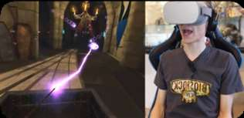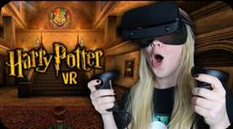

Looking ahead, the future of popular culture will likely continue to evolve in response to technological advancements, changing societal values, and the demand for inclusive and engaging narratives. The success of franchises like Harry Potter provides a blueprint for how stories can resonate globally while fostering deep connections with audiences across multiple platforms.

**13**

## IMPORTANCE FOR SOCIETY BOTH NOW AND IN THE FUTURE

Popular culture, as exemplified by the Harry Potter phenomenon, continues to hold significant importance for society both now and in the future. Here are several reasons why

#### CULTURAL INFLUENCE AND IDENTITY

Popular culture shapes collective identity and provides shared experiences that transcend geographical and cultural boundaries. The global impact of Harry Potter illustrates how a single narrative can resonate deeply across diverse societies, fostering a sense of unity and understanding.

#### EDUCATIONAL AND INSPIRATIONAL VALUE

Works like Harry Potter encourage literacy and critical thinking, particularly among younger audiences. They demonstrate the power of storytelling to ignite imagination, empathy, and a love for reading, which are crucial skills for personal development and societal progress.

#### ECONOMIC AND INDUSTRY IMPACT

The success of franchises like Harry Potter stimulates various industries, including publishing, film, merchandise, and tourism. This economic impact creates jobs, spurs innovation, and contributes to local and global economies. (Wallis, 2007)

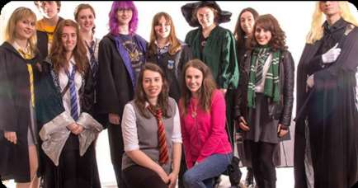

14

#### TECHNOLOGICAL INTEGRATION

Popular culture often drives technological advancements and innovations. For instance, the Harry Potter franchise has spurred developments in visual effects, digital media, and immersive entertainment experiences.

#### SOCIAL COMMENTARY AND REFLECTION

Popular culture serves as a mirror to societal issues and values, offering commentary on politics, ethics, and social norms. The themes explored in Harry Potter, such as prejudice, friendship, and the power of choice, resonate with real-world challenges and encourage critical reflection.

#### GENERATIONAL INFLUENCE

As today’s popular culture becomes tomorrow’s history, it shapes generational perspectives and memories. The enduring popularity of Harry Potter suggests that its impact will continue to be felt as new generations discover and reinterpret its themes.

In summary, popular culture will continue to be significant because of its capacity to foster human connections, stimulate originality and creativity, provide amusement and education, and represent society ideals. With its widespread appeal and ongoing success, the Harry Potter series is a prime example of how popular culture can go beyond its original medium and establish itself as a timeless cultural icon. The ways in which popular culture impacts and molds our shared experience will change along with society. (Highfield, 2002)

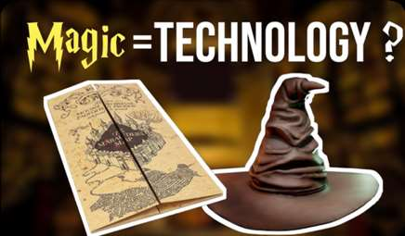

**15**

# REFERENCE

Eerkens, J. W., 2003. Residential Mobility and Pottery Use in the Western Great Basin. *Current anthropology,* 44(5), p. 724.

Gui-Hu, L., 2008. The Dialysis of "Harry Potter" Cultural Phenomena. *Journal of Hubei Radio & Television University,* 11(2), p. 43.

Highfield, R., 2002. *The Science of Harry Potter.* s.l.:Viking Adult.

Inglehart, R. R., 1997. *Modernization and Postmodernization.* s.l.:s.n.

Karjala, D., 2006. Harry Potter, Tanya Grotter, and the Copyright Derivative Work. *Social Science Research Network.*

Lee, C. S. & Ma, L., 2012. News sharing in social media: The effect of gratifications and prior experience. *Computers in human behavior,* 28(2), pp. 331 - 350.

Nijman, V. & Nekaris, K. A.-I., 2017. The Harry Potter effect: The rise in trade of owls as pets in Java and Bali, Indonesia. *Global ecology and conservation,* Volume 11, pp. 84-94.

Schmid, H. H. & Klimmt, C. C., 2011. A magically nice guy: Parasocial relationships with Harry Potter across different cultures. *The international communication gazette,* 73(3).

Walker, B., Holling, C. S., Carpenter, S. R. & Kinzig, A. P., 2004. Resilience, Adaptability and Transformability in Social-ecological Systems. *Ecology and society,* 9(2), pp. 20-64.

Wallis, J. D., 2007. Orbitofrontal Cortex and Its Contribution to Decision-Making. *Annual review of neuroscience,* 30(1), pp. 31-56.

Wolosky, S. S., 2012. &lt;i&gt;Harry Potter&lt;/i&gt;’s Ethical Paradigms: Augustine, Kant, and Feminist Moral Theory. *Children's literature,* 40(1).

**THANK YOU !**



By Yasiru Prabodha

### cl/othmfl3/11/90