The factors affecting when using social media on student’s life
Module: Academic English and Study skills (OTHM)

Student Name: L.H.G. Yasiru Prabodha
Student Number: CL/OTWMFL3/11/90

Acknowledgment
Above all, I want to extend my sincere gratitude to Mrs. Chameera Wijayathunga, our lecturer, for generously imparting her knowledge to me during our lessons in the lecture room. I am deeply appreciative of my parents for their unwavering encouragement and financial support. A heartfelt thank you goes out to my best friends, whose assistance was invaluable during the creation of this proposal.

Abstract
The following research reports manifest the factors effecting when social media on students' life. With the advancement of the Internet and telecommunication technologies, social media has become an integral part of our day to day lives. The use of social media has gradually changed and impacted on every aspect of the society, especially the higher education context. Social media in higher education has been researched by many, the impact of social media on students' academic performance has not been addressed sufficiently, particularly in the Sri Lanka context. In today's world where the Internet has experienced tremendous growth, social networking sites have become highly significant in students' lives. Social media are web-based communication tools that enable people to interact with each other by both sharing and consuming information.

Table of contents

Acknowledgment 2
Abstract 2
Introduction 5
Research Questions 6
Research Objectives 6
Literature Review 7
Conceptual Framework 7
Cyber Bullying 8
Mental Health 10
Education 14
Data Analysis 17
Gender 17
Age 19
Qualification 21
Mental Health 23
Cyber Bullying 25
Education 27
Conclusion 29
Recommendation 30
References 31
Appendix 33

Table of figures
Figure 1 Gender 17
Figure 2 Age 19
Figure 3 Qualification 21
Figure 4 School Belonging impacts Well Being 23
Figure 5 A talk helps mental health 23
Figure 6 Open talk side mental health 24
Figure 7 Interaction boost mental health 24
Figure 8 Social communication boost mental health 24
Figure 9 Cyber bulling can cause serious emotional distress 25
Figure 10 Cyberbully impact on focus 25
Figure 11 cyber bullying impact on attendance 26
Figure 12 cyber bulling harms students’ confidence 26
Figure 13 Education and awareness programs reduce cyber bulling 26
Figure 14 Technology boost class quality 27
Figure 15 Testing harms creativity and critical thinking skills 27
Figure 16 online learning has positive and negative effects 28
Figure 17 Smaller classes gives better learning 28
Figure 18 Social economic status effect educational resources 28

Introduction

Since beginning of human history peoples have been exchanging wide an array of information, ideas and attitudes through the interchange sings and symbols. As primitive cultures evolved into more complex civilizations, their communication systems grew significantly, resulting in more regular information exchanges. (Wickramasurendra, et al., 2021)
Social media is a variety of technologies that facilitate the exchange of ideas and information among their users. The first social media platform was Sixdegrees, which was launched in 1997 and closed in 2001. Social media platforms such as Facebook, YouTube, Twitter, Instagram, TikTok and LinkedIn have come to popularity as the world's major social media networks. By early 2023, more than 4.7 billion individuals worldwide will be accessing social media, accounting for nearly 60% of the global population. (Dollarhide, 2023)
Cyberbullying is a pervasive and damaging problem in social media. This type of harassment, which is generally carried out online or through digital communication platforms, includes verbal, emotional, or even threatening abuse. The Internet's anonymity and accessibility have increased the frequency of cyberbullying, which affects individuals of all ages. Some cyberbullying crosses the line into unlawful or criminal behavior. (Assistant Secretary for Public Affairs (ASPA), 2023)
Social media has a significant impact on student mental health. Continuous exposure to well-crafted online identities, the frequency of cyberbullying, and the constant need to maintain a perfect digital image can all lead to increased stress and anxiety. Addiction to social media can alter sleep habits, harm academic performance, and aggravate mental health issues. Continuous scrolling and comparing with others can lead to feelings of inadequacy and sadness. Furthermore, fear of missing out (FOMO) can magnify feelings of isolation and loneliness. It is vital for students to strike a good balance in their online presence and prioritise their mental health. (Nazari, et al., 2023)
Social media has had a significant impact on student education, showing itself in a variety of ways. It provides students with access to a large array of information and instructional tools, enhancing their learning experiences. It does, however, provide considerable distractions. The temptation of notifications and real-time updates might reduce students' capacity to focus throughout their study. Furthermore, social media typically contributes to academic procrastination, jeopardising time management and overall roductivity. On the plus side, social media may be used for collaborative learning and communication with peers and instructors. Its ability to stimulate educational discourse and facilitate group projects can improve the educational experience. Nonetheless, the overall influence of social media on student education is primarily determined by how well it is handled and integrated into students' learning routines. (Chen & Xiao, 2022)

Research Questions
What are the factors affecting when using social media on students’ life?

Research Objectives
To find out the factors affecting when using social media on students’ life.

Literature Review

Conceptual Framework
Independent Variables Independent Variables

CYBER BULLING

USE OF SOCIAL MEDIA
MENTAL HEALTH

EDUCATION

Cyber Bullying
In the digital age, the pervasive use of social media has undeniably transformed the landscape of communication and social interaction, particularly among students. The allure of virtual platforms lies in their ability to connect individuals, foster relationships, and provide a space for self-expression. However, this digital realm is not immune to the darker side of human behavior, and one concerning phenomenon that has emerged is cyberbullying. Defined as the use of electronic means to intimidate, harass, or threaten others, cyberbullying poses a significant threat to the well-being of students navigating the intricate web of online relationships.
As students increasingly integrate social media into their daily lives, the factors influencing the occurrence and impact of cyberbullying demand meticulous examination. This literature review delves into the multifaceted dimensions surrounding cyberbullying on social media platforms, shedding light on the nuances that define its prevalence and implications for students. By scrutinizing the intricate interplay of social, individual, and contextual factors, this review seeks to offer a comprehensive understanding of the challenges posed by cyberbullying in the realm of students' lives.
1. Definition and Forms of Cyberbullying
To set the foundation, it is crucial to understand the definition and forms of cyberbullying. Cyberbullying refers to the use of electronic communication to intimidate, harass, or threaten an individual. This can take various forms, including online harassment, spreading rumors, exclusion, and impersonation. Understanding the different manifestations of cyberbullying is essential for identifying its prevalence and impact on students.
2. Social Media Platforms and Cyberbullying
One significant factor influencing cyberbullying is the social media platforms themselves. Different platforms have distinct features and norms that may facilitate or mitigate cyberbullying. The anonymity provided by some platforms can exacerbate negative behaviors, while reporting and moderation features on others may act as deterrents. Examining the role of specific social media platforms in cyberbullying incidents can provide valuable insights.

3. Individual Factors
Students' individual characteristics and behaviors play a vital role in their susceptibility to cyberbullying. Factors such as self-esteem, emotional resilience, and online behavior contribute to the likelihood of being targeted or engaging in cyberbullying activities. Understanding how individual differences interact with social media use is crucial for developing targeted interventions.
4. Peer Influence and Social Dynamics
The social nature of cyberbullying implicates the influence of peers and social dynamics. Peer relationships, group dynamics, and social hierarchies within online communities contribute to the prevalence and perpetuation of cyberbullying. Exploring the influence of peer interactions on social media platforms can shed light on the mechanisms behind cyberbullying incidents.
5. Parental Involvement and Supervision
The role of parents in mitigating cyberbullying is significant. Parental involvement, communication, and supervision of online activities can serve as protective factors against cyberbullying. Investigating the impact of parental guidance on students' social media use and their experiences with cyberbullying can provide insights into effective preventive measures.
6. School and Educational Interventions
Schools play a crucial role in addressing cyberbullying by implementing educational programs, policies, and interventions. Examining the effectiveness of school-based initiatives in creating awareness, fostering a positive online culture, and providing support for victims can contribute to the development of comprehensive strategies.

In navigating the complex terrain of social media, where the boundaries between the physical and digital worlds blur, the issue of cyberbullying emerges as a formidable challenge for students, educators, parents, and policymakers alike. This literature review has sought to unravel the intricate web of factors influencing cyberbullying, emphasizing the need for a holistic approach to address this pervasive issue. (Margolis & Amanbekova, 1970)
The examination of social media platforms and their unique features, coupled with an exploration of individual factors, has illuminated the nuanced nature of cyberbullying incidents. Peer dynamics and social influences, both online and offline, have been identified as critical contributors to the prevalence and perpetuation of cyberbullying, underscoring the importance of considering the broader social context.
Parental involvement and supervision emerge as potential protective factors, offering a foundation for intervention strategies. Moreover, the role of schools in creating a safe online environment through educational programs and policies is pivotal. As this review concludes, it advocates for collaborative efforts among educators, parents, and policymakers to develop targeted interventions that not only curb the immediate effects of cyberbullying but also foster a digital culture rooted in empathy, understanding, and support for students navigating the intricate landscape of social media. Only through such comprehensive measures can we hope to mitigate the adverse impact of cyberbullying on students' lives and cultivate a positive online experience for the generations to come. (Anderson, 2023)

Mental Health
The pervasive integration of social media into the daily lives of students has brought forth a myriad of opportunities and challenges, particularly in relation to mental health. This literature review delves into the intricate web of factors that impact the mental well-being of students as they navigate the complex landscape of social media platforms. As these platforms become central to communication, self-expression, and social connection, it becomes imperative to critically examine the various dimensions that contribute to the intricate relationship between social media use and mental health, with a specific focus on the profound impact on students. The exploration of these factors is essential for educators, parents, policymakers, and mental health professionals alike to develop a nuanced understanding and implement strategies that foster a healthier digital environment for students. (Zsila & Reyes, 2023)

1. Social Comparison Theory
- Positive Side
Social media allows students to connect with peers, fostering a sense of camaraderie and shared experiences. It can positively influence self-perception through exposure to diverse perspectives.
- Negative Side
Excessive exposure to curated content may lead to unrealistic comparisons, causing feelings of inadequacy and low self-esteem among students. Constant social comparison can contribute to heightened stress levels and mental health challenges.

2. Fear of Missing Out (FOMO)
- Positive Side
Social media helps students stay informed about social events, academic opportunities, and community activities, reducing the likelihood of missing out on valuable experiences.
- Negative Side
Uncontrolled FOMO, fueled by social media, can lead to anxiety, depression, and a constant need to participate in every online trend. It may create a constant sense of urgency and dissatisfaction with one's life.

3. Cyberbullying and Online Harassment:
- Positive Side
Social media platforms can serve as platforms for positive communication and support. Anti-bullying campaigns and interventions on these platforms can help create a safer online environment.
- Negative Side
The anonymity provided by social media can contribute to cyberbullying, leading to severe mental health consequences for victims. Online harassment may exacerbate anxiety, depression, and feelings of isolation among students.

4. Sleep Disruption:
- Positive Side
Social media can provide educational resources and support networks, enhancing students' academic experience and contributing to a positive online community.
- Negative Side
Late-night social media use, particularly before bedtime, can disrupt sleep patterns, leading to fatigue, decreased cognitive function, and a higher risk of mental health issues such as depression and anxiety.

5. Social Support and Connection:
- Positive Side
Social media facilitates connections, allowing students to maintain relationships, seek emotional support, and build a sense of community, which can positively impact mental well-being.
- Negative Side
Overreliance on social media for support may lead to superficial connections, and negative interactions online can contribute to feelings of loneliness and isolation, negatively affecting mental health.

6. Academic and Career Opportunities:
- Positive Side
Social media can be a valuable tool for students to explore academic and career opportunities, connect with professionals, and access resources that contribute positively to their personal development.
- Negative Side
Excessive time spent on social media, especially without clear goals, can lead to academic neglect and hinder career development, causing stress and negatively impacting mental health.
The intertwining of social media and students' mental health is a multifaceted phenomenon influenced by a range of factors. The literature reviewed highlights the intricate dance between social comparison, the fear of missing out, cyberbullying, sleep disruption, and the potential for social support. While the negative consequences of excessive social media use are evident, it is crucial to recognize the potential positive aspects, such as the facilitation of social support and connection.
Addressing the challenges posed by social media requires a holistic approach, involving not only individual resilience but also concerted efforts from educational institutions, families, and social media platforms. Educators can play a pivotal role in promoting digital literacy and teaching students how to navigate social media in a healthy manner. Parents can engage in open communication with their children, fostering awareness and resilience to the negative aspects of social media. Policymakers need to explore regulatory frameworks that ensure the responsible use of these platforms and protect users from online harms. (Murtaza, 2023)
In essence, this literature review emphasizes the importance of understanding the dynamic interplay between social media and mental health among students. By acknowledging the complexities of this relationship, stakeholders can work collaboratively to mitigate the adverse effects, harness the positive potentials, and foster a digital landscape that nurtures the mental well-being of the upcoming generation.

Education
In the contemporary educational landscape, the pervasive influence of social media on students cannot be overstated. The ubiquity of platforms such as Facebook, Instagram, Twitter, and others has transformed the way students engage with information, peers, and the educational process. As this digital revolution unfolds, it becomes imperative to comprehensively examine the factors that mold the impact of social media on students' lives, particularly within the educational realm. This literature review delves into the intricate interplay of elements that shape students' experiences, encompassing academic performance, online collaboration, psychological well-being, digital literacy, and the profound influence of cultural and societal factors. (Everson, et al., 2015)
Understanding the multifaceted nature of these influences is essential for educators, policymakers, and researchers seeking to navigate the delicate balance between leveraging the positive aspects of social media and mitigating its potential drawbacks. By scrutinizing the existing literature, we aim to shed light on the nuanced dynamics that characterize the intersection of social media and education, providing insights that can inform strategies to foster a healthy and productive digital environment for students.
1. Academic Performance
Numerous studies have investigated the relationship between social media use and academic performance. While some research suggests a negative correlation, indicating that excessive use of social media may lead to decreased academic achievement, other studies argue that the impact is nuanced and depends on the nature and purpose of social media engagement. Factors such as multitasking, time management, and the type of content consumed on social media platforms play crucial roles in determining the impact on academic outcomes.
2. Online Learning and Collaboration
The advent of online education and collaborative platforms has transformed the traditional learning landscape. Social media serves as a medium for students to connect, collaborate, and share resources. Research indicates that well-managed online communities and collaborative learning environments on social media positively contribute to educational experiences. However, challenges such as distraction, information overload, and cyberbullying can also emerge, influencing the overall educational impact.
3. Social Comparison and Psychological Well-being
Social media platforms often encourage social comparison, which can impact students' psychological well-being. Studies suggest that exposure to idealized representations of peers' lives on social media may lead to feelings of inadequacy and stress. This psychological impact can affect students' self-esteem, motivation, and overall mental health, consequently influencing their engagement with education.
4. Digital Literacy and Critical Thinking
The ability to critically evaluate information and navigate the digital landscape is increasingly vital for students. Social media platforms are rich sources of information, yet they also pose risks such as misinformation and digital manipulation. Research emphasizes the importance of promoting digital literacy skills among students to empower them to navigate social media responsibly. Educational institutions play a crucial role in integrating digital literacy into curricula to prepare students for the challenges of the digital age.
5. Cultural and Societal Influences
The impact of social media on students is not uniform across different cultural and societal contexts. Cultural norms, societal expectations, and access to technology can vary significantly, influencing the ways in which students engage with social media in an educational context. Understanding these contextual factors is essential for developing targeted interventions and educational strategies.

The complex relationship between social media and students' lives in the educational context requires a nuanced and multifaceted approach. The factors influencing this dynamic interaction are diverse, ranging from the impact on academic performance to the intricate web of social comparison, psychological well-being, and digital literacy. As educational institutions grapple with the evolving landscape, it is clear that a one-size-fits-all approach is insufficient.
To harness the benefits of social media and mitigate potential pitfalls, educators and policymakers must consider the unique contextual factors at play. The promotion of digital literacy, fostering positive online collaboration, and addressing the psychological ramifications of social media use are paramount. Furthermore, recognizing the cultural and societal nuances that shape students' digital experiences is vital for tailoring interventions that resonate with diverse student populations.
As the digital era continues to unfold, further research is warranted to stay abreast of evolving social media trends and their implications for education. The synthesis of knowledge presented in this literature review serves as a foundation for future endeavors, urging stakeholders to proactively shape educational environments that empower students to navigate the digital landscape with resilience, critical thinking, and a holistic understanding of the factors at play (Amoo, 2022)

Data Analysis
The questionnaire was distributed using google forms and 50 responses have been collected. The responses are analyzed in this chapter based on the questions asked and the responses arrived

Gender
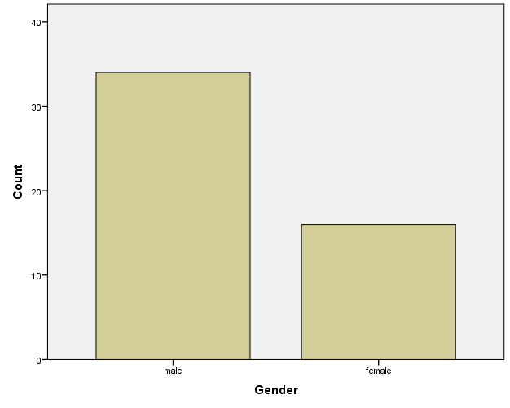
Figure 1 Gender

There were 50 respondents who had answered the questionnaire out of which 27 people were male and 23 were female. It could be seen that more male people have filled the questionnaire. The gender distribution of survey respondents is depicted in the graph as it relates to the factors that affect students' use of social media. Of the individuals involved, 16% identified as female and 34% as male.
The data indicates that there was a clear gender gap in the survey sample, with more men than women represented. The survey's overall findings and conclusions may be impacted by this gender distribution because the experiences and viewpoints of men may predominate. When examining the survey's main focus—the variables influencing students' lives when they use social media—it becomes imperative to take into account any potential gender-specific differences in the responses. Men and women may use social media in different ways and have different tastes when it comes to how it affects their daily lives. Therefore, a more thorough knowledge of these characteristics would be provided by a more balanced gender representation in the poll.

It is crucial to evaluate the poll results cautiously and acknowledge that they can be biased toward the male perspective given the male-majority setting. Future studies might strive for a more equal gender distribution to reduce this bias and provide a more comprehensive and representative examination of the variables impacting students' life when it comes to social media use.

Age
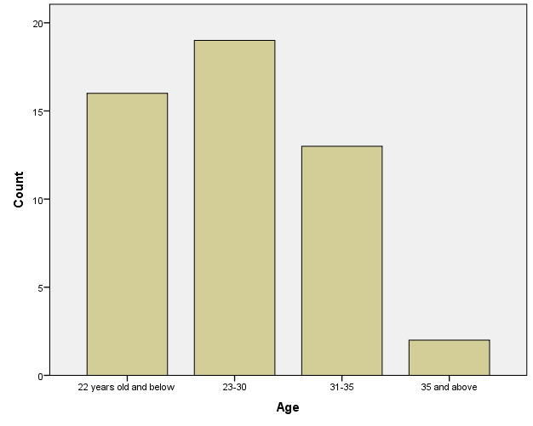
Figure 2 Age
The age of social media users significantly influences how these platforms affect students' lives. We asked a wide range of pupils to participate in our survey, and the results showed clear trends in the responses according to age groupings. Interestingly, 19 out of the respondents are in the 23–30 age group, which is the largest cohort. This demographic most likely consists of young individuals who are enrolled in college or are just starting their professions. Their increased presence implies a heavy dependence on social media for networking, communication, and information exchange.

Remarkably, the age range of 22 and under is the second-largest group, with 16 respondents. This research highlights the widespread impact of social media on even younger pupils, possibly signifying the early incorporation of these platforms into their social and academic lives.
As we get older, the number of responses drops. The 31-35 age bracket had 13 respondents, indicating that people's reliance on social media is decreasing as they get older. Notably, the 35 and above category has the fewest respondents, with only two people. This could signal a decrease in social media activity as people move into more established stages of their lives, where priority may shift to family, job, and other offline activities.
To summarize, the age of social media users has a considerable impact on the function and impact of these platforms in students' life. Younger people, particularly those aged 22 and under, rely heavily on social media, but older age groups show a progressive drop in involvement, possibly due to shifting priorities and responsibilities. Understanding age-related phenomena is critical for creating tailored interventions and encouraging pupils to use social media responsibly.

Qualification

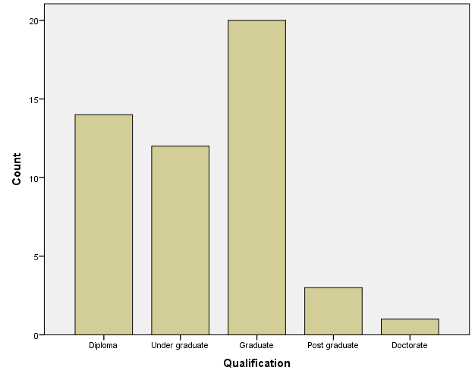
Figure 3 Qualification
Individuals' credentials have a crucial role in the impact of social media platforms on students' life. In a poll of 50 respondents, it was discovered that the distribution of credentials among participants had a significant impact on their social media usage patterns. Twenty of the respondents were graduates, 14 held diplomas, 12 were undergraduates, three had postgraduate certificates, and one earned a PhD.
Graduate students, the largest category, frequently take a more balanced and knowledgeable approach to social media. Their academic experience provides them with critical thinking abilities, allowing them to distinguish genuine information from the large pool available online. Diploma holders, on the other hand, may rely more on social media for knowledge due to gaps in their official education, albeit being a smaller group. Undergraduates, who make up a sizable proportion, are more likely to be impacted by peer interactions and trends on social media, which affect their behavior and decision-making.
Although there are fewer postgraduate and doctorate responders, they demonstrate a trend of lower social media activity. This might be due to their focused academic endeavors, which result in a more disciplined and purposeful usage of social media sites. According to the statistics, students' educational level has a substantial influence on how they browse and use social media, influencing their information intake, critical thinking, and overall online activity. Understanding these interactions is critical for educators, legislators, and parents who want to assist children toward balanced and appropriate usage of social media in both their academic and personal life.

Mental Health
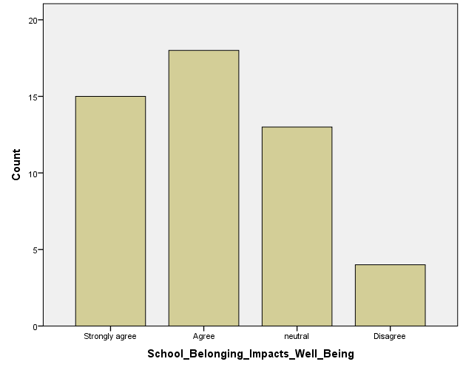
The graph depicts respondents' attitudes of the relationship between a sense of belonging in the school community and kids' social well-being. A sizable 18 people highly believe that a sense of belonging considerably helps to students' social well-being, while 15 agree, 13 are indifferent, and just 4 disagree, with none severely disagree. This implies a widespread confidence in the good influence of the school community on kids' social well-being.

Figure 4 School Belonging impacts Well Being

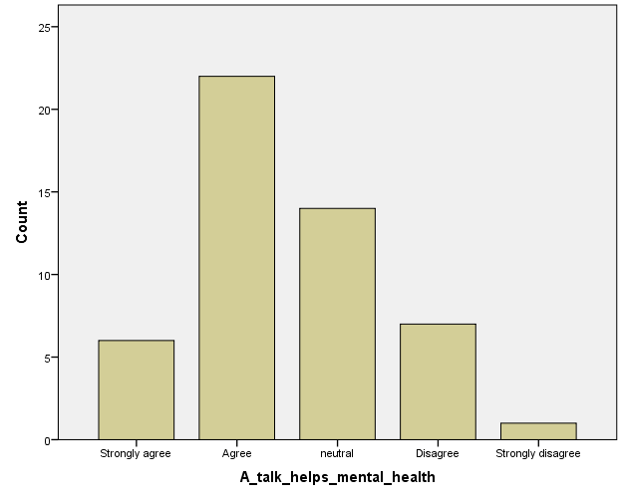
The graph depicts individual answers to the relationship between encouraging open communication, lowering stigma around mental health concerns, and improving students' social well-being. A significant majority of 36 respondents strongly agree or agree with the statement, suggesting broad conviction in the favorable impact of open communication and less stigma on students' mental health and general social well-being.

Figure 5 A talk helps mental health
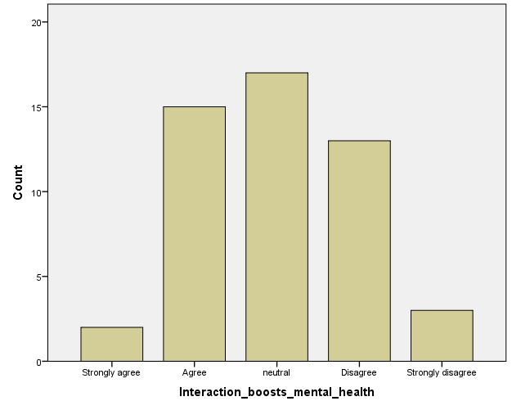
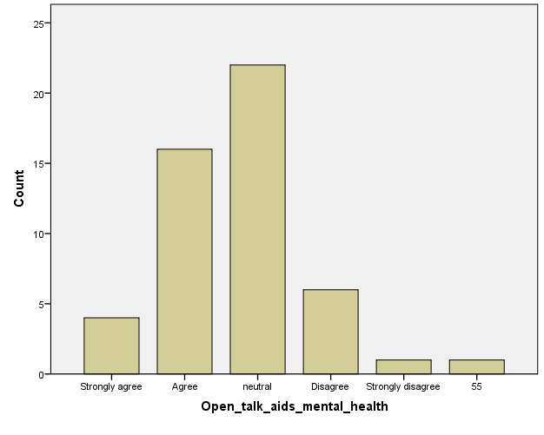
The use of social media significantly influences students' mental health. A survey indicates that a substantial majority, with 38 out of 50 respondents either strongly agreeing or agreeing, believe that fostering open communication and reducing stigma around mental health issues can positively impact the social well-being of students. This underscores the importance of addressing mental health concerns in the context of social media use for a healthier student life.
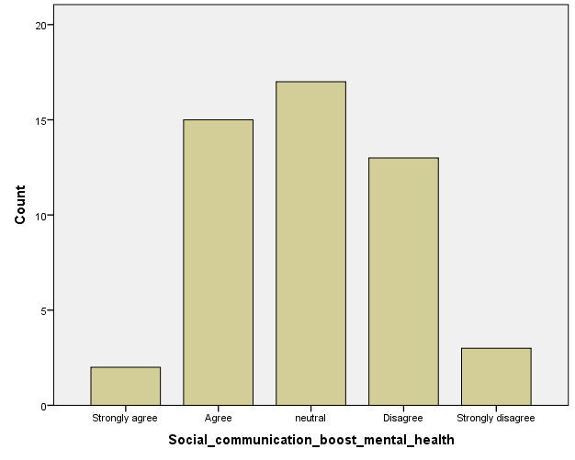
Figure 6 Open talk side mental health
The graph depicts replies to the question on the advantages of enough social activities for students' mental health. It reveals that a majority of respondents, 32 (64%), strongly agree or agree with the statement. Only a small minority of five responders (10%) disagree or strongly disagree. This implies a widespread belief in the beneficial effects of social involvement on mental health.
The graph depicts responses to the question on the significance of developing healthy social interactions and relationships in the school setting for improving students' social and mental health. A large majority (23 respondents) strongly agree, with 13 agreeing. Only a few people disagree, with five disapproving and three strongly disagreeing, indicating a general consensus on the positive influence of school-based social contacts on children' mental health.
Figure 7 Interaction boost mental health

Figure 8 Social communication boost mental health

Cyber Bullying
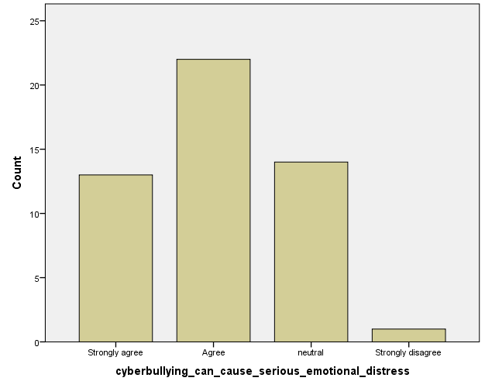
The graph illustrates opinions on the emotional impact of cyberbullying. A significant majority supports the idea, with 13 strongly agreeing and 22 agreeing. A notable portion remains neutral (14), while a minimal number disagrees (0) or strongly disagrees (1), highlighting broad acknowledgment of cyberbullying's emotional consequences.

Figure 9 Cyber bulling can cause serious emotional distress
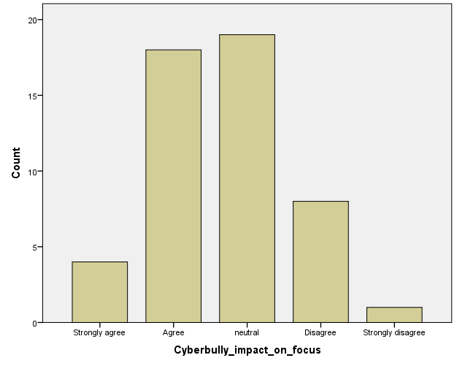
The bar graph illustrates opinions regarding cyberbullying's impact on students' academic focus. A significant majority agrees on its negative influence, with 22 in agreement and 9 in disagreement. However, 19 remain neutral, indicating diverse viewpoints.

Figure 10 Cyberbully impact on focus

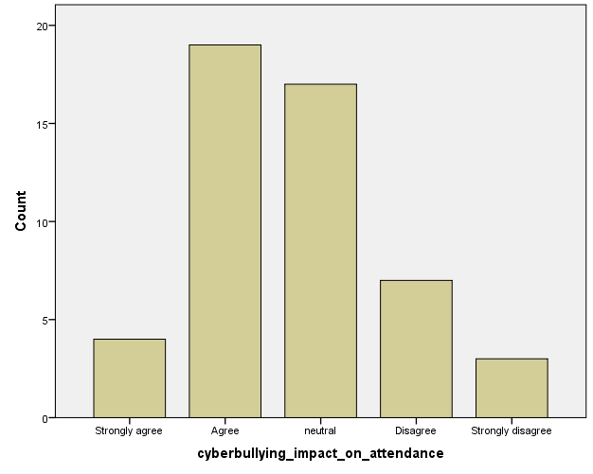
The bar graph illustrates opinions on how cyberbullying affects students' confidence in participating in classroom discussions. A substantial majority (24) agrees, some are neutral (17), fewer disagree (4), and minimal strongly agree (3) or strongly disagree (2), indicating consensus on the impact.

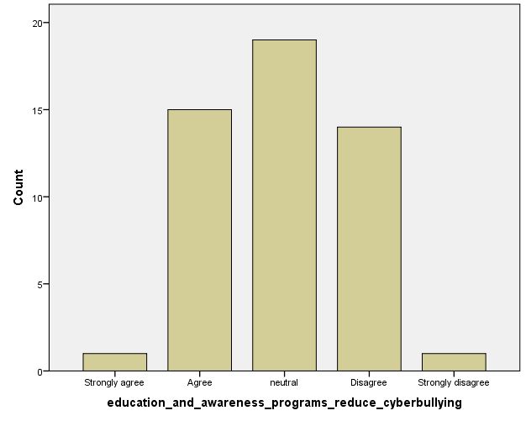
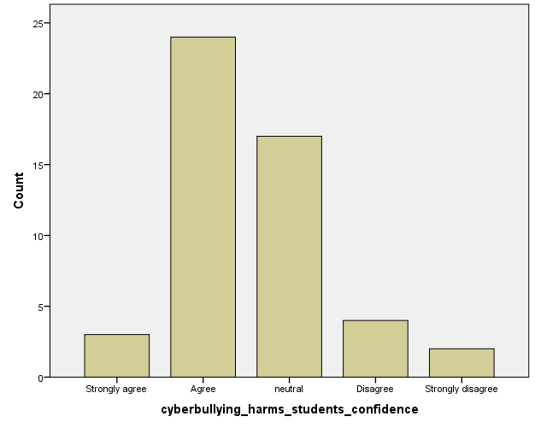
Figure 11 cyber bullying impact on attendance
The bar graph depicts views on education and awareness programs' impact on cyberbullying reduction. Some agree (15), others are neutral (19), and some disagree (14). Few strongly agree (1) or disagree (1), showing varied perspectives.
Figure 12 cyber bulling harms students’ confidence
The bar graph illustrates widespread support for integrating technology in classrooms to enhance educational quality. A significant majority (35) agrees, some are neutral (12), and few disagree (3), indicating a positive sentiment toward technology in education.
Figure 13 Education and awareness programs reduce cyber bulling

Education
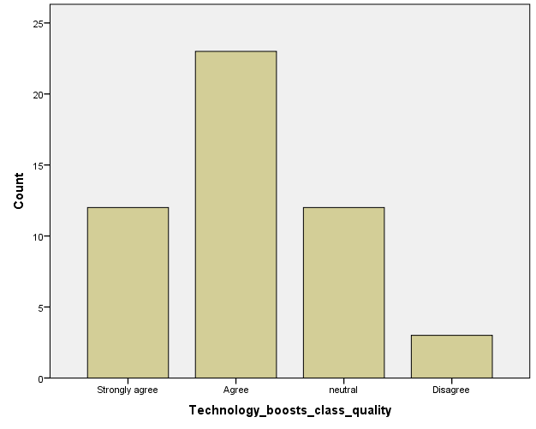
The bar graph illustrates widespread support for integrating technology in classrooms to enhance educational quality. A significant majority (35) agrees, some are neutral (12), and few disagree (3), indicating a generally positive sentiment toward incorporating technology in education.

Figure 14 Technology boost class quality
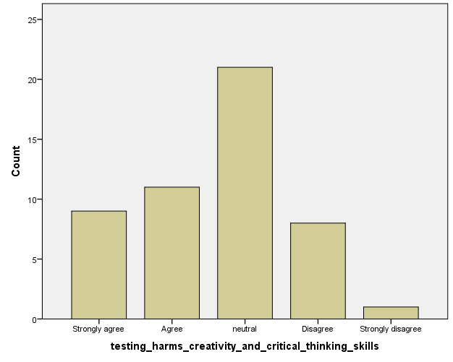
The bar graph depicts views on the influence of standardized testing on students' creativity and critical thinking. A significant percentage strongly supports (9), some agree (11), a substantial portion remains neutral (21), and fewer disagree (8), with only one strongly disagreeing. The graph reflects diverse perspectives on the issue.
Figure 15 Testing harms creativity and critical thinking skills
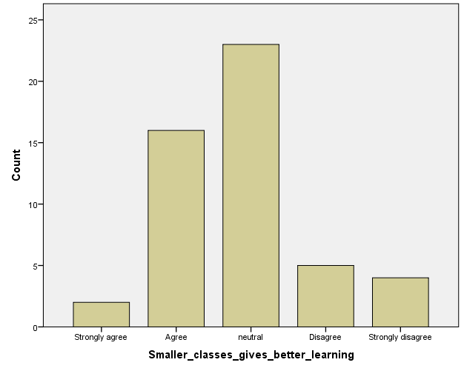
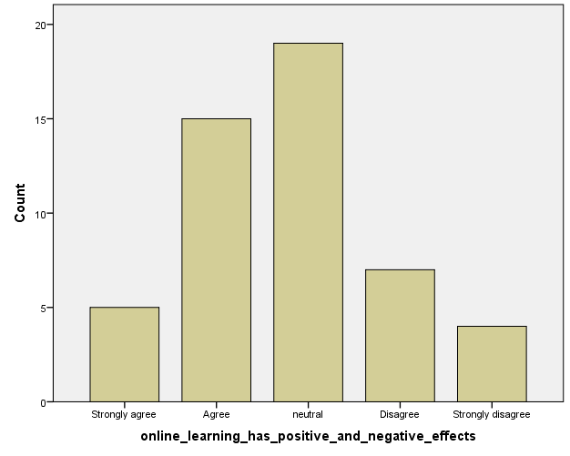
The bar graph illustrates opinions regarding class size's impact on learning. A majority agree that smaller classes enhance learning (16), while a considerable number remain neutral (23). A minority disagree (5) or strongly disagree (4), showcasing varied viewpoints on the subject.
Figure 16 online learning has positive and negative effects
The bar graph illustrates perceptions regarding the impact of a student's socioeconomic status on educational access. While 14 agree, 24 remain neutral. Conversely, 9 disagree, with 3 strongly disagreeing. These findings highlight diverse viewpoints on the extent of this influence.

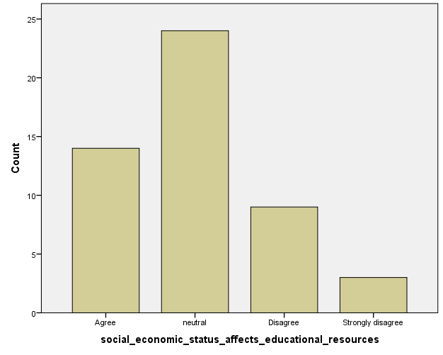
Figure 17 Smaller classes gives better learning
The bar graph illustrates varying opinions on the impact of widespread online learning platforms on a student's socioeconomic status. A significant percentage supports the positive implications for educational access and effectiveness, while others remain neutral or express disagreement with the notion.
Figure 18 Social economic status effect educational resources

Conclusion

In conclusion, the intricate relationship between students and social media unfolds across three critical dimensions: cyberbullying, mental health, and education. The pervasive use of social media platforms offers unprecedented opportunities for connection and self-expression but is not devoid of challenges. Cyberbullying poses a significant threat, influenced by social, individual, and contextual factors. A comprehensive understanding of the nuanced interplay is crucial for effective intervention.

The impact on mental health reflects a dual nature, with positive aspects such as social support juxtaposed against negative consequences like social comparison and sleep disruption. Recognizing these complexities underscores the need for collaborative efforts among educators, parents, and policymakers to foster a healthier digital environment.

In education, social media's influence is multifaceted, impacting academic performance, online collaboration, psychological well-being, and digital literacy. To navigate this complex landscape, tailored approaches acknowledging cultural and societal influences are essential. The synthesis of knowledge presented in this literature review serves as a foundation for proactive measures, urging stakeholders to empower students with resilience, critical thinking, and a holistic understanding of the factors shaping their digital experiences. As the digital era unfolds, ongoing research and collaborative efforts are imperative to guide the evolution of social media's role in students' lives and education.

Recommendation
- Algorithmic Intervention
Implement advanced algorithms and artificial intelligence tools to proactively detect and prevent cyberbullying. Machine learning models can analyze patterns of communication, identify potentially harmful content, and intervene before it escalates. Continuous refinement of these algorithms is essential to keep pace with evolving cyberbullying tactics.

- Incorporate Mindfulness Training
Integrate mindfulness training into educational programs, teaching students techniques for staying present and aware while using social media. Mindfulness can help students develop a balanced perspective, reducing the likelihood of negative emotional responses triggered by social comparison or fear of missing out.

References
Amoo, D. K., 2022. Effects of Social Media On Student Academic Performance. [Online]
Available at: https://edupadi.com/blog/effects-of-social-media-on-student-academic-performance/
[Accessed 8 February 2024].
Anderson, B., 2023. How Social Media Fuels Bullying and Cyberbullying among Students. [Online]
Available at: https://psychtimes.com/mental-health/the-impact-of-social-media-on-bullying-and-cyberbullying-in-schools/
[Accessed 8 February 2024].
Assistant Secretary for Public Affairs (ASPA), 2023. What Is Cyberbullying. [Online]
Available at: https://www.stopbullying.gov/cyberbullying/what-is-it#:~:text=Cyberbullying%20includes%20sending%2C%20posting%2C%20or,into%20unlawful%20or%20criminal%20behavior.
[Accessed 08 November 2023].
Castells, M., 2000. The rise of the network society. 2nd ed. Oxford: Blackwell Publishers.
Chen, M. & Xiao, X., 2022. The effect of social media on the development of students' affective variables. [Online]
Available at: https://www.ncbi.nlm.nih.gov/pmc/articles/PMC9521624/
[Accessed 9 November 2023].
Dollarhide, M., 2023. Investopedia. [Online]
Available at: https://www.investopedia.com/terms/s/social-media.asp#:~:text=Social%20media%20is%20digital%20technology,shares%2C%20comments%2C%20and%20discussion.
[Accessed 8 November 2023].
Everson, M., Gaggioli, A., Hsieh, S. & Krauskopf, K., 2015. Students' learning styles and their effects on the use of social media technology for learning. [Online]
Available at: https://www.sciencedirect.com/science/article/abs/pii/S0736585315301155
[Accessed 8 February 2024].
Madams, 2023. Maryville University Online. [Online]
Available at: https://online.maryville.edu/blog/evolution-social-media/
[Accessed 06 November 2023].
Margolis, J. & Amanbekova, D., 1970. Social Media and Cyberbullying. [Online]
Available at: https://link.springer.com/chapter/10.1007/978-3-031-24804-7_6
[Accessed 8 February 2024].
Murtaza, G., 2023. The Impact of Social Media on Students' Academic Performance. [Online]
Available at: https://www.linkedin.com/pulse/impact-social-media-students-academic-performance-ghulam-murtaza
[Accessed 8 February 2024].
Nazari, A., Hosseinnia, M., Torkian, S. & Garmaroudi, G., 2023. Social media and mental health in students: a cross-sectional study during the Covid-19 pandemic - BMC Psychiatry. [Online]
Available at: https://bmcpsychiatry.biomedcentral.com/articles/10.1186/s12888-023-04859-w
[Accessed 9 November 2023].
Wickramasurendra, J. M., Jagoda, D. J. & Rathnayake, R. M., 2021. Factors influencing social media addiction among G.C.E. Advanced Level students in Sri Lanka: A case study in colombo district, Sri Lanka. Sri Lanka Journal of Social Sciences and Humanities, 1 08, 1(2), pp. 1-11.
Zsila, &. & Reyes, M. E. S., 2023. Pros & cons: impacts of social media on mental health - BMC Psychology. [Online]
Available at: https://bmcpsychology.biomedcentral.com/articles/10.1186/s40359-023-01243-x
[Accessed 8 February 2024].

Appendix
As a student regarding for OTHM with ICBT campus Colombo the questioner is designed to gather data to complete the research for which the topic is impact of social media on students’ life
Select your gender
- Male
- Female

Select your age
- 22 years below
- 23-30
- 30-35
- 35 and below

Higher education qualification
- Diploma
- Under graduate
- Graduate
- Post graduate
- doctorate

Mental Health
- Do you think that a sense of belonging in the school community contributes significantly to the social well-being of students?
- Do you think that fostering open communication and reducing stigma around mental health issues can positively impact the social well-being of students?
- Do you think that fostering open communication and reducing stigma around mental health issues can positively impact the social well-being of students?
- Do you think that providing ample opportunities for students to engage in social activities is beneficial for their mental health?
- Do you think that promoting positive social interactions and relationships within the school setting is essential for enhancing students' social mental health?

Cyberbullying
- Do you think cyberbullying can cause serious emotional distress?
- Do you agree or disagree that cyberbullying has a negative impact on students' academic focus?
- Do you think cyberbullying affects students' confidence in actively participating in classroom discussions?
- Do you believe that education and awareness programs effectively reduce cyberbullying?
- Do you think cyberbullying influences students' willingness to attend school regularly?
Education
- Do you agree that using technology into classrooms improves overall educational quality?
- To what extent do you agree or disagree that the emphasis on standardized testing harms students' creativity and critical thinking skills?
- Do you think that smaller class sizes make for a better learning environment for students?
- To what extent do you believe a student's socioeconomic status influences their access to educational resources and opportunities?
- Do you agree or disagree that the widespread use of online learning platforms has both positive and negative implications for educational access and effectiveness?

