The factors affecting when using social media on students ‘life
Module: Academic English and Study skills (OTHM)

Student Name: L.H.G. Yasiru Prabodha
Student Number: CL/OTWMFL3/11/90
Acknowledgment
Above all, I want to extend my sincere gratitude to Mrs. Chameera Wijayathunga, our lecturer, for generously imparting her knowledge to me during our lessons in the lecture room. I am deeply appreciative of my parents for their unwavering encouragement and financial support. A heartfelt thank you goes out to my best friends, whose assistance was invaluable during the creation of this proposal.

Abstract
The following research reports manifest the factors effecting when social media on students' life. With the advancement of the Internet and telecommunication technologies, social media has become an integral part of our day to day lives. The use of social media has gradually changed and impacted on every aspect of the society, especially the higher education context. Social media in higher education has been researched by many, the impact of social media on students' academic performance has not been addressed sufficiently, particularly in the Sri Lanka context. In today's world where the Internet has experienced tremendous growth, social networking sites have become highly significant in students' lives. Social media are web-based communication tools that enable people to interact with each other by both sharing and consuming information.

Table of contents

Table of figures

Introduction

Since beginning of human history peoples have been exchanging wide an array of information, ideas and attitudes through the interchange sings and symbols. As primitive cultures evolved into more complex civilizations, their communication systems grew significantly, resulting in more regular information exchanges. (Wickramasurendra, et al., 2021)
Social media is a variety of technologies that facilitate the exchange of ideas and information among their users. The first social media platform was Sixdegrees, which was launched in 1997 and closed in 2001. Social media platforms such as Facebook, YouTube, Twitter, Instagram, TikTok and LinkedIn have come to popularity as the world's major social media networks. By early 2023, more than 4.7 billion individuals worldwide will be accessing social media, accounting for nearly 60% of the global population. (Dollarhide, 2023)
Cyberbullying is a pervasive and damaging problem in social media. This type of harassment, which is generally carried out online or through digital communication platforms, includes verbal, emotional, or even threatening abuse. The Internet's anonymity and accessibility have increased the frequency of cyberbullying, which affects individuals of all ages. Some cyberbullying crosses the line into unlawful or criminal behavior. (Assistant Secretary for Public Affairs (ASPA), 2023)
Social media has a significant impact on student mental health. Continuous exposure to well-crafted online identities, the frequency of cyberbullying, and the constant need to maintain a perfect digital image can all lead to increased stress and anxiety. Addiction to social media can alter sleep habits, harm academic performance, and aggravate mental health issues. Continuous scrolling and comparing with others can lead to feelings of inadequacy and sadness. Furthermore, fear of missing out (FOMO) can magnify feelings of isolation and loneliness. It is vital for students to strike a good balance in their online presence and prioritise their mental health. (Nazari, et al., 2023)
Social media has had a significant impact on student education, showing itself in a variety of ways. It provides students with access to a large array of information and instructional tools, enhancing their learning experiences. It does, however, provide considerable distractions. The temptation of notifications and real-time updates might reduce students' capacity to focus throughout their study. Furthermore, social media typically contributes to academic procrastination, jeopardising time management and overall roductivity. On the plus side, social media may be used for collaborative learning and communication with peers and instructors. Its ability to stimulate educational discourse and facilitate group projects can improve the educational experience. Nonetheless, the overall influence of social media on student education is primarily determined by how well it is handled and integrated into students' learning routines. (Chen & Xiao, 2022)

Research Questions
What are the factors affecting when using social media on students’ life?

Research Objectives
To find out the factors affecting when using social media on students’ life.

Literature Review

Conceptual Framework
Independent Variables Independent Variables

CYBER BULLING

USE OF SOCIAL MEDIA
MENTAL HEALTH

z

EDUCATION

Cyber Bullying
In the digital age, the pervasive use of social media has undeniably transformed the landscape of communication and social interaction, particularly among students. The allure of virtual platforms lies in their ability to connect individuals, foster relationships, and provide a space for self-expression. However, this digital realm is not immune to the darker side of human behavior, and one concerning phenomenon that has emerged is cyberbullying. Defined as the use of electronic means to intimidate, harass, or threaten others, cyberbullying poses a significant threat to the well-being of students navigating the intricate web of online relationships.
As students increasingly integrate social media into their daily lives, the factors influencing the occurrence and impact of cyberbullying demand meticulous examination. This literature review delves into the multifaceted dimensions surrounding cyberbullying on social media platforms, shedding light on the nuances that define its prevalence and implications for students. By scrutinizing the intricate interplay of social, individual, and contextual factors, this review seeks to offer a comprehensive understanding of the challenges posed by cyberbullying in the realm of students' lives.
1. Definition and Forms of Cyberbullying
To set the foundation, it is crucial to understand the definition and forms of cyberbullying. Cyberbullying refers to the use of electronic communication to intimidate, harass, or threaten an individual. This can take various forms, including online harassment, spreading rumors, exclusion, and impersonation. Understanding the different manifestations of cyberbullying is essential for identifying its prevalence and impact on students.
2. Social Media Platforms and Cyberbullying
One significant factor influencing cyberbullying is the social media platforms themselves. Different platforms have distinct features and norms that may facilitate or mitigate cyberbullying. The anonymity provided by some platforms can exacerbate negative behaviors, while reporting and moderation features on others may act as deterrents. Examining the role of specific social media platforms in cyberbullying incidents can provide valuable insights.
3. Individual Factors
Students' individual characteristics and behaviors play a vital role in their susceptibility to cyberbullying. Factors such as self-esteem, emotional resilience, and online behavior contribute to the likelihood of being targeted or engaging in cyberbullying activities. Understanding how individual differences interact with social media use is crucial for developing targeted interventions.
4. Peer Influence and Social Dynamics
The social nature of cyberbullying implicates the influence of peers and social dynamics. Peer relationships, group dynamics, and social hierarchies within online communities contribute to the prevalence and perpetuation of cyberbullying. Exploring the influence of peer interactions on social media platforms can shed light on the mechanisms behind cyberbullying incidents.
5. Parental Involvement and Supervision
The role of parents in mitigating cyberbullying is significant. Parental involvement, communication, and supervision of online activities can serve as protective factors against cyberbullying. Investigating the impact of parental guidance on students' social media use and their experiences with cyberbullying can provide insights into effective preventive measures.
6. School and Educational Interventions
Schools play a crucial role in addressing cyberbullying by implementing educational programs, policies, and interventions. Examining the effectiveness of school-based initiatives in creating awareness, fostering a positive online culture, and providing support for victims can contribute to the development of comprehensive strategies.

In navigating the complex terrain of social media, where the boundaries between the physical and digital worlds blur, the issue of cyberbullying emerges as a formidable challenge for students, educators, parents, and policymakers alike. This literature review has sought to unravel the intricate web of factors influencing cyberbullying, emphasizing the need for a holistic approach to address this pervasive issue.
The examination of social media platforms and their unique features, coupled with an exploration of individual factors, has illuminated the nuanced nature of cyberbullying incidents. Peer dynamics and social influences, both online and offline, have been identified as critical contributors to the prevalence and perpetuation of cyberbullying, underscoring the importance of considering the broader social context.
Parental involvement and supervision emerge as potential protective factors, offering a foundation for intervention strategies. Moreover, the role of schools in creating a safe online environment through educational programs and policies is pivotal. As this review concludes, it advocates for collaborative efforts among educators, parents, and policymakers to develop targeted interventions that not only curb the immediate effects of cyberbullying but also foster a digital culture rooted in empathy, understanding, and support for students navigating the intricate landscape of social media. Only through such comprehensive measures can we hope to mitigate the adverse impact of cyberbullying on students' lives and cultivate a positive online experience for the generations to come.

Mental Health
The pervasive integration of social media into the daily lives of students has brought forth a myriad of opportunities and challenges, particularly in relation to mental health. This literature review delves into the intricate web of factors that impact the mental well-being of students as they navigate the complex landscape of social media platforms. As these platforms become central to communication, self-expression, and social connection, it becomes imperative to critically examine the various dimensions that contribute to the intricate relationship between social media use and mental health, with a specific focus on the profound impact on students. The exploration of these factors is essential for educators, parents, policymakers, and mental health professionals alike to develop a nuanced understanding and implement strategies that foster a healthier digital environment for students.

1. Social Comparison Theory
- Positive Side
Social media allows students to connect with peers, fostering a sense of camaraderie and shared experiences. It can positively influence self-perception through exposure to diverse perspectives.
- Negative Side
Excessive exposure to curated content may lead to unrealistic comparisons, causing feelings of inadequacy and low self-esteem among students. Constant social comparison can contribute to heightened stress levels and mental health challenges.

2. Fear of Missing Out (FOMO)
- Positive Side
Social media helps students stay informed about social events, academic opportunities, and community activities, reducing the likelihood of missing out on valuable experiences.
- Negative Side
Uncontrolled FOMO, fueled by social media, can lead to anxiety, depression, and a constant need to participate in every online trend. It may create a constant sense of urgency and dissatisfaction with one's life.

3. Cyberbullying and Online Harassment:
- Positive Side
Social media platforms can serve as platforms for positive communication and support. Anti-bullying campaigns and interventions on these platforms can help create a safer online environment.
- Negative Side
The anonymity provided by social media can contribute to cyberbullying, leading to severe mental health consequences for victims. Online harassment may exacerbate anxiety, depression, and feelings of isolation among students.

4. Sleep Disruption:
- Positive Side
Social media can provide educational resources and support networks, enhancing students' academic experience and contributing to a positive online community.
- Negative Side
Late-night social media use, particularly before bedtime, can disrupt sleep patterns, leading to fatigue, decreased cognitive function, and a higher risk of mental health issues such as depression and anxiety.

5. Social Support and Connection:
- Positive Side
Social media facilitates connections, allowing students to maintain relationships, seek emotional support, and build a sense of community, which can positively impact mental well-being.
- Negative Side
Overreliance on social media for support may lead to superficial connections, and negative interactions online can contribute to feelings of loneliness and isolation, negatively affecting mental health.

6. Academic and Career Opportunities:
- Positive Side
Social media can be a valuable tool for students to explore academic and career opportunities, connect with professionals, and access resources that contribute positively to their personal development.
- Negative Side
Excessive time spent on social media, especially without clear goals, can lead to academic neglect and hinder career development, causing stress and negatively impacting mental health.
The intertwining of social media and students' mental health is a multifaceted phenomenon influenced by a range of factors. The literature reviewed highlights the intricate dance between social comparison, the fear of missing out, cyberbullying, sleep disruption, and the potential for social support. While the negative consequences of excessive social media use are evident, it is crucial to recognize the potential positive aspects, such as the facilitation of social support and connection.
Addressing the challenges posed by social media requires a holistic approach, involving not only individual resilience but also concerted efforts from educational institutions, families, and social media platforms. Educators can play a pivotal role in promoting digital literacy and teaching students how to navigate social media in a healthy manner. Parents can engage in open communication with their children, fostering awareness and resilience to the negative aspects of social media. Policymakers need to explore regulatory frameworks that ensure the responsible use of these platforms and protect users from online harms.
In essence, this literature review emphasizes the importance of understanding the dynamic interplay between social media and mental health among students. By acknowledging the complexities of this relationship, stakeholders can work collaboratively to mitigate the adverse effects, harness the positive potentials, and foster a digital landscape that nurtures the mental well-being of the upcoming generation.

Education

In the contemporary educational landscape, the pervasive influence of social media on students cannot be overstated. The ubiquity of platforms such as Facebook, Instagram, Twitter, and others has transformed the way students engage with information, peers, and the educational process. As this digital revolution unfolds, it becomes imperative to comprehensively examine the factors that mold the impact of social media on students' lives, particularly within the educational realm. This literature review delves into the intricate interplay of elements that shape students' experiences, encompassing academic performance, online collaboration, psychological well-being, digital literacy, and the profound influence of cultural and societal factors.
Understanding the multifaceted nature of these influences is essential for educators, policymakers, and researchers seeking to navigate the delicate balance between leveraging the positive aspects of social media and mitigating its potential drawbacks. By scrutinizing the existing literature, we aim to shed light on the nuanced dynamics that characterize the intersection of social media and education, providing insights that can inform strategies to foster a healthy and productive digital environment for students.
1. Academic Performance
Numerous studies have investigated the relationship between social media use and academic performance. While some research suggests a negative correlation, indicating that excessive use of social media may lead to decreased academic achievement, other studies argue that the impact is nuanced and depends on the nature and purpose of social media engagement. Factors such as multitasking, time management, and the type of content consumed on social media platforms play crucial roles in determining the impact on academic outcomes.
2. Online Learning and Collaboration
The advent of online education and collaborative platforms has transformed the traditional learning landscape. Social media serves as a medium for students to connect, collaborate, and share resources. Research indicates that well-managed online communities and collaborative learning environments on social media positively contribute to educational experiences. However, challenges such as distraction, information overload, and cyberbullying can also emerge, influencing the overall educational impact.
3. Social Comparison and Psychological Well-being
Social media platforms often encourage social comparison, which can impact students' psychological well-being. Studies suggest that exposure to idealized representations of peers' lives on social media may lead to feelings of inadequacy and stress. This psychological impact can affect students' self-esteem, motivation, and overall mental health, consequently influencing their engagement with education.
4. Digital Literacy and Critical Thinking
The ability to critically evaluate information and navigate the digital landscape is increasingly vital for students. Social media platforms are rich sources of information, yet they also pose risks such as misinformation and digital manipulation. Research emphasizes the importance of promoting digital literacy skills among students to empower them to navigate social media responsibly. Educational institutions play a crucial role in integrating digital literacy into curricula to prepare students for the challenges of the digital age.
5. Cultural and Societal Influences
The impact of social media on students is not uniform across different cultural and societal contexts. Cultural norms, societal expectations, and access to technology can vary significantly, influencing the ways in which students engage with social media in an educational context. Understanding these contextual factors is essential for developing targeted interventions and educational strategies.

The complex relationship between social media and students' lives in the educational context requires a nuanced and multifaceted approach. The factors influencing this dynamic interaction are diverse, ranging from the impact on academic performance to the intricate web of social comparison, psychological well-being, and digital literacy. As educational institutions grapple with the evolving landscape, it is clear that a one-size-fits-all approach is insufficient.
To harness the benefits of social media and mitigate potential pitfalls, educators and policymakers must consider the unique contextual factors at play. The promotion of digital literacy, fostering positive online collaboration, and addressing the psychological ramifications of social media use are paramount. Furthermore, recognizing the cultural and societal nuances that shape students' digital experiences is vital for tailoring interventions that resonate with diverse student populations.
As the digital era continues to unfold, further research is warranted to stay abreast of evolving social media trends and their implications for education. The synthesis of knowledge presented in this literature review serves as a foundation for future endeavors, urging stakeholders to proactively shape educational environments that empower students to navigate the digital landscape with resilience, critical thinking, and a holistic understanding of the factors at play.

Data Analysis
The questionnaire was distributed using google forms and 50 responses have been collected. The responses are analyzed in this chapter based on the questions asked and the responses arrived
#Add-basic-charts-set

Mental Health
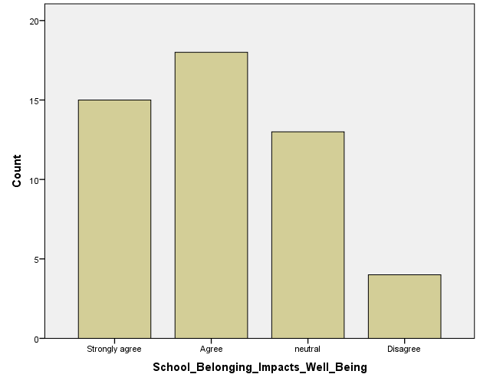
The graph displays respondents' opinions about cyberbullying as a serious problem in the modern internet era, with a particular emphasis on how it affects students' use of social media. 39 out of 50 people strongly agree or agree, demonstrating a widespread worry about how cyberbullying affects students' online safety.

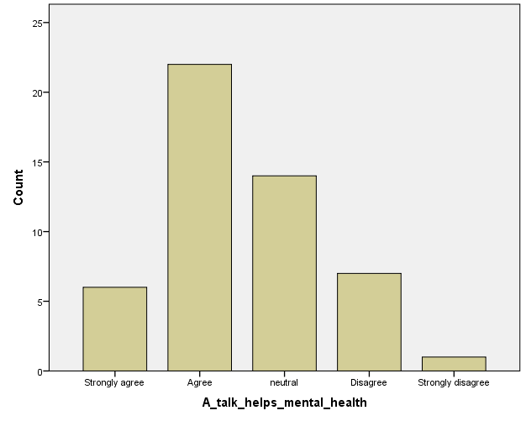
The graph displays respondents' opinions about cyberbullying as a serious problem in the modern internet era, with a particular emphasis on how it affects students' use of social media. 39 out of 50 people strongly agree or agree, demonstrating a widespread worry about how cyberbullying affects students' online safety.

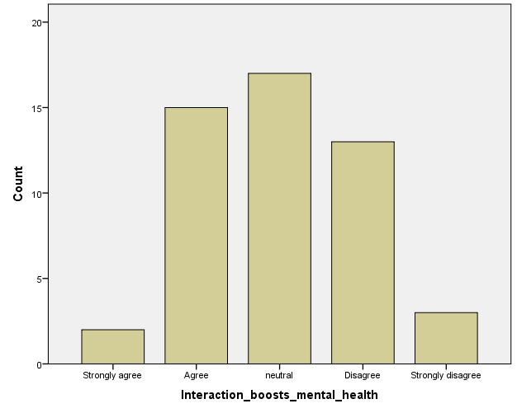
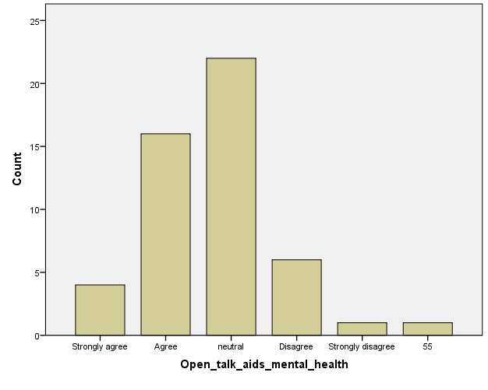
The graph displays respondents' opinions about cyberbullying as a serious problem in the modern internet era, with a particular emphasis on how it affects students' use of social media. 39 out of 50 people strongly agree or agree, demonstrating a widespread worry about how cyberbullying affects students' online safety.

The graph displays respondents' opinions about cyberbullying as a serious problem in the modern internet era, with a particular emphasis on how it affects students' use of social media. 39 out of 50 people strongly agree or agree, demonstrating a widespread worry about how cyberbullying affects students' online safety.

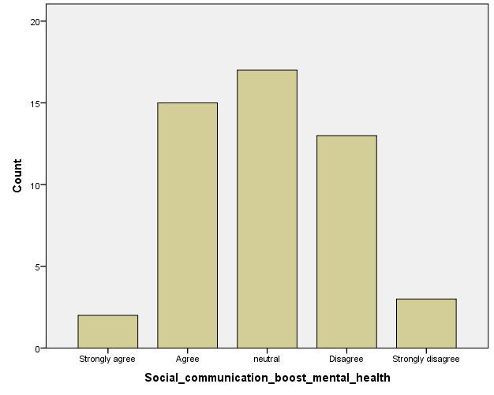
The graph displays respondents' opinions about cyberbullying as a serious problem in the modern internet era, with a particular emphasis on how it affects students' use of social media. 39 out of 50 people strongly agree or agree, demonstrating a widespread worry about how cyberbullying affects students' online safety.

Cyber Bullying
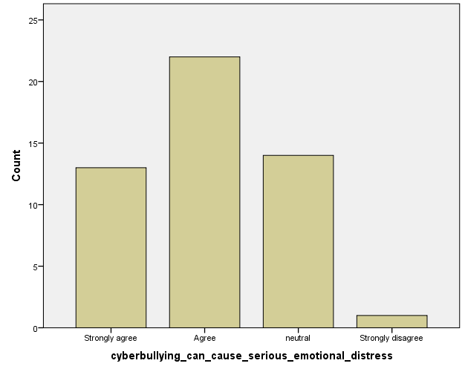
The graph displays respondents' opinions about cyberbullying as a serious problem in the modern internet era, with a particular emphasis on how it affects students' use of social media. 39 out of 50 people strongly agree or agree, demonstrating a widespread worry about how cyberbullying affects students' online safety.

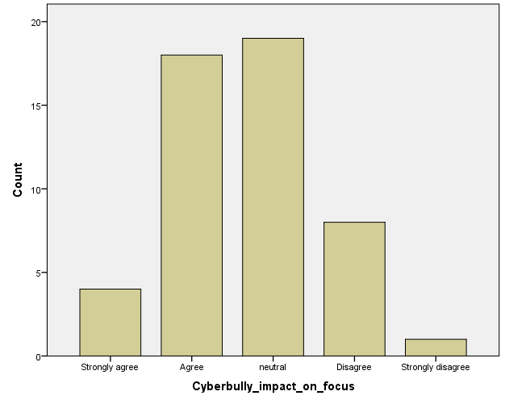
The graph displays respondents' opinions about cyberbullying as a serious problem in the modern internet era, with a particular emphasis on how it affects students' use of social media. 39 out of 50 people strongly agree or agree, demonstrating a widespread worry about how cyberbullying affects students' online safety.

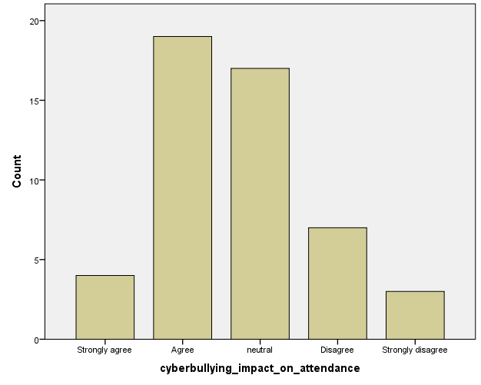
The graph displays respondents' opinions about cyberbullying as a serious problem in the modern internet era, with a particular emphasis on how it affects students' use of social media. 39 out of 50 people strongly agree or agree, demonstrating a widespread worry about how cyberbullying affects students' online safety.

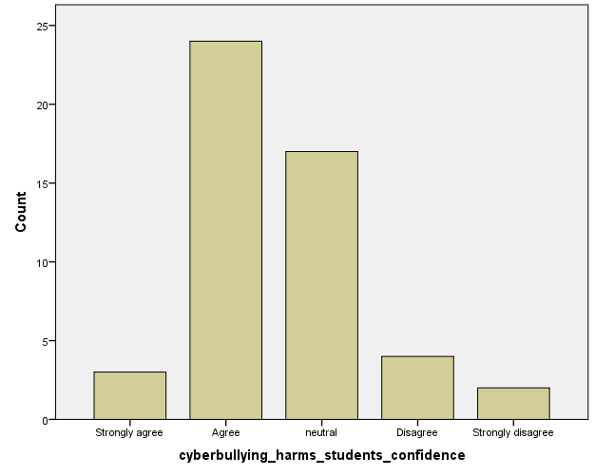
The graph displays respondents' opinions about cyberbullying as a serious problem in the modern internet era, with a particular emphasis on how it affects students' use of social media. 39 out of 50 people strongly agree or agree, demonstrating a widespread worry about how cyberbullying affects students' online safety.

The graph displays respondents' opinions about cyberbullying as a serious problem in the modern internet era, with a particular emphasis on how it affects students' use of social media. 39 out of 50 people strongly agree or agree, demonstrating a widespread worry about how cyberbullying affects students' online safety.

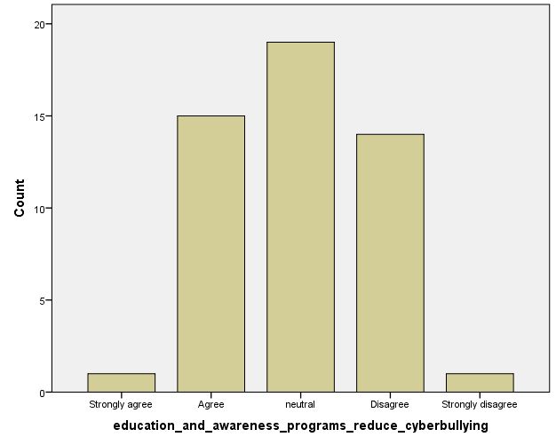

Education
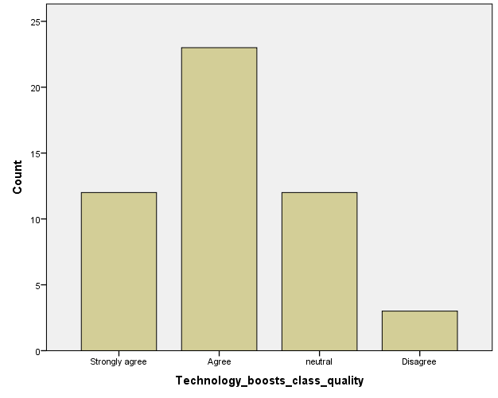
The graph displays respondents' opinions about cyberbullying as a serious problem in the modern internet era, with a particular emphasis on how it affects students' use of social media. 39 out of 50 people strongly agree or agree, demonstrating a widespread worry about how cyberbullying affects students' online safety.

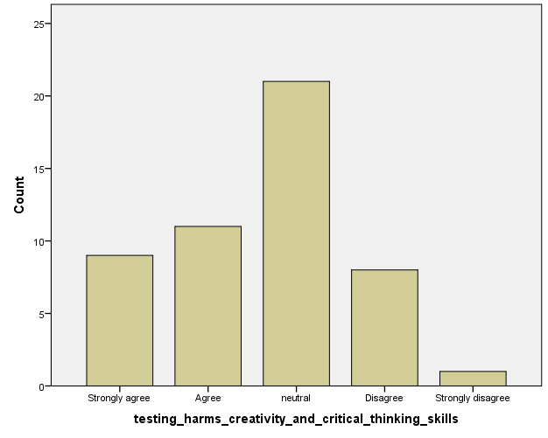
The graph displays respondents' opinions about cyberbullying as a serious problem in the modern internet era, with a particular emphasis on how it affects students' use of social media. 39 out of 50 people strongly agree or agree, demonstrating a widespread worry about how cyberbullying affects students' online safety.

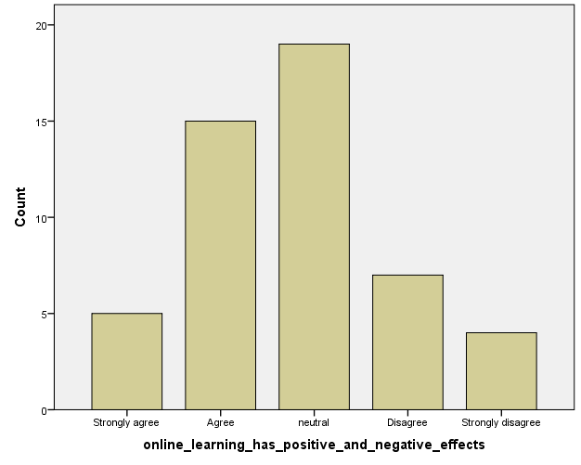
The graph displays respondents' opinions about cyberbullying as a serious problem in the modern internet era, with a particular emphasis on how it affects students' use of social media. 39 out of 50 people strongly agree or agree, demonstrating a widespread worry about how cyberbullying affects students' online safety.

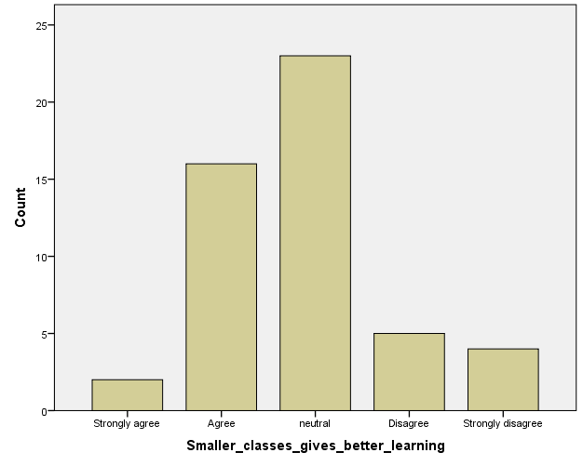
The graph displays respondents' opinions about cyberbullying as a serious problem in the modern internet era, with a particular emphasis on how it affects students' use of social media. 39 out of 50 people strongly agree or agree, demonstrating a widespread worry about how cyberbullying affects students' online safety.

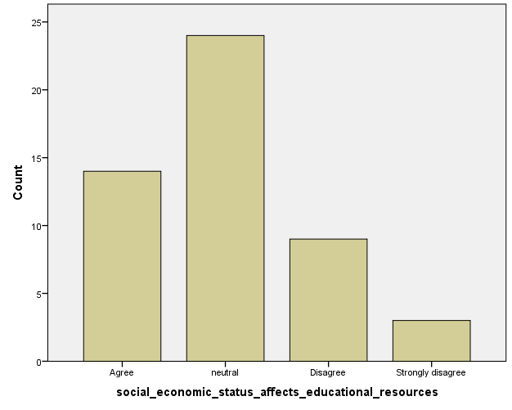
The graph displays respondents' opinions about cyberbullying as a serious problem in the modern internet era, with a particular emphasis on how it affects students' use of social media. 39 out of 50 people strongly agree or agree, demonstrating a widespread worry about how cyberbullying affects students' online safety.

Reference

Assistant Secretary for Public Affairs (ASPA), 2023. What Is Cyberbullying. [Online]
Available at: https://www.stopbullying.gov/cyberbullying/what-is-it#:~:text=Cyberbullying%20includes%20sending%2C%20posting%2C%20or,into%20unlawful%20or%20criminal%20behavior.
[Accessed 08 November 2023].
Castells, M., 2000. The rise of the network society. 2nd ed. Oxford: Blackwell Publishers.
Chen, M. & Xiao, X., 2022. The effect of social media on the development of students' affective variables. [Online]
Available at: https://www.ncbi.nlm.nih.gov/pmc/articles/PMC9521624/
[Accessed 9 November 2023].
Dollarhide, M., 2023. Investopedia. [Online]
Available at: https://www.investopedia.com/terms/s/social-media.asp#:~:text=Social%20media%20is%20digital%20technology,shares%2C%20comments%2C%20and%20discussion.
[Accessed 8 November 2023].
Madams, 2023. Maryville University Online. [Online]
Available at: https://online.maryville.edu/blog/evolution-social-media/
[Accessed 06 November 2023].
Nazari, A., Hosseinnia, M., Torkian, S. & Garmaroudi, G., 2023. Social media and mental health in students: a cross-sectional study during the Covid-19 pandemic - BMC Psychiatry. [Online]
Available at: https://bmcpsychiatry.biomedcentral.com/articles/10.1186/s12888-023-04859-w
[Accessed 9 November 2023].
Wickramasurendra, J. M., Jagoda, D. J. & Rathnayake, R. M., 2021. Factors influencing social media addiction among G.C.E. Advanced Level students in Sri Lanka: A case study in colombo district, Sri Lanka. Sri Lanka Journal of Social Sciences and Humanities, 1 08, 1(2), pp. 1-11.

Conclusion

In conclusion, the intricate relationship between students and social media unfolds across three critical dimensions: cyberbullying, mental health, and education. The pervasive use of social media platforms offers unprecedented opportunities for connection and self-expression but is not devoid of challenges. Cyberbullying poses a significant threat, influenced by social, individual, and contextual factors. A comprehensive understanding of the nuanced interplay is crucial for effective intervention.

The impact on mental health reflects a dual nature, with positive aspects such as social support juxtaposed against negative consequences like social comparison and sleep disruption. Recognizing these complexities underscores the need for collaborative efforts among educators, parents, and policymakers to foster a healthier digital environment.

In education, social media's influence is multifaceted, impacting academic performance, online collaboration, psychological well-being, and digital literacy. To navigate this complex landscape, tailored approaches acknowledging cultural and societal influences are essential. The synthesis of knowledge presented in this literature review serves as a foundation for proactive measures, urging stakeholders to empower students with resilience, critical thinking, and a holistic understanding of the factors shaping their digital experiences. As the digital era unfolds, ongoing research and collaborative efforts are imperative to guide the evolution of social media's role in students' lives and education.

Recommendation
- Algorithmic Intervention
Implement advanced algorithms and artificial intelligence tools to proactively detect and prevent cyberbullying. Machine learning models can analyze patterns of communication, identify potentially harmful content, and intervene before it escalates. Continuous refinement of these algorithms is essential to keep pace with evolving cyberbullying tactics.

- Incorporate Mindfulness Training
Integrate mindfulness training into educational programs, teaching students techniques for staying present and aware while using social media. Mindfulness can help students develop a balanced perspective, reducing the likelihood of negative emotional responses triggered by social comparison or fear of missing out.

