Tierion

1. library(magrittr)
2. library(dplyr)
3. library(ggplot2)
4. library(readr)
5. library(fitdistrplus)
6. library(DAAG)
7. library("ggplot2")
8. library(anytime)
10. tierion **<-** read_delim('C:/Users/ygaoq/OneDrive/MyDocuments/2019 Spring/Statistics/Project/Blockchain-Tokens-Data-Analytics/networktierionTX.txt', delim = " ", col_names = F)
11. names(tierion) **<-** c('fromID', 'toID', 'unixTime', 'tokenAmount')
12. decimals **<-** 10^8
13. supply **<-** 1 * 10^9
14. tierionFiltered **<-filter**(tierion,tokenAmount **<** **decimals** * supply)  #filter out all outliers
16. #figure out how many users indruced those unnormal transcation
17. tierion_outliers**<-** filter(tierion,tokenAmount **>**= decimals * supply)
18. user_outliers **<-** tierion_outliers %**>**% group_by(toID) %**>**% summarise(nn = n()) %**>**% ungroup
19. number_users_outliers**<-nrow**(user_outliers)
20. number_users_outliers
22. #get top X buyers data
23. buys**<-tierionFiltered**%**>**% group_by(toID) %**>**% summarise(nn = n()) %**>**% ungroup #change the supply and decimals amount
24. buys_sorted_dec**<-buys**[order(-buys$n),]
25. #top 30 active buyers and number of buys
26. top_30_buyers**<-buys_sorted_dec**%**>**%head(30)
27. top_30_buyers
29. ########################################Question 1############################################
31. #####group by user pairs#####
32. buys_pairs**<-tierionFiltered**%**>**% group_by(fromID, toID) %**>**% summarise(nn = n()) %**>**% ungroup
33. for (row in 1:nrow(buys_pairs)) {
34. a**<-buys_pairs**[row,"fromID"]
35. b**<-buys_pairs**[row,"toID"]
36. for (inner_row in row:nrow(buys_pairs)) {
37. c**<-buys_pairs**[inner_row,"fromID"]
38. d**<-buys_pairs**[inner_row,"toID"]
39. if(a==d&&b==c){
40. buys_pairs[inner_row,"fromID"]**<-d**
41. buys_pairs[inner_row,"toID"]**<-c**
42. }
43. }
44. }
45. buys_pairs**<-tierionFiltered**%**>**% group_by(fromID*toID+fromID+toID) %**>**% summarise(nn = n()) %**>**% ungroup
46. buys_pairs**<-tierionFiltered**%**>**% group_by(fromID, toID) %**>**% summarise(nn = n()) %**>**% ungroup
47. buys_pair_sorted_asc**<-buys_pairs**[order(buys_pairs$n),]
48. buys_pair_less_30**<-subset**(buys_pair_sorted_asc,n**<30**)
50. #####find out estimates of paramaters of several distribution based on the buys_pairs data set#####
51. exp_dis **<-** fitdist(buys_pair_less_30$n, 'exp')
52. exp_dis
53. gamma_dis **<-** fitdist(buys_pair_less_30$n, 'gamma')
54. gamma_dis
55. lnorm_dis **<-** fitdist(buys_pair_less_30$n, 'lnorm')
56. lnorm_dis
57. pois_dis **<-** fitdist(buys_pair_less_30$n, 'pois')
58. pois_dis
59. weibull_dis **<-** fitdist(buys_pair_less_30$n, 'weibull')
60. weibull_dis
62. gofstat(list(exp_dis, gamma_dis, lnorm_dis))
63. descdist(buys_sorted_asc$n,boot=1000)
65. #lognorm
66. fit_lnorm **<-** fitdist(buys_pair_less_30$n,"lnorm")
67. summary(fit_lnorm)
68. plot(fit_lnorm)
69. cdfcomp(fit_lnorm)
71. #exp
72. fit_exp **<-** fitdist(buys_pair_less_30$n,"exp")
73. summary(fit_exp)
74. plot(fit_exp)
75. cdfcomp(fit_exp)
77. #gamma
78. fit_gamma **<-** fitdist(buys_pair_less_30$n,"gamma")
79. summary(fit_gamma)
80. plot(fit_gamma)
81. cdfcomp(fit_gamma)
83. #weibull
84. fit_weibull **<-** fitdist(buys_pair_less_30$n,"weibull")
85. summary(fit_weibull)
87. #normal
88. fit_normal **<-** fitdist(buys_pair_less_30$n,"norm")
89. summary(fit_normal)
91. #pois
92. #normal
93. fit_pois **<-** fitdist(buys_pair_less_30$n,"pois")
94. summary(fit_pois)
96. #unif
97. fit_unif **<-** fitdist(buys_pair_less_30$n,"unif")
98. summary(fit_unif)
99. plot(fit_unif)
100. cdfcomp(fit_unif)
102. ######################draw graph#######################
103. all_density **<-** ggplot(data=buys_pair_less_30) +
104. geom_histogram(bins=30,aes(x = buys_pair_less_30$n, ..density..)) +
105. stat_function(fun = dlnorm, args = list(meanlog = 0.2373987, sdlog = 0.4791316),
106. colour = "red")+
107. stat_function(fun = dgamma, args = list(shape = 3.020395, rate=2.000602),
108. colour = "blue")+
109. stat_function(fun=dexp, args=list(rate=0.6623558),colour="green")+
110. stat_function(fun=dweibull, args=list(shape=1.360851, scale=1.678697),colour="yellow")+
111. stat_function(fun=dpois, args=list(lambda=1.509763),colour="orange")+  xlab("No.Buys")
112. all_density
114. ########################################Question 1############################################

117. ########################################Question 2############################################
118. tierion_prices **<-** read_delim("C:/Users/ygaoq/OneDrive/MyDocuments/2019 Spring/Statistics/Project/Blockchain-Tokens-Data-Analytics/tierion", delim = "\t", col_names = T) #load token price data
119. names(tierion_prices) **<-** make.names(names(tierion_prices))
120. tierion_prices **<-** tierion_prices %**>**% mutate(date = as.Date(Date, format = '%m/%d/%Y'))
122. tierion **<-** read_delim('C:/Users/ygaoq/OneDrive/MyDocuments/2019 Spring/Statistics/Project/Blockchain-Tokens-Data-Analytics/networktierionTX.txt', delim = " ", col_names = F)
123. names(tierion) **<-** c('fromID', 'toID', 'unixTime', 'tokenAmount')
124. decimals **<-** 10^8
125. supply **<-** 1 * 10^9
126. tierion_filtered **<-filter**(tierion,tokenAmount **<** **decimals** * supply)
127. ## convert data type of unixTime
128. tierion_filtered **<-** tierion_filtered %**>**%
129. mutate(date = anydate(unixTime))
130. names(tierion_filtered) **<-** c('fromID', 'toID', 'unixTime', 'tokenAmount', 'date')
132. ## merge the prices and edge
133. tierion_merged**<-merge**(x = tierion_prices, y = tierion_filtered, by = "date", all.x = TRUE)
135. ################Determin K##########################
136. top_30_buyers**<-buys_sorted_dec**%**>**%head(30)
138. top_K**<-c**(1:30)
139. count **<-** 1
140. for (val in top_K) {
141. top_K_buyers**<-buys_sorted_dec**%**>**%head(val)
142. filter_K_tierion_merged**<-filter**(tierion_merged,toID %in% top_K_buyers$toID)
143. filter_K_tierion_merged=transform(filter_K_tierion_merged,average_price= (Open+Close)/2)
144. filter_K_tierion_merged$num_Date **<-**  as.numeric(as.POSIXct(filter_K_tierion_merged$date))
145. filered**<-filter_K_tierion_merged**%**>**% group_by(num_Date) %**>**% summarise(nn = n(),Close=mean(Close),tokenAmount=sum(tokenAmount),Open=mean(Open))
146. shift **<-** function(x, n){
147. c(x[-(seq(n))], rep(NA, n))
148. }
149. filered$new_Close**<-shift**(filered$Close,1)
150. num_rows**<-nrow**(filered)
151. filered[-num_rows,]
152. regression**<-lm**(filered$new_Close~filered$tokenAmount+filered$n+filered$Open)
154. setwd("C:/Users/ygaoq/Desktop/Tierion")
155. yourfilename=paste("W",val,".txt",sep="")
156. capture.output(summary(regression),append = TRUE,file = "C:/Users/ygaoq/Desktop/Tierion/Final_Result.txt")

159. summary(regression)
160. par(mfcol=c(2,2))
161. setwd("C:/Users/ygaoq/Desktop/Tierion")
162. yourfilename=paste("A",val,".png",sep="")
163. png(file=yourfilename)
164. opar **<-** par(mfrow=c(2,2))
165. plot(regression)
166. dev.off()
167. }

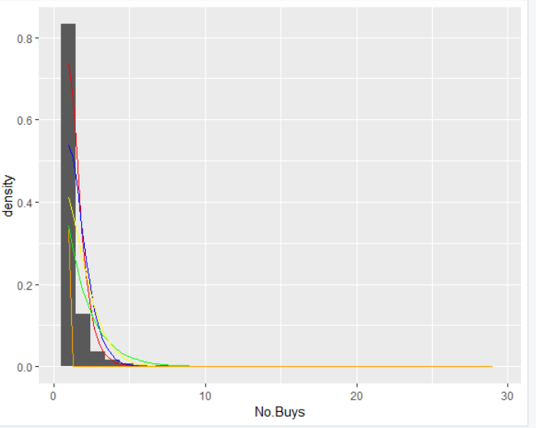

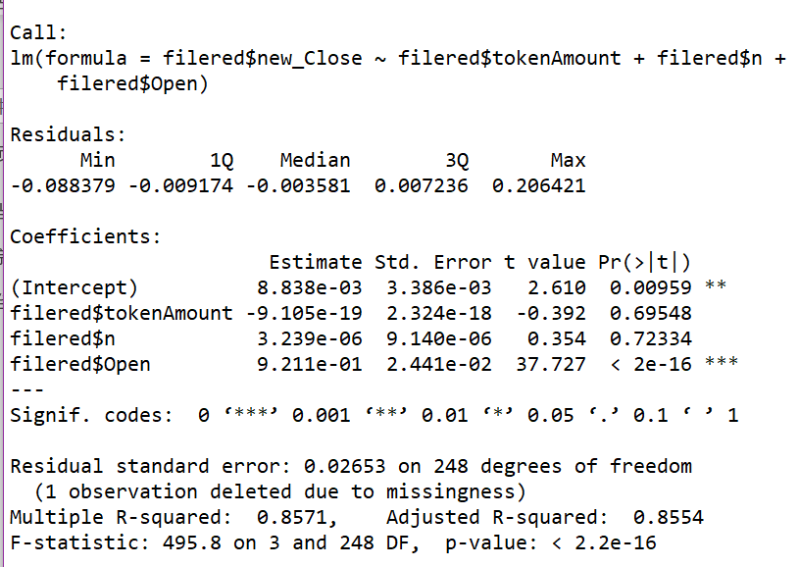

Aragon

1. library(magrittr)
2. library(dplyr)
3. library(ggplot2)
4. library(readr)
5. library(fitdistrplus)
6. library(DAAG)
7. library("ggplot2")
8. library(anytime)
10. aragon **<-** read_delim('C:/Users/ygaoq/OneDrive/MyDocuments/2019 Spring/Statistics/Project/Blockchain-Tokens-Data-Analytics/networkaragonTX.txt', delim = " ", col_names = F)
11. names(aragon) **<-** c('fromID', 'toID', 'unixTime', 'tokenAmount')
12. decimals **<-** 10^18
13. supply **<-** 39609523
14. aragonFiltered **<-filter**(aragon,tokenAmount **<** **decimals** * supply)  #filter out all outliers
16. #figure out how many users indruced those unnormal transcation
17. aragon_outliers**<-** filter(aragon,tokenAmount **>**= decimals * supply)
18. user_outliers **<-** aragon_outliers %**>**% group_by(toID) %**>**% summarise(nn = n()) %**>**% ungroup
19. number_users_outliers**<-nrow**(user_outliers)
20. number_users_outliers
22. #get top X buyers data
23. buys**<-aragonFiltered**%**>**% group_by(toID) %**>**% summarise(nn = n()) %**>**% ungroup #change the supply and decimals amount
24. buys_sorted_dec**<-buys**[order(-buys$n),]
25. #top 30 active buyers and number of buys
26. top_30_buyers**<-buys_sorted_dec**%**>**%head(30)
27. top_30_buyers
29. ########################################Question 1############################################
31. #####group by user pairs#####
32. buys_pairs**<-aragonFiltered**%**>**% group_by(fromID, toID) %**>**% summarise(nn = n()) %**>**% ungroup
33. for (row in 1:nrow(buys_pairs)) {
34. a**<-buys_pairs**[row,"fromID"]
35. b**<-buys_pairs**[row,"toID"]
36. for (inner_row in row:nrow(buys_pairs)) {
37. c**<-buys_pairs**[inner_row,"fromID"]
38. d**<-buys_pairs**[inner_row,"toID"]
39. if(a==d&&b==c){
40. buys_pairs[inner_row,"fromID"]**<-d**
41. buys_pairs[inner_row,"toID"]**<-c**
42. }
43. }
44. }
45. buys_pairs**<-aragonFiltered**%**>**% group_by(fromID*toID+fromID+toID) %**>**% summarise(nn = n()) %**>**% ungroup
46. buys_pairs**<-aragonFiltered**%**>**% group_by(fromID, toID) %**>**% summarise(nn = n()) %**>**% ungroup
47. buys_pair_sorted_asc**<-buys_pairs**[order(buys_pairs$n),]
48. buys_pair_less_30**<-subset**(buys_pair_sorted_asc,n**<30**)
49. buys_pair_data**<-buys_pair_less_30**
51. #####find out estimates of paramaters of several distribution based on the buys_pairs data set#####
52. exp_dis **<-** fitdist(buys_pair_data$n, 'exp')
53. exp_dis
54. gamma_dis **<-** fitdist(buys_pair_data$n, 'gamma')
55. gamma_dis
56. lnorm_dis **<-** fitdist(buys_pair_data$n, 'lnorm')
57. lnorm_dis
58. pois_dis **<-** fitdist(buys_pair_data$n, 'pois')
59. pois_dis
60. weibull_dis **<-** fitdist(buys_pair_data$n, 'weibull')
61. weibull_dis
63. gofstat(list(exp_dis, gamma_dis, lnorm_dis))
64. descdist(buys_sorted_asc$n,boot=1000)
66. #lognorm
67. fit_lnorm **<-** fitdist(buys_pair_less_30$n,"lnorm")
68. summary(fit_lnorm)
69. plot(fit_lnorm)
70. cdfcomp(fit_lnorm)
72. #exp
73. fit_exp **<-** fitdist(buys_pair_less_30$n,"exp")
74. summary(fit_exp)
75. plot(fit_exp)
76. cdfcomp(fit_exp)
78. #gamma
79. fit_gamma **<-** fitdist(buys_pair_less_30$n,"gamma")
80. summary(fit_gamma)
81. plot(fit_gamma)
82. cdfcomp(fit_gamma)
84. #weibull
85. fit_weibull **<-** fitdist(buys_pair_less_30$n,"weibull")
86. summary(fit_weibull)
88. #normal
89. fit_normal **<-** fitdist(buys_pair_less_30$n,"norm")
90. summary(fit_normal)
92. #pois
93. #normal
94. fit_pois **<-** fitdist(buys_pair_less_30$n,"pois")
95. summary(fit_pois)
97. #unif
98. fit_unif **<-** fitdist(buys_pair_less_30$n,"unif")
99. summary(fit_unif)
100. plot(fit_unif)
101. cdfcomp(fit_unif)
103. ######################draw graph#######################
104. all_density **<-** ggplot(data=buys_pair_less_30) +
105. geom_histogram(bins=30,aes(x = buys_pair_less_30$n, ..density..)) +
106. stat_function(fun = dlnorm, args = list(meanlog = 0.1537565, sdlog = 0.4012176),
107. colour = "red")+
108. stat_function(fun = dgamma, args = list(shape = 4.034757, rate=3.040920),
109. colour = "blue")+
110. stat_function(fun=dexp, args=list(rate=0.7536976),colour="green")+
111. stat_function(fun=dweibull, args=list(shape=1.464309, scale=1.488009),colour="yellow")+
112. stat_function(fun=dpois, args=list(lambda=1.326792),colour="orange")+
113. xlab("No.Buys")
114. all_density
116. ########################################Question 1############################################

119. ########################################Question 2############################################
120. aragon_prices **<-** read_delim("C:/Users/ygaoq/OneDrive/MyDocuments/2019 Spring/Statistics/Project/Blockchain-Tokens-Data-Analytics/aragon", delim = "\t", col_names = T) #load token price data
121. names(aragon_prices) **<-** make.names(names(aragon_prices))
122. aragon_prices **<-** aragon_prices %**>**% mutate(date = as.Date(Date, format = '%m/%d/%Y'))
124. aragon **<-** read_delim('C:/Users/ygaoq/OneDrive/MyDocuments/2019 Spring/Statistics/Project/Blockchain-Tokens-Data-Analytics/networkaragonTX.txt', delim = " ", col_names = F)
125. names(aragon) **<-** c('fromID', 'toID', 'unixTime', 'tokenAmount')
126. decimals **<-** 10^18
127. supply **<-** 39609523
128. aragon_filtered **<-filter**(aragon,tokenAmount **<** **decimals** * supply)
129. ## convert data type of unixTime
130. aragon_filtered **<-** aragon_filtered %**>**%
131. mutate(date = anydate(unixTime))
132. names(aragon_filtered) **<-** c('fromID', 'toID', 'unixTime', 'tokenAmount', 'date')
134. ## merge the prices and edge
135. aragon_merged**<-merge**(x = aragon_prices, y = aragon_filtered, by = "date", all.x = TRUE)
137. ################Determin K##########################
138. top_30_buyers**<-buys_sorted_dec**%**>**%head(30)
140. top_K**<-c**(1:30)
141. count **<-** 1
142. for (val in top_K) {
143. top_K_buyers**<-buys_sorted_dec**%**>**%head(val)
144. filter_K_aragon_merged**<-filter**(aragon_merged,toID %in% top_K_buyers$toID)
145. filter_K_aragon_merged=transform(filter_K_aragon_merged,average_price= (Open+Close)/2)
146. filter_K_aragon_merged$num_Date **<-**  as.numeric(as.POSIXct(filter_K_aragon_merged$date))
147. filered**<-filter_K_aragon_merged**%**>**% group_by(num_Date) %**>**% summarise(nn = n(),Close=mean(Close),tokenAmount=sum(tokenAmount),Open=mean(Open))
148. shift **<-** function(x, n){
149. c(x[-(seq(n))], rep(NA, n))
150. }
151. filered$new_Close**<-shift**(filered$Close,1)
152. num_rows**<-nrow**(filered)
153. filered[-num_rows,]
154. regression**<-lm**(filered$new_Close~filered$tokenAmount+filered$n+filered$Open)
156. setwd("C:/Users/ygaoq/Desktop/aragon")
157. yourfilename=paste("W",val,".txt",sep="")
158. capture.output(summary(regression),append = TRUE,file = "C:/Users/ygaoq/Desktop/aragon/Final_Result.txt")

161. summary(regression)
162. par(mfcol=c(2,2))
163. setwd("C:/Users/ygaoq/Desktop/aragon")
164. yourfilename=paste("A",val,".png",sep="")
165. png(file=yourfilename)
166. opar **<-** par(mfrow=c(2,2))
167. plot(regression)
168. dev.off()
169. }

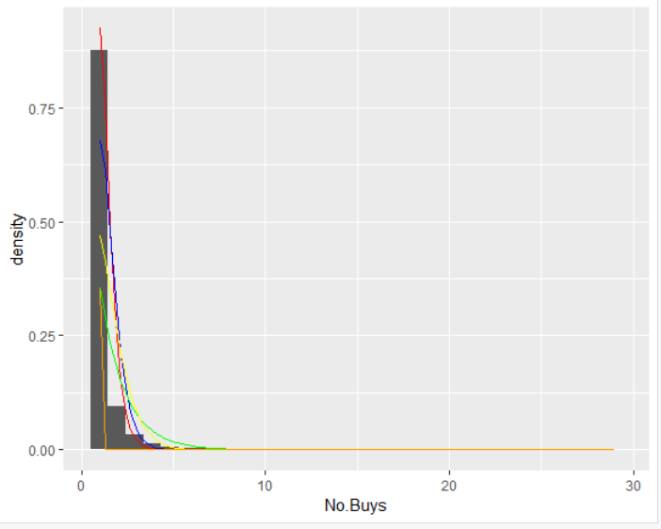

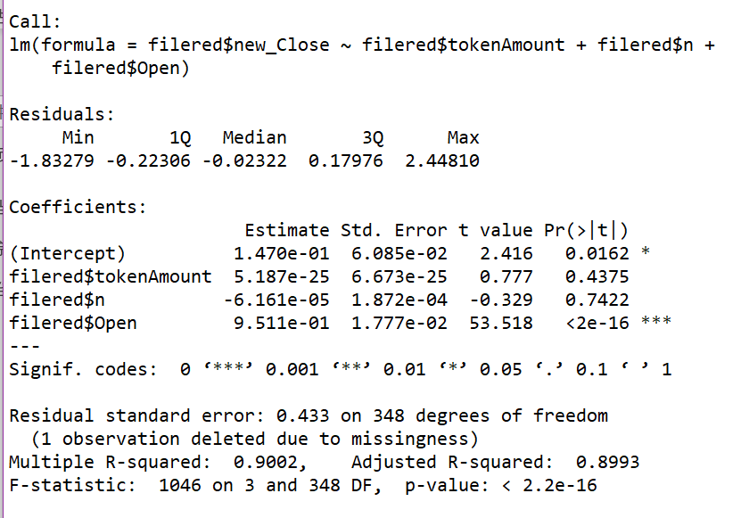

Bitqy

1. library(magrittr)
2. library(dplyr)
3. library(ggplot2)
4. library(readr)
5. library(fitdistrplus)
6. library(DAAG)
7. library("ggplot2")
8. library(anytime)
10. bitqy **<-** read_delim('C:/Users/ygaoq/OneDrive/MyDocuments/2019 Spring/Statistics/Project/Blockchain-Tokens-Data-Analytics/networkbitqyTX.txt', delim = " ", col_names = F)
11. names(bitqy) **<-** c('fromID', 'toID', 'unixTime', 'tokenAmount')
12. decimals **<-** 2
13. supply **<-** 1 * 10^10
14. bitqyFiltered **<-filter**(bitqy,tokenAmount **<** **decimals** * supply)  #filter out all outliers
16. #figure out how many users indruced those unnormal transcation
17. bitqy_outliers**<-** filter(bitqy,tokenAmount **>**= decimals * supply)
18. user_outliers **<-** bitqy_outliers %**>**% group_by(toID) %**>**% summarise(nn = n()) %**>**% ungroup
19. number_users_outliers**<-nrow**(user_outliers)
20. number_users_outliers
22. #get top X buyers data
23. buys**<-bitqyFiltered**%**>**% group_by(toID) %**>**% summarise(nn = n()) %**>**% ungroup #change the supply and decimals amount
24. buys_sorted_dec**<-buys**[order(-buys$n),]
25. #top 30 active buyers and number of buys
26. top_30_buyers**<-buys_sorted_dec**%**>**%head(30)
27. top_30_buyers
29. ########################################Question 1############################################
31. #####group by user pairs#####
32. buys_pairs**<-bitqyFiltered**%**>**% group_by(fromID, toID) %**>**% summarise(nn = n()) %**>**% ungroup
33. for (row in 1:nrow(buys_pairs)) {
34. a**<-buys_pairs**[row,"fromID"]
35. b**<-buys_pairs**[row,"toID"]
36. for (inner_row in row:nrow(buys_pairs)) {
37. c**<-buys_pairs**[inner_row,"fromID"]
38. d**<-buys_pairs**[inner_row,"toID"]
39. if(a==d&&b==c){
40. buys_pairs[inner_row,"fromID"]**<-d**
41. buys_pairs[inner_row,"toID"]**<-c**
42. }
43. }
44. }
45. buys_pairs**<-bitqyFiltered**%**>**% group_by(fromID*toID+fromID+toID) %**>**% summarise(nn = n()) %**>**% ungroup
46. buys_pairs**<-bitqyFiltered**%**>**% group_by(fromID, toID) %**>**% summarise(nn = n()) %**>**% ungroup
47. buys_pair_sorted_asc**<-buys_pairs**[order(buys_pairs$n),]
48. buys_pair_less_30**<-subset**(buys_pair_sorted_asc,n**<30**)
49. buys_pair_data**<-buys_pair_less_30**
51. #####find out estimates of paramaters of several distribution based on the buys_pairs data set#####
52. exp_dis **<-** fitdist(buys_pair_data$n, 'exp')
53. exp_dis
54. gamma_dis **<-** fitdist(buys_pair_data$n, 'gamma')
55. gamma_dis
56. lnorm_dis **<-** fitdist(buys_pair_data$n, 'lnorm')
57. lnorm_dis
58. pois_dis **<-** fitdist(buys_pair_data$n, 'pois')
59. pois_dis
60. weibull_dis **<-** fitdist(buys_pair_data$n, 'weibull')
61. weibull_dis
63. gofstat(list(exp_dis, gamma_dis, lnorm_dis))
64. descdist(buys_sorted_asc$n,boot=1000)
66. #lognorm
67. fit_lnorm **<-** fitdist(buys_pair_less_30$n,"lnorm")
68. summary(fit_lnorm)
69. plot(fit_lnorm)
70. cdfcomp(fit_lnorm)
72. #exp
73. fit_exp **<-** fitdist(buys_pair_less_30$n,"exp")
74. summary(fit_exp)
75. plot(fit_exp)
76. cdfcomp(fit_exp)
78. #gamma
79. fit_gamma **<-** fitdist(buys_pair_less_30$n,"gamma")
80. summary(fit_gamma)
81. plot(fit_gamma)
82. cdfcomp(fit_gamma)
84. #weibull
85. fit_weibull **<-** fitdist(buys_pair_less_30$n,"weibull")
86. summary(fit_weibull)
88. #normal
89. fit_normal **<-** fitdist(buys_pair_less_30$n,"norm")
90. summary(fit_normal)
92. #pois
93. #normal
94. fit_pois **<-** fitdist(buys_pair_less_30$n,"pois")
95. summary(fit_pois)
97. #unif
98. fit_unif **<-** fitdist(buys_pair_less_30$n,"unif")
99. summary(fit_unif)
100. plot(fit_unif)
101. cdfcomp(fit_unif)
103. ######################draw graph#######################
104. all_density **<-** ggplot(data=buys_pair_less_30) +
105. geom_histogram(bins=30,aes(x = buys_pair_less_30$n, ..density..)) +
106. stat_function(fun = dlnorm, args = list(meanlog = 0.9122759, sdlog = 0.9075324),
107. colour = "red")+
108. stat_function(fun = dgamma, args = list(shape = 1.2923088, rate=0.3361498),
109. colour = "blue")+
110. stat_function(fun=dexp, args=list(rate=0.2600901),colour="green")+
111. stat_function(fun=dweibull, args=list(shape=1.083871, scale=3.982783),colour="yellow")+
112. stat_function(fun=dpois, args=list(lambda=3.844821),colour="orange")+
113. xlab("No.Buys")
114. all_density
116. ########################################Question 1############################################

119. ########################################Question 2############################################
120. bitqy_prices **<-** read_delim("C:/Users/ygaoq/OneDrive/MyDocuments/2019 Spring/Statistics/Project/Blockchain-Tokens-Data-Analytics/bitqy", delim = "\t", col_names = T) #load token price data
121. names(bitqy_prices) **<-** make.names(names(bitqy_prices))
122. bitqy_prices **<-** bitqy_prices %**>**% mutate(date = as.Date(Date, format = '%m/%d/%Y'))
124. bitqy **<-** read_delim('C:/Users/ygaoq/OneDrive/MyDocuments/2019 Spring/Statistics/Project/Blockchain-Tokens-Data-Analytics/networkbitqyTX.txt', delim = " ", col_names = F)
125. names(bitqy) **<-** c('fromID', 'toID', 'unixTime', 'tokenAmount')
126. decimals **<-** 2
127. supply **<-** 1 * 10^10
128. bitqy_filtered **<-filter**(bitqy,tokenAmount **<** **decimals** * supply)
129. ## convert data type of unixTime
130. bitqy_filtered **<-** bitqy_filtered %**>**%
131. mutate(date = anydate(unixTime))
132. names(bitqy_filtered) **<-** c('fromID', 'toID', 'unixTime', 'tokenAmount', 'date')
134. ## merge the prices and edge
135. bitqy_merged**<-merge**(x = bitqy_prices, y = bitqy_filtered, by = "date", all.x = TRUE)
137. ################Determin K##########################
138. top_30_buyers**<-buys_sorted_dec**%**>**%head(30)
140. top_K**<-c**(1:30)
141. count **<-** 1
142. for (val in top_K) {
143. top_K_buyers**<-buys_sorted_dec**%**>**%head(val)
144. filter_K_bitqy_merged**<-filter**(bitqy_merged,toID %in% top_K_buyers$toID)
145. filter_K_bitqy_merged=transform(filter_K_bitqy_merged,average_price= (Open+Close)/2)
146. filter_K_bitqy_merged$num_Date **<-**  as.numeric(as.POSIXct(filter_K_bitqy_merged$date))
147. filered**<-filter_K_bitqy_merged**%**>**% group_by(num_Date) %**>**% summarise(nn = n(),Close=mean(Close),tokenAmount=sum(tokenAmount),Open=mean(Open))
148. shift **<-** function(x, n){
149. c(x[-(seq(n))], rep(NA, n))
150. }
151. filered$new_Close**<-shift**(filered$Close,1)
152. num_rows**<-nrow**(filered)
153. filered[-num_rows,]
154. regression**<-lm**(filered$new_Close~filered$tokenAmount+filered$n+filered$Open)
156. setwd("C:/Users/ygaoq/Desktop/bitqy")
157. yourfilename=paste("W",val,".txt",sep="")
158. capture.output(summary(regression),append = TRUE,file = "C:/Users/ygaoq/Desktop/bitqy/Final_Result.txt")

161. summary(regression)
162. par(mfcol=c(2,2))
163. setwd("C:/Users/ygaoq/Desktop/bitqy")
164. yourfilename=paste("A",val,".png",sep="")
165. png(file=yourfilename)
166. opar **<-** par(mfrow=c(2,2))
167. plot(regression)
168. dev.off()
169. }

