Lab5: Hosting a web service using Kubernetes cloud orchestration
Please fill in the report and submit the pdf to NYUClasses
Name: | Eugene Wang | ID: | yjw259 | Date:

Objectives
- Understand the concept of container and the reason for cloud orchestration
- Get familiar with the Kubernetes and how to use the Kubernetes orchestration tool.
- Experience with hosting a popular cloud service using Kubernetes
- Use Kubernetes to deploy your WordPress server with a trivial loadbalancer
- Understand that you can manage Kubernetes services on Google Cloud Platform (Google Kubernetes Engine)

Experiments Tasks

Basics
- Go through the Kubernetes introduction to get the general idea of Kubernetes
https://kubernetes.io/docs/concepts/overview/what-is-kubernetes/

Install Tools
- Install Docker:
https://docs.docker.com/engine/install/ubuntu/
- Install kubectl:
https://kubernetes.io/docs/tasks/tools/install-kubectl/
- Install Minikube:
https://kubernetes.io/docs/tasks/tools/install-minikube/
- Install Helm:
https://github.com/helm/helm

Host a Wordpress server on Kubernetes Cluster
  - Make sure the installation is complete
  - Run a single-node Kubernetes cluster locally
  - Deploy your WordPress server using helm
https://hub.helm.sh/charts/bitnami/wordpress
  - Use kubectl commands to interact with Kubernetes cluster
  - Verify your deployment of wordpress both on your browser and terminal
  - Monitor the status of your Kubernetes cluster

- Reports

  - General
1. (a) What is a container from an operating systems perspective?
(b) Why are cgroups important to containers?
(a) For (host) OS, the (running) containers are just another application software processes. For those applications inside the container, container is an (light-weighted) abstraction of the OS.
(b) Cgroups is a linux kernel feature to control resources (namespace,CPU,I/O,etc) for processes. Cgroups enables processes to run in an isolated space.
Ref: https://itnext.io/breaking-down-containers-part-0-system-architecture-37afe0e51770

2. In Docker what does the ENTRYPOINT command allow you to do?
We use ENTRYPOINT command in dockerfile to run the program. It will be the first program when we run an image.

3. (a) In Kubernetes, what is a pod and why is it useful?
(b) What is a label and why is it useful?
A Pod is a group of containers, with shared storage/network resources, and the same namespace. Pod are useful because it enable these containers to efficiently communicate.
Labels are key/value pairs used to specify pods and manage/group/filter pods/resources. It is useful because we can use it to highlight the ownership of a pod, control the timing to run the pods, or limit the resources.

- (a) In Kubernetes, what is a service and why is it useful?
(b) What is a ReplicaSet and why is it useful?
A Kubernetes service is a logical abstraction for a group of pods (which perform as a whole to provide a function). Since pods are frequently created/deleted, a Kubernetes service enables a group of pods, which as a whole provide that function (web service, for example) to be assigned a name and unique IP address. It is useful because we can use function to divide/manage pods.

A ReplicaSet ensures that a specified number of pod replicas are running at any given time. It is useful because we can use it to ensure reliability, manage load balance, and do autoscaling.

- What is the difference between a pod and a node?

A Node is a worker machine in Kubernetes and may be either a virtual or a physical machine. A Pod always runs on a Node.

3.2 Verify your installation

- Screenshots of running docker successfully
sudo docker run hello-world
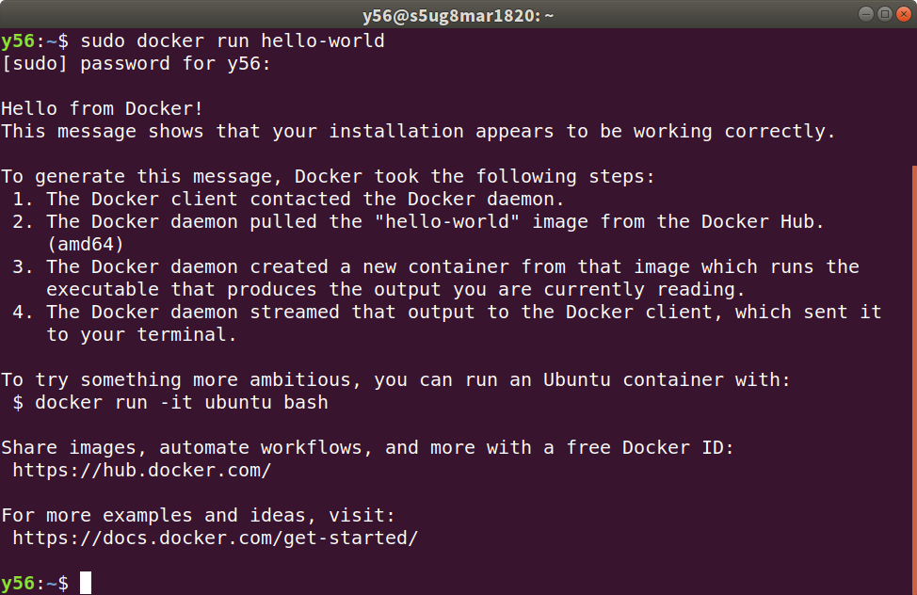

- Screenshots showing that you can start minikube successfully
minikube start --driver=docker
minikube status
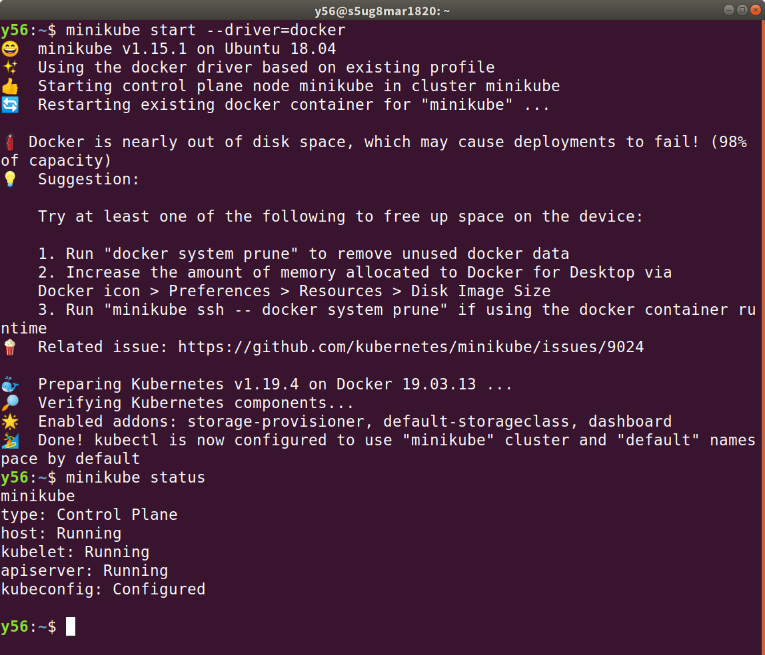

- Screenshots of verifying kubectl configuration
kubectl cluster-info
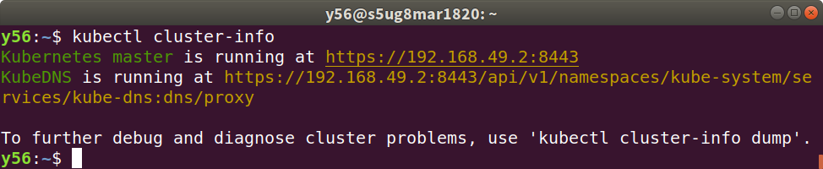

3.3 Deploy your WordPress
- Explain the commands
(a)
kubectl get pods: List all pods
kubectl get services: List all services in the namespace
(b)
kubectl describe deployment: Get details of your Deployment
kubectl logs <pod-name>: Print the logs for a pod

- Screenshots of your terminals showing that your pod is up (Hint: use a command in 9a)
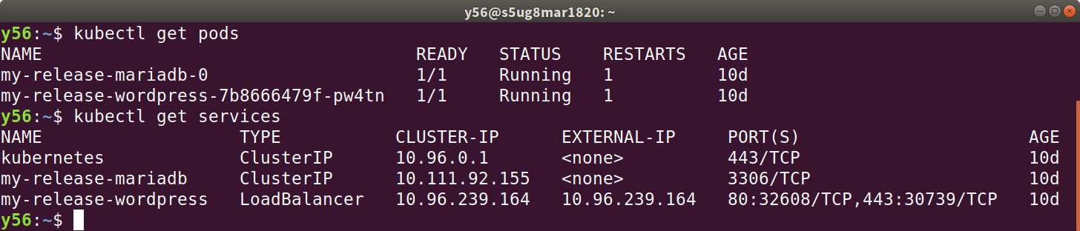

- Screenshots of your terminals showing your running service along with the external IP address that can be used to access your pod. (Hint: use commands in 9a)
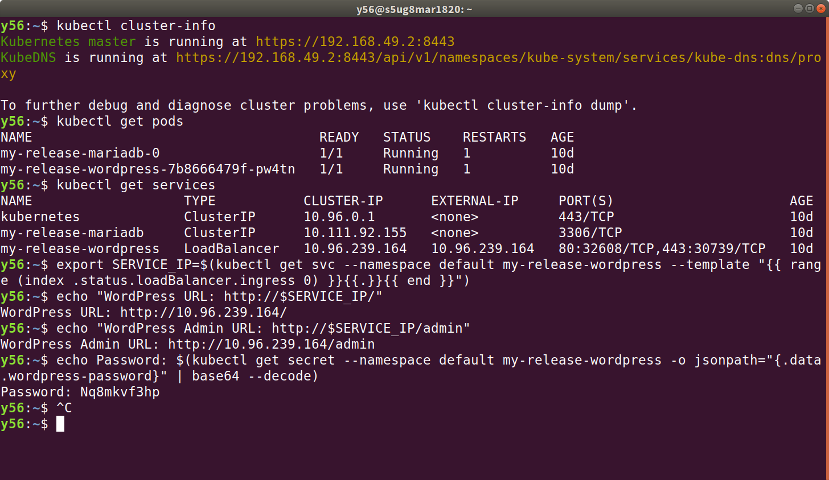

- (a)Screenshots of your browser running your wordpress. What is your wordpress URL?
(b)Screenshots of login to your wordpress as admin
http://10.96.239.164/
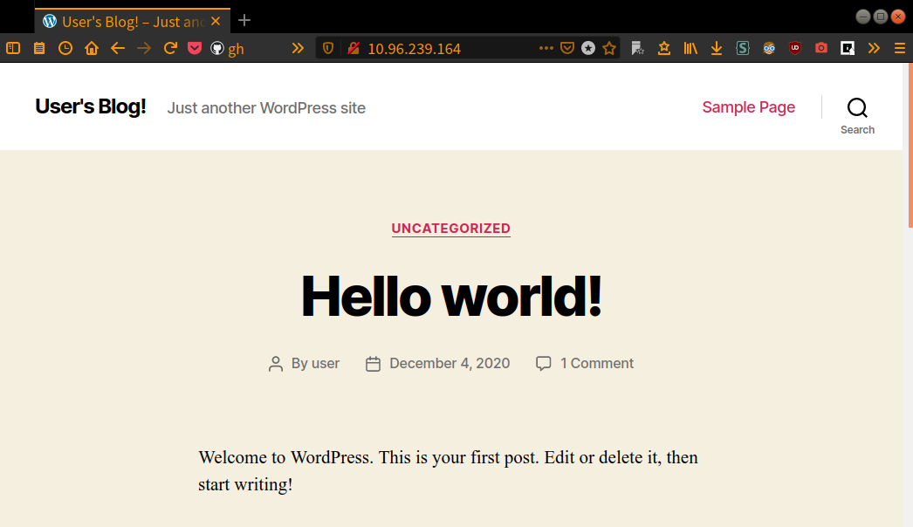
–
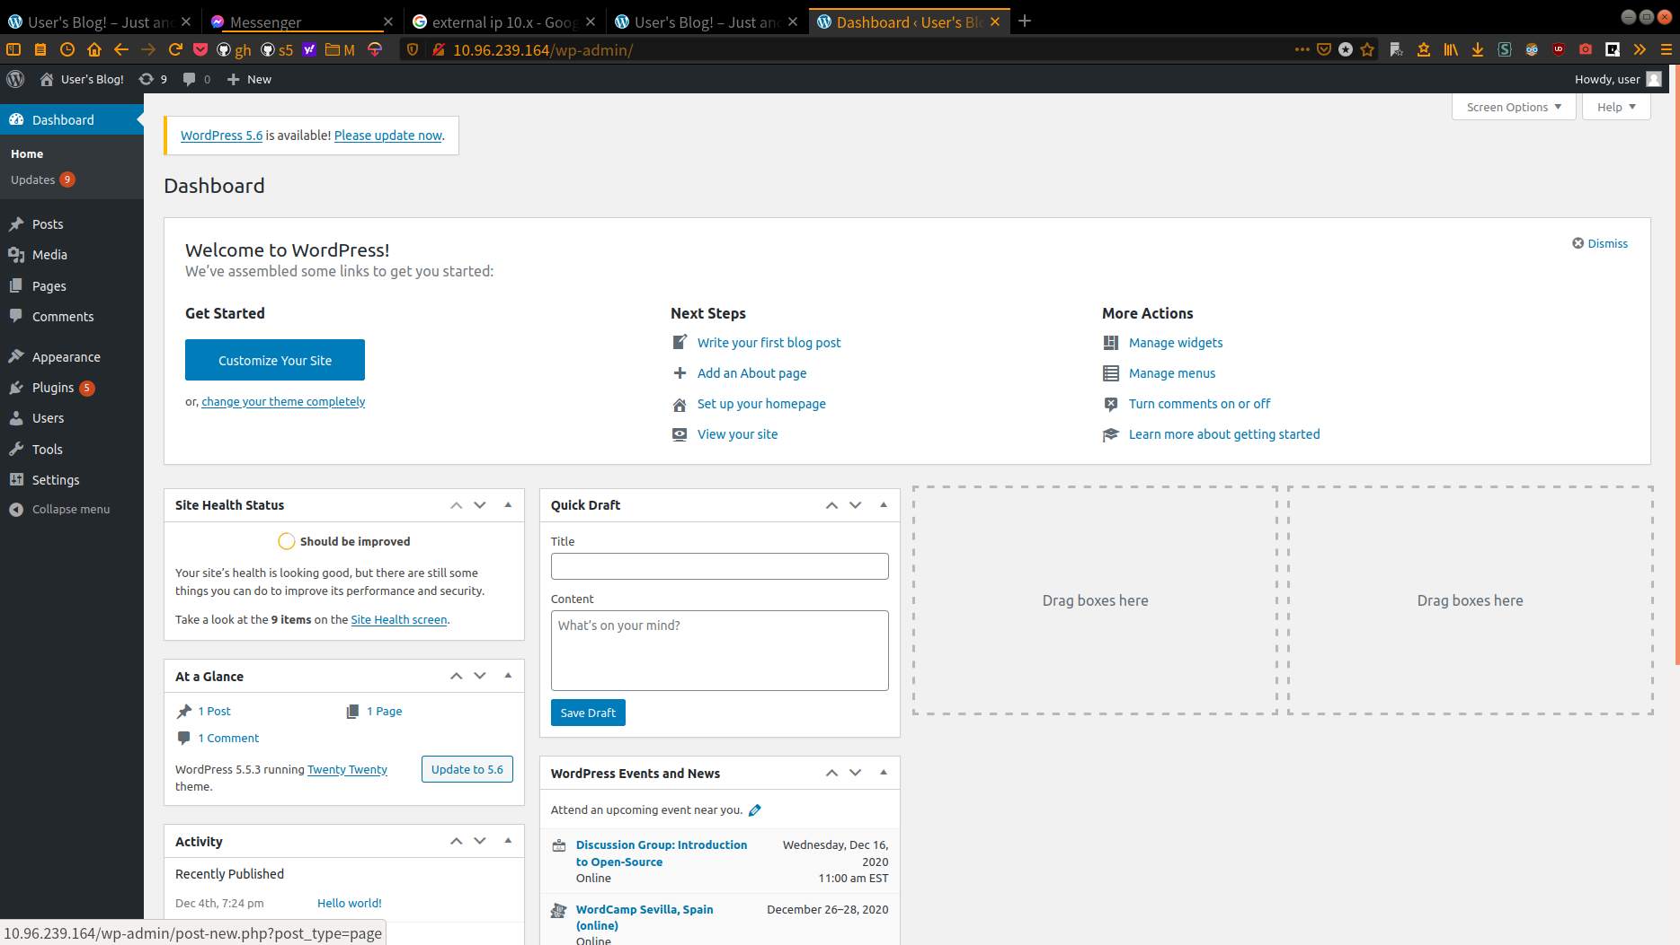

- What happens after you manually delete a pod using the following command?
kubectl delete pods <your-pod-name>
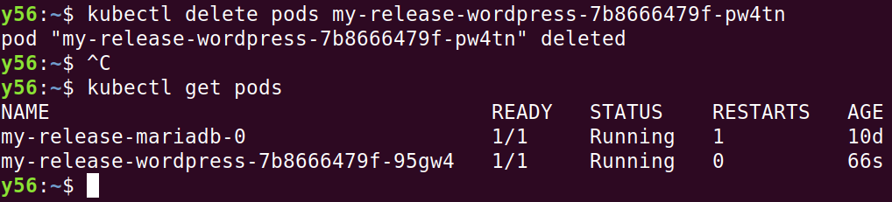
It restart a new pod. You can see the age is 66 sec.

- Screenshots of your Kubernetes Dashboard. What is the health status of your workloads?
All healthy for all workload.
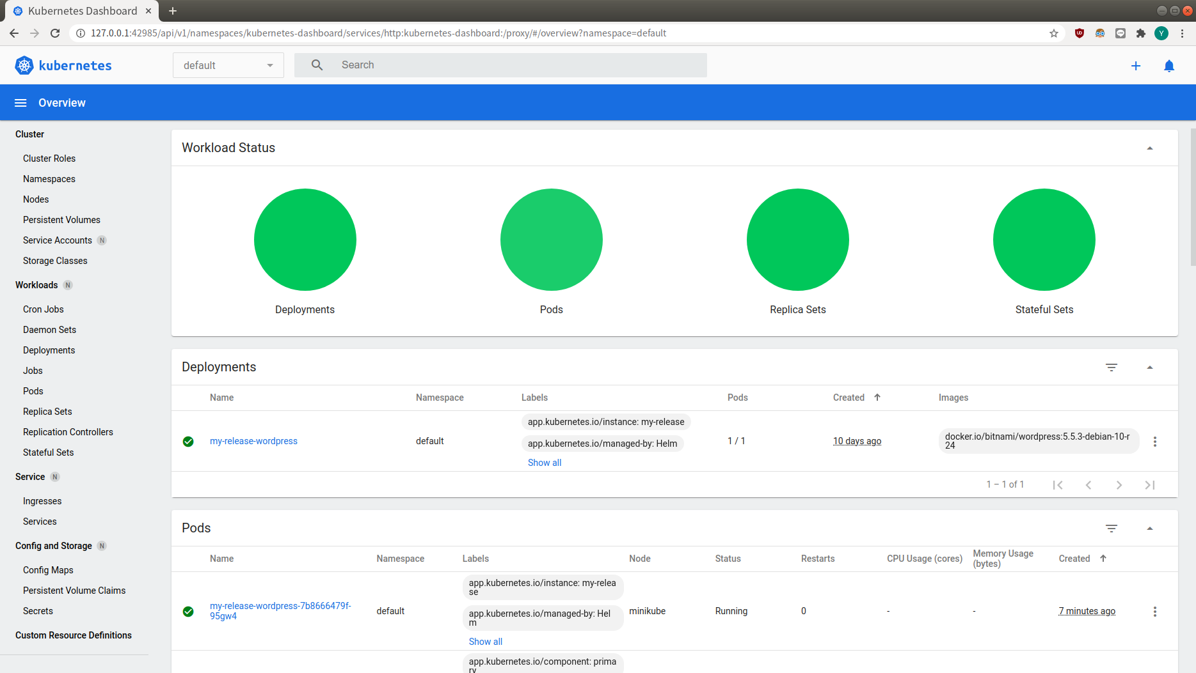

- Challenges you’ve encountered while doing this experiment and explain how you manage to solve them. If you do not experience any problem, simply say no problem.
1. permission problem, solved by
sudo usermod -aG docker $USER && newgrp docker
2. external ip problem, solved by
minikube tunnel

I am using native ubuntu 18.04 and Internet of the US.

We have zero tolerance to forged or fabricated data!! A single piece of forged/fabricated data would bring the total score down to zero.

