Lab3 Report: SDN Open Virtual Switches
* Please fill in the report and submit the pdf to NYUClasses
Name: |  | ID: |  | Date:

Objectives
- Understand SDN and get familiar with controllers.

References
- https://github.com/faucetsdn/ryu/blob/master/ryu/app/simple_switch_13.py
- https://ryu.readthedocs.io/en/latest/ofproto_v1_3_ref.html
- Slides

Experiments
  - Use Mininet to create the following topology: (4 Hosts, 4 OVSes ) with a remote controller
  - Use RYU to implement the controller (you can use other controller such as BEACON, POX, etc...)
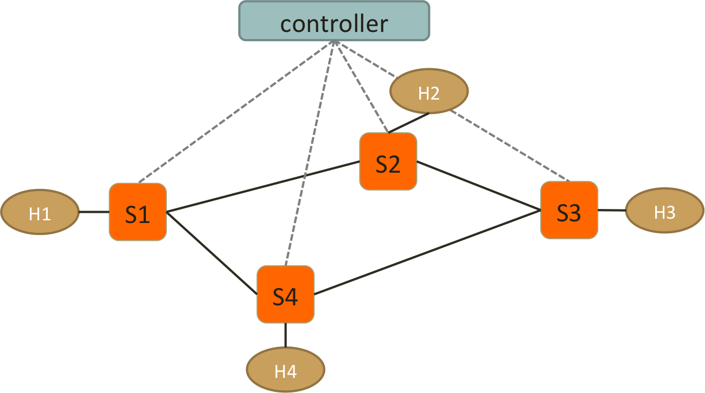
  - Test Connectivity using ping. (Hint: take care of ARP packets in the controller and install proper rules for them.)
  - Enforce these policies:
- Everything follows shortest path
- When there are two shortest paths with equal costs available
  - ICMP and TCP packets take the clockwise path OK
    - e.g. S1-S2-S3, S2-S3-S4 OK
  - UDP packets take the counterclockwise path OK
    - e.g. S1-S4-S3, S2-S1-S4 OK
  - H2 and H4 cannot send HTTP traffic (TCP with dst_port:80) OK
    - New connections are dropped with a TCP RST sent back to H2 or H4 OK
    - To be more specific, when the first TCP packet (SYN) arrives S2 or S4, forwarded it to controller, controller then create a RST packet and send it back to the host. OK
  - H1 and H4 cannot send UDP traffic OK
    - simply drop packets at switches OK
Important! Handle the flow rules in Packet-In and let the controller handles the rules dynamically.
If you use static rules for those policies or handle them in SwitchFeatureHandler, your lab score will be removed.

Reports
- Screenshots of your mininet with “pingall”, before and after starting the controller.
sudo mn --custom topology.py --topo mytopo --mac --arp --switch ovsk --controller remote

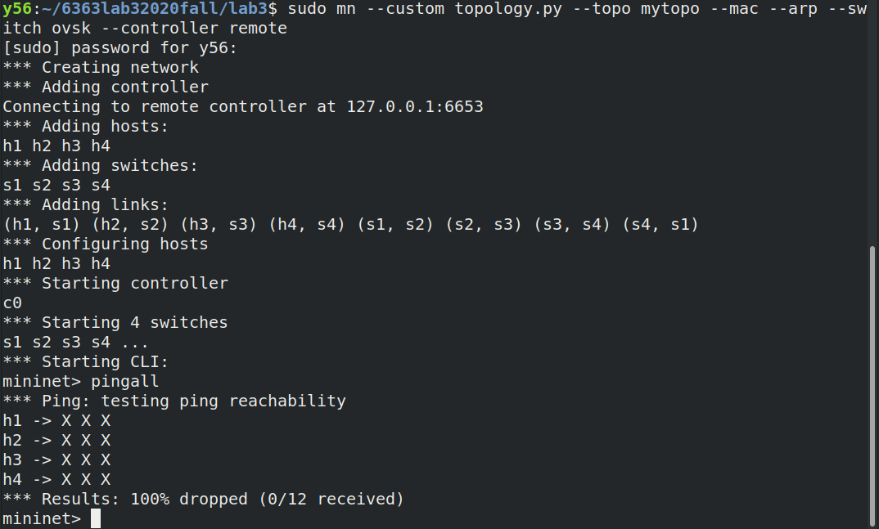
sh ./flow.sh
where flow.sh is
sudo ovs-vsctl set Bridge s1 protocols=OpenFlow13
sudo ovs-vsctl set Bridge s2 protocols=OpenFlow13
sudo ovs-vsctl set Bridge s3 protocols=OpenFlow13
sudo ovs-vsctl set Bridge s4 protocols=OpenFlow13

ryu-manager --verbose sample_code.py

got
OSError: [Errno 98] Address already in use
according to Internet it
if get error:
`OSError: [Errno 98] Address already in use`
then:
`sudo lsof -i :6653`
`sudo kill that_pid`
wait on
move onto main mode
move onto main mode
move onto main mode
for a while

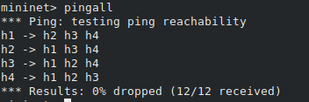
- How do you generate different traffic? Which tools do you use to generate: ICMP, TCP, UDP and HTTP traffic?
- arp: arping
  - h1 arping h2
  - h1 arp -a // show arp table
- icmp: ping/pingall
  - pingall
  - h1 ping h2
- tcp/udp: nc (netcat) or iperf
  - iperf
    - in xterm of host A: as server: iperf -s (-u) -p
    - in xterm of host B: as client: iperf -c dst_IP (-u) -p
  - netcat
    - nc -l (-u) 22 // to listen as server
    - nc -z -v -u dst_IP port_number // -v for verbose // -z for not containing data // as client
- http: (ie tcp@8080)
  - iperf
    - in xterm of host A: as server: iperf -s (-u) -p
    - in xterm of host B: as server: iperf -c dst_IP (-u) -p
- Generate ICMP flows from H4 to H3, and take screenshots of the flow table on S2 and S3 before and after the flow is generated to show that your flow follow the right path. (ovs-ofctl dump-flows)
 | Before ICMP flow is generated | After ICMP flow is generated
S2 | see above
S3 | see above
- Generate TCP flows (dst_port: 8080) from H4 to H2, and take screenshots of the flow table on S1 and S3 before and after the flow is generated. (ovs-ofctl dump-flows) Also, the screenshot of your Mininet or host that generates/receives the TCP traffic.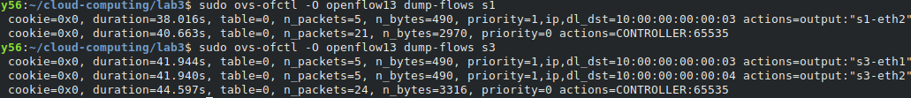
 | Before TCP flow is generated | After TCP flow is generated
S1 | see above
S3 | see above
 | Generates TCP traffic | Receives TCP traffic
Mininet or hosts | see below | 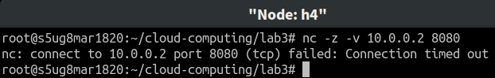
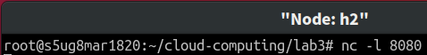
- Generate UDP flows from H2 to H4, and take screenshots of the flow table on S1 and S3 before and after the flow is generated. (ovs-ofctl dump-flows) Also, the screenshot of your Mininet or host that generates/receives the UDP traffic.
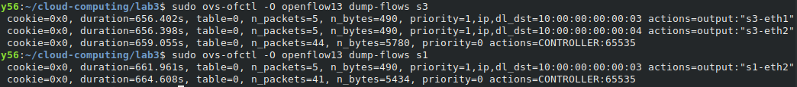
 | Before UDP flow is generated | After UDP flow is generated
S1 | see above | see below
S3 | see above | see below
 | Generates UDP traffic | Receives UDP traffic
Mininet or hosts | 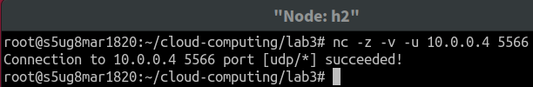 | 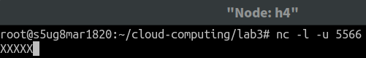
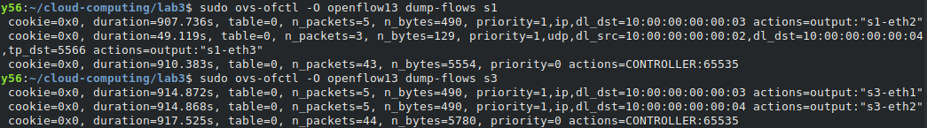
- Generate HTTP traffic from H2 to H1, and take screenshots of the flow table on S2 before and after the flow is generated. (ovs-ofctl dump-flows) Also, the screenshot of your Mininet or host that generates/receives the HTTP traffic.
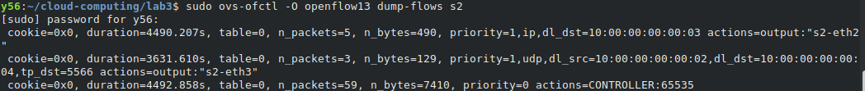
 | Before HTTP flow is generated | After HTTP flow is generated
S2 | see above | see below
 | Generates HTTP traffic | Receives HTTP traffic
Mininet or hosts | 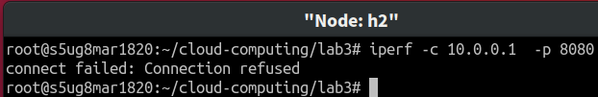 | 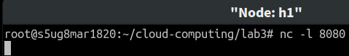
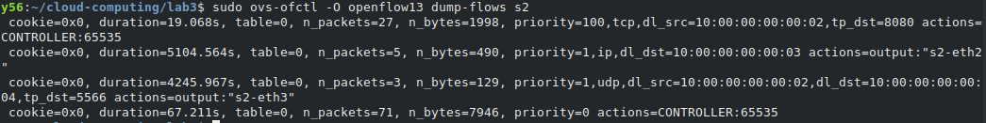
Note: “Connection refused” means the RST packets is successfully sent back to S2. Otherwise, you need to check if your RST packets is correct. e.g., 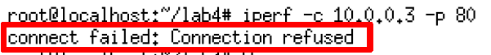

- Generate UDP traffic from H4 to H2, and take screenshots of the flow table on S4 before and after the flow is generated. (ovs-ofctl dump-flows) Also, the screenshot of your Mininet or host that generates/receives the UDP traffic.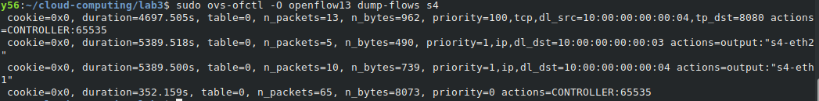
 | Before UDP flow is generated | After UDP flow is generated
S4 | see above | see below
 | Generates UDP traffic | Receives UDP traffic
Mininet or hosts | 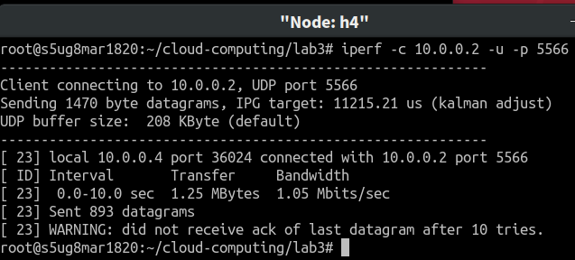 | 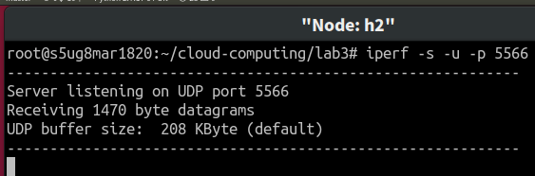
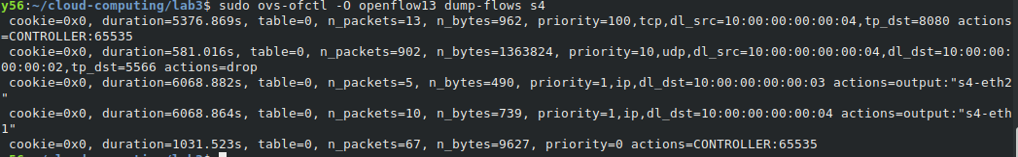

- Please find what is “Spanning Tree” and “Spanning Tree Protocol”? What’s the purpose of the protocol?
- “Spanning Tree”
  - A spanning tree T of an undirected graph G is a subgraph that is a tree which includes all of the vertices of G, with a minimum possible number of edges.
- “Spanning Tree Protocol”
  - To avoid loops which will echo too much when flood((broadcast radiation)). STP is a network protocol that builds a loop-free logical topology for Ethernet networks (L2 network) .
- What’s the purpose of the protocol?
  - To avoid loops which will echo too much when flood(broadcast radiation).

- Is it necessary to implement spanning tree in SDN for packet forwarding? Why?
NO, control plane should make sure that the flow tables in the data plane will not form loops. In SDN, switches obey control plane, having no needs to find spanning trees by themselves.
- If you want to find spanning tree in SDN, how will you implement and what is the difference between traditional “Spanning Tree Protocol” and the one in SDN?
I will let the controller collect traffic and calculate MST for us (using Kruskal's Algorithm). Then let the controller input the flow tables to all switches.

Using SDN can ease the burden of switches and use the spanning tree w/ minimum path cost

https://osrg.github.io/ryu-book/en/html/spanning_tree.html

- List three advantages of using OpenVSwitch and SDN controller compared to IP networks. Briefly explain why
- easy control traffic if we have privilege.
- can use different priority to send data (can be according to service type or fee)
- can do more service (firewall, security, etc) w/ white boxes
- easy to version up and configure switches remotely

- Include the controller’s code.
(Upload with your report or attach a sharable link)
https://github.com/y56/cloud-computing/blob/master/lab3/controller-lab3.py

- Include the topology file
(Upload with your report or attach a sharable link)
https://github.com/y56/cloud-computing/blob/master/lab3/topology.py

- Challenges you’ve encountered while doing this experiment, and explain how you manage to solve them. If you do not experience any problem, simply say no problem.
so difficult
little explanation of ryu
little clue

We have zero tolerance to forged or fabricated data!! A single piece of forged/fabricated data would bring the total score down to zero.

