Part 1: Linear Algebra (17 marks)
(a) Use Gaussian elimination and back substitution to find the solution for the system of equations
8𝑥+7𝑦+3𝑧=18,
−7𝑥−4𝑦−4𝑧=−11,
−6𝑥+5𝑦−4𝑧=−15
Write down the steps of the solution process. [7 marks]
Solution
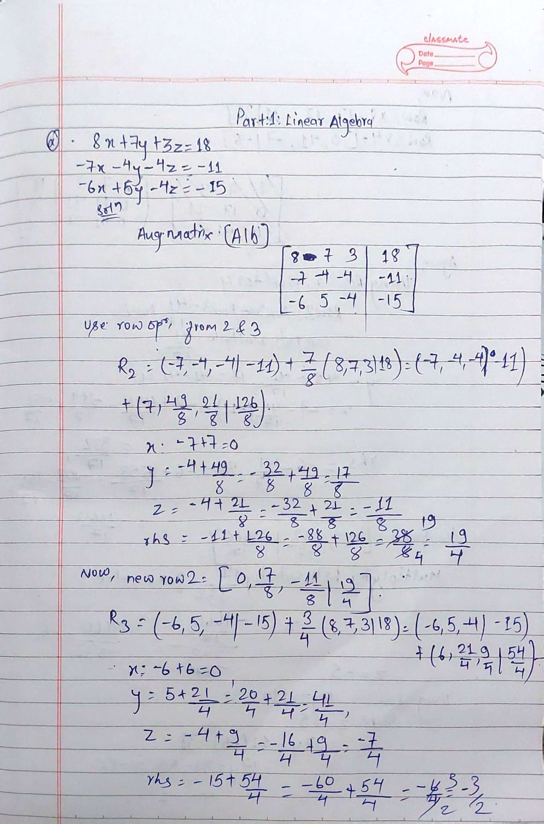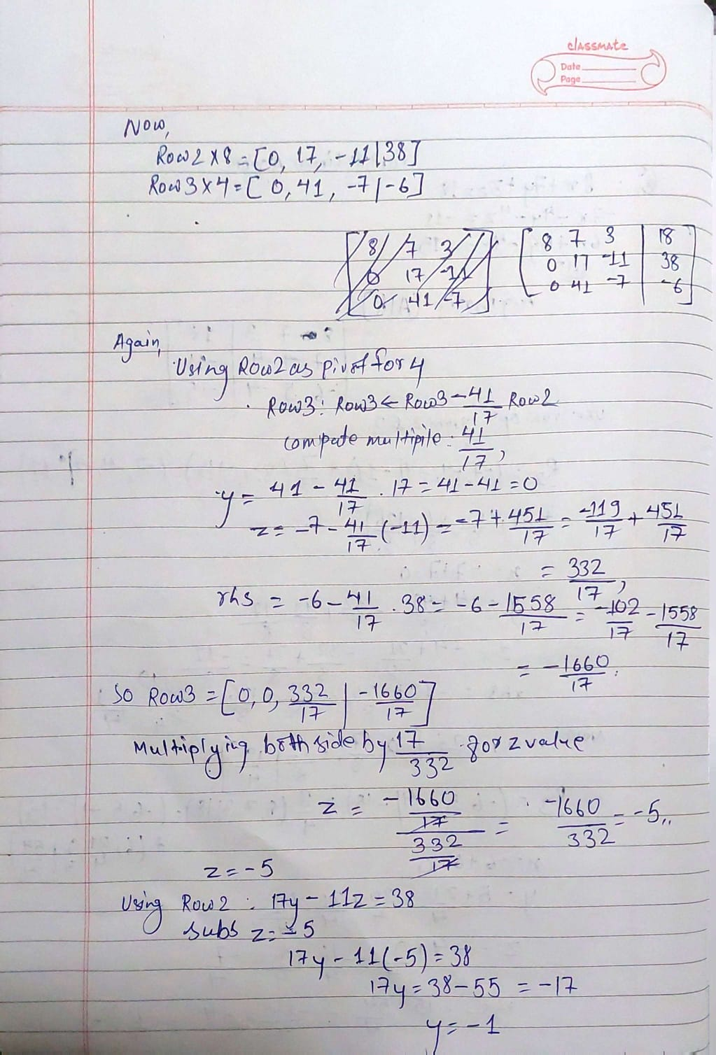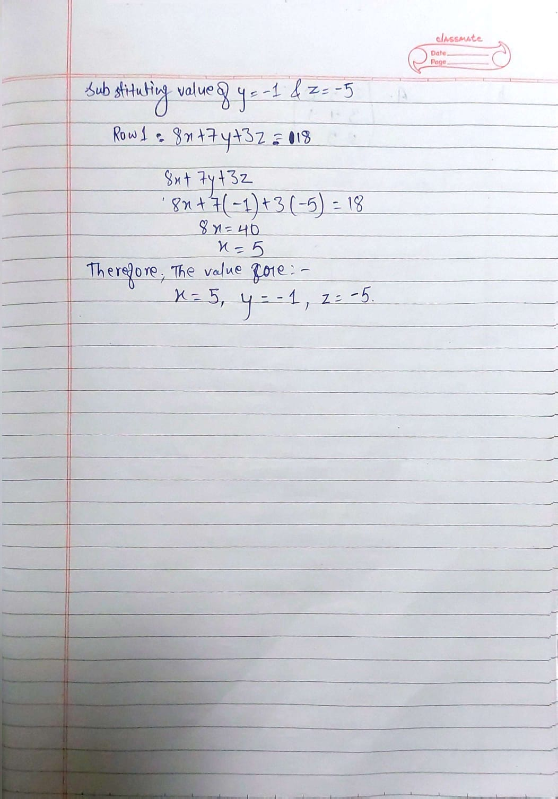
Therefore,
Answer
The value for
X=5
Y= -1
Z= -5
(b) Write down the first 8 digits of your student number, followed by 1, and arrange them in a 3x3 matrix starting from the top left corner. That is, if your student number is 23018745, you will get the matrix (230187451)
Then write and run Python code for the following tasks.
- Calculate the determinant of the matrix.
- Determine whether the matrix is singular or not.
- If the matrix is not singular, calculate and print the inverse matrix. If the matrix is singular, print a message stating that the matrix inverse cannot be calculated and go to step 4.
- Multiply the original matrix by its transpose, print the result.
- Calculate the sum of the diagonal elements of the matrix obtained in step 4.
Solution
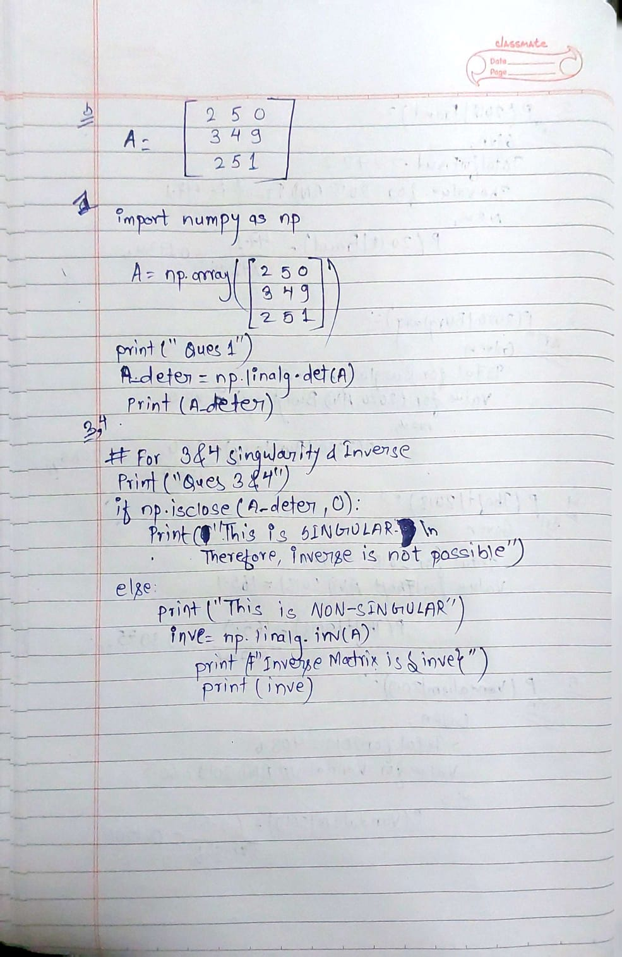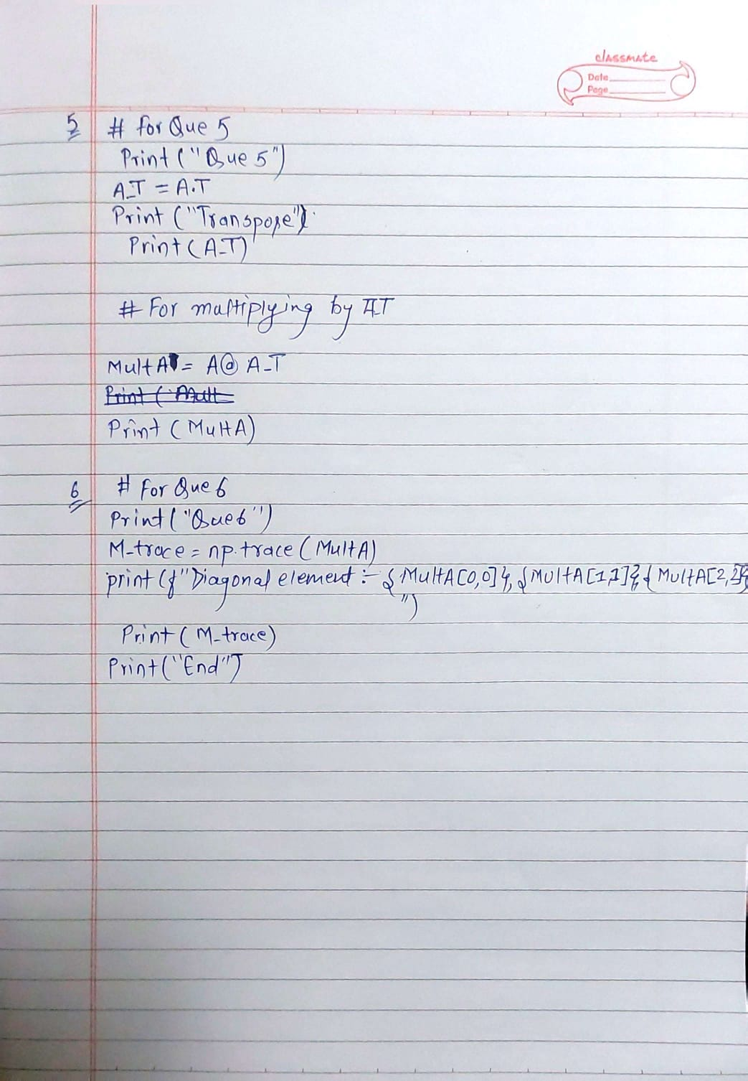
Here is the screenshot of the code and execution

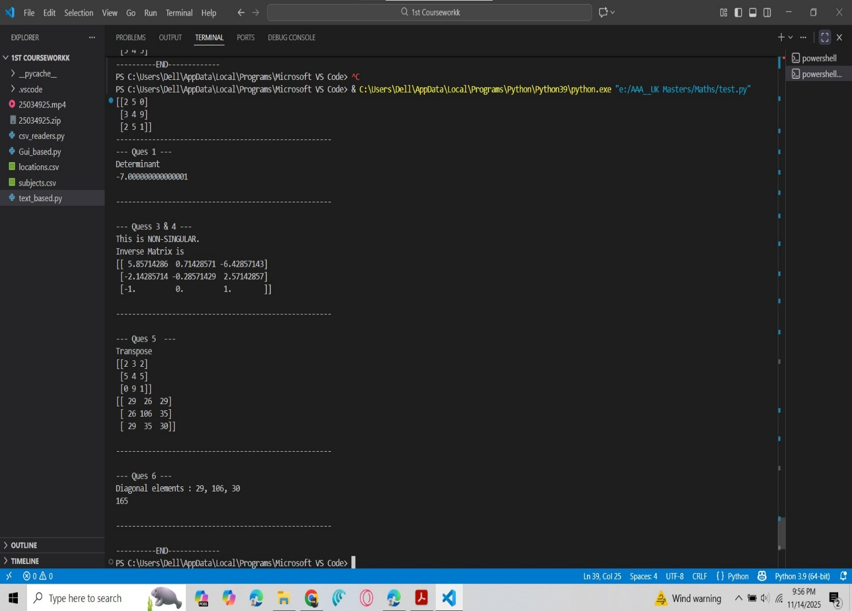

Therefore, The answer are
1. Determinant =-7
2. This is Not Singular
And
3. The inverse is
$$\begin{matrix}[ 5.85714286 & -0.71428571 & 6.42857143 \\ 2.14285714 & 0.28571429 & -2.57142857 \\ -1 & 0 & 1 ]\end{matrix}$$

4. Transpose
$$\begin{matrix}[ 29 & 26 & 29 \\ 26 & 106 & 35 \\ 29 & 35 & 30 ]\end{matrix}$$
5. The sum of diagonal element is 165
Part 2: Optimization (30 marks)
(a) Consider the function 𝑓(𝑥)=𝑥+42𝑥2−𝑥+8
Determine the absolute maximum and absolute minimum of this function in the interval [−10,10]. Write down the steps of the solution. Calculate both the positions and the values of the absolute extrema, with the accuracy of at least 3 significant digits. [10 marks]
Solution:
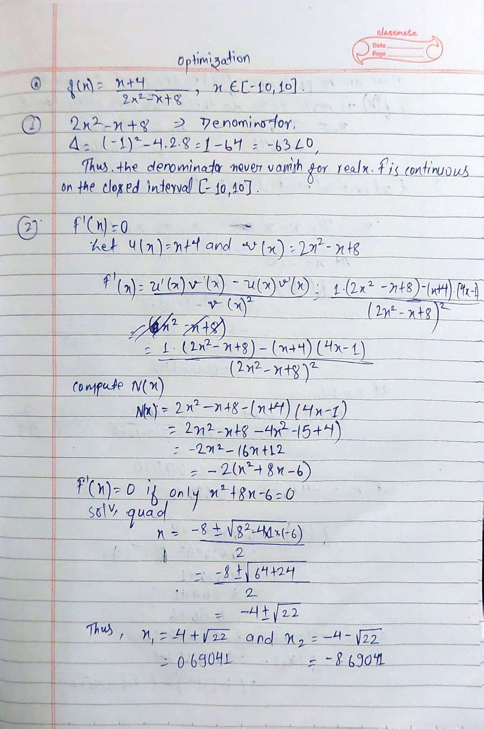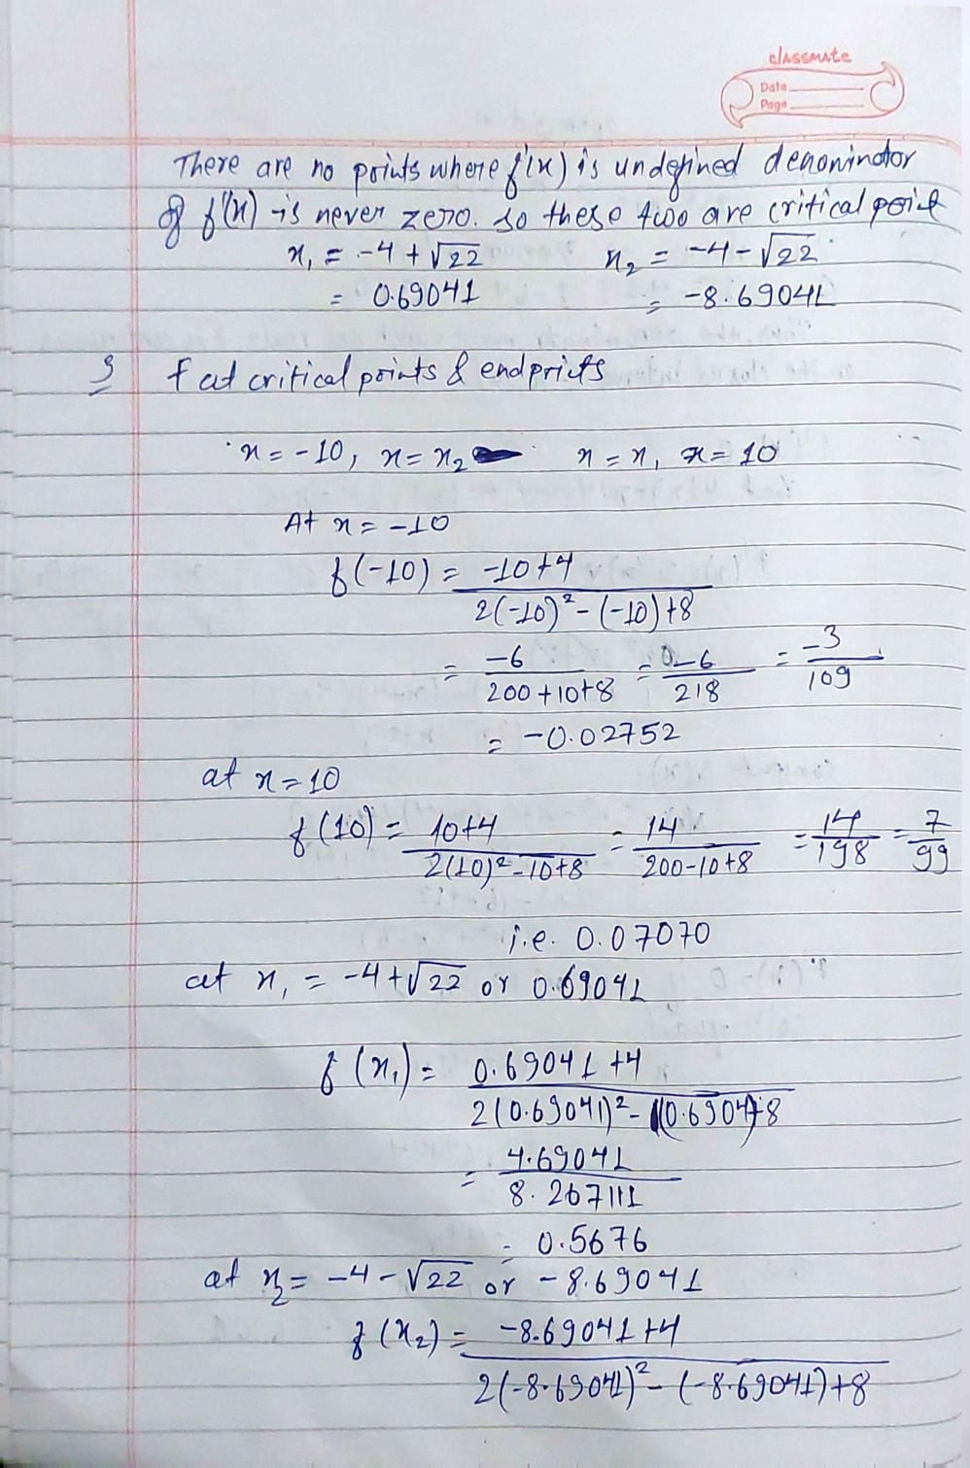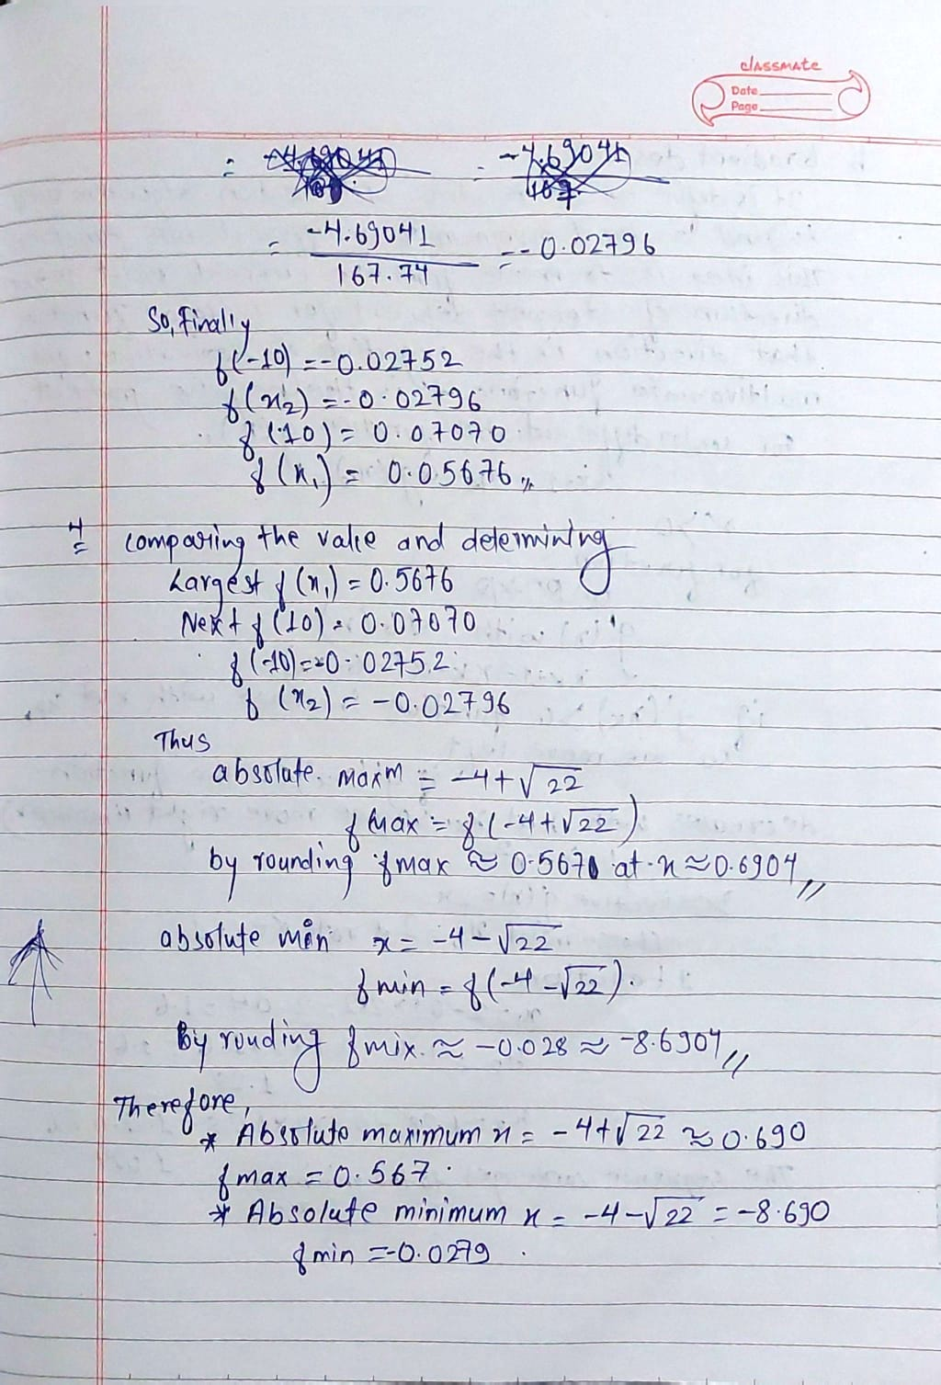
The answer are
Two critical Points
-4+22^ (1/2) = 0.690
-4-22^ (1/2) = -8.69
and we calculated for
f(-10)= -0.02752
f(10)=0.07070
f(0.690)=0.5676
f(-8.69)= 0.02796
Therefore,
Absolute Maxm value is 0.5676 that occurs at position x in 0.690
Absolute Minm value is -0.02796 that occur at position x in -8.69
b. Explain the concept of the gradient descent method with the help of a suitable example. Discuss advantages and disadvantages of this method for finding the maximum and minimum of a function. [10 marks]
Soultion:
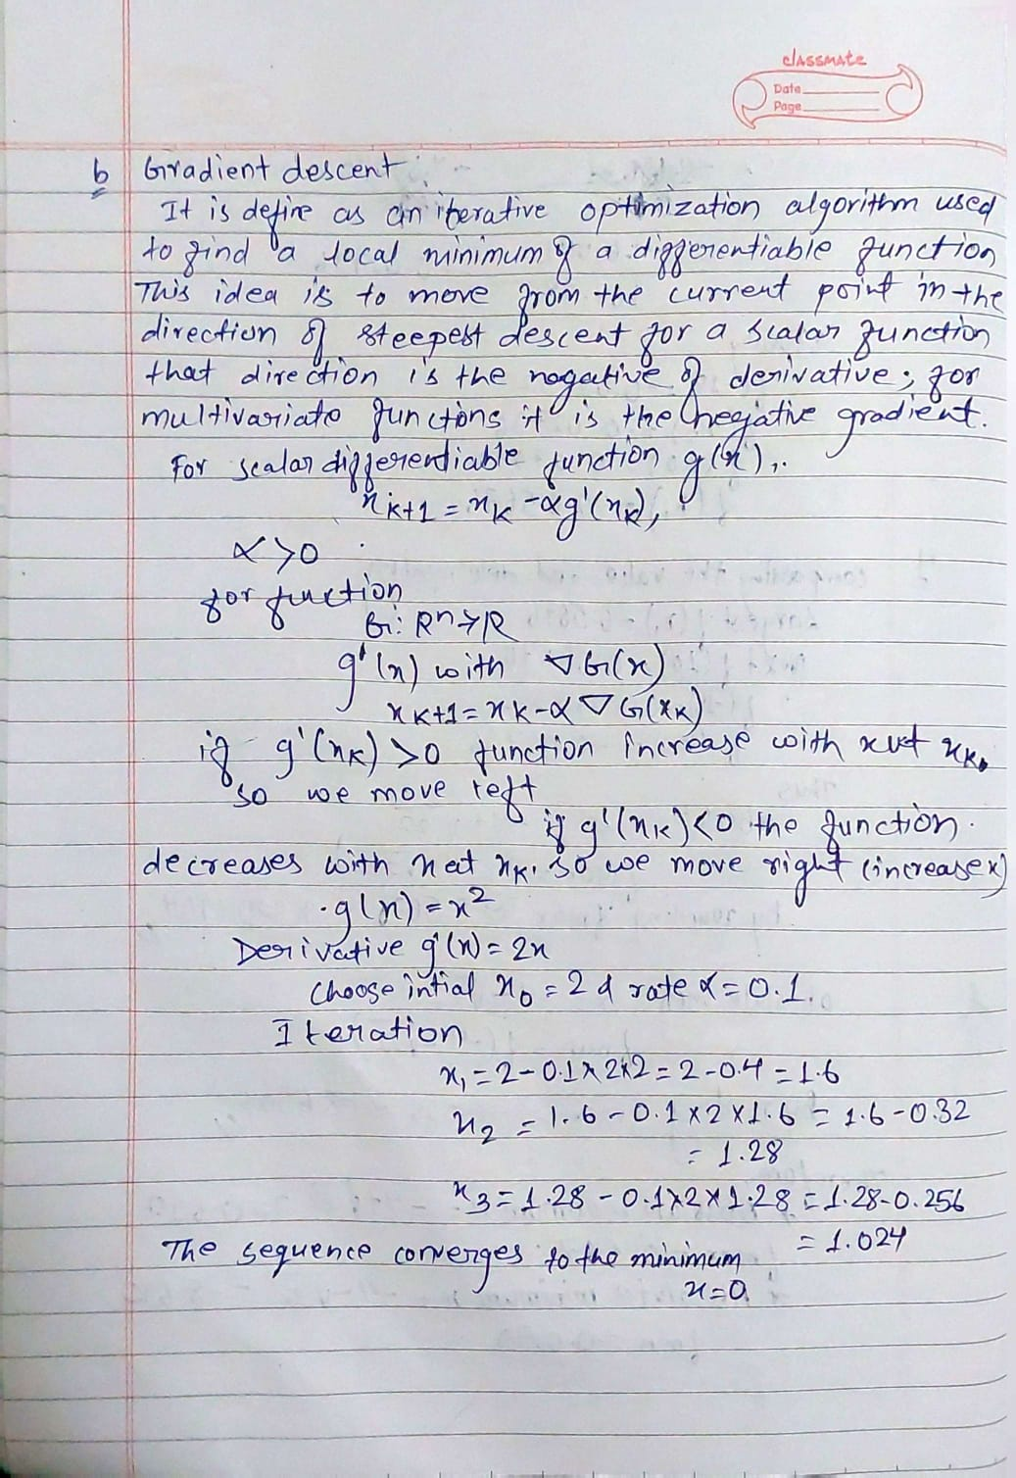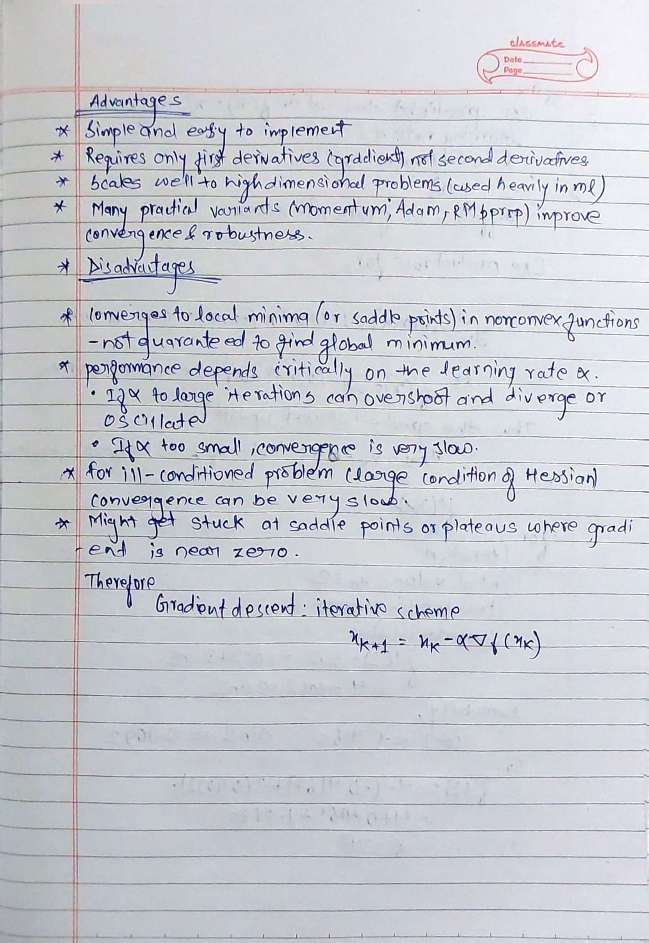
Therefore, by periodically taking a little step in the sharpest downhill direction that is defined by the slope at the present position the approach determines the minimum of a function.

(c) Consider the function
𝑓(𝑥)=𝑥2−𝑥cos𝑥
Assume that the learning rate is 𝛼=0.2 and the initial value is 𝑥=2. Using this information, calculate the first 3 iterations of the gradient descent method to find the minimum of the function, with the accuracy of at least 3 significant digits. [10 marks]
Solutions:
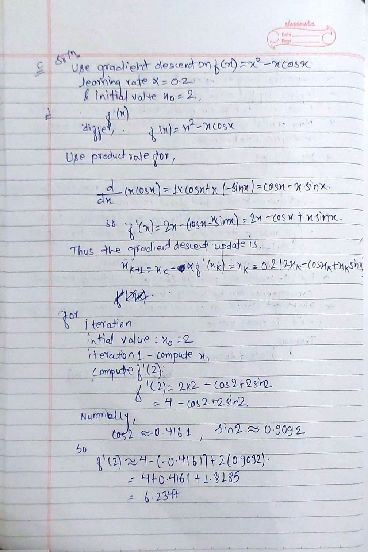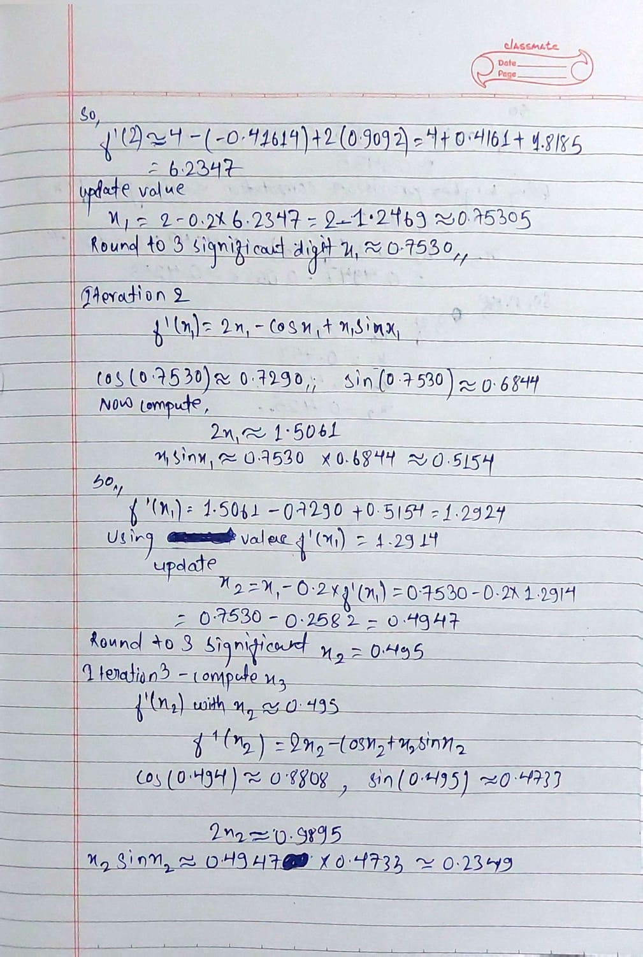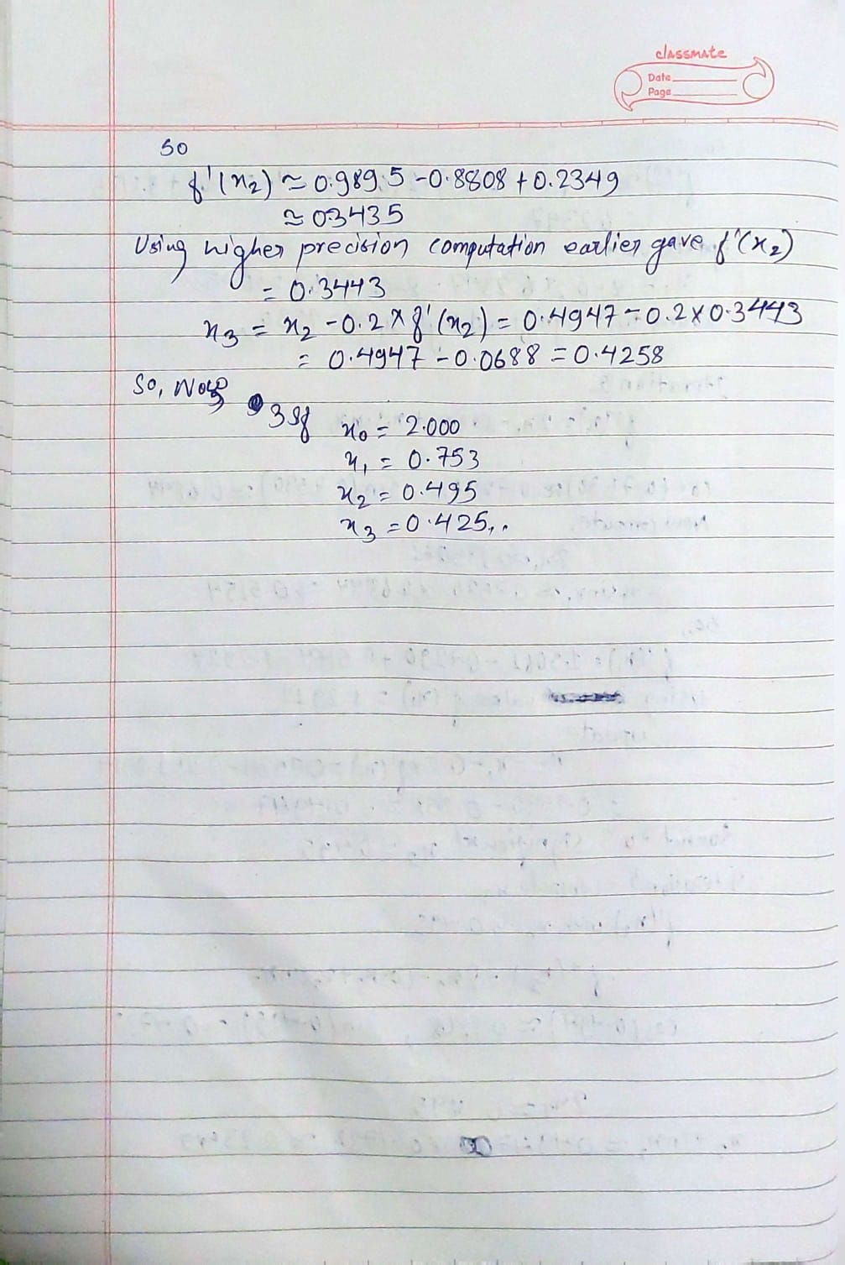
Therefore,
The answer are is
X0=2
the first iteration are
X1=0.753
X2=0.495
X3=0.425
Part 3: Conditional probability (25 marks)
(a) Explain the concept of the Bayes theorem of conditional probability with the help of a suitable example. [10 marks]
Solutions:
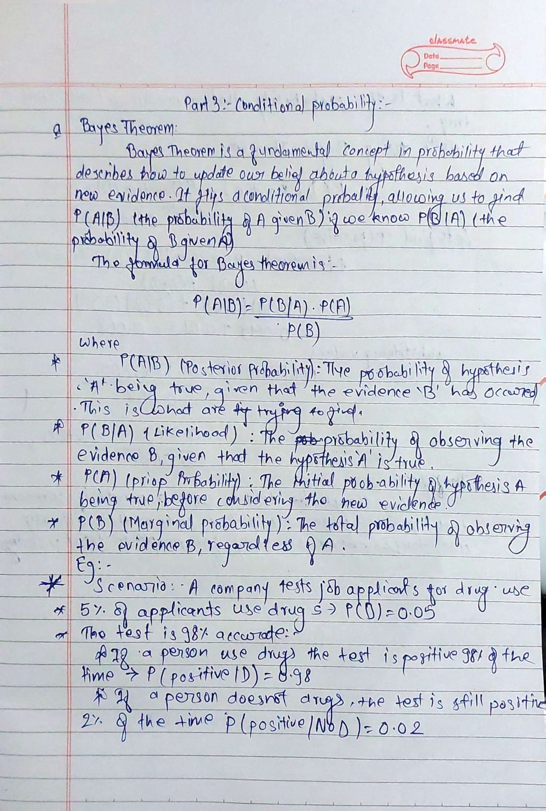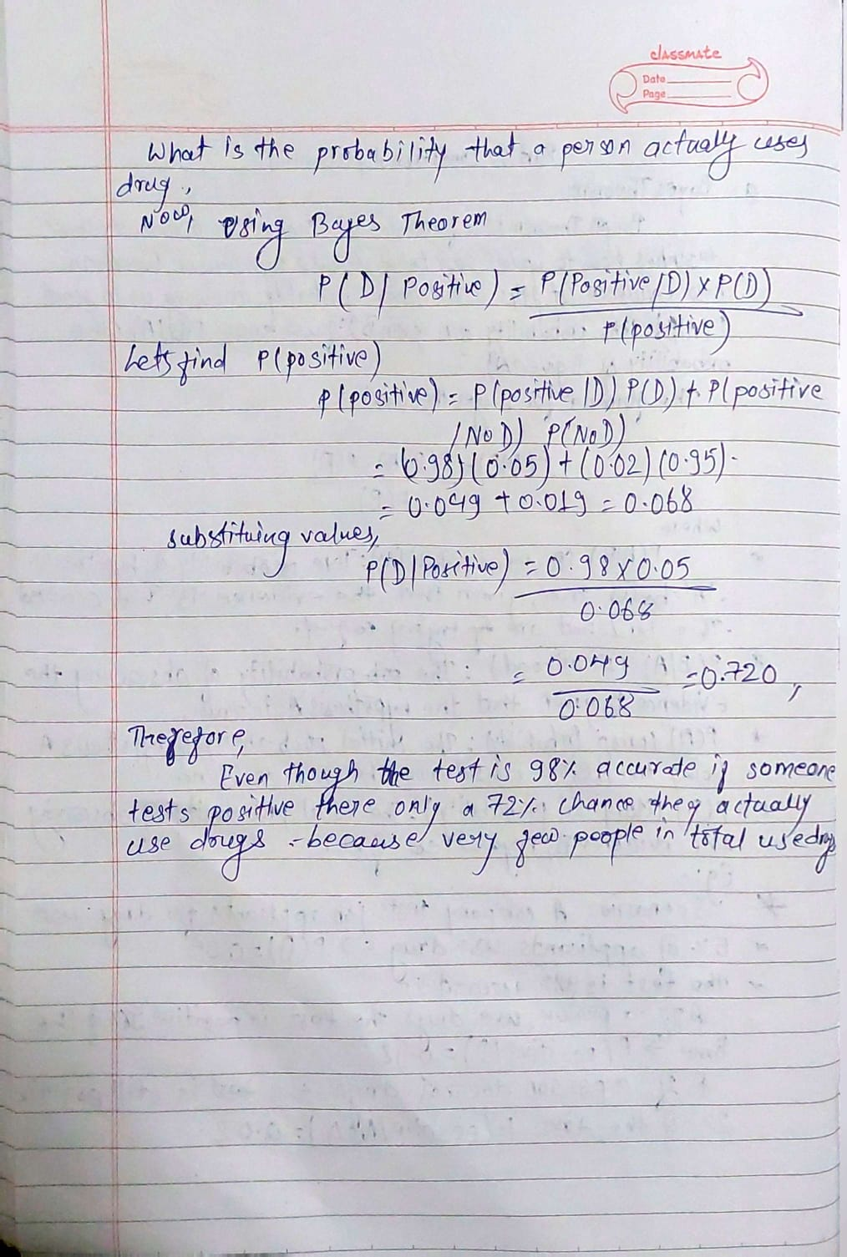

Therefore, Bayes' theorem is a formula that uses the logical impact of recent data to statistically update an initial assumption.

(b) Table 1 shows the data (crime rate for 100000 population) for non-violent crime in the state of Colorado in 2017-2021. The total data is 2142.5. Assuming that a random non-violent crime has been committed during this period, calculate the following probabilities [5 marks]:
P(Vandalism) = ?
P(2020 AND Theft) = ?
P(2018 OR Burglary) = ?
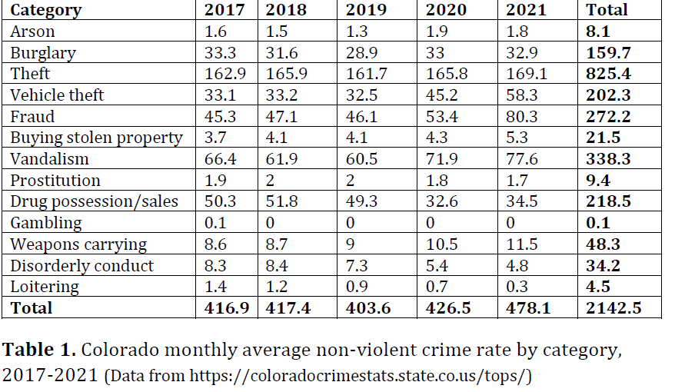
(c) Using the information given in Table 1 calculate the following conditional probabilities [10 marks]:
P(2017|Arson) = ?
P(2018|Fraud) = ?
P(2020|Burglary) = ?
P(Theft|2018) = ?
P(Vandalism|2019) = ?
Solutions:
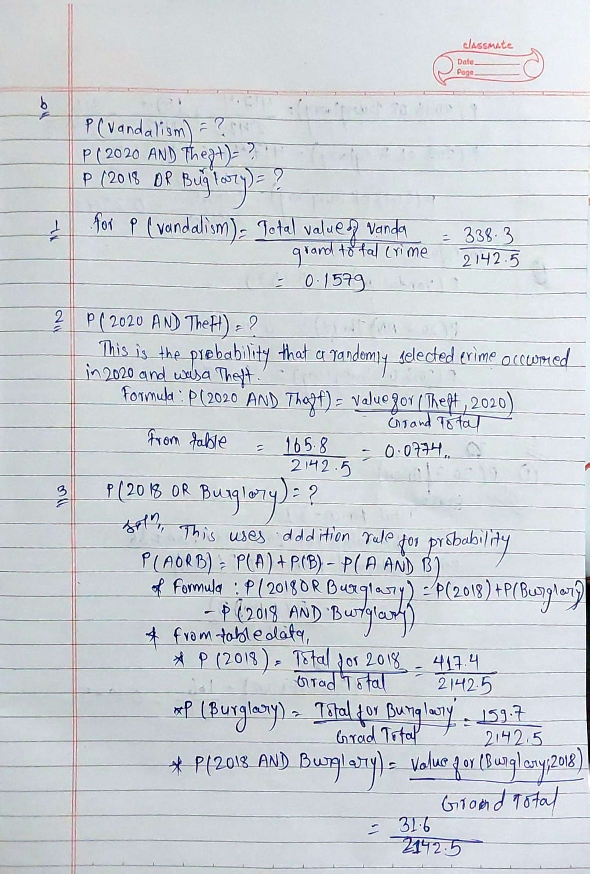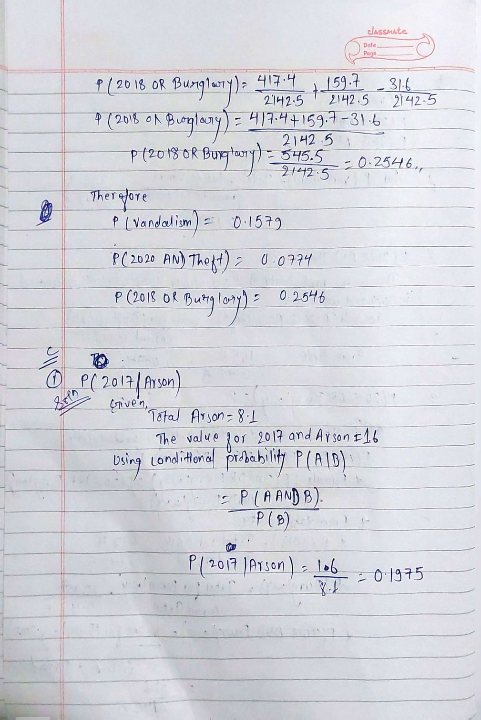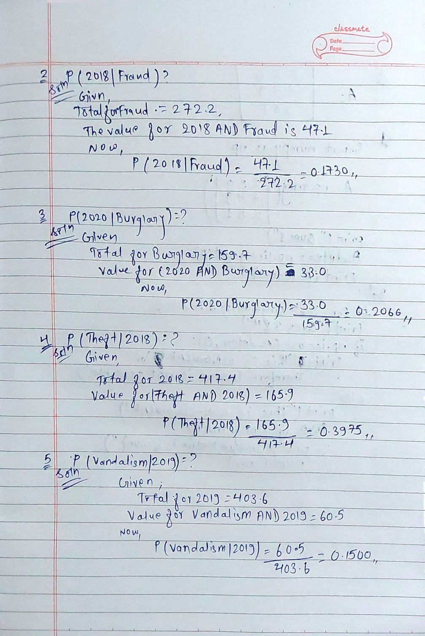
Therefore,
The answer are in
b.
P(Vandalism) = 0.1579
P(2020 AND Theft) = 0.0774
P(2018 OR Burglary) = 0.2546
c.
P(2017|Arson) = 0.1975
P(2018|Fraud) = 0.1730
P(2020|Burglary) = 0.2066
P(Theft|2018) = 0.3975
P(Vandalism|2019) = 0.1500

