Analysis of indicators among 45 companies (mean, min, max)

MEAN
The mean net margin among the 45 analysed companies is 19.23%. It means that on average companies earn about 0.19$ of profit per 1$ of revenue — a mid-range value.
The mean ROA among the 45 companies is 10%. It means that on average a company's assets generate 10% of profit — a moderate value.
The mean ROE is 5%, meaning that on average 5% of profit is generated per unit of equity.
The mean debt-to-equity is -0.33; however, this negative value is distorted by companies with negative equity. Therefore the median was calculated instead, and it equals 0.67. It means that a typical company has 0.67$ of debt per 1$ of equity.
The mean current ratio is 1.49. It means that on average current assets cover current liabilities about 1.5 times.

MIN

Net margin
APD (Basic Materials) has the lowest net margin among the 45 firms, at -3.28%. It means that each 1$ of revenue generated about 0.03$ of loss — in other words, APD made a loss in this period. This is a very low value, whereas the normal range is 5-10%.
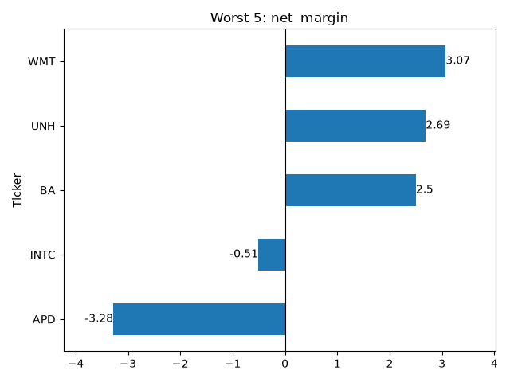
Intel (INTC) has a net margin of -0.5% in its latest statement (2025-12-31). The other indicators were then calculated, and it turned out that Intel also had negative ROA and ROE. Only D/E and current ratio were normal: D/E of 0.41 means low debt, and a current ratio of 2.02 means current assets cover current liabilities twice over — a high level of safety. To explain the negative margin, ROA and ROE, I checked Yahoo Finance: Intel had a high level of costs in this period, stemming from heavy investment and capital accumulation. At the start, investments cause more costs than income, hence the negative values of those indicators. This is consistent with financial theory.
Ticker | sector | net_margin | roa | roe | dte | current_ratio
INTC | Technology | -0.51 | -0.13 | -0.23 | 0.41 | 2.02

ROA
APD also has the lowest ROA, at -0.96% (normal range 5-10%). Each 1$ of APD's assets generated about 1% of loss. Its ROE was -2.63% (normal range 10-15%). The three negative indicators (net margin, ROA, ROE) mean the firm made a loss in the last period. This stems from a loss on the sale of a business: since operating income was positive, I conclude that the loss came solely from this sale. APD completed the sale of its liquefied natural gas (LNG) process technology and equipment business to Honeywell.
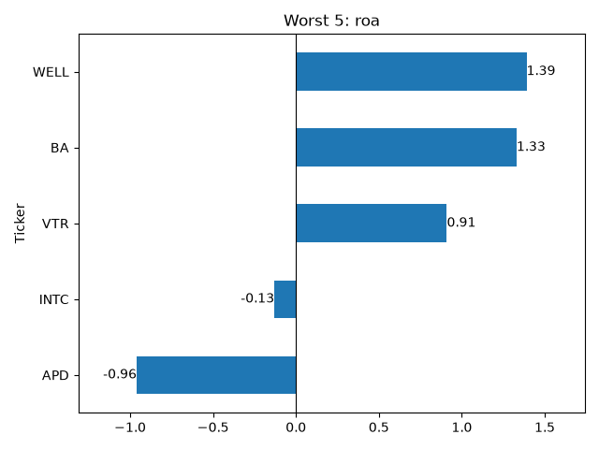

ROE
MCD has the lowest ROE, at -478.4%. Each 1$ of equity is associated with 4.784$ of loss. McDonald's stockholders' equity was -1.79B in 2025. This stems from McDonald's strategy of repurchasing its own shares.
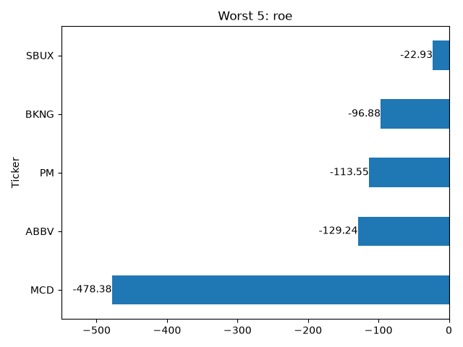

DTE
The lowest debt-to-equity is also in MCD, at -30.62, again because of this strategy. It stems from the negative value of stockholders' equity: equity is about -18B while total debt is about 54B.
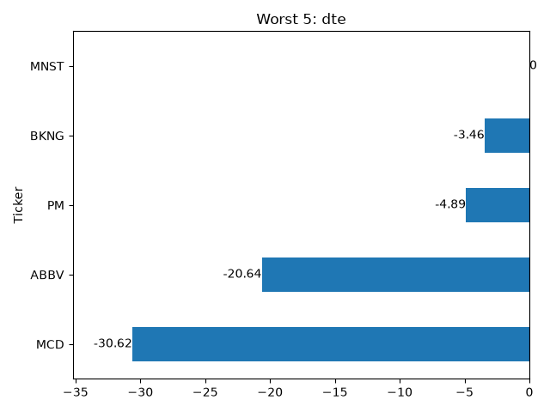

Current ratio
The lowest current ratio is 0.55, in DUK. It means that current assets cover only 55% of current liabilities, whereas the normal value is around 1. However, Duke Energy is a utility with many customers who pay regularly for energy, so DUK has minimal risk of losing financial liquidity. DUK also has high total debt, especially current liabilities, reflected in its D/E of 1.75 — the company has 1.75$ of debt per 1$ of equity.
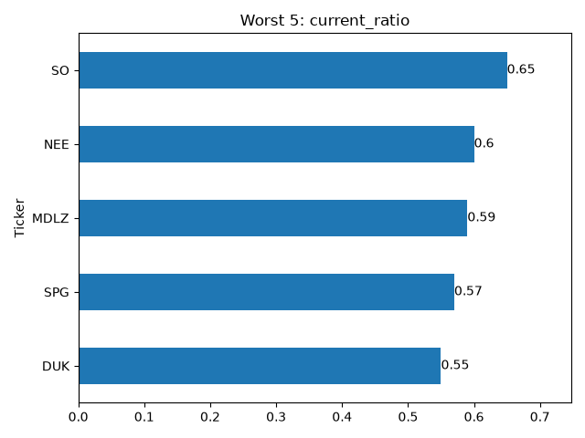

MAX

Net margin
The highest net margin is in SPG, at 72.7%. Net income is 4.68B$. However, SPG is a Real Estate company, and a large part of its profit is affected by depreciation. Depreciation is 1.8B$ and is an accounting (non-cash) expense, so the real cash-generating result is closer to 4.68 + 1.8 = 6.4B$. The indicator is so high because SPG is the largest Real Estate fund among the companies analysed.
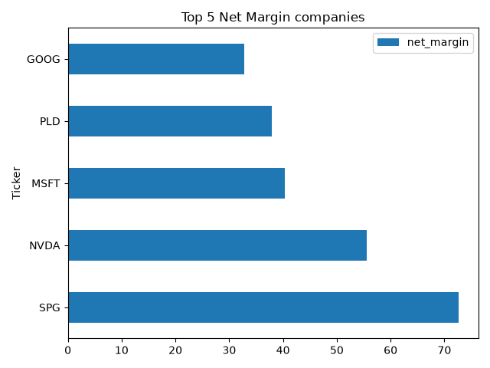
SPG is also the second worst company by current ratio. It has a low level of current assets (mainly receivables) compared to current liabilities. ROA shows that non-current assets are significantly higher than current ones (normal for a real estate company). D/E shows that total debt covers stockholders' equity 5.6 times — a risky, high level of debt.
Ticker | sector | net_margin | roa | roe | dte | Current ratio
SPG | Real Estate | 72,71 | 11,4 | 88,85 | 5,6 | 0,57

ROA
The highest ROA is in NVDA, at 58%. It means that 1$ of assets generates 0.58$ of profit. Nvidia holds a larger part of its assets as current assets (short-term investments and receivables) and a smaller part as non-current assets (machinery, furniture, equipment, investments and goodwill).
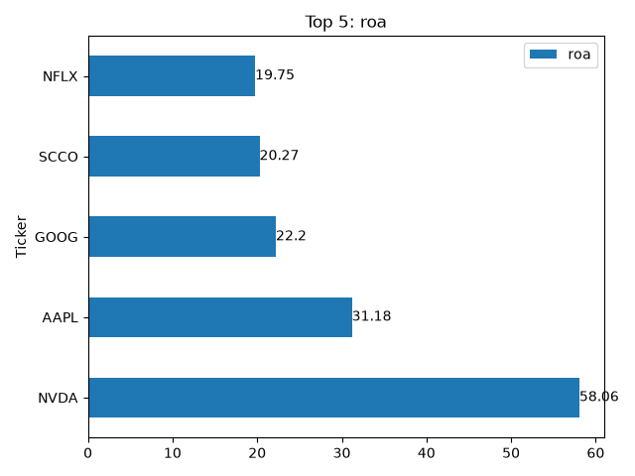

ROE
The highest ROE is in AAPL, at 151.9%. It means that 1$ of stockholders' equity generates 1.51$ of profit. Its net margin (net income / total revenue) of 28% means Apple keeps 28 cents from every 1$ of revenue. This very high ROE is partly inflated by a relatively small equity base.
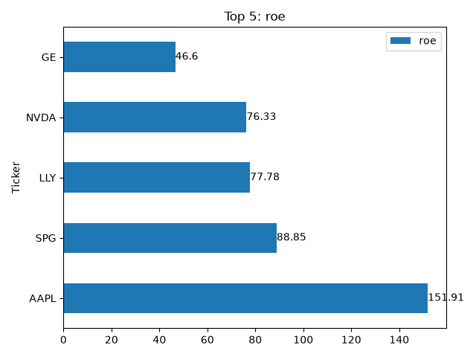

DTE
The highest debt-to-equity is in BA, at about 10. It means that for each 1$ of equity there is roughly 10$ of debt — Boeing is funded mainly by debt. This stems from a series of crises in 2020-2024, during which BA had a very weak (at times negative) stockholders' equity.
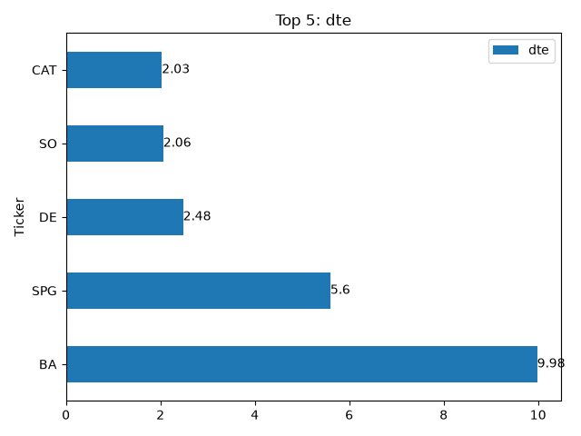

Current ratio
The highest current ratio is in WELL, at 5.34. This is very high — current liabilities are covered by current assets more than 5 times. It is very safe, but can also mean inefficient resource management. It is not typical for the Real Estate sector. Welltower holds cash in order to redeploy it. Current assets are 9.91B$, of which cash is 5B$ and receivables 4.7B$. On the one hand, half of the current assets are truly liquid (cash); on the other, receivables become liquid only once they are collected. Such a high level of receivables is acceptable precisely because Welltower also holds a high level of safe cash.
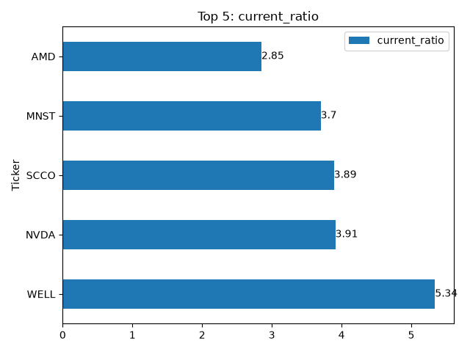
Welltower is also the 5th worst company by ROA, at 1.39%. This again stems from the high level of non-current assets, which is normal for a real estate company.
Ticker | sector | net_margin | roa | roe | dte | current_ratio
WELL | Real Estate | 8.78 | 1.39 | 2.22 | 0.51 | 5.34

Analysis of indicators among 9 sectors
All sector averages were calculated using the median. This method gives a central value without the influence of outliers, producing more representative and robust results.

Net margin
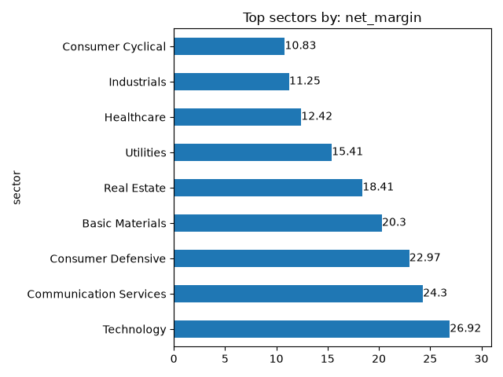

The Technology sector has the highest net margin, at 26.92% — about 27% of revenue is profit. The cost ratio shows that 50% of revenue goes to cost of production, which leaves about 23% for operational costs. A net margin of 27% therefore reflects high prices relative to costs. This high pricing power stems from the specificity of the sector: brand, technology and limited competition.
The second sector is Communication Services, with a net margin of 24.3%. Its cost ratio is almost the same, at 51.51%. The situation is similar: mainly digital products with high prices thanks to limited competition, brand and technology.
The Consumer Defensive sector has an average net margin of 22.97%. Its cost ratio is 44.15%, which means gross margin is about 55% and operational costs about 32%. The net margin is high, stemming from the specificity of the sector: essential goods, products and food. However, both production and operational costs are relatively high, stemming from large rental space and delivery costs.
The worst net margin is in Consumer Cyclical, at 10.83%, with a cost ratio of about 63%. This is natural for the sector, which sells non-essential goods such as cars, luxury brands and holidays. Production consumes about two thirds of revenue, so the net margin is naturally lower than in, for example, the opposite Consumer Defensive sector.
The Industrials sector is the second worst, with an 11.25% net margin and the highest cost ratio of all sectors, at 68.5%. This directly explains the low net margin: 68.5% of revenue is consumed by production costs.
Healthcare shows the opposite situation: its net margin (12.42%) is almost the same as Industrials, yet its cost ratio is the lowest of all sectors, at 26.76%. This means that most of the gap between gross and net profit is consumed by operational costs, not production. This stems from the specificity of the sector — high spending on R&D programmes, marketing and regulatory costs.

ROA
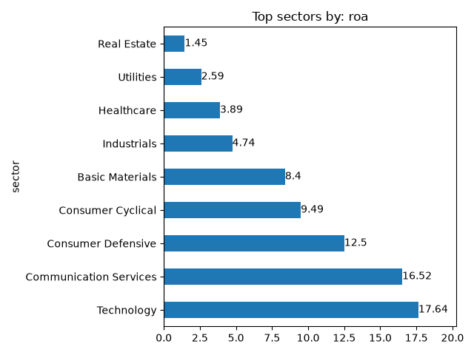
Technology is first by ROA, at 17.64% — 17.64% of profit is generated per unit of assets. The first factor is the high net margin, meaning each sale brings a lot of profit. The asset turnover of 0.45 means 1$ of assets generates 45 cents of revenue — a low value, so assets turn over slowly. This follows from the fact that the non-current ratio is 65% (factories, production lines, etc.), which weighs down ROA and asset turnover. However, net income is so high that, despite the heavy assets, ROA still comes out the highest of all sectors.
Communication Services is second, with an ROA of 16.52%. As in Technology, net income is high and each sale brings strong profit, which lifts ROA. The asset turnover is higher, at 0.68 (a moderate value: 1$ of assets generates 0.68$ of revenue). The non-current ratio is 70.3% (70% of assets are non-current), high because of costly networks and licences. On average, assets in this sector are even more encumbered than in Technology, so ROA is slightly lower — but net income is still high enough to cover assets at 16.52%.
The worst sector by ROA is Real Estate, at 1.45% — 1$ of assets generates only about 1.45 cents of profit. This low value stems from heavily encumbered assets: the non-current ratio is 94.3%, so non-current assets make up 94.3% of total assets and current assets a bit more than 5%. Asset turnover is 0.16, meaning very slow turnover — slow sales, long cycles. The net margin is 18.41% (18.41$ of profit per 100$ of revenue), a high value. So although turnover is slow and assets are heavily encumbered, the net margin is high: on average, Real Estate sales generate large profits despite the expensive, slow-turning assets.
The Utilities sector is very similar to Real Estate: ROA = 2.59%, non-current ratio = 93.61%, asset turnover = 0.16. Because its non-current ratio and net margin (15.41%) are slightly lower, ROA is a little higher than in Real Estate. Infrastructure costs and heavy assets weigh ROA down.
Consumer Cyclical is also an interesting case: ROA = 9.49% (9.49$ of profit per 100$ of assets), non-current ratio = 72% (current assets 28%), asset turnover = 0.88 (the fastest among sectors), net margin = 10.83% (the lowest). ROA is relatively high thanks to the fast turnover, despite the 72% non-current ratio and the low net margin. Production of non-essential goods is expensive, but the price per sale is also high (luxury goods), and the fast asset turnover shows a moderate-to-high sales frequency.

DTE
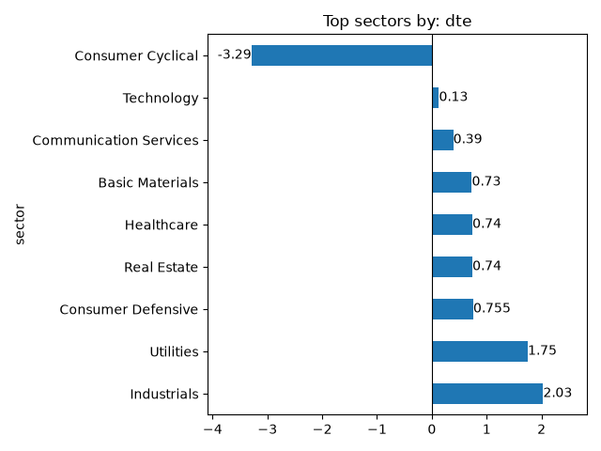
Industrials has the highest D/E, at 2.03 — total debt covers equity twice over, indicating a high level of debt. However, its non-current ratio is only 46.76%, which is a bit confusing, since a higher level of non-current assets would be expected alongside such debt. I checked the individual firms in the sector to find an outlier, and it was Boeing (D/E about 10). But the median of 2.03 corresponds to Caterpillar — so the median is not distorted by the Boeing outlier and genuinely represents a typical firm. The moderately high debt stems from the specificity of the sector: long production cycles and capital intensity.
In the Utilities sector the D/E is 1.75 (moderately high). Here it is explained by the very high non-current ratio of 93.61%: the sector needs a lot of debt to finance machinery and infrastructure. It also earns revenue from regular, predictable payments, which allows these companies to carry larger debts safely.
Real Estate is an interesting case: its D/E is low, at 0.74 — for 1$ of equity there is 0.74$ of debt, a safe relation. Yet this sector has the highest non-current ratio of all. One would expect high non-current assets to go with high debt, but here it is the opposite. This sector does not rely on debt to finance its non-current assets; its asset turnover is very low, so it cannot afford to take on much more debt.
Communication Services and Technology have similarly moderate non-current ratios and very low D/E — 0.39 and 0.13 respectively. These sectors have high profits and do not need much debt financing.
The Consumer Cyclical sector has a negative median D/E. This time it is not a single-outlier problem: checking the individual firms, 3 of 5 had negative and 2 of 5 positive D/E. The negative values reflect negative equity in those firms (an accounting effect of share buybacks). For this sector the D/E is therefore not representative and should not be interpreted.

ROE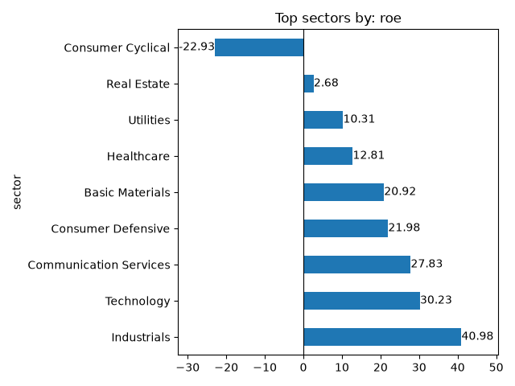
The Technology sector has an ROE of 30.23% — each 1$ of equity brings 0.30$ of profit. ROE is high while D/E is the lowest of all sectors, which indicates that this high ROE comes strictly from the sector's efficiency, not from debt. The high ROA confirms this.
Industrials has the highest ROE, at about 41%. However, its ROA is only 4.74%. This large gap stems from the high D/E (above 2), meaning total debt is twice the stockholders' equity. It indicates that the high ROE comes from financial leverage, not from the efficiency of the sector.
Utilities has one of the lower ROEs, at 10.31%. Its ROA was also among the smallest (2.59%), and D/E is moderate (1.75). This creates a situation similar to Industrials, but the low ROA stems from the high level of non-current assets. The stable revenues allow utility firms to carry high debt safely, which raises ROE above what the low ROA alone would give.
For Consumer Cyclical the same problem repeats: on average stockholders' equity is negative, so this indicator is not representative.

Current ratio
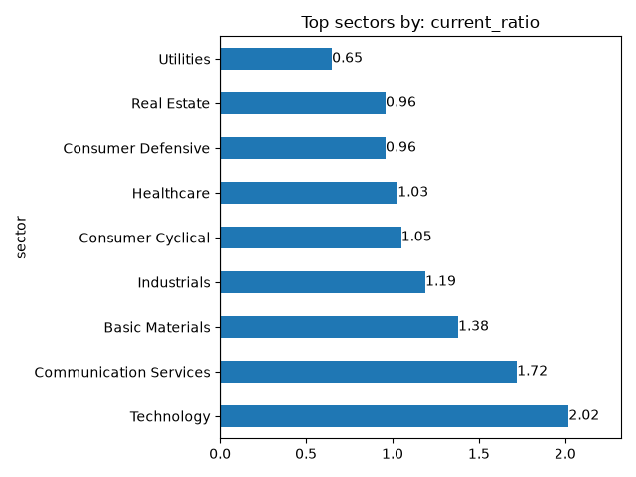
The Technology sector has the highest current ratio, at 2.02 — for each 1$ of current liabilities there are 2$ of current assets. This is a safe position. It stems from the specificity of the sector: high ROA means high profits and a high cash level (current assets), while low D/E means a low average level of liabilities. This liquidity is mostly real cash.
A value between 1 and 2 is a normal, safe level. The Basic Materials sector has a current ratio of 1.38 — a moderately safe level, stemming from a high level of inventories. Basic Materials does not generate as much cash as Technology.
Healthcare and Consumer Cyclical have current ratios near 1, meaning current assets roughly equal current liabilities. The reasons differ. Consumer Cyclical has high asset turnover, so it does not need to hold assets for long — cash comes in quickly. Healthcare has stable income independent of the business cycle, so it does not need to keep a high current ratio. In both cases the level is safe.
The Utilities sector has the lowest current ratio, at 0.65 — current assets cover only about two thirds of current liabilities. Why? This stems from the specificity of the sector: its income is the most stable of all analysed sectors, so it would be irrational to hold a higher level of current assets.

Indicators correlation
To check how the indicators move together, I created a correlation matrix, which shows how strong the relationships between individual indicators are and whether they confirm the conclusions from the previous chapter.
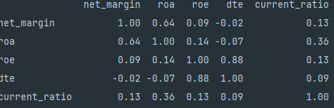
However, the problem of outliers still exists. Therefore I created a second correlation matrix, this time using the Spearman method, which is robust to outliers. The result differed, especially for the indicators affected by outliers.
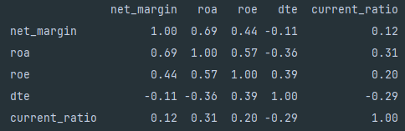
As we can see, net margin, ROA and current ratio did not change much, whereas ROE and D/E did — this difference stems from companies with negative equity. To avoid distortion, I analyse the second (Spearman) matrix.
The correlation scale:
0,00 | 0,10 | Lack of correlation
0,10 | 0,30 | Weak correlation
0,30 | 0,50 | Moderate correlation
0,50 | 0,70 | Strong correlation
0,70 | 0,90 | Very strong correlation
0,90 | 1,00 | Perfect correlation

Profitability:
- net margin ROA (0.69) ROE (0.57) — the profitability indicators grow together. They measure different aspects of the same underlying efficiency.
Laverage trap:
- D/E ROE (0.39), however D/E ROA (-0.36). Debt increases ROE but decreases ROA.
Liquidity:
- current ratio has only a weak/moderate correlation with all other indicators. It is an independent measure of liquidity.

REGRESION MODEL
To build a regression model I chose ROE as the explained (dependent) variable, because ROE measures the return for stockholders.
The explanatory variables are ROA, D/E and net margin. Current ratio was not included, because its weak correlation with the other indicators would add noise to the model.
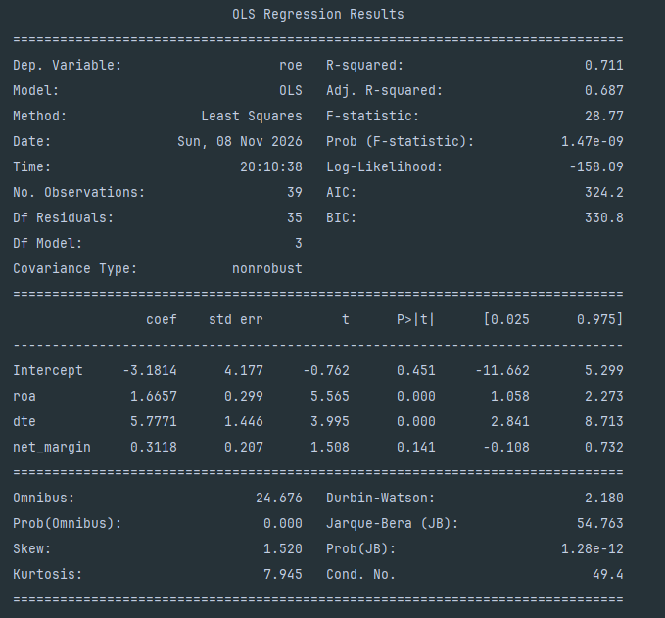
When ROA grows by 1, ROE increases by 1.6657. The p-value is well below 0.05, so the variable is significant.
When D/E grows by 1, ROE increases by 5.7771. The p-value is also below 0.05, so the variable is significant.
The net margin coefficient is not significant — its effect is already captured by ROA, with which it is strongly correlated.
The adjusted R-squared shows that 68.7% of the variation in ROE is explained by the model. The variables explain the dependent variable well. Prob(F) is also low, which confirms the overall significance of the model.
In short, the model is significant and the variables explain ROE well. The strongest driver of ROE is D/E — higher debt means higher ROE (the leverage effect). ROA also explains ROE well, through net income. Net margin is not a significant predictor once ROA is included.

Conclusion
This project analysed the financial indicators of 45 companies across 9 sectors to understand what drives profitability and how it differs between sectors. The analysis showed that sector profitability depends largely on the nature of the business. Digital-product sectors (Technology, Communication Services) have the highest margins, because their products carry high prices relative to production costs. Physical-product sectors (Industrials, Consumer Cyclical) have low margins, because production consumes most of the revenue. Capital-intensive sectors (Utilities, Real Estate) show very low ROA, because their heavy non-current assets (infrastructure, property) generate little profit per unit of assets.
The central finding concerns the leverage trap in ROE. Both the correlation analysis (D/E vs ROE +0.39, D/E vs ROA -0.36) and the regression model confirmed that a high ROE does not always reflect a better company — it often reflects higher debt. The regression showed that ROE is explained by ROA (efficiency) and D/E (leverage), with debt being the strongest driver (coefficient 5.78). This means ROE must always be read together with ROA and D/E; otherwise a debt-inflated ROE can be mistaken for real efficiency. The model explained 68.7% of the variation in ROE (adjusted R-squared 0.687).
Limitations: the sample is small (45 large companies, not the whole market) and based on a single reporting period. Several companies with negative equity (from share buybacks) distort ROE and D/E, so these indicators were analysed using medians and filtered data. Each sector contains only 5 companies, which limits the strength of the sector-level conclusions.

https://www.airproducts.com/company/news-center/2024/09/0930-air-products-completes-sale-of-lng-business
https://finance.yahoo.com/markets/stocks/articles/mcdonald-mcd-negative-shareholder-equity-200118409.html

