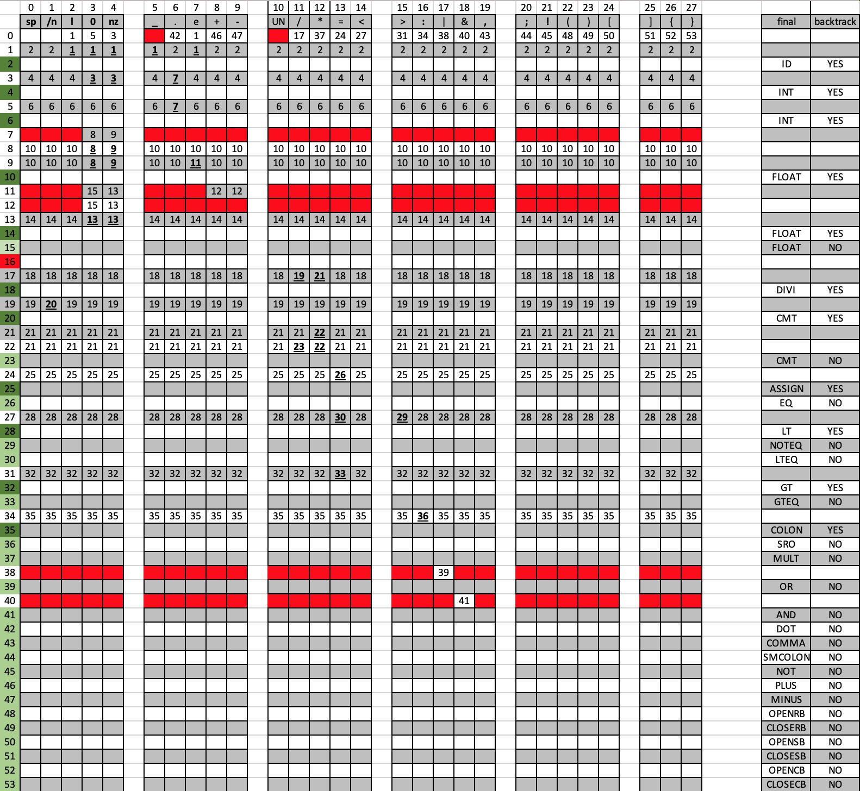

NOTE:

Dark green cell: final state, need back track

Light green cell: final state, does not need back track

Red cell: error state with state number 16

Empty cell: start state with state number 0