**Assignment 1 Template**

**LAST NAME: Feng**

**FIRST NAME:Yuan**

**USERID: y87feng**

**UWaterloo ID 20600787**

**Problem 1: Fill in the information below based on your data set which was generated using your ID number as the seed for the random number generator.**

**The first five numbers in your Gaussian data set are:**

|  |  |  |  |  |
| --- | --- | --- | --- | --- |
| **-15.57** | **-14.70** | **-13.44** | **-11.51** | **-10.33** |

**Sample mean = 6.84365**

**Sample standard deviation =8.224135**

**The five number summary is:**

|  |  |  |  |  |
| --- | --- | --- | --- | --- |
| **-15.57** | **1.67** | **6.925** | **12.255** | **27.59** |

**Sample median = 6.925**

**Range = 27.59-(-15.57)=43.16**

**IQR =12.255-1.67=10.585**

**Sample skewness = -0.114017**

**Sample kurtosis = 2.956375**

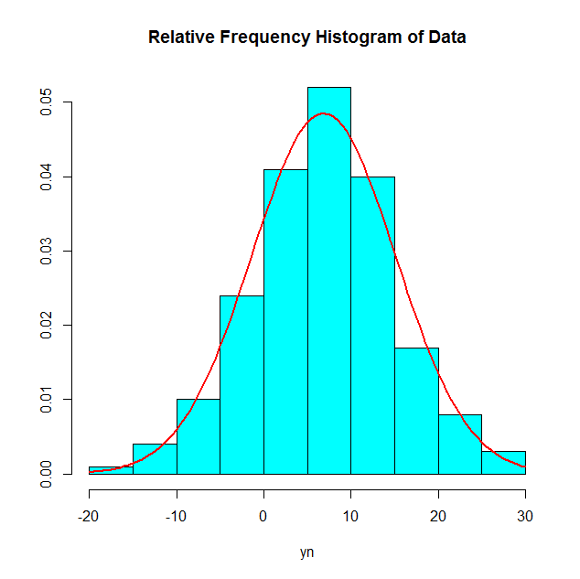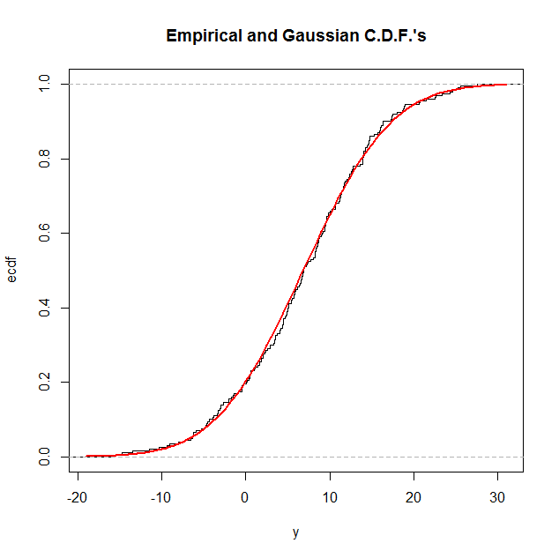

**Problem 2: The first five numbers in your Exponential data set are:**

|  |  |  |  |  |
| --- | --- | --- | --- | --- |
| **0.01** | **0.08** | **0.09** | **0.10** | **0.10** |

**Sample mean = 7.39855**

**Sample standard deviation =8.194635**

**The five number summary is:**

|  |  |  |  |  |
| --- | --- | --- | --- | --- |
| **0.01** | **1.9** | **4.55** | **9.705** | **46.69** |

**Sample median = 4.55**

**Range = 46.69-0.01=46.68**

**IQR =9.705-1.9=7.805**

**Sample skewness =2.215232**

**Sample kurtosis = 8.624793**

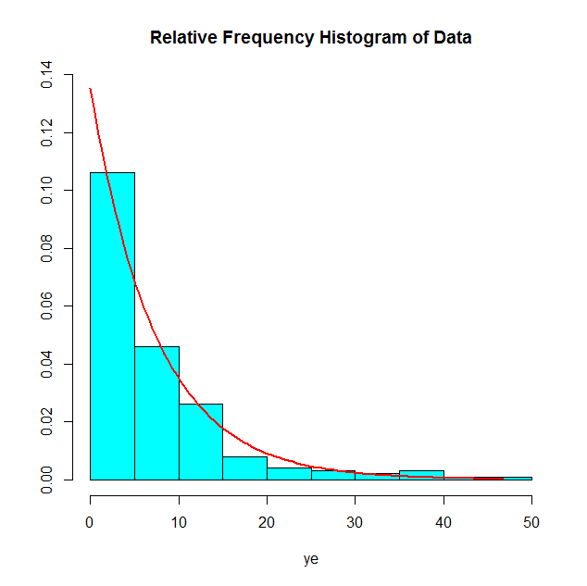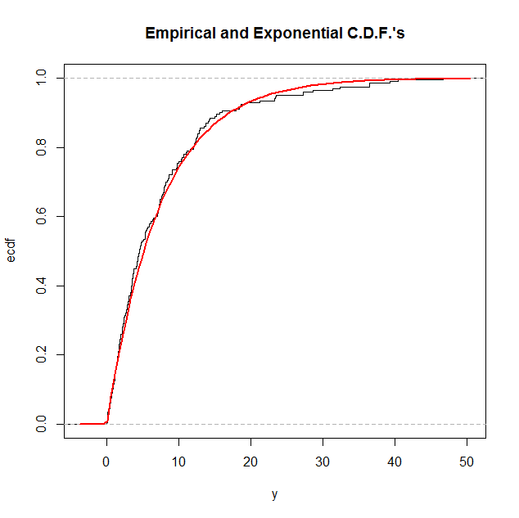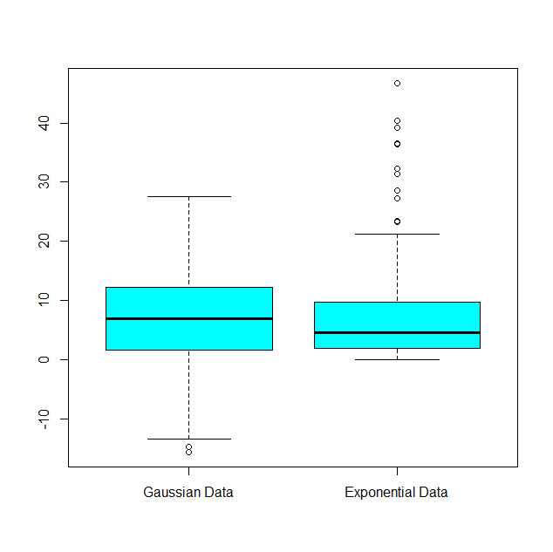

**Problem 3: The first five numbers in your Gamma data set are:**

|  |  |  |  |  |
| --- | --- | --- | --- | --- |
| **1.05** | **2.15** | **2.67** | **3.97** | **3.97** |

**Sample mean = 22.34425**

**Sample standard deviation = 12.56108**

**The five number summary is:**

|  |  |  |  |  |
| --- | --- | --- | --- | --- |
| **1.05** | **13.065** | **20.125** | **29.68** | **64.36** |

**Sample median = 20.125**

**Range = 64.36-1.05=63.31**

**IQR = 29.68-13.065=16.615**

**Sample skewness = 1.000275**

**Sample kurtosis = 3.916763**

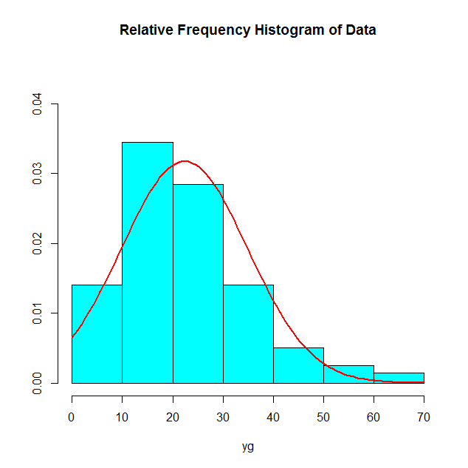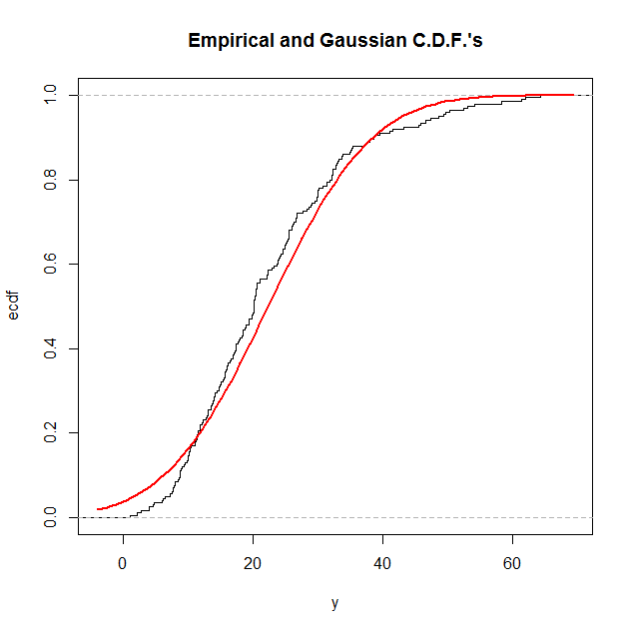

**Based on the numerical summaries and the graphical summaries for the Gamma data** **discuss how well the** **Gaussian model fits these data. Your answer should be written in complete sentences.**

For Gaussian data we expect the mean and median to be equal. In Gamma data, the mean and median are very close, so the Gaussian data fits these data very well.

**Problem 4:**

**Alpha =6.84365 Beta =7.39855**

**The first five pairs of numbers in your bivariate data set are:**

|  |  |
| --- | --- |
| **x** | **y** |
| **3.9** | **31.0** |
| **11.7** | **95.3** |
| **4.1** | **22.5** |
| **18.7** | **127.3** |
| **7.8** | **60.8** |

**Sample Correlation =0.9343387**

