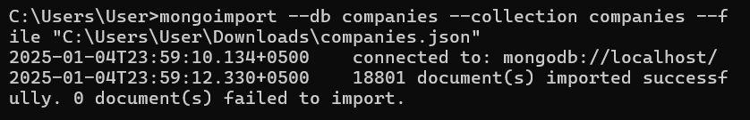

Task 1

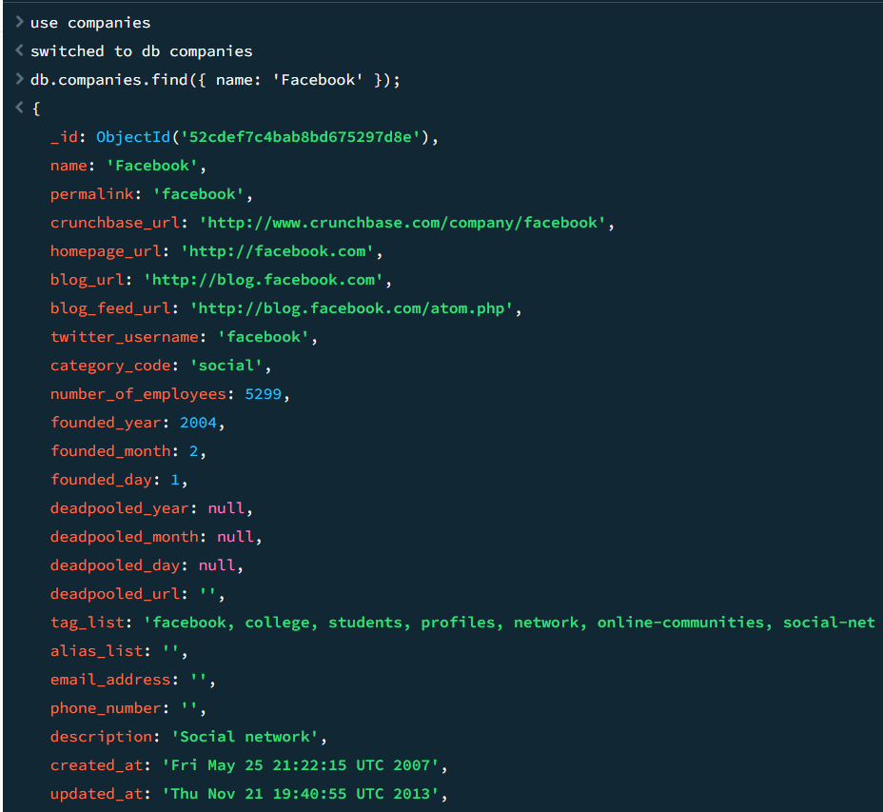

This query searches the companies collection for documents where the field name is equal to 'Facebook'.

Task 2

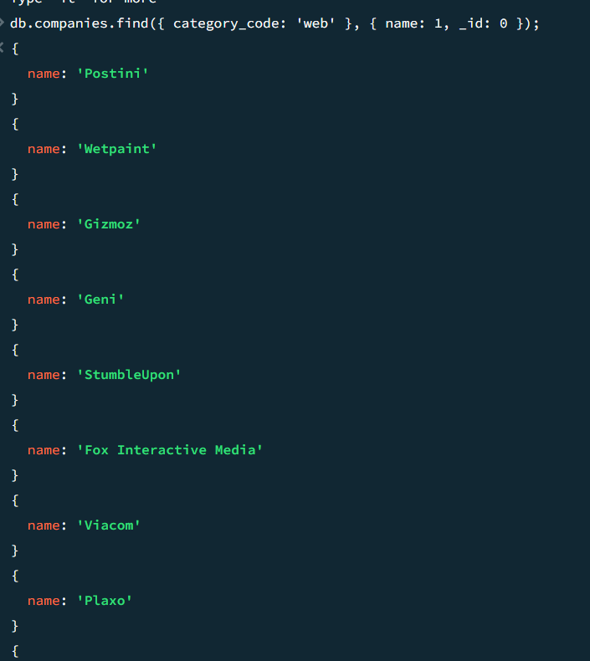

This query retrieves documents where the category_code field is 'web'. The second argument { name: 1, _id: 0 } is a projection, which ensures that only the name field is displayed while excluding the _id field.

Task 3

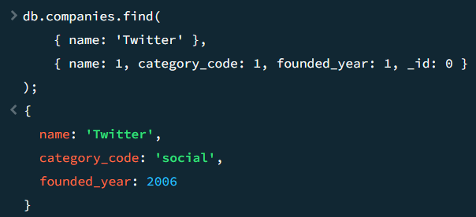

This query searches for documents where the name field is 'Twitter'. It returns only the fields name, category_code, and founded_year, while excluding _id.

Task 4

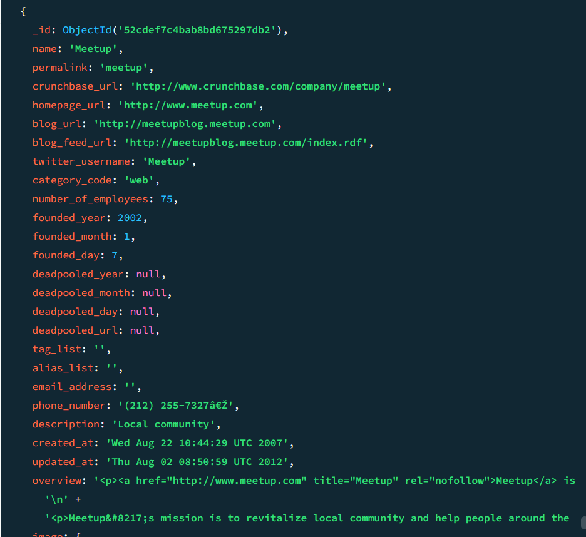

This query retrieves documents where the category_code is 'web', but limits the output to the first 50 results using the .limit(50) function.

Task 5

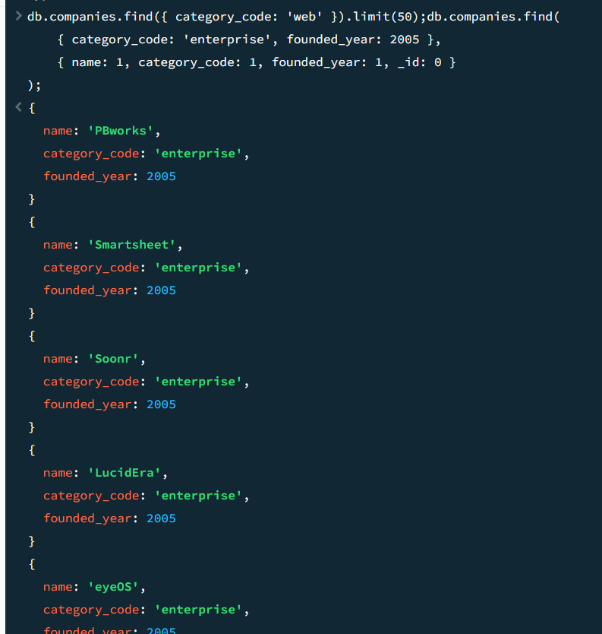

This query retrieves documents where category_code is 'enterprise' and founded_year is 2005. The projection ensures only the fields name, category_code, and founded_year are displayed.

Task 6  
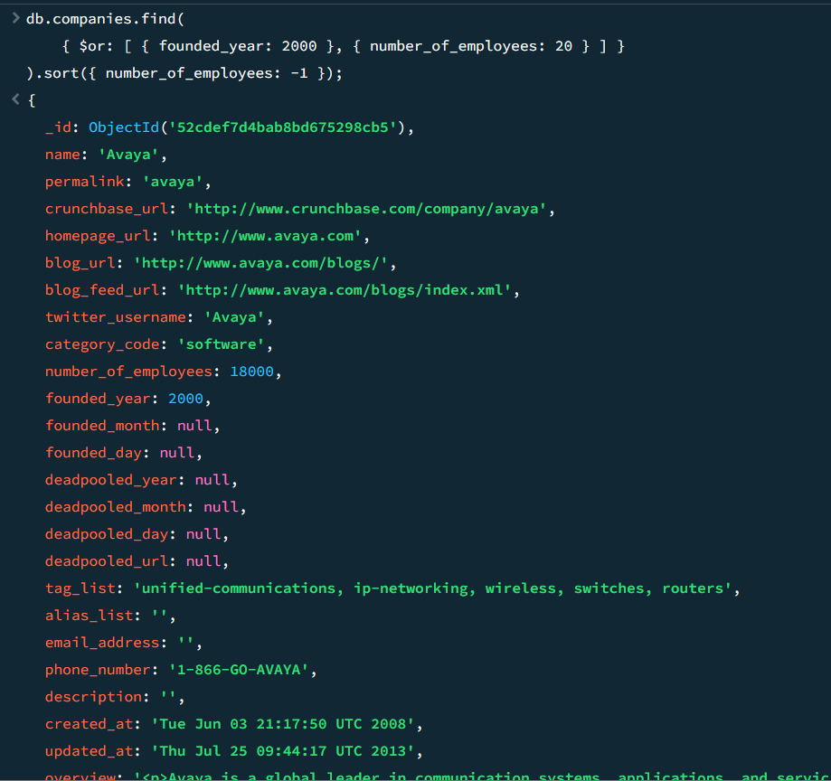

This query uses the $or operator to find documents where either founded_year is 2000 or number_of_employees is 20. The .sort({ number_of_employees: -1 }) function orders the results in descending order of number_of_employees.

Task 7

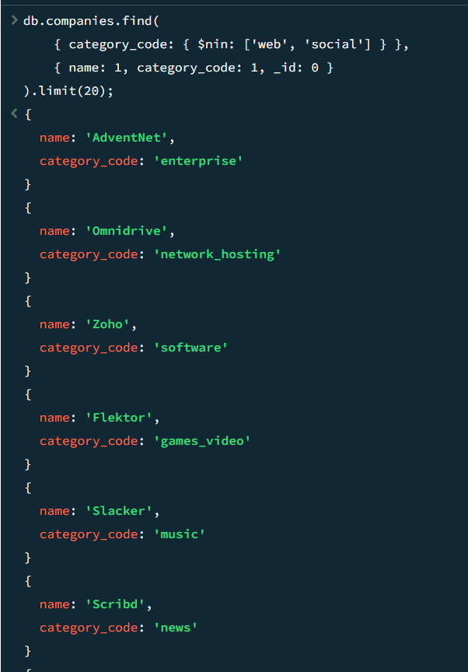

This query uses the $nin operator to exclude documents where category_code is either 'web' or 'social'. It limits the results to 20 documents and displays only the name and category_code fields.

Task 8

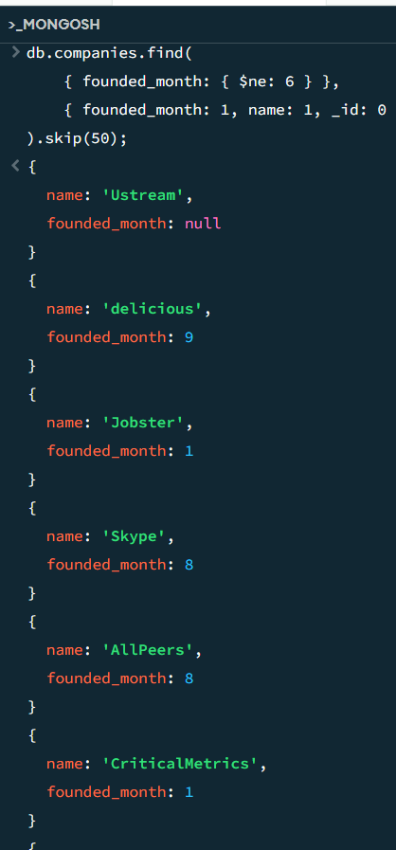

This query uses the $ne operator to exclude documents where founded_month is 6 (June). It skips the first 50 documents using .skip(50) and retrieves only the founded_month and name fields.

Task 9  
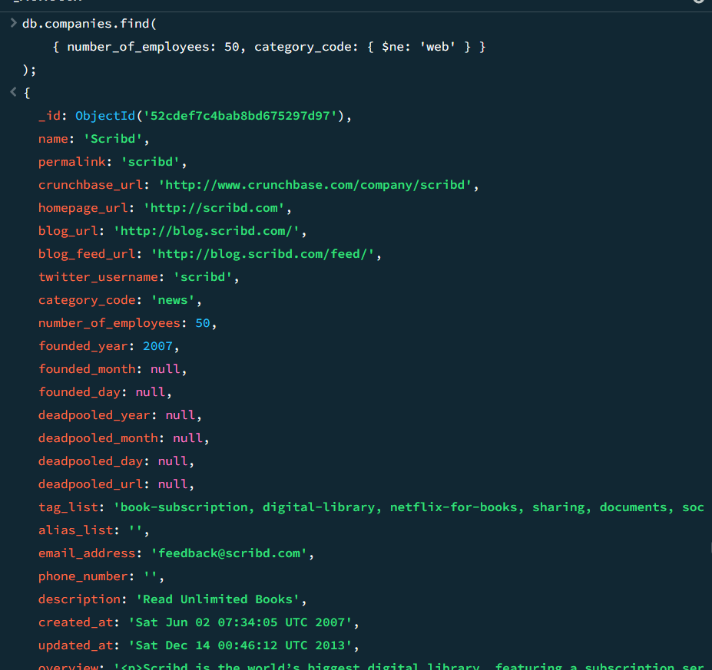

This query retrieves documents where number_of_employees is 50 but excludes those where category_code is 'web' using the $ne operator.

Task 10  
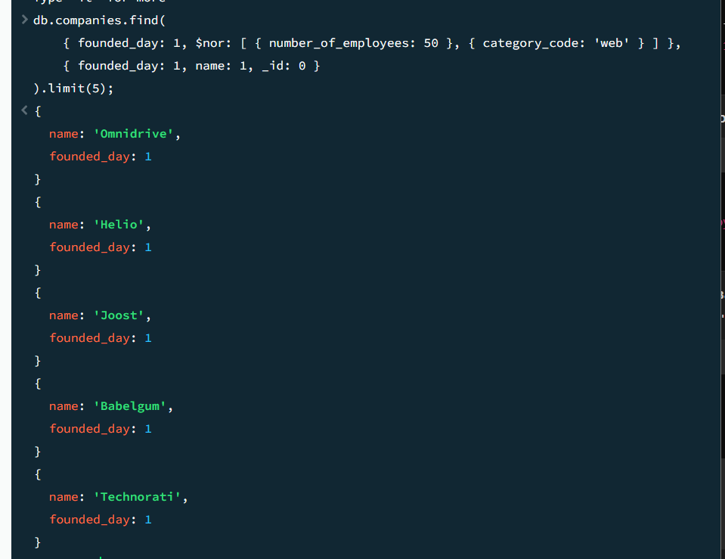

This query uses $nor to exclude documents where number_of_employees is 50 or category_code is 'web'. It limits the results to 5 and retrieves only the founded_day and name fields.

Task 11

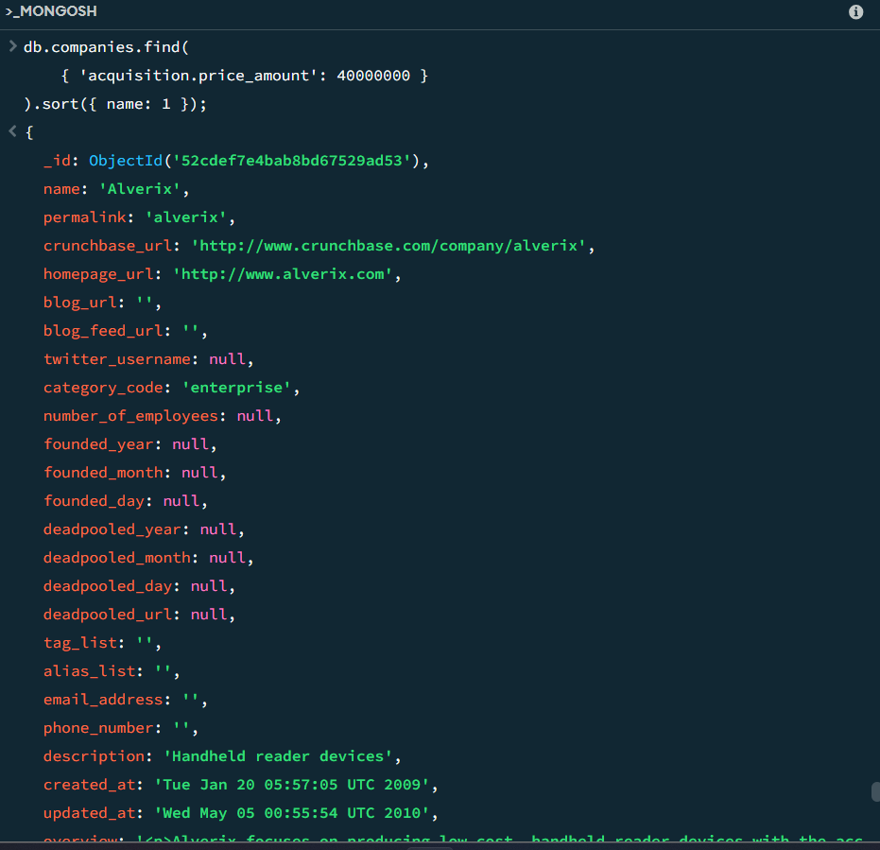

This query searches for documents where the nested field price_amount in the acquisition object is 40,000,000. It sorts the results alphabetically by the name field using .sort({ name: 1 }).

Task 12

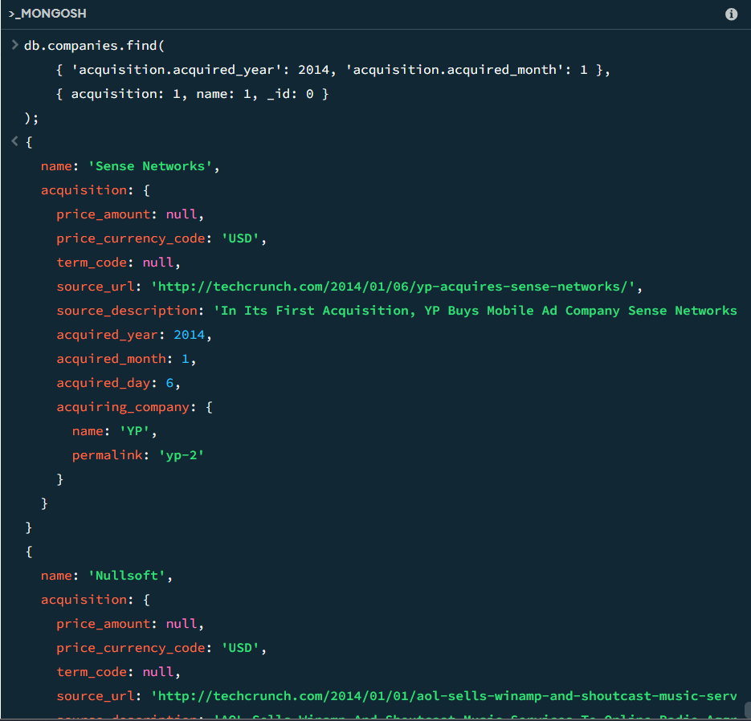

This query searches for documents where the nested field price_amount in the acquisition object is 40,000,000. It sorts the results alphabetically by the name field using .sort({ name: 1 }).