Aldongar Yerkin 230856 15.09.2024

1) LS command

This command displays the manual page for the 'ls' command



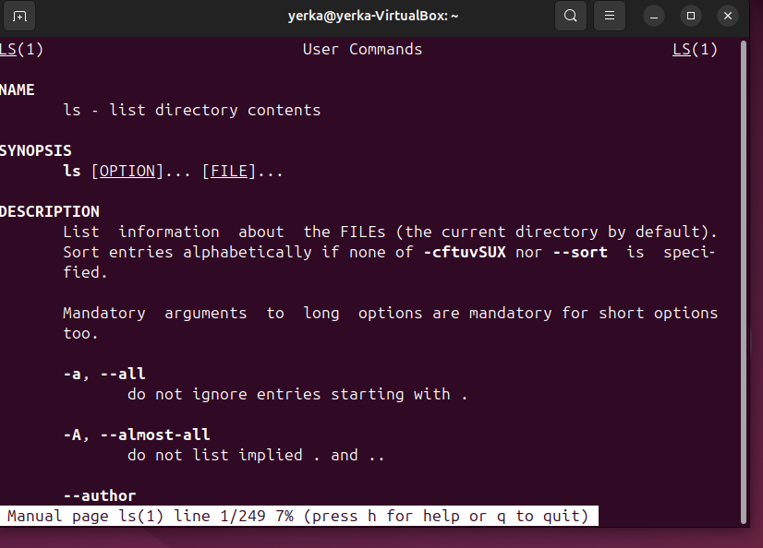

This command shows additional detailed information about the 'ls' command



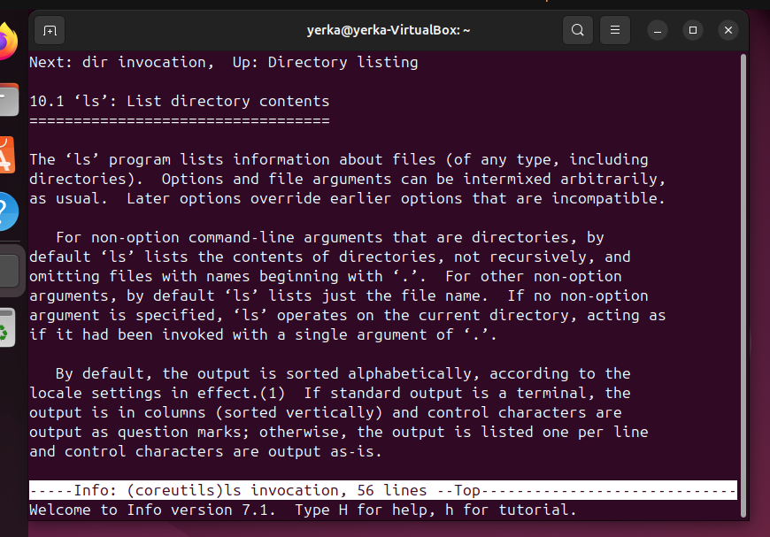

This command searches for commands related to time

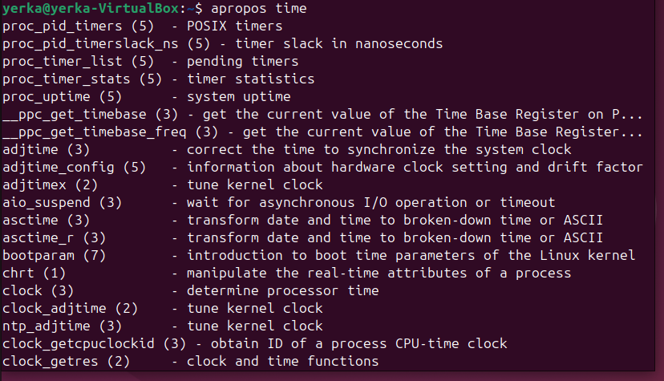

This command provides a brief description of the 'ls' command



This command shows the location of the executable, source code, and man pages for the 'ls' command



This command searches for files or directories by name

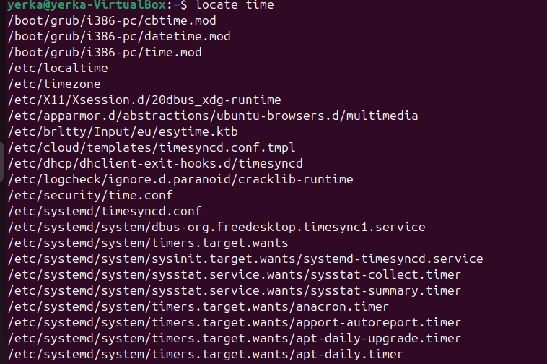

This command checks how long the computer has been running



This command displays the currently running processes

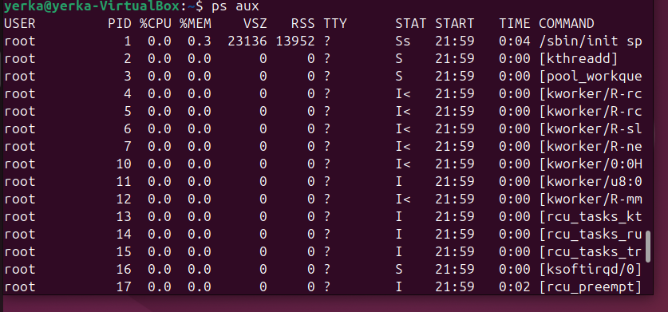

This command shows the name of the operating system



This command displays detailed information about the CPU (processor)

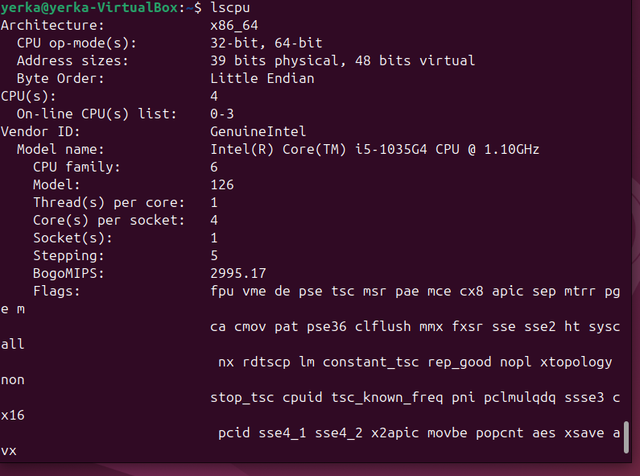

2) management commands:

This command lists all files in the system by recursively searching every directory from the root '/'



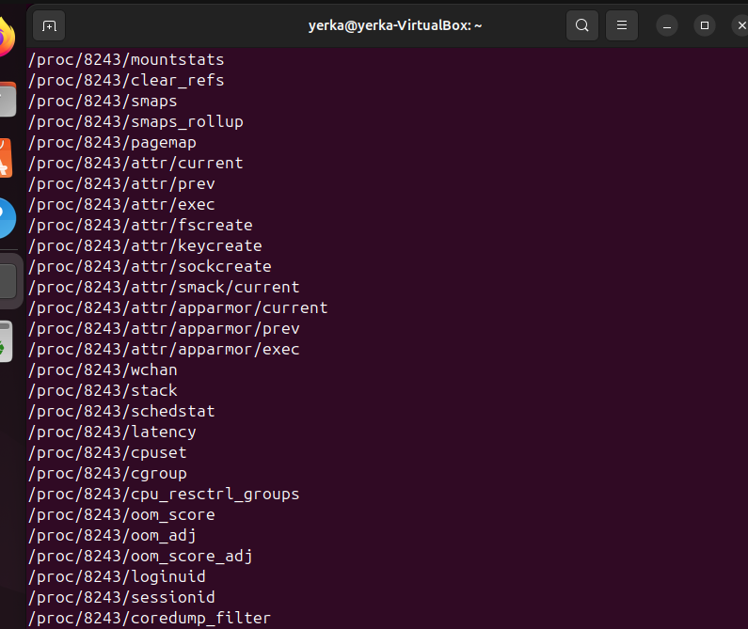

This command navigates to the 'games' folder in the parent directory; if it doesn't exist, it creates it and navigates there



This command shows the name of the current directory



This command displays the full current working path



This command searches for a specific word or phrase within 'text.txt'



This command counts the number of occurrences of the searched term in 'text.txt'



This command replaces all occurrences of 'Hello' with 'Bye’ in 'text.txt'



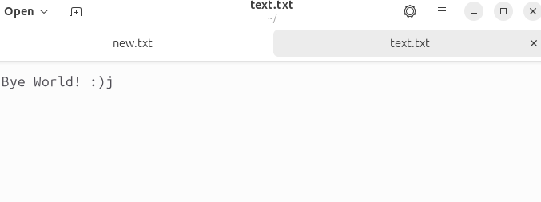

3) Working with CSV

This command extracts specific columns (1 and 3) from the 'data.csv' file

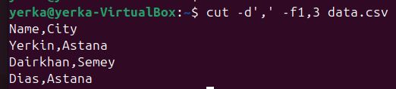

This command sorts the output from the 'cut' command by the second column

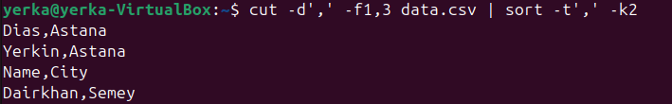

This command shows the first few lines of the 'data.csv' file

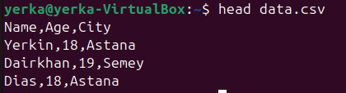

This command shows the last few lines of the 'data.csv' file

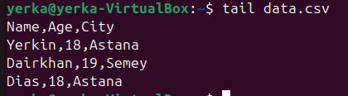

4) Process management

This command starts the 'www.google.com' process by opening the browser to Google’s homepage

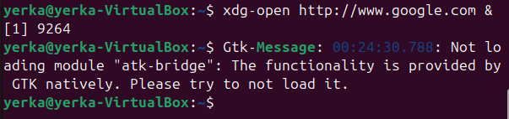

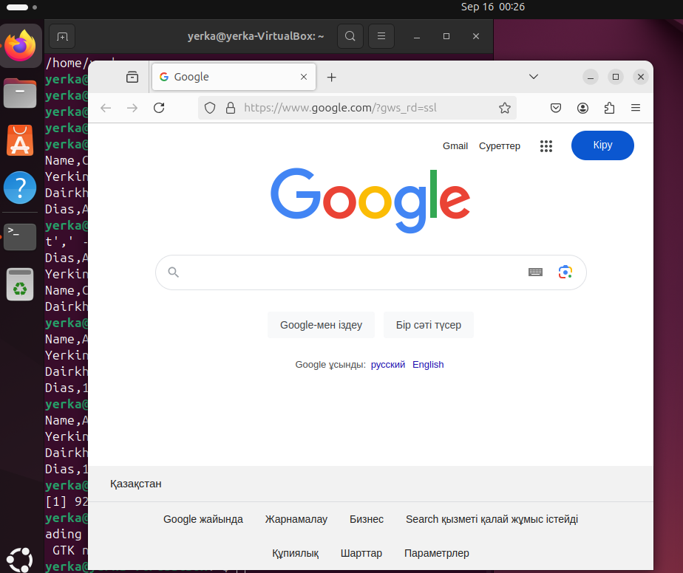

This command checks if the 'google.com' process is running

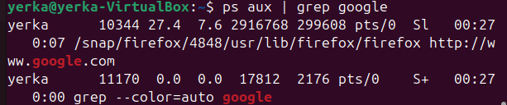

This command runs the 'uptime' command in the background to check computer activity time 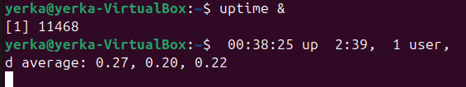

**5)Switching between graphical and text modes:**

Ctrl + Alt + F1 to F6

