Aldongar Yerkin 230856 SE 2318

Task 1

Create a directory called test_directory

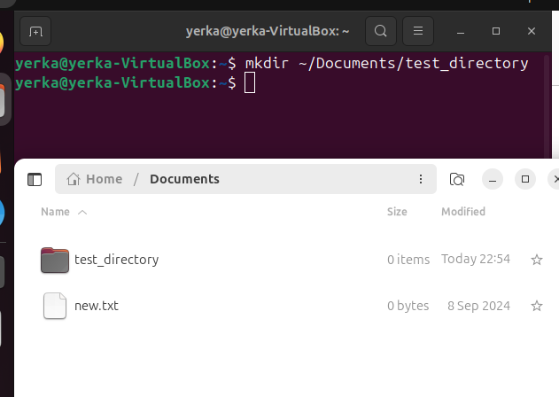

2) Create the specified files within test_directory

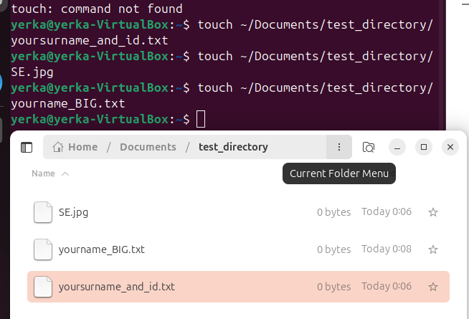

3) Verify the files and directory creation

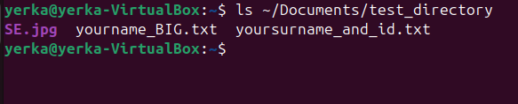

4) Use cat commands to display file content

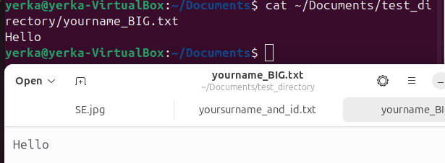

5) Use more commands to display file content

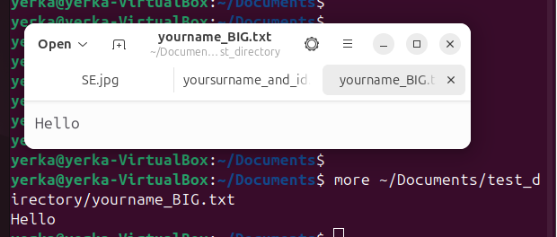

6) Use less commands to display file content



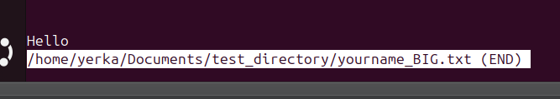

Task 2

1) Create a directory called f_directory

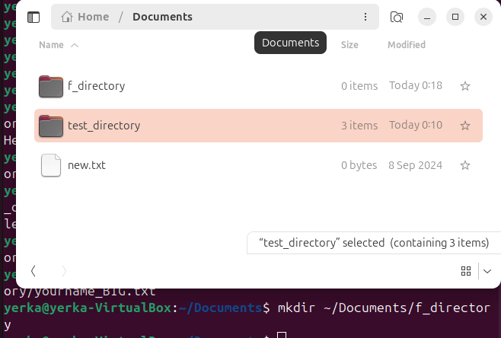

2) Copy the files from test_directory to f_directory

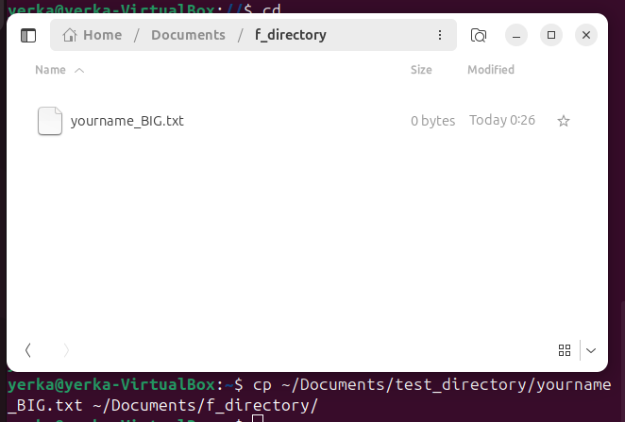

3) Copy the files from test_directory to f_directory

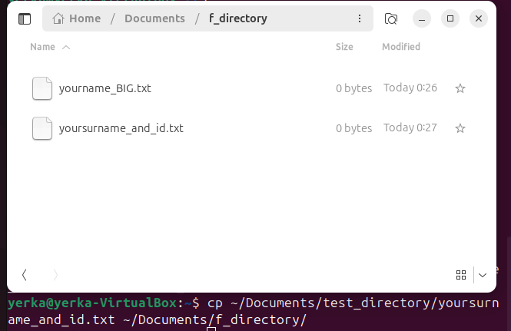

4) Copy the files from test_directory to f_directory

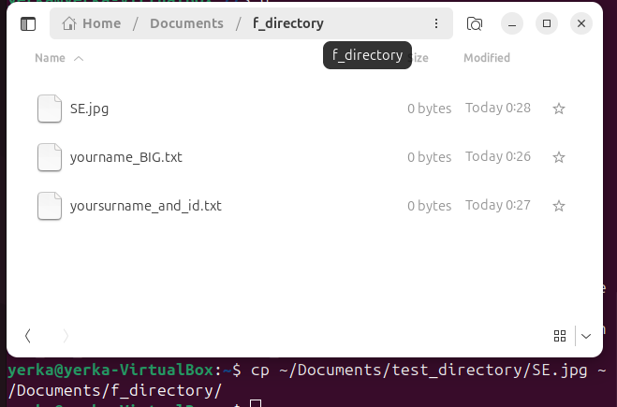

5) Rename the files in f_directory by adding 'f' at the beginning

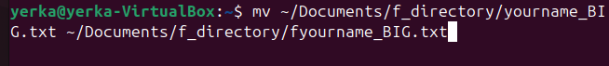





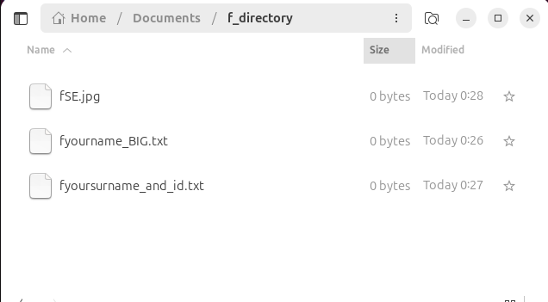

6) Create additional files f1.txt, f2.txt, f22.txt, fa.jpg

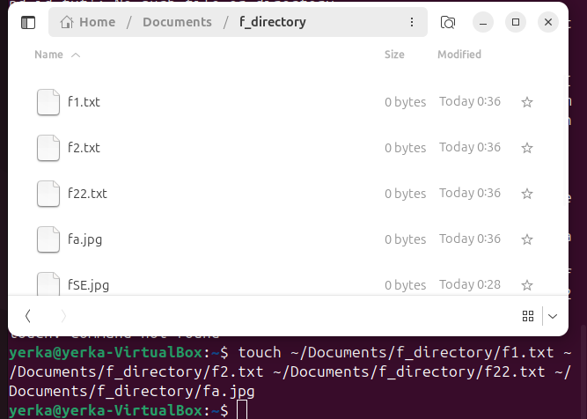

7) Verify the files creation

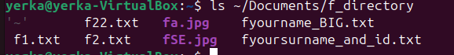

8) Show files with .txt extension

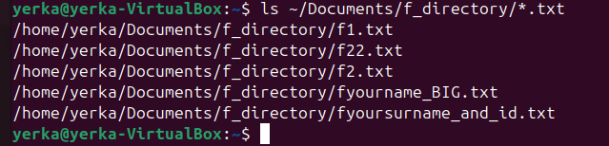

9) Show files with pattern f.txt

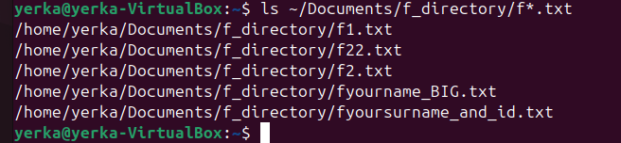

Show files with pattern f[0-9].txt

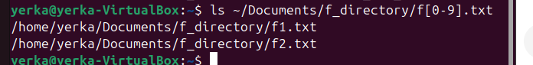

Show files with pattern fy.txt

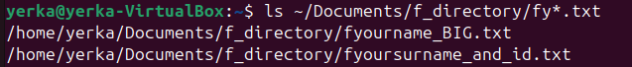

Show files with pattern f[0-9][0-9].txt

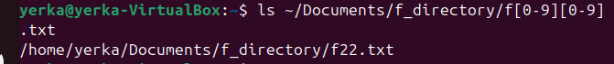

Task 3

1) Create a tar.gz archive of "archive_directory"

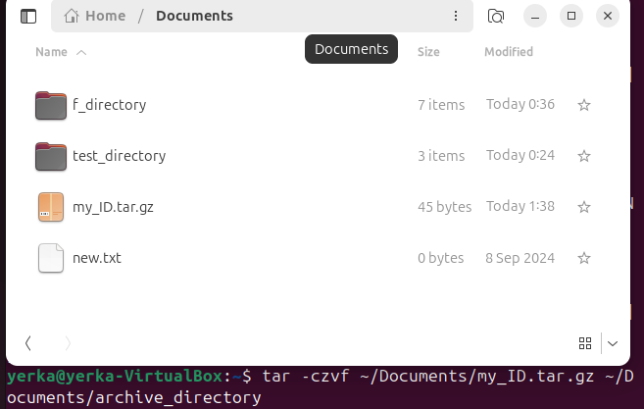

2) Verify that the archive file was created



3) Make the archive file hidden

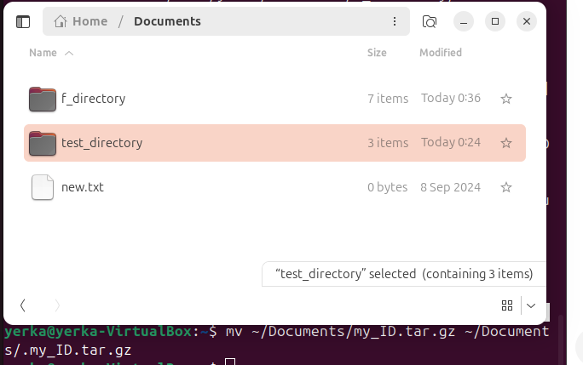

4) Check for hidden elements



Task 4

1) Navigate to the root directory, go to /var/log, display syslog, and return home in one line



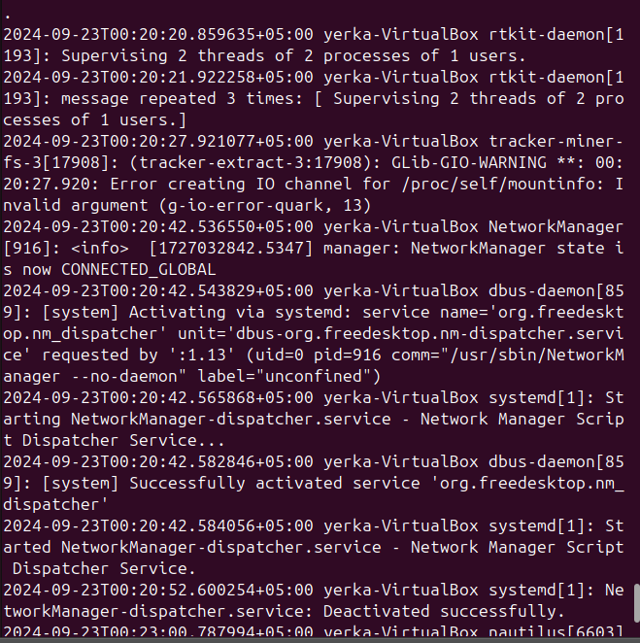

2) Show the path



Task 5

1) Create a random directory in f_directory2 and Create three files in the random directory

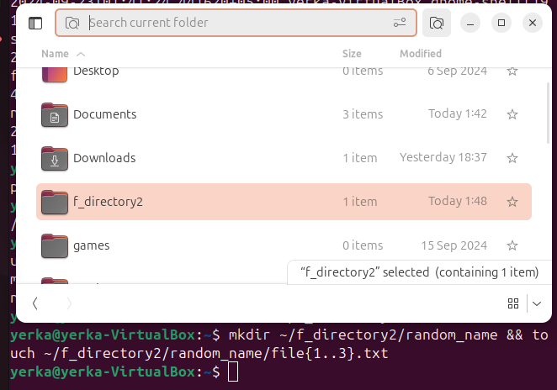

2) Go out of f_directory2 and delete all files within f_directory2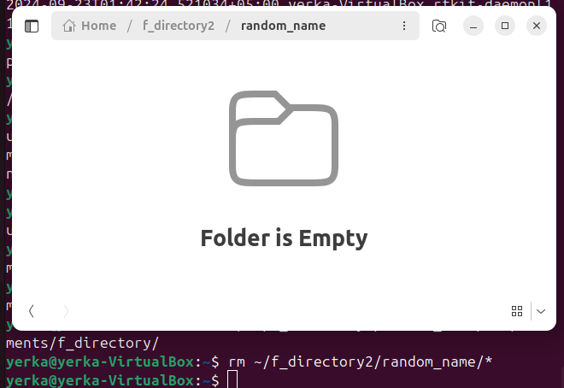

3) Check if files are deleted



4) Change the permissions of file1.txt



5) Remove file2.txt

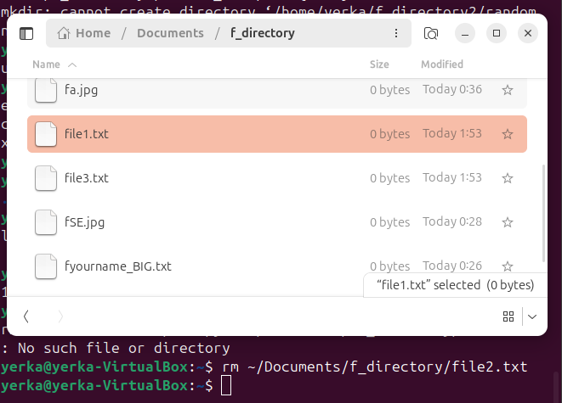

6) Check settings of files

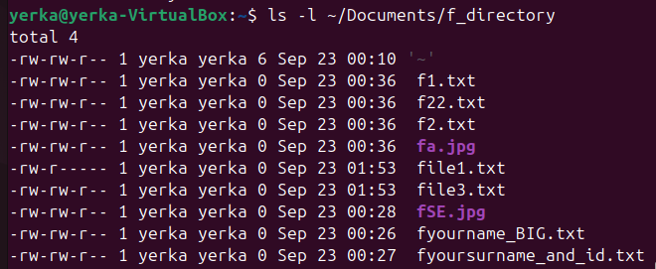

CISCO

