**Assignment 6  
Aldongar Yerkin**

**SE – 2318**

**Class Main**

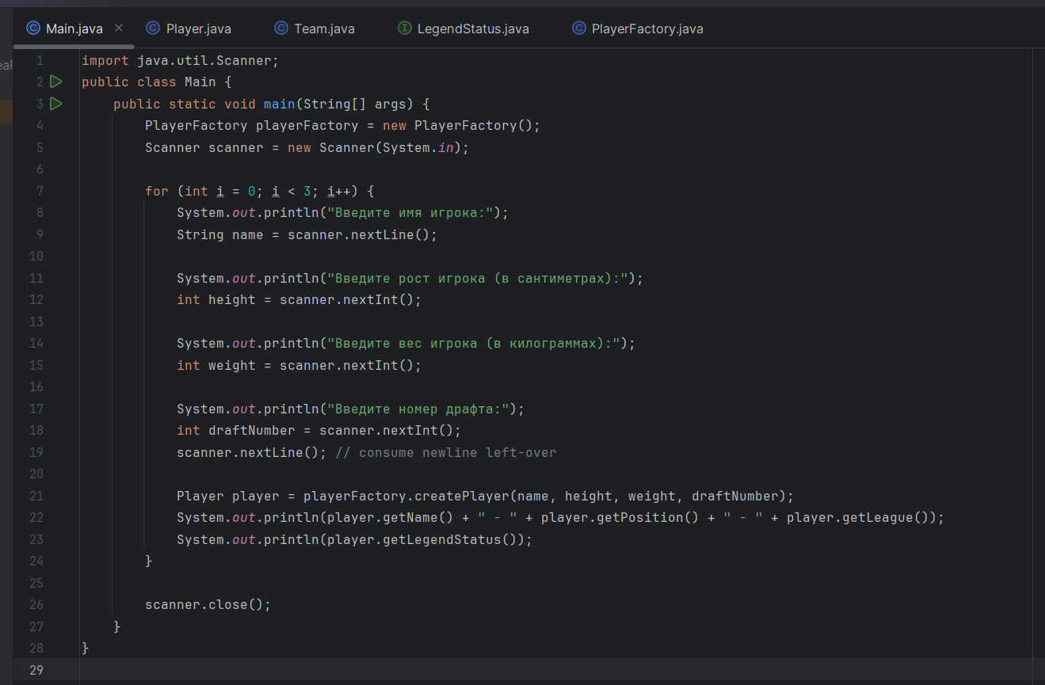

**Player Class**

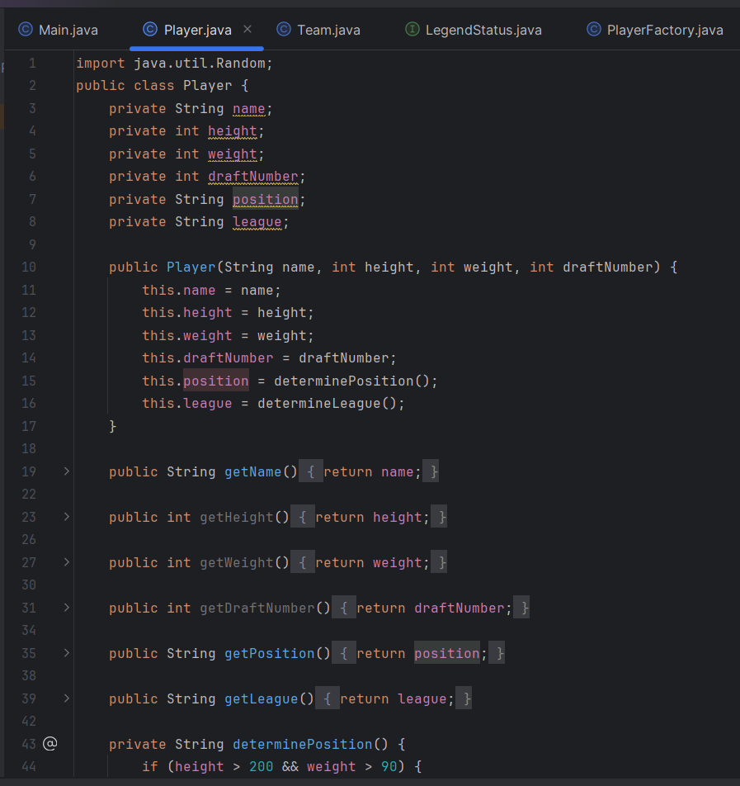

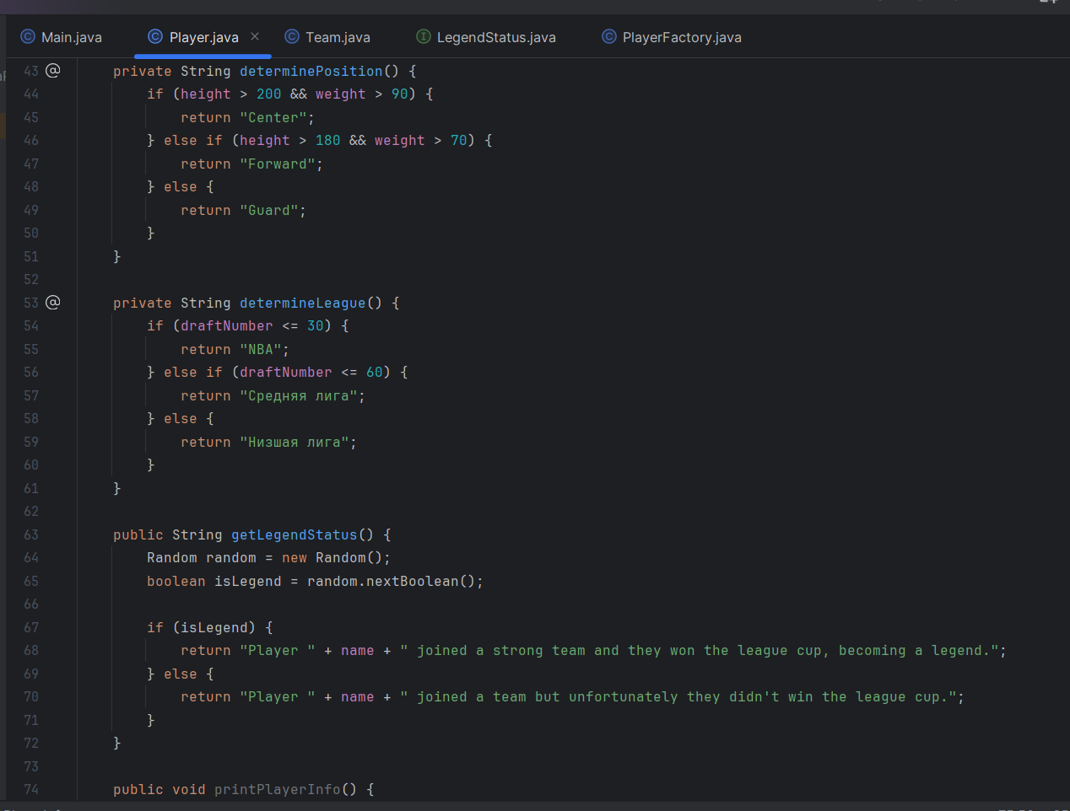

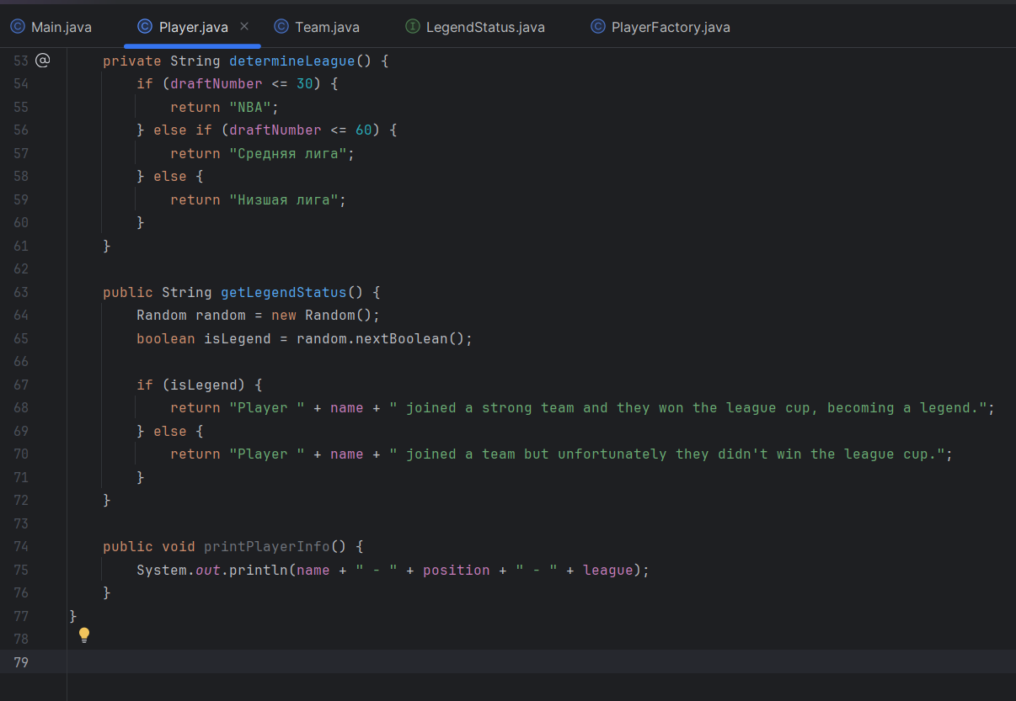

**LegendStatus Interface**

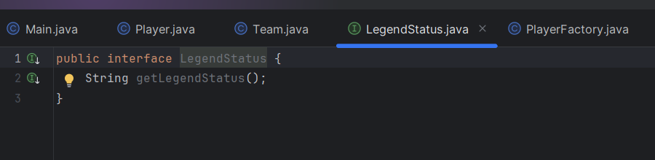

**PlayerFactory class (pattern)**

