Businessplots for R

# **1. Introduction**

Goal:

Collect the most needed plots for business in R. The goal is not to tweak the plots at maximum, but rather provide an easy-to-use platform that creates useful plots which can be used for interpreting the data an using the plots in presentations. Creating the plots in R enables automatic KPI plotting.

Basic setup:

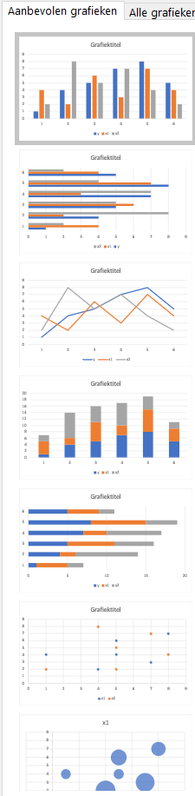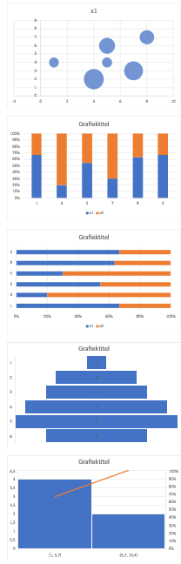

Advanced setup:

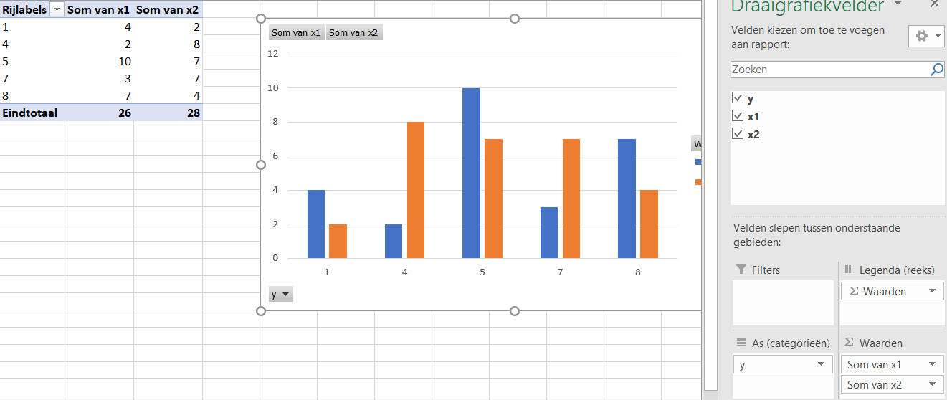

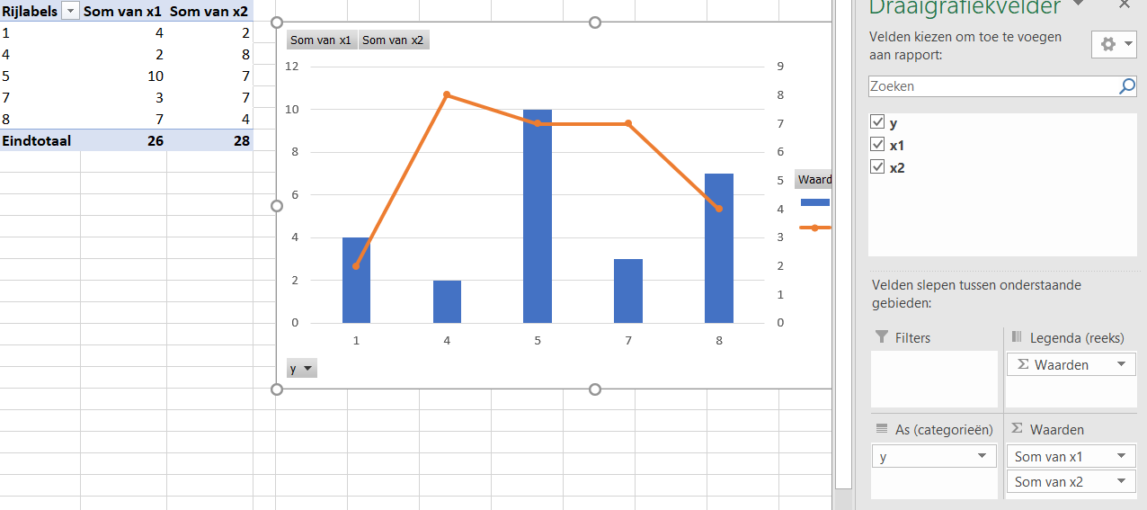

# **2. Data**

Types of data to consider:

1. Target + explanatory variables
2. Date + 1/multiple series
3. Multiple series/products with scoring on different criteria