IdentityHashMap is same like HashMap, but only difference is the IDHM uses “==” operator to compare and HashMap uses .equals() method to compare objects.

By this DHM does not compare the value and checks only the reference equality, and thereby it works little faster than HashMap.

HM uses hashCode() but since IDHM does not use equals() methos, it also does not use hashCode() method() instead it uses System.identityHashCode(object).

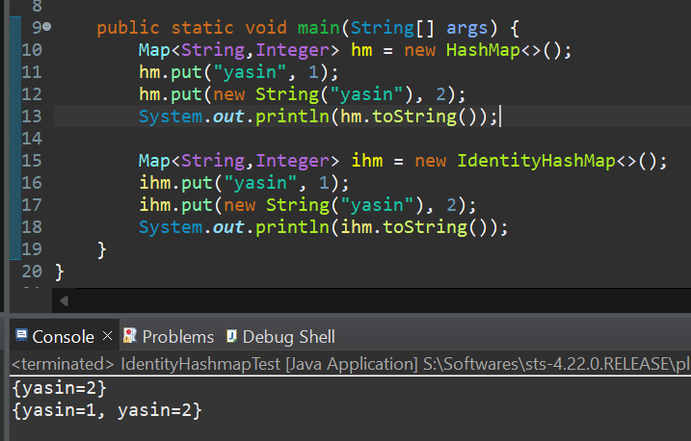

Reference : https://www.youtube.com/watch?v=n2AHnM09mpw