Comparable:

* Meant for default sorting order
* Present in java.lang package
* Contains compareTo()
* All wrapper class and string class implements comparable

Comparator

* Meant for custom sorting order
* Present in java.util package
* Contains compare() and equals()

Comparable handson:

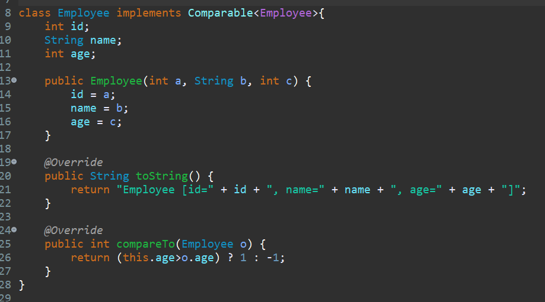

Comparator handson:

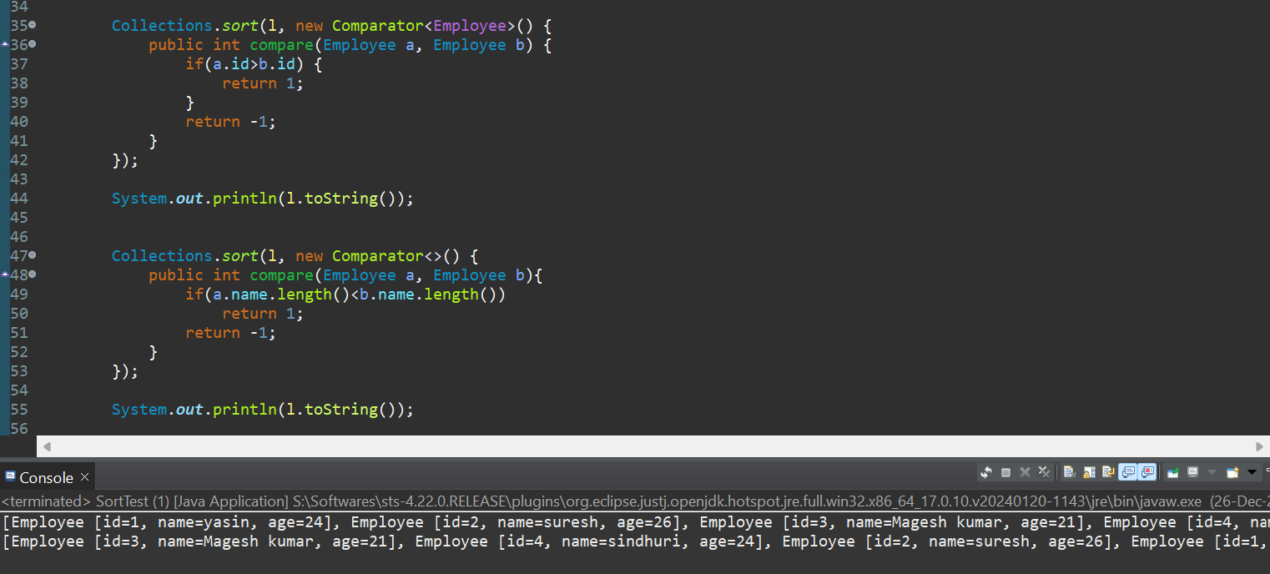

Now writing this with lambda expression

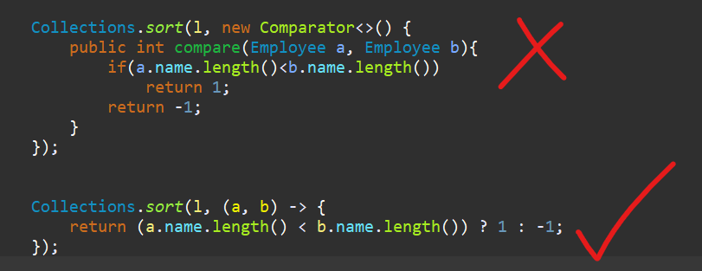

Practice handson file:

