JDBC – Java Database Connectivity

There are 7 steps to perform for JDBC operation.

1. Import package.
2. Load driver.
3. Register driver.
4. Create connection.
5. Create statement.
6. Execute statement.
7. Close connection.

JDBC URL consists of 3 parts

1. Jdbc
2. DB vendor name
3. Network url: port number / DB name

Example: “jdbc: postgresql://localhost:5432/MyDb”

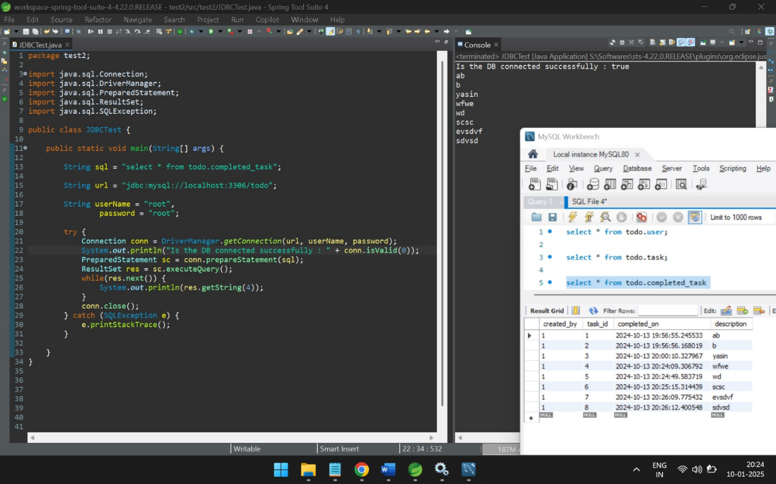

To execute a query:

1. DDL -> Boolean execute() -> returns successful execution or not.
2. DML -> int executeUpdate() -> return number of rows affected.
3. DRL -> ResultSet executeQuery() -> returns table object data.