In java iterator is used to traverse through the collections.

ConcurrentModificationException occurs if we update the list when we are traversing it or while one thread id traversing and other thread modifies it, that is when we ad or remove or update elements in the list.

Fail-fast:

Fail fast iterators throw the exception immediately when we make changes to the collection while iterating, because the iterators are pointing to the original collection. Some examples are ArrayList, HashMap etc.

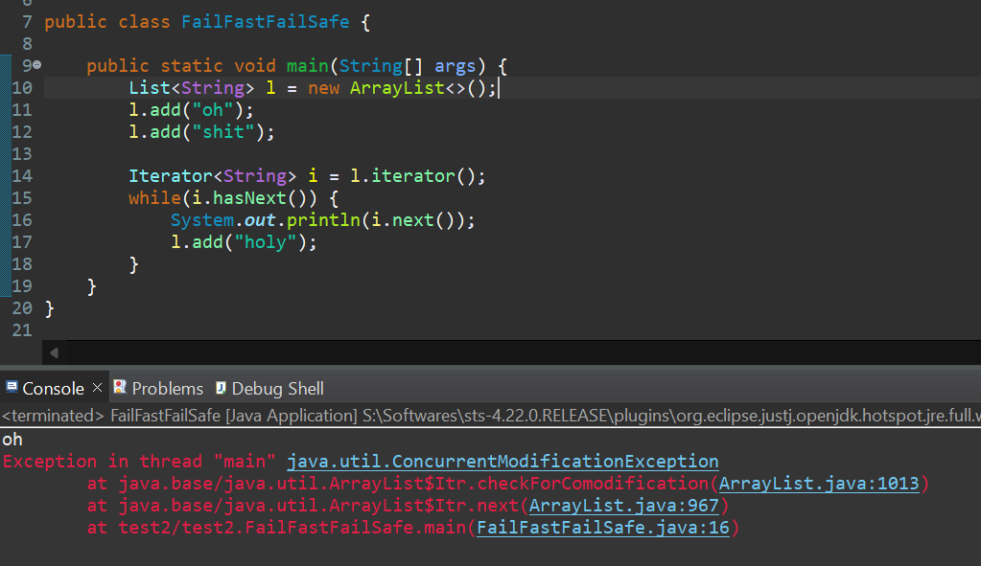

Fail-safe:

Fail safe iterators work on the copy of the collection, and thereby removing the exception chances.

Since they are cloning the whole collection, they require more space while processing. Some examples are CopyOnWriteArrayList, ConcurrentHashMap etc.

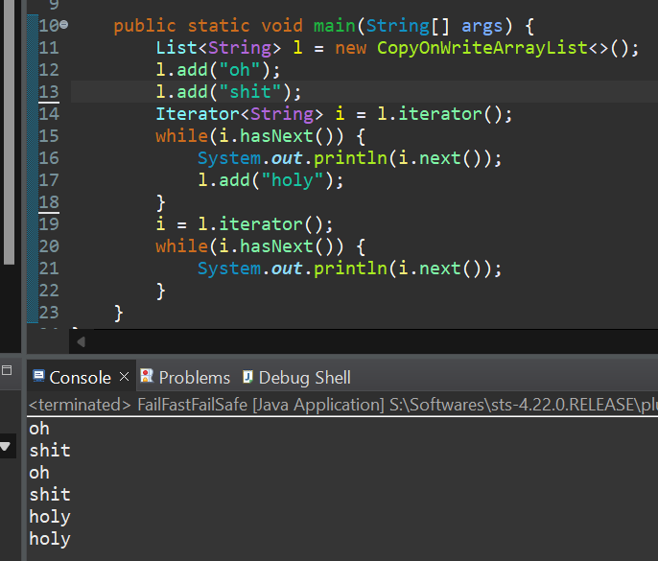

Reference : <https://www.youtube.com/watch?v=1xSIz2JPIj4>