Holly shit!!

All the OOPs concepts are broken by reflection.

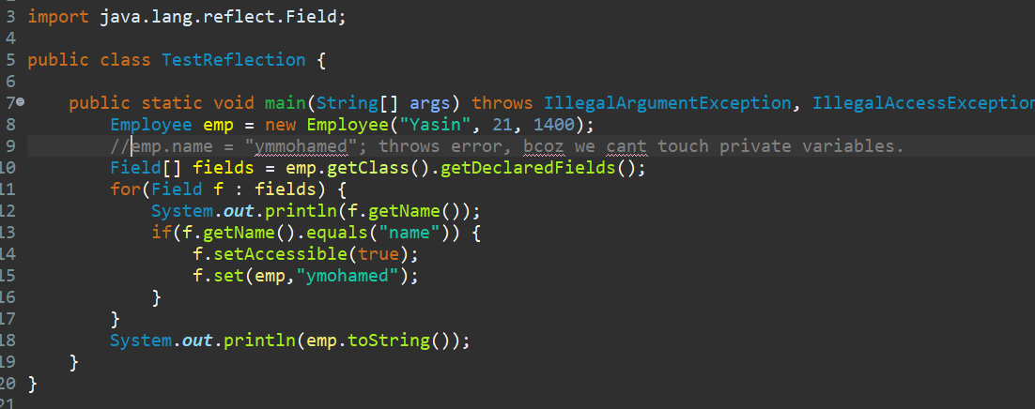

* We can reflect the class and edit it whatever we need during run time.
* This reflection feature is mostly used by frameworks.
* Spring framework uses reflection all over it.

Drawbacks:

* If we don’t know what we are exactly doing using reflection, we’ll be bringing very bad bugs in our code.
* Slow performance while using reflection.
* Use reflection if you want to make the world suffer, else avoid it.