Rest Template:

* A powerful tool to work with Restful web services provided by spring framework.
* Simplifies the process of making HTTP calls and handling responses.
* Dependency provided by spring.
* It is synchronous and blocking, because a thread will wait for response.

Dependency:

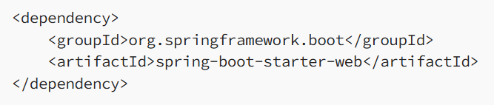

Configuration:

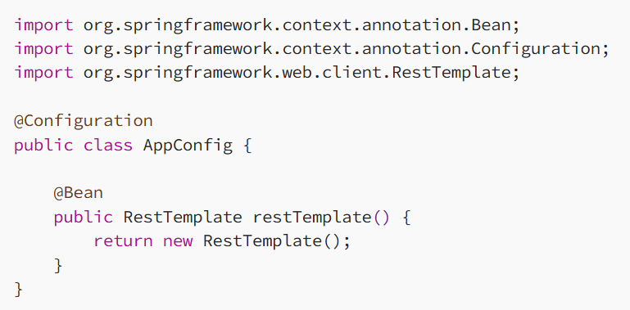

Using rest template to call an endpoint:

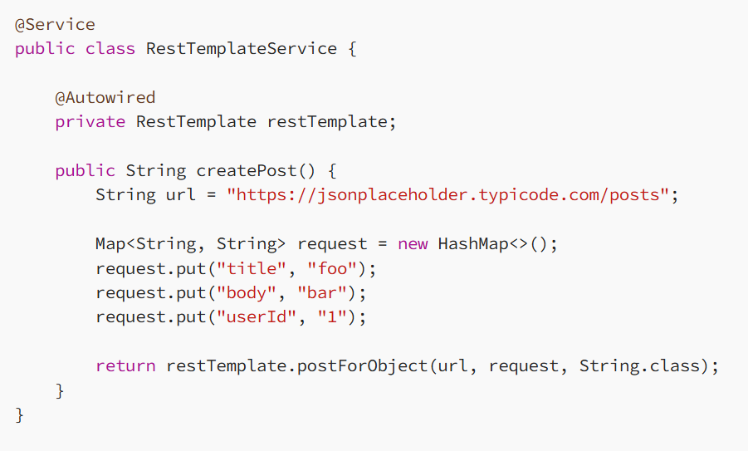

Common methods used are:

* restTemplate.getForObject(), getForEntity()
* postForObject(), postForEntity()
* restTemplate.delete()
* put()
* patchForObject()

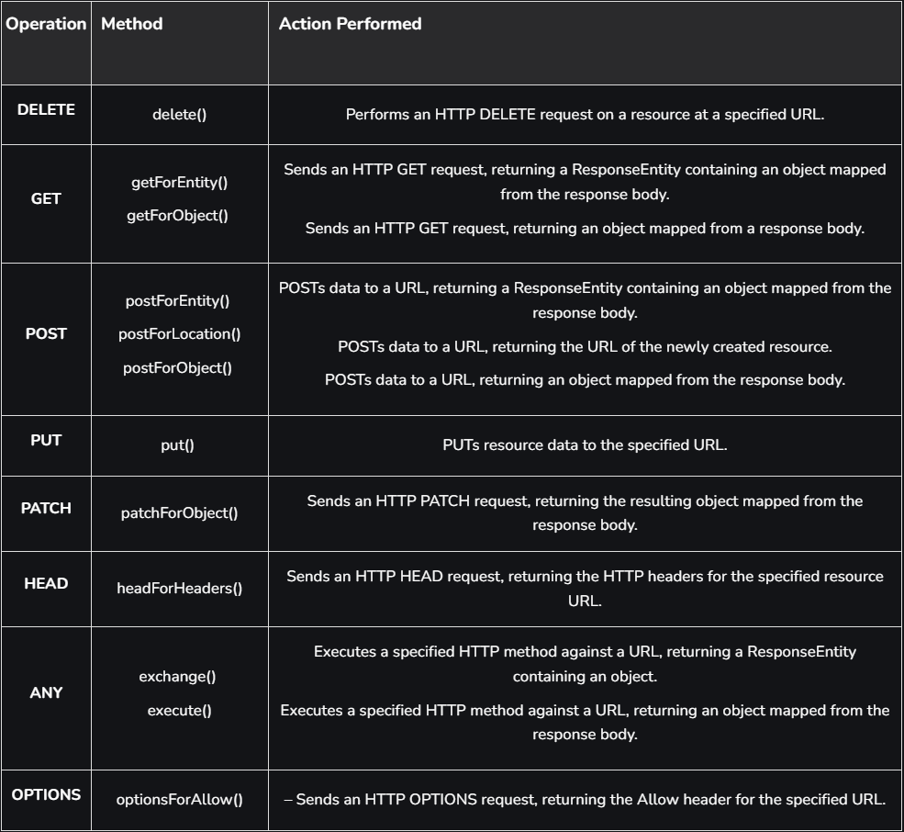

Reference:

1. <https://medium.com/@psdevraye/understanding-resttemplate-in-java-spring-when-and-how-to-use-it-79500987a53c>
2. <https://www.geeksforgeeks.org/spring-resttemplate/>