Web Client:

* Newer version fo handling REST services provided by spring.
* WebClient is part of WebFlux, which is a non-blocking web functionality.
* This will be faster, since a thread wont be waiting for getting response from the HTTP call.

Dependency:

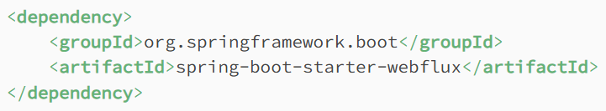

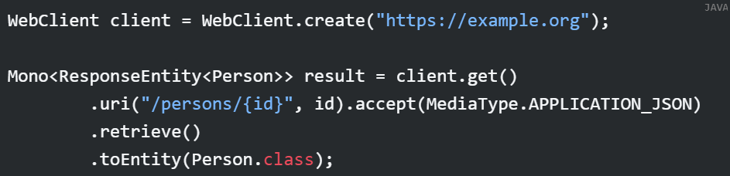

RestTemplate vs WebClient:

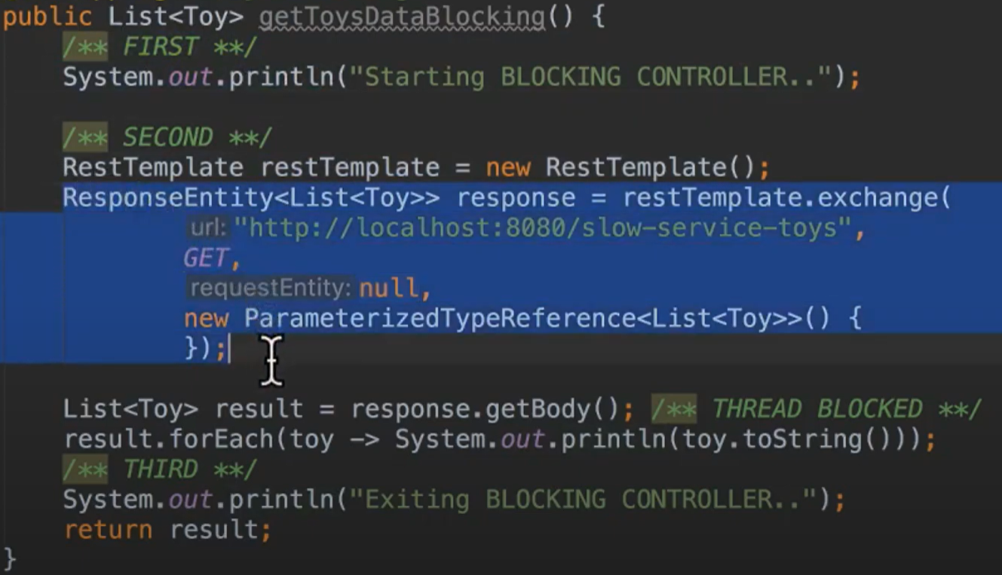

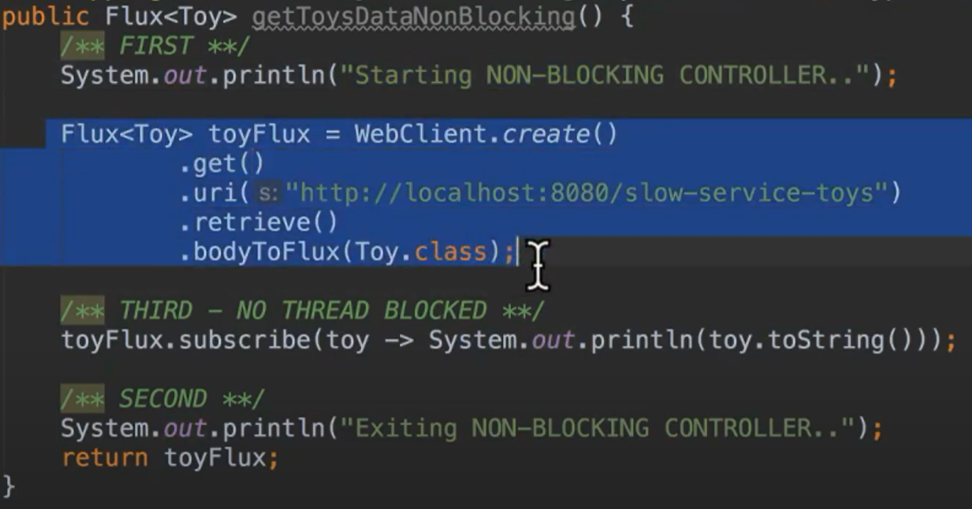

Reference:

1. <https://docs.spring.io/spring-framework/reference/web/webflux-webclient/client-retrieve.html>
2. <https://www.youtube.com/watch?v=u5ntfWnEWvg>