Reference: <https://www.youtube.com/watch?v=fsG1XaZEa78>

Indexes are built on a table against one or more columns and are handled by database service to provide us quicker results on queries.

CREATE INDEX index_name

ON table_name(column1, column2,..);

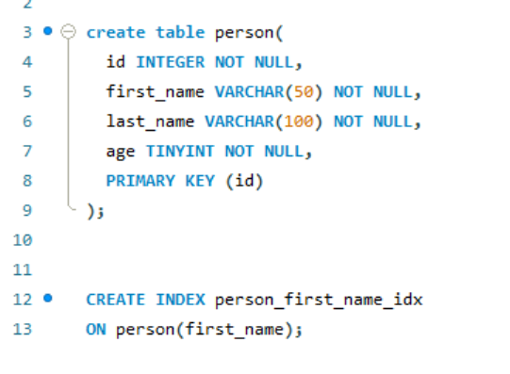

Disadvantages of indexes:

1. Indexes take additional space in DB.
2. Every time you do add or update or delete, the same operation should be done with the index also.