SUPPLEMENTARY MATERIALS

Supplementary Materials for A Decision-Consequence Auditing Framework for Reliable Surrogate-Assisted Optimization in Expensive Engineering Design
Shu-Chuan Chu¹˒², Ya-Yu Zhang¹, Zhenyu Meng³, Jia Zhao⁴, and Jeng-Shyang Pan¹˒²˒*
¹ School of Computer Science, Nanjing University of Information Science and Technology, Nanjing 210044, Jiangsu, China
² School of Artificial Intelligence/School of Future Technology, Nanjing University of Information Science and Technology, Nanjing 210044, Jiangsu, China
³ School of Computer Science and Software, Zhaoqing University, Zhaoqing 526061, China
⁴ School of Information Engineering, Jiangxi University of Water Resources and Electric Power, Nanchang 330099, China
* Corresponding author: Jeng-Shyang Pan, 100112@nuist.edu.cn
ORCID: S. Chu, 0000-0003-2117-0618; Y.-Y. Zhang, 0009-0001-2272-4654; Z. Meng, 0000-0002-1466-8082; Jia Zhao, 0000-0002-3652-1903; J.-S. Pan, 0000-0002-3128-9025
This document preserves secondary analyses, complete denominators, resource measurements, application transfer, high-dimensional extensions, sensitivity studies, and recovery accounting supporting the main article. The main article contains the prespecified primary Black-Box Optimization Benchmarking (BBOB) contrasts and finite-element engineering results. Dimension is denoted by D. No supplementary analysis reverses the failed development optimization-benefit gate.

S0 Evidence Map and Reproducibility Checklist
The supplement is organized by the claims made in the main article. Scientific results, resource measurements, and recovery records are separated so that interrupted physical calls and implementation checks cannot be mistaken for optimization evidence.

S0.1 Evidence map
1. Calibration and decision utility: S1-S2, Tables S1-S7, and Figures S1-S4 provide declaration counts, failure fractions, common-history diagnostics, and common-state utility.
2. External descriptive context: S3, Tables S8-S12, and Figures S5-S6 report full BBOB endpoints and exclusive process costs under distinct search histories.
3. Transfer evidence: S4-S5, Tables S13-S19, and Figures S7-S10 cover LassoBench and the 300-dimensional experiment.
4. Sensitivity: S6-S7, Tables S20-S24, and Figures S11-S13 report model, training-cap, and total-budget sensitivity.
5. Information order and accounting: S7.3-S8.3 and Table S25 preserve finite-element replay, source hashes, recovery ledgers, and matched-initialization evidence.
6. Additional mechanism and engineering evidence: S9-S10, Tables S26-S32 and Figure S14 contain the frozen Gaussian-process (GP) intervention, delayed policy outcomes, force-position transfer, fixed-policy comparisons and full revision cost boundary.

S0.2 Reproducibility checklist
1. Runtime: Windows 11, Python 3.12.13, and dependency lock files for the main, application, GP, and reporting environments.
2. Hardware: AMD Ryzen 7 9700X, 16 logical threads, and approximately 31.1 gibibytes (GiB) of physical memory; numerical-library threads are limited to one per worker.
3. Randomness: Purpose-specific seed maps cover initialization, candidate generation, mode selection, optimization repeats, and bootstrap analyses.
4. Protocols and parameters: Frozen JavaScript Object Notation (JSON) configurations retain budgets, function and instance lists, model settings, and entry-point arguments.
5. Information order: Prediction-before-evaluation (PRE) and post-label (LABEL) journals, prediction-time training indices, candidate arrays, and separate diagnostic-label archives are retained.
6. Integrity: Source fingerprints, dependency hashes, raw-file hashes, endpoint replay, and expected aggregate tables are archived.
7. Data and applications: BBOB and Comparing Continuous Optimizers (COCO) identifiers, fixed LassoBench datasets and splits, and the deterministic EngiBench finite-element parameterization are recorded.
8. Recovery: Incomplete units, canonical-versus-physical call ledgers, rerun seeds, and exclusion rules are archived separately.
The manuscript sources, implementation, frozen configurations, and dependency records are available in the public repository https://github.com/ya-yu-zhang/Reliable-Surrogate-Assisted-Optimization-in-Expensive-Engineering-Design. Approximately 13.6 GB of raw experiment outputs and the full execution archives are not committed to that repository. The reported experiments can be regenerated using the documented environments and configurations; archived raw data are available from the corresponding author upon reasonable request. Public visibility should not be interpreted as an open-source license; third-party implementations and publisher templates retain their own terms. The detailed audit trail remains in S8; this map is a navigation layer rather than a substitute for those records.

S1 Development diagnostics and common-state evidence

S1.1 Exploration, failure, and sparse declarations
The prediction-error-monitoring prototype with temporal weighting (PEM-T) explores approximately 36.6% and 33.4% of post-initialization evaluations, compared with approximately 10% for the fixed control. Its observed failure fractions are approximately 9.9% and 9.5%. The corresponding spatiotemporal configuration is denoted by PEM-ST. The pooled false-discovery proportion is denoted by FDP; an unavailable value is denoted by NA. Being near the nominal monitoring level does not correspond to better endpoints.
Table S1: Joint closed-loop decision indicators, 72 runs per dimension/method
D | Method | Exploration | Failure | Claims | False | Pooled FDP
10 | PEM_ST | 0.3574 | 0.1062 | 7 | 4 | 0.5714
10 | PEM_T | 0.3664 | 0.0986 | 3 | 1 | 0.3333
10 | error_only | 0.1574 | 0.0847 | 4 | 2 | 0.5000
10 | fixed01 | 0.0995 | 0.0843 | 4 | 2 | 0.5000
10 | stagnation_only | 0.2338 | 0.0972 | 2 | 0 | 0.0000
20 | PEM_ST | 0.3478 | 0.1098 | 32 | 2 | 0.0625
20 | PEM_T | 0.3335 | 0.0946 | 0 | 0 | NA
20 | error_only | 0.1475 | 0.0864 | 8 | 4 | 0.5000
20 | fixed01 | 0.1017 | 0.0868 | 10 | 9 | 0.9000
20 | stagnation_only | 0.2394 | 0.0951 | 1 | 1 | 1.0000

PEM-T makes only three declarations in dimension 10, one false, and no declarations in dimension 20. The latter FDP is NA, rather than zero. PEM-ST makes 32 declarations with two false in dimension 20, but its endpoint remains worse. Table S1's pooled declaration ratio is distinct from a mean over runs with nonzero declarations. These sparse denominators do not establish stable conditional success probabilities.
The numbers of realized improvements and false claims within each declared subset are shown in Figure S1.
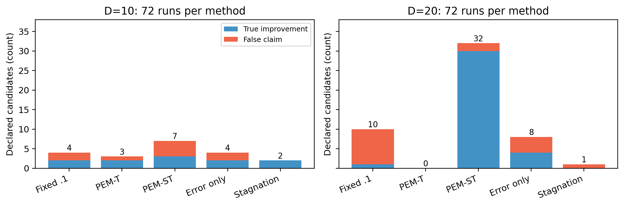
Figure S1: Counts of actual improvement and false claims on declared candidates. A zero column denotes no declarations, not an established reliability advantage.
Figure S1 exposes both the rarity and composition of improvement declarations. PEM-T makes only three declarations in dimension 10 and none in dimension 20, whereas PEM-ST and the fixed controls produce larger declared subsets. Blue and orange segments distinguish realized improvements from false claims. A missing bar therefore represents an empty conditional sample, while a tall orange segment identifies a declaration rule whose apparent candidates often fail to improve the incumbent.
Failure-only feedback is less detrimental than full feedback on the endpoint summary but still does not achieve an overall benefit over fixed .1. Its combined removal of width and stagnation cannot isolate those terms' independent contributions.

S1.2 Common-history diagnostics
Table S2 uses the same T bound within each frozen history/model/pool. Under fixed .3 histories, failures at the actually selected point exceed pool failures. Under greedy histories, their ordering reverses. The observation supports history-dependent differences among monitoring objects and does not support a universal direction of selection-induced undercoverage. Each dimension/history has 288 frozen states; each state contributes one actually selected candidate, 256 pool candidates, and 26 top-10% candidates.
Table S2: Temporal bounds across monitoring objects
D | History | Pool | Top 10% | Actually selected
10 | fixed03 | 0.0425 | 0.0290 | 0.1250
10 | greedy | 0.1070 | 0.0395 | 0.0868
10 | pool_random | 0.0773 | 0.0944 | 0.0521
20 | fixed03 | 0.0481 | 0.0423 | 0.1424
20 | greedy | 0.1691 | 0.0843 | 0.0938
20 | pool_random | 0.0935 | 0.1062 | 0.1042

Failure fractions for the selected candidate, full pool, and predicted top 10% are compared in Figure S2.
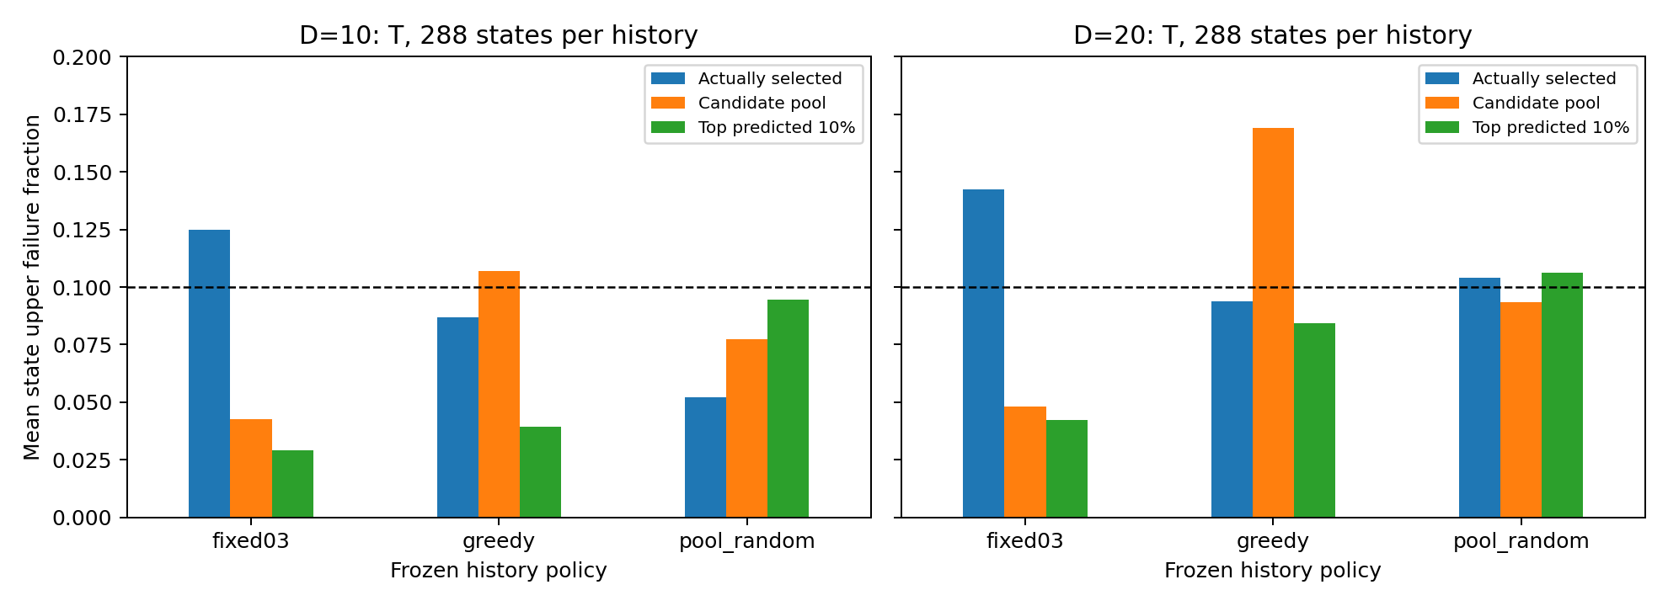
Figure S2: State-averaged one-sided failure fractions under frozen common histories. The dashed target is .1. Pool labels are correlated and are not treated as independent problems.
Figure S2 compares three monitored objects at identical frozen states: the actually selected candidate, the entire candidate pool, and the top 10% by predicted value. Under fixed 03 histories, the selected-candidate bar is highest; under greedy histories, the pool and top-10% bars become higher. The dashed 0.1 line is crossed in different directions across histories, which supports reporting the monitored object and its generating policy together.
Table S3 compares calibrators on the actually selected points, with the three histories equally weighted. The calibrator labels denote global (G), spatial (S), temporal (T), and spatiotemporal (ST) weighting; effective sample size is denoted by ESS. Spatial localization lowers some diagnostic losses and margins; this is a common-history estimation result, not a closed-loop optimization gain or a coverage guarantee. Approximately one quarter of the dimension-10 checkpoint states fall back because of support, whereas these dimension-20 checkpoints do not.
Table S3: Calibrators on actually selected points
D | Calibrator | Quantile loss | Margin | ESS | Fallback
10 | G | 0.1355 | 1.1044 | 45.5000 | 0.0000
10 | S | 0.1241 | 0.9463 | 38.8140 | 0.2500
10 | ST | 0.1187 | 0.9175 | 32.1634 | 0.2500
10 | T | 0.1284 | 1.0262 | 37.7288 | 0.2500
20 | G | 0.1465 | 0.9365 | 74.7500 | 0.0000
20 | S | 0.1322 | 0.7874 | 60.5382 | 0.0000
20 | ST | 0.1307 | 0.7643 | 42.6863 | 0.0000
20 | T | 0.1409 | 0.9114 | 52.3172 | 0.0000

Pool-declaration subsets are also sparse: T has only 13 declared candidates under dimension-10 fixed .3 histories, and one under dimension-20 fixed .3 histories. Full state, nonempty-state, candidate, and failure denominators are publicly retained in the diagnostic CSV files. Stable reliability is not inferred from a small or empty subset.

S1.3 Common-state immediate utility
Table S4 reports normalized true improvement at one chosen candidate from the same frozen pool. T upper-bound selection is identical to mean greedy and is not repeated as an independent column. Full feedback has lower mean immediate improvement than mean greedy and than the predeclared fixed .3 rule in all six dimension/history cells.
Table S4: Common-state normalized one-step improvement
D | History | Mean | Fixed .3 | Feedback
10 | fixed03 | 0.0260 | 0.0219 | 0.0213
10 | greedy | 0.0310 | 0.0257 | 0.0251
10 | pool_random | 0.1240 | 0.0925 | 0.0867
20 | fixed03 | 0.0350 | 0.0238 | 0.0172
20 | greedy | 0.0541 | 0.0433 | 0.0381
20 | pool_random | 0.1326 | 0.0871 | 0.0795

Immediate utility does not exclude a delayed benefit from exploration; however, the closed-loop development experiment supplies no evidence of that benefit for this prototype. It is therefore unsupported to state that additional distance exploration repaired the model.

S2 Independent validation diagnostics and external references

S2.1 History, declarations, and effective support
The history-interaction estimates are D=10: +0.0851 (Holm p=0.00149); D=20: +0.1225 (Holm p=0.00065); D=40: +0.1449 (Holm p=0.00170). This is the fixed .3 selected-minus-pool difference minus the greedy corresponding difference. Across policies, identical seeds do not imply identical candidate pools. These differences describe the coupled history/policy system rather than a fixed-pool causal effect.
Table S5: Temporal pool and actually selected failure fractions, under the prespecified state/run/instance/function aggregation.
D | History | Pool failure | Selected failure
10 | fixed03 | 0.0479 | 0.1215
10 | greedy | 0.1018 | 0.0903
10 | pool_random | 0.0859 | 0.0660
20 | fixed03 | 0.0442 | 0.0833
20 | greedy | 0.1494 | 0.0660
20 | pool_random | 0.0900 | 0.0729
40 | fixed03 | 0.0505 | 0.0799
40 | greedy | 0.1850 | 0.0694
40 | pool_random | 0.0978 | 0.0694

The corresponding selected-minus-pool contrasts are shown in Figure S3.
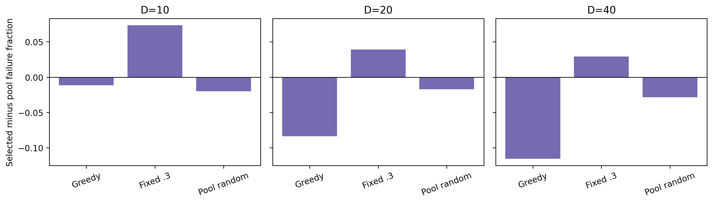
Figure S3: Selected-minus-pool failures by preselected history. A reversal is retained rather than interpreted as universal selection deterioration.
Figure S3 expresses the same comparison as a signed difference (selected minus pool). Fixed03 bars are positive and greedy bars are negative in every dimension; random-pool bars stay nearer zero. The repeated sign reversal demonstrates that selected-point coverage cannot be summarized independently of the history-generating policy.
Table S6: Exploration, failures, and declaration denominators in independent closed-loop runs. FDP is pooled false/claims; no-claim FDP is NA.
D | Method | Exploration | Failure | Claims | False | Pooled FDP
10 | PEM_ST | 0.3936 | 0.1052 | 48 | 23 | 0.4792
10 | PEM_T | 0.3967 | 0.1008 | 31 | 20 | 0.6452
10 | fixed01 | 0.0949 | 0.0812 | 35 | 21 | 0.6000
20 | PEM_ST | 0.3687 | 0.1078 | 158 | 36 | 0.2278
20 | PEM_T | 0.3644 | 0.0942 | 34 | 27 | 0.7941
20 | fixed01 | 0.1018 | 0.0833 | 48 | 32 | 0.6667
40 | PEM_ST | 0.3701 | 0.1196 | 870 | 98 | 0.1126
40 | PEM_T | 0.3435 | 0.0964 | 155 | 30 | 0.1935
40 | fixed01 | 0.1007 | 0.0930 | 388 | 71 | 0.1830

For PEM-T, D=10: 31 declarations, 20 false, pooled FDP 64.5%; D=20: 34 declarations, 27 false, pooled FDP 79.4%; D=40: 155 declarations, 30 false, pooled FDP 19.4%. An approximately .1 overall failure fraction does not imply an approximately .1 false-declaration fraction. These small declaration denominators do not establish stable per-declaration probabilities. ST lowers the descriptive selected-point quantile loss in all nine dimension/history cells, yet its closed-loop endpoint remains worse than fixed .1 in every dimension. These are separate diagnostic and trajectory comparisons, not an identified causal relationship.
Table S7: Descriptive state-mean support across the three preselected history policies and four checkpoints.
D | Calibrator | State mean ESS | State mean fallback
10 | ST | 32.9284 | 0.2500
10 | T | 37.7288 | 0.2500
20 | ST | 43.6167 | 0.0000
20 | T | 52.3172 | 0.0000
40 | ST | 49.4855 | 0.0004
40 | T | 58.5602 | 0.0000

Temporal and spatiotemporal effective support across checkpoint order is shown in Figure S4.
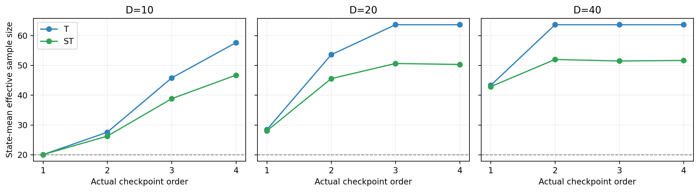
Figure S4: T/ST effective support at the four actual checkpoint orders. The threshold is an engineering guard and does not guarantee coverage.
Figure S4 shows that effective support grows with checkpoint order for both temporal (T) and spatiotemporal (ST) weighting. T retains more effective observations than ST after localization, and the gap is largest in dimensions 20 and 40. Both curves remain above the support guard after the earliest checkpoint, but the plateaus emphasize that passing the guard is a numerical eligibility condition rather than evidence of calibrated coverage.
The first diagnostic checkpoints are 41/100, 61/200, and 101/400. Sparse declared-pool subsets disclose nonempty states, candidate counts, and failures separately. Localized quantile-loss, margin, ESS, and fallback differences and the five fixed BBOB structure groups are available in full secondary tables; no favorable subgroup is promoted to a primary result.

S2.2 External background references
Sobol and the pycma implementation of covariance matrix adaptation evolution strategy (CMA-ES) retain their own search mechanisms and initialization. Their 1,296 runs and 302,400 paid evaluations passed separate journal audits. For descriptive common-scale comparison only, each external run's final error is divided by the matching internal common-initialization error, and medians are taken after this run-level normalization. The external optimizers never receive those internal labels. This supports budget-matched background comparison, not a same-history causal comparison or reproduction of published SAEA competitors.
Table S8: Descriptive background endpoint scores over all 24 functions. Lower is better; no additional test family is introduced.
D | Fixed .1 | PEM-T | PEM-ST | Sobol | CMA-ES
10 | -0.8823 | -0.7156 | -0.7465 | -0.0805 | -0.4275
20 | -0.8761 | -0.7763 | -0.7877 | -0.1066 | -0.4799
40 | -0.7934 | -0.7295 | -0.7041 | -0.1029 | -0.4440

Gaussian-process expected improvement (GP-EI) and author-code trust-region Bayesian optimization (TuRBO-1) use separate frozen protocols and strict pre-call budget guards. Their complete audited outcomes are included in the main article. Author-code restart counterexamples are control-flow checks, not performance observations. Resource precheck instances are excluded from every benchmark table.

S3 Complete BBOB references and exclusive resource evidence

S3.1 Full descriptive BBOB reference evidence
Both frozen GP-EI and author TuRBO-1 batches complete 648 runs and 151,200 paid evaluations each, without reducing functions, repeats, GP training, or acquisition candidates. Together with the six internal and two basic references, all ten methods include 6,480 runs and 1,512,000 paid evaluations. External methods retain their own search and initialization. The matching internal initial-error denominator enters analysis only; normalization precedes within-instance medians. The 24 function scores are equally weighted. These descriptive comparisons add no significance family and do not reproduce the unavailable SAEA competitors.
GP-EI implements classical expected improvement [3] using the explicitly frozen kernel and search; it is not an exact reproduction of original EGO software. TuRBO-1 uses the author local trust-region implementation [25] with an external paid-call guard.
Table S9: Full ten-method function-mean log-relative endpoint scores. Lower is better.
Method | D=10 | D=20 | D=40
greedy | -0.9152 | -0.9014 | -0.8158
fixed01 | -0.8823 | -0.8761 | -0.7934
fixed03 | -0.7829 | -0.771 | -0.7097
pool_random | -0.1683 | -0.2223 | -0.2623
PEM_T | -0.7156 | -0.7763 | -0.7295
PEM_ST | -0.7465 | -0.7877 | -0.7041
sobol | -0.0805 | -0.1066 | -0.1029
cma_es | -0.4275 | -0.4799 | -0.444
gp_ei | -1.3292 | -1.033 | -0.9323
turbo₁ | -1.102 | -1.1219 | -1.0389

The complete ten-method BBOB endpoint comparison is shown in Figure S5.
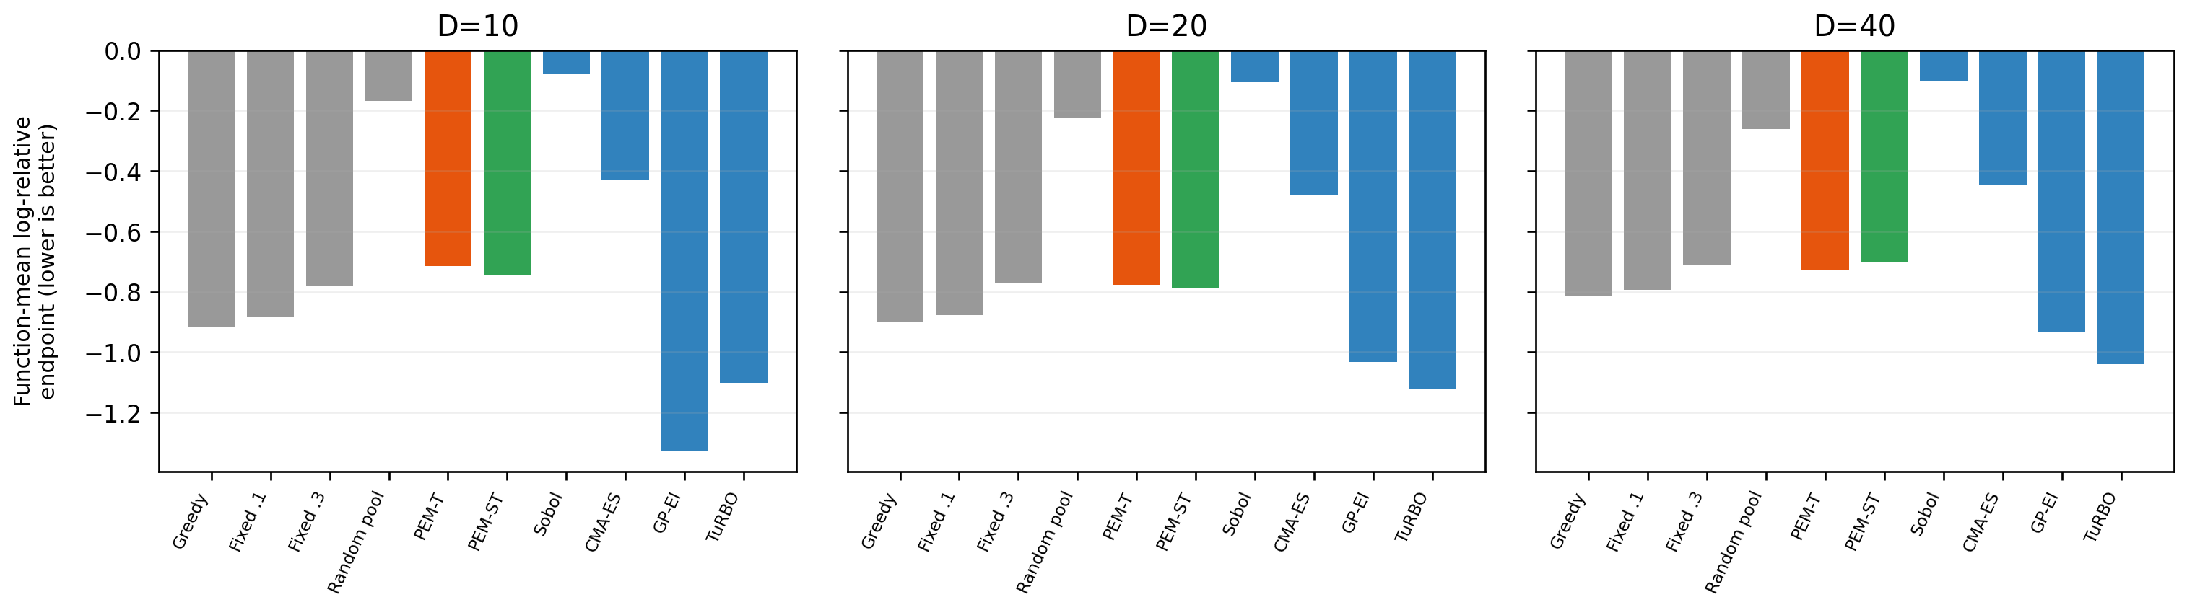
Figure S5: Complete BBOB background reference endpoints; no partial runs or resource-precheck instances.
Figure S5 retains the full ten-method ordering in each dimension. TuRBO-1 and GP-EI occupy different positions across dimensions, while Sobol remains close to zero and the internal methods form a tighter negative-error group. The panel-wise variation supports use of these methods as descriptive context; it does not justify a cross-protocol causal ranking because their initialization and search mechanisms differ.

S3.2 Exclusive cost evidence
The frozen resource design contains 54 fresh, serial process measurements on f1/instance4 across D=10/20/40 and three repeats of six methods. Their 12,600 paid calls are reported as cost observations, excluded from benchmark effect estimation. Actual process and background central-processing-unit (CPU) guards precede measurements. Runtime includes journaling and each method retains its own initialization. Greedy/fixed controls still perform temporal monitoring, so these are implemented-system costs, not stripped-down ideal algorithm costs.
Table S10: D=10; three-run medians; full min/max and per-process observations remain in the supplement CSV.
Method | Algorithm s | Nonobjective s | Peak GiB | Post-init prep s
PEM_ST | 0.6547 | 0.6543 | 0.0945 | 0.0108
PEM_T | 0.6075 | 0.6072 | 0.0947 | 0.01
fixed01 | 0.602 | 0.6016 | 0.0947 | 0.0099
gp_ei | 27.6737 | 27.6724 | 0.2863 | 0.3456
greedy | 0.5983 | 0.5979 | 0.0945 | 0.0098
turbo₁ | 7.4536 | 7.4522 | 0.3905 | 0.0923

Table S11: D=20; three-run medians; full min/max and per-process observations remain in the supplement CSV.
Method | Algorithm s | Nonobjective s | Peak GiB | Post-init prep s
PEM_ST | 1.6909 | 1.6901 | 0.0946 | 0.012
PEM_T | 1.5254 | 1.5246 | 0.0948 | 0.0108
fixed01 | 1.5252 | 1.5244 | 0.0948 | 0.0108
gp_ei | 175.864 | 175.861 | 0.3059 | 1.0989
greedy | 1.5246 | 1.5238 | 0.0945 | 0.0108
turbo₁ | 35.0159 | 35.013 | 0.5936 | 0.2183

Table S12: D=40; three-run medians; full min/max and per-process observations remain in the supplement CSV.
Method | Algorithm s | Nonobjective s | Peak GiB | Post-init prep s
PEM_ST | 4.7496 | 4.7476 | 0.096 | 0.0157
PEM_T | 4.3878 | 4.3856 | 0.0962 | 0.0145
fixed01 | 4.3787 | 4.3766 | 0.0965 | 0.0145
gp_ei | 1308.81 | 1308.8 | 0.3073 | 4.0897
greedy | 4.3615 | 4.3594 | 0.0958 | 0.0144
turbo₁ | 255.912 | 255.906 | 1.0791 | 0.7993

The measured-overhead and assumed-objective-cost scenarios are shown in Figure S6.
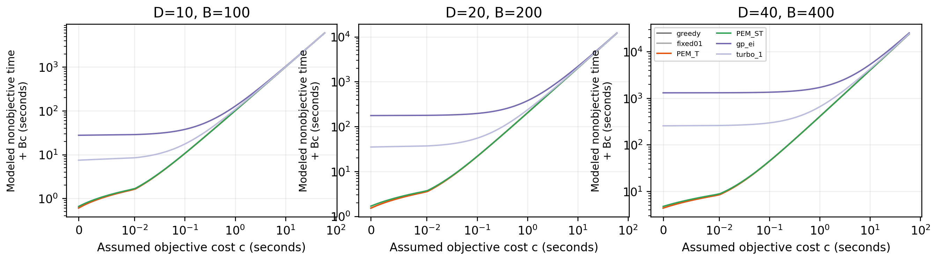
Figure S6: Hypothetical objective-cost scenarios from serial measurements; all methods use the same B in a dimension.
Figure S6 separates measured algorithm overhead from an assumed per-evaluation objective cost. The left side of each log-scale panel is dominated by method overhead, which is largest for GP-EI and TuRBO-1. As objective cost increases, all lines approach the common slope imposed by the identical evaluation budget. The intersections mark cost regimes in which overhead ceases to dominate; they are scenario calculations, not measured parallel speedups.
At an assumed objective cost c, total time is modeled as measured nonobjective time plus Bc. This scenario is not an observed application acceleration. Equal evaluation budgets have equal objective-cost slopes and cannot establish evaluation savings.

S4 LassoBench application transfer

S4.1 LassoBench mechanism transfer
LassoBench [24] provides the application objectives. A separate protocol is frozen before formal seed42 labels. Three original tasks (D=60/100/180), eight methods, twenty optimization repeats, and 500 evaluations yield 480 runs and 240,000 full configuration evaluations (1,200,000 cross-validation (CV) fold solves). Internal initialization is 140/220/380 paid calls; external initialization remains native. The author five-fold full-fidelity objective, fixed data/splits, solver settings, bounds, and target definitions are unchanged.
Unknown optimum is never imputed. The main endpoint is original validation loss. After all 500 labels are saved, the first lowest-validation configuration receives exactly one author test call, adding 480 single fits separately. Synthetic test mean squared prediction error (MSPE) uses the author fixed oracle normalizer, while the deoxyribonucleic-acid (DNA) task uses absolute test mean squared error (MSE); these scales are not pooled. The first and third quartiles are denoted by Q1 and Q3, respectively. The synthetic constructor computes its fixed test normalizer, but no test-performance result enters any optimization feedback.
Table S13: synt_simple; twenty optimization-run dispersion and post-completion test medians.
Method | CV median | Q1 | Q3 | Test MSPE median | F-score median
PEM_ST | 0.7896 | 0.7656 | 0.8528 | 1.1435 | 0.6667
PEM_T | 0.7714 | 0.7557 | 0.8654 | 1.2013 | 0.6667
cma_es | 0.758 | 0.7176 | 0.7826 | 1.072 | 0.5455
fixed01 | 0.7534 | 0.7092 | 0.816 | 1.1441 | 0.6667
gp_ei | 1.0118 | 0.9392 | 1.0847 | 1.1167 | 0.6
greedy | 0.7501 | 0.703 | 0.7755 | 1.1078 | 0.6
sobol | 1.2057 | 1.0326 | 1.2544 | 1.1865 | 0.4808
turbo₁ | 0.6448 | 0.5888 | 0.7032 | 1.0643 | 0.6

Table S14: synt_medium; twenty optimization-run dispersion and post-completion test medians.
Method | CV median | Q1 | Q3 | Test MSPE median | F-score median
PEM_ST | 1.146 | 1.1122 | 1.1731 | 0.7697 | 0.7692
PEM_T | 1.1519 | 1.1327 | 1.1684 | 0.7562 | 0.8013
cma_es | 1.1888 | 1.1345 | 1.237 | 0.7927 | 0.625
fixed01 | 1.1186 | 1.0751 | 1.1418 | 0.7486 | 0.7692
gp_ei | 1.61 | 1.5226 | 1.7486 | 0.8469 | 0.6667
greedy | 1.1103 | 1.069 | 1.1616 | 0.7703 | 0.7692
sobol | 1.8953 | 1.7099 | 2.0302 | 0.8846 | 0.625
turbo₁ | 1.0277 | 0.9575 | 1.0632 | 0.835 | 0.625

Table S15: DNA; twenty optimization-run dispersion and post-completion test medians.
Method | CV median | Q1 | Q3 | Test MSPE median | F-score median
PEM_ST | 0.3071 | 0.3056 | 0.3092 | 0.3304 | NA
PEM_T | 0.3073 | 0.3054 | 0.3093 | 0.3277 | NA
cma_es | 0.3014 | 0.2992 | 0.3043 | 0.3285 | NA
fixed01 | 0.306 | 0.3025 | 0.3079 | 0.3307 | NA
gp_ei | 0.336 | 0.3328 | 0.3384 | 0.3495 | NA
greedy | 0.3057 | 0.3042 | 0.3067 | 0.327 | NA
sobol | 0.3348 | 0.332 | 0.3375 | 0.3439 | NA
turbo₁ | 0.3028 | 0.3005 | 0.3052 | 0.3278 | NA

Table S16: Prespecified application family, PEM-T minus fixed .1 raw final validation loss. Positive favors the fixed control. Intervals are unadjusted paired-run bootstrap confidence intervals (CIs).
Task | Median difference | CI low | CI high | Holm p | Loss | Win | Tie
synt_simple | 0.0503 | 0.0032 | 0.0725 | 0.0826 | 14 | 6 | 0
synt_medium | 0.0393 | 0.0221 | 0.0626 | 0.0192 | 16 | 4 | 0
DNA | 0.0027 | 0.0005279 | 0.0044 | 0.0592 | 16 | 4 | 0

synt_simple: higher, Holm p=0.0826; synt_medium: higher, Holm p=0.0192; DNA: higher, Holm p=0.0592.
The three comparisons form an application-only Holm family, separate from the nine BBOB mechanism tests. Twenty repeats describe optimization randomness on one fixed dataset and split per task, not twenty independent datasets. The Wilcoxon and paired bootstrap assumptions and limits are retained regardless of significance or direction.
Original-scale validation endpoints for the three LassoBench tasks are shown in Figure S7. Interquartile range is denoted by IQR in Figures S7 and S8.
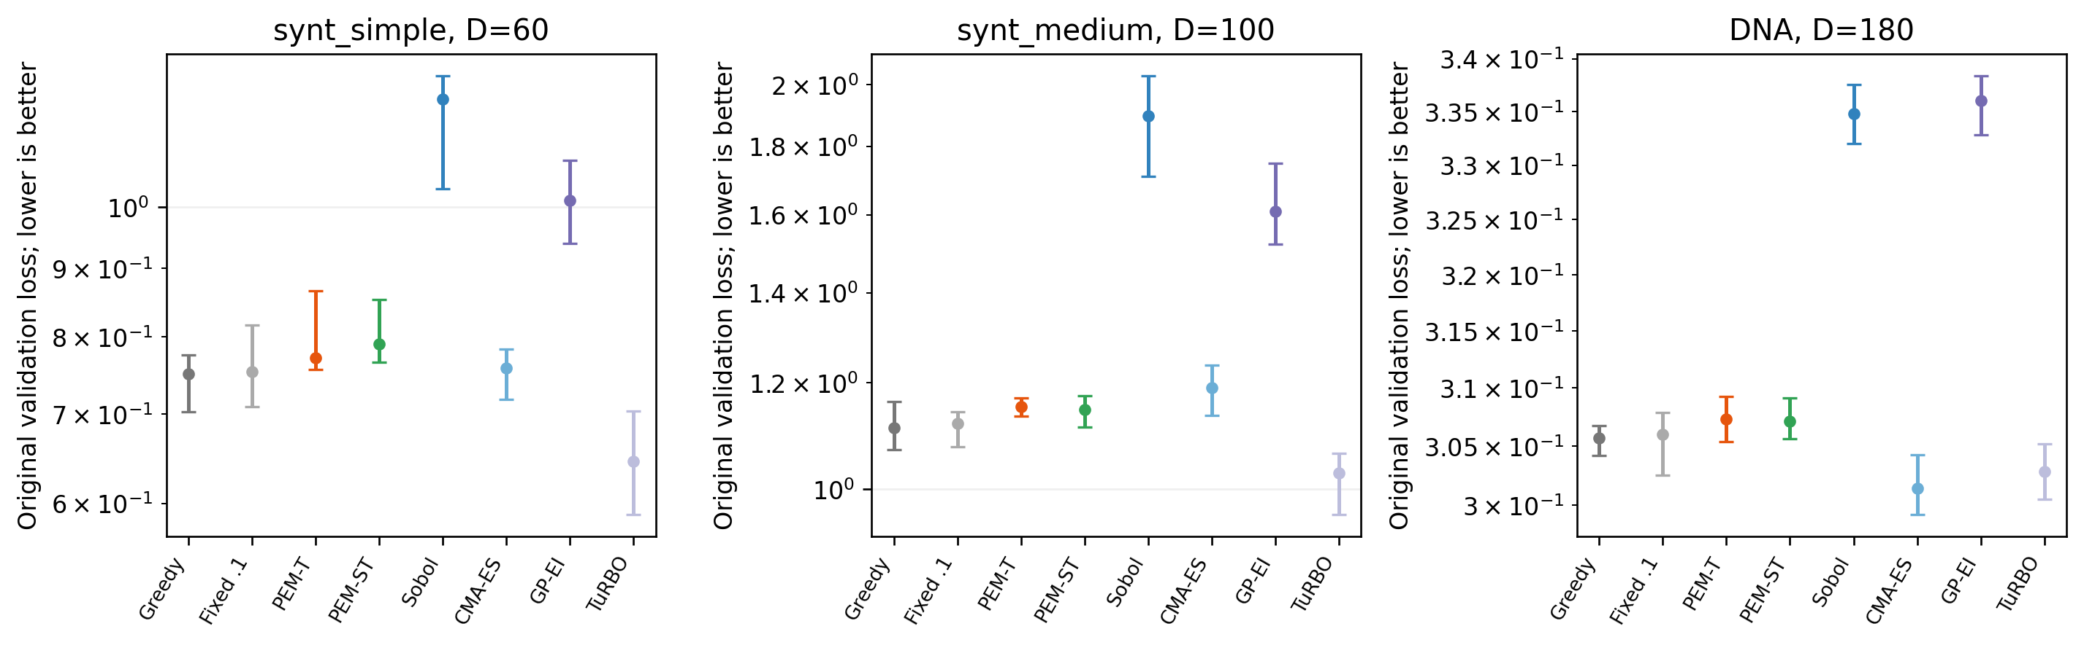
Figure S7: Application original validation endpoints with run-IQR bars; unknown-optimum error is never constructed.
Figure S7 reports the original validation loss on its native scale for each LassoBench task. The synt_simple and synt_medium panels separate the lower-loss internal and trust-region methods from Sobol and GP-EI, whereas the DNA panel compresses most methods into a narrow band. The run-interquartile bars reveal substantial dispersion for the weaker synthetic-task endpoints and discourage conclusions based only on median rank.
Their median and interquartile convergence histories are shown in Figure S8.
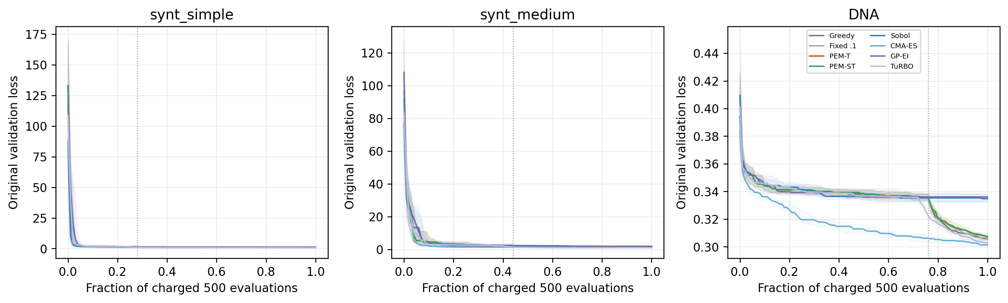
Figure S8: Application original-loss median and IQR curves. The dotted line marks internal initialization; external designs differ. Zero fraction displays the first paid label.
Figure S8 shows how the endpoint differences arise. Most improvement on the two synthetic tasks occurs early, followed by long plateaus, while DNA retains smaller and more gradual changes. The dotted initialization boundary applies to the internal configurations only; external curves begin from their native designs. The figure is therefore used to describe timing and stability, not to claim identical starting conditions.
Table S17: Descriptive post-initialization selected-point monitoring; no hidden pool objectives are acquired.
Task | Method | Failure | Q-loss | Claims | False | Pooled FDP | No-claim runs
DNA | PEM_ST | 0.0704 | 0.0698 | 0 | 0 | NA | 20
DNA | PEM_T | 0.0629 | 0.084 | 0 | 0 | NA | 20
DNA | fixed01 | 0.0346 | 0.0627 | 0 | 0 | NA | 20
DNA | greedy | 0.0079 | 0.041 | 1 | 1 | 1.0000 | 19
synt_medium | PEM_ST | 0.1036 | 0.0778 | 53 | 46 | 0.8679 | 1
synt_medium | PEM_T | 0.0887 | 0.0904 | 7 | 6 | 0.8571 | 14
synt_medium | fixed01 | 0.0505 | 0.0452 | 27 | 23 | 0.8519 | 5
synt_medium | greedy | 0.0134 | 0.0147 | 60 | 54 | 0.9000 | 1
synt_simple | PEM_ST | 0.1103 | 0.0946 | 75 | 74 | 0.9867 | 1
synt_simple | PEM_T | 0.0931 | 0.1104 | 7 | 6 | 0.8571 | 15
synt_simple | fixed01 | 0.0549 | 0.0476 | 76 | 74 | 0.9737 | 1
synt_simple | greedy | 0.0367 | 0.0137 | 220 | 218 | 0.9909 | 0

These closed-loop histories differ between methods and do not identify same-pool causal effects. Zero declarations give NA FDP, with counts disclosed. The 300-dimensional synt_high extension therefore uses its separately frozen 1,000-evaluation protocol, reported in Section S5. Application findings cannot undo the failed original development gate.

S5 Predefined 300-dimensional extension
The predefined synt_high extension used 1,000 paid evaluations because the unchanged internal initialization requires 620, exceeding the 500-evaluation primary-application budget. Eight methods completed 20 optimization runs on one fixed seed42 data set and split (160 runs; 160,000 validation evaluations; 800,000 CV-fold solves), followed by exactly one held-out test call per completed run. The low-effective-dimensional synthetic construction and different budget preclude a general high-dimensional or cross-task superiority claim.

S5.1 Endpoints and convergence
Table S18: Results for Endpoints and convergence
Method | Validation median [Q1, Q3] | Test MSPE median [Q1, Q3] | Test F-score median [Q1, Q3]
greedy | 1.38 [1.334, 1.435] | 1.508 [1.466, 1.608] | 0.6897 [0.6522, 0.7186]
fixed01 | 1.392 [1.345, 1.442] | 1.615 [1.484, 1.677] | 0.6977 [0.6596, 0.7317]
PEM_T | 1.364 [1.338, 1.439] | 1.58 [1.503, 1.653] | 0.7143 [0.678, 0.7548]
PEM_ST | 1.372 [1.312, 1.476] | 1.614 [1.525, 1.653] | 0.6977 [0.6818, 0.7317]
sobol | 18.54 [16.12, 22.64] | 13.45 [10.07, 19.15] | 0.3314 [0.3055, 0.354]
cma_es | 1.145 [1.089, 1.179] | 1.696 [1.612, 1.909] | 0.6522 [0.6, 0.6667]
gp_ei | 17.04 [14.89, 21] | 13.5 [9.747, 19.81] | 0.359 [0.3123, 0.3709]
turbo₁ | 1.157 [1.128, 1.265] | 1.654 [1.6, 1.798] | 0.723 [0.6977, 0.75]

The 300-dimensional endpoint distribution is shown in Figure S9.
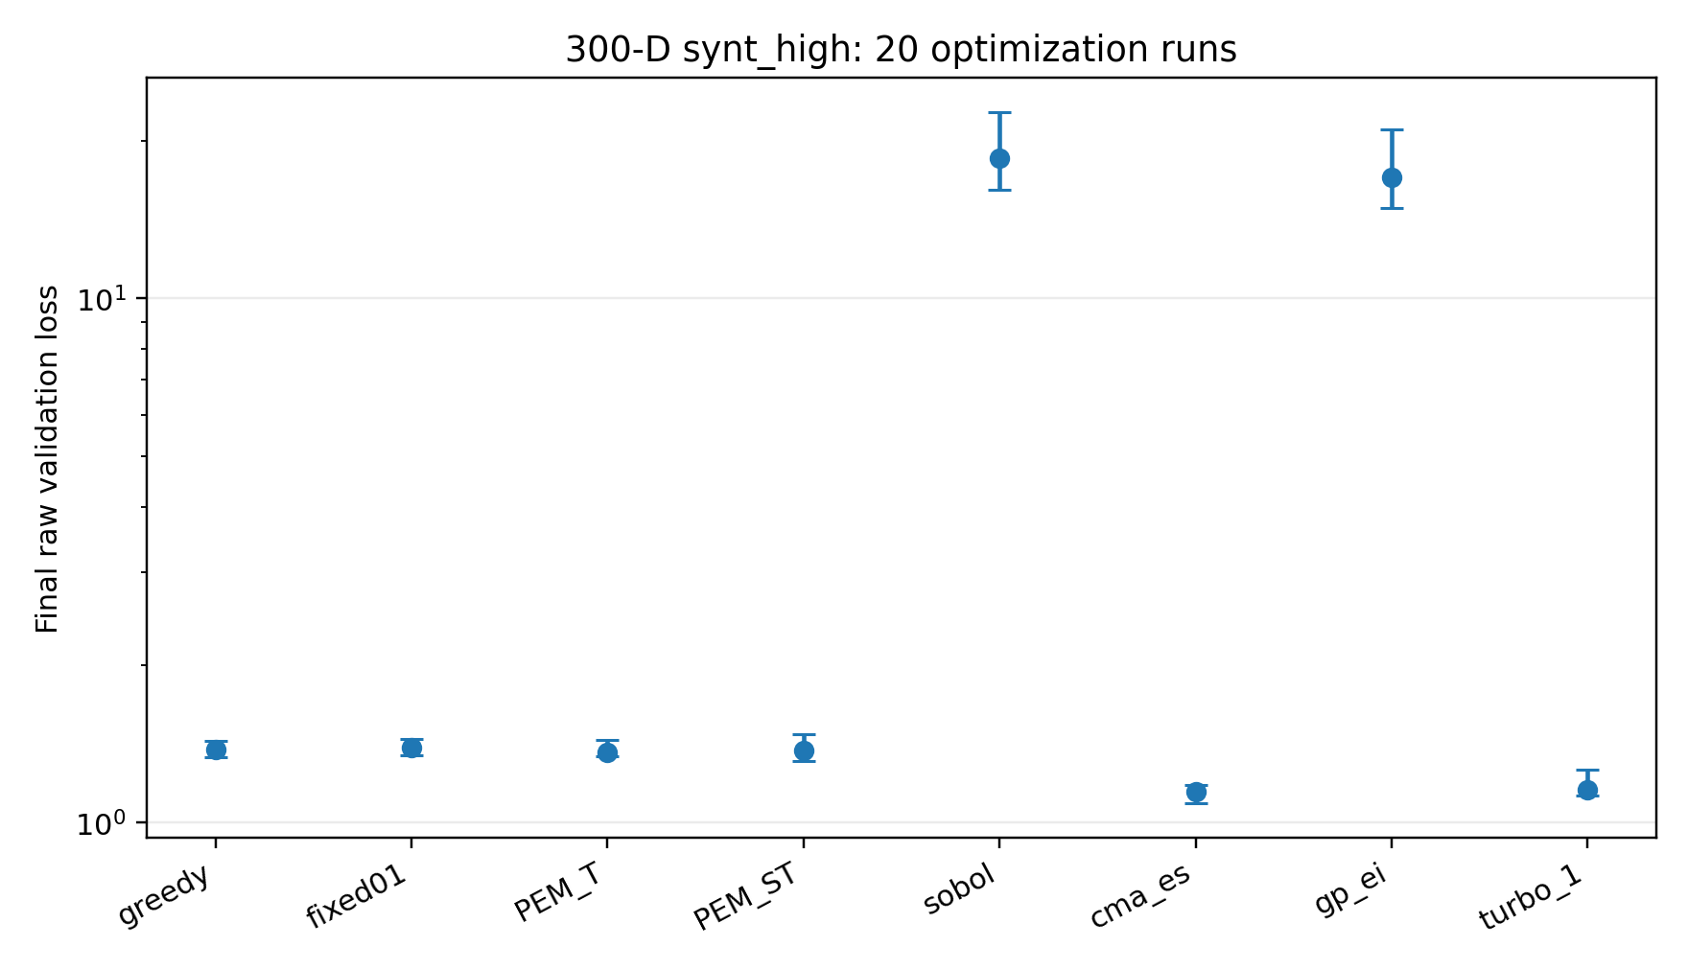
Figure S9: High-dimensional endpoints
Figure S9 separates the 300-dimensional methods into two endpoint groups. The four internal configurations, CMA-ES, and TuRBO-1 finish near the lower cluster, whereas Sobol and GP-EI remain more than an order of magnitude higher on the logarithmic axis. Interquartile bars are shown for all methods so that the apparent grouping can be assessed against between-run variability.
The associated paid-budget convergence histories are shown in Figure S10.
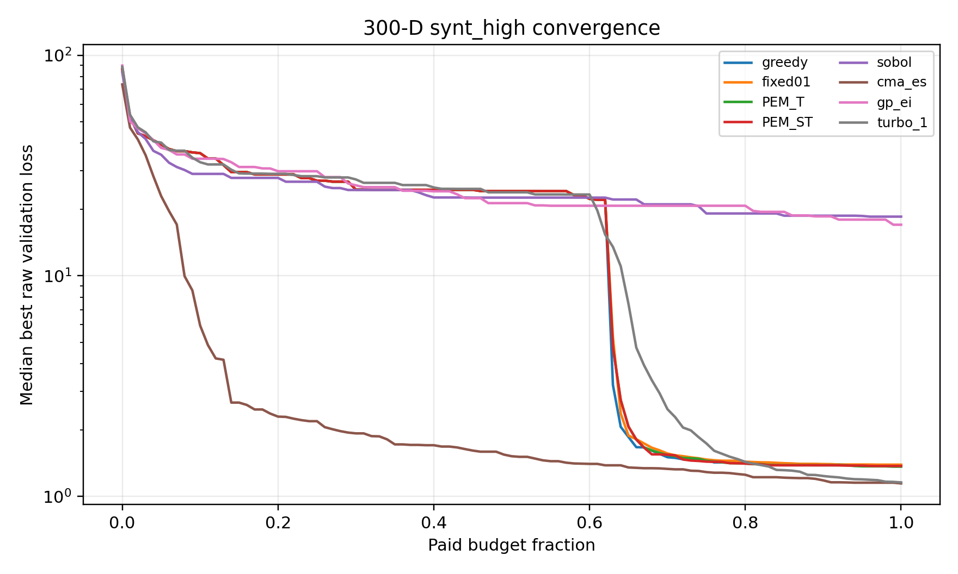
Figure S10: High-dimensional convergence
Figure S10 reveals distinct routes to the lower endpoint cluster. TuRBO-1 improves early and continuously; the internal methods change sharply only after their long initialization consumes about 62% of the budget. CMA-ES improves later, while Sobol and GP-EI remain on the upper plateau. This timing difference is why the 1,000-evaluation protocol is reported separately from the primary 500-evaluation application study.
The prespecified descriptive PEM_T-minus-fixed 01 median raw-loss difference was -0.01788, with paired-run bootstrap interval [-0.06477, 0.05017] and 11/9/0 negative/positive/zero differences. No p-value was computed and this contrast was not added to the three-test primary application family. The interval conditions on one fixed data set and split.

S5.2 Selected-point feedback and resource boundary
Table S19: Results for Selected-point feedback and resource boundary
Method | Failure | QLoss | Explore | Fallback | Claims | FDP
greedy | 0.07447 | 0.01695 | 0 | 0 | 257 | 1
fixed01 | 0.07895 | 0.03878 | 0.09618 | 0 | 127 | 0.9921
PEM_T | 0.08921 | 0.07535 | 0.3405 | 0 | 5 | 1
PEM_ST | 0.1266 | 0.06124 | 0.3854 | 0.01184 | 119 | 0.9916

Feedback summaries cover the 380 post-initialization selections per internal run. They describe each closed-loop history and do not establish same-pool causal effects or conformal error control. Before formal labels, eight separate full-budget resource runs completed 8,000 validation evaluations and zero test calls. Their mixed-load timings supported feasibility only; formal optimization times are reported as observed process costs rather than exclusive speedups.

S6 Prespecified model and training-cap sensitivity
Five preselected BBOB structure representatives (f1, f6, f10, f15, f20), dimensions 20/40, instances 14-16, and three optimization repeats evaluated PEM_T under the base setting and four one-factor perturbations. All 450 runs and 135,000 paid evaluations completed; no hidden diagnostic labels or inferential tests were added. This local sensitivity study does not select a replacement default. Area under the convergence curve is denoted by AUC.
Table S20: Results for Prespecified model and training-cap sensitivity
D | Variant | Endpoint median [Q1, Q3] | AUC median [Q1, Q3]
20 | base | -1.536 [-2.168, -0.8568] | -0.962 [-1.292, -0.5037]
20 | cap128 | -1.439 [-1.903, -0.7494] | -0.9267 [-1.28, -0.5181]
20 | cap512 | -1.536 [-2.168, -0.8568] | -0.962 [-1.292, -0.5037]
20 | scale125 | -1.085 [-1.722, -0.6441] | -0.6593 [-1.087, -0.3838]
20 | scale500 | -1.473 [-2.095, -0.6943] | -0.776 [-1.079, -0.4353]
40 | base | -1.275 [-1.676, -0.8544] | -0.8335 [-1.096, -0.5196]
40 | cap128 | -0.9176 [-1.179, -0.5716] | -0.6855 [-0.8808, -0.4435]
40 | cap512 | -1.235 [-1.69, -0.8008] | -0.8185 [-1.123, -0.5374]
40 | scale125 | -0.8456 [-1.18, -0.5364] | -0.5406 [-0.7806, -0.3901]
40 | scale500 | -1.151 [-1.311, -0.7564] | -0.7301 [-0.9111, -0.4361]

Paired model and training-cap endpoint distributions are shown in Figure S11.
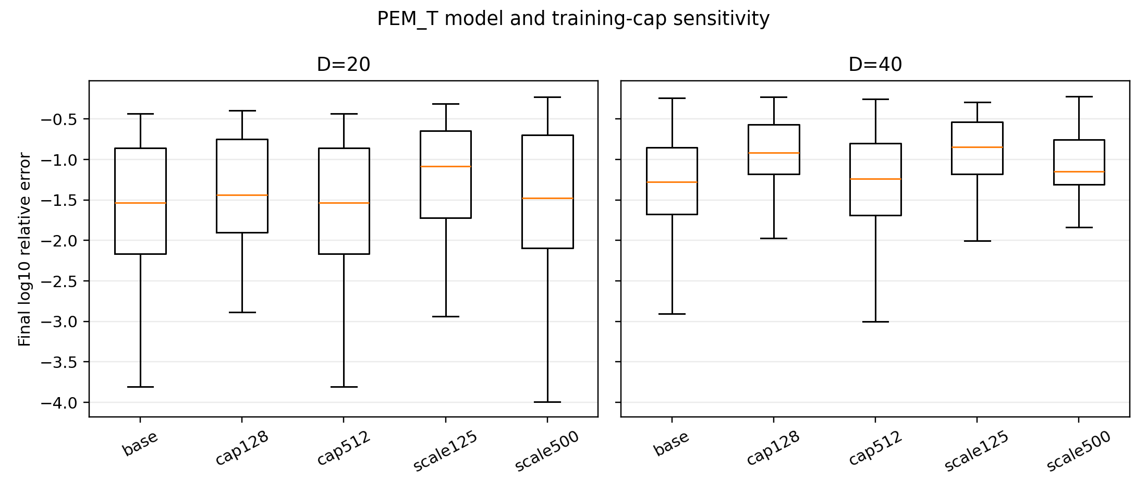
Figure S11: Model and training-cap sensitivity
Figure S11 displays paired endpoint distributions for the base model, two training caps, and two length-scale variants. Cap512 coincides with the base configuration in dimension 20 because the cap is never reached. Other variants shift the median and spread, especially in dimension 40, but none converts the sensitivity analysis into an unqualified favorable result for the feedback mechanism.
Paired differences below are variant minus base in final log10 relative error. Negative values favor the variant descriptively.
Table S21: Results for Prespecified model and training-cap sensitivity
D | Variant | Difference median [Q1, Q3] | Negative | Positive | Zero
20 | cap128 | 0.06854 [0, 0.1836] | 11 | 30 | 4
20 | cap512 | 0 [0, 0] | 0 | 0 | 45
20 | scale125 | 0.2805 [0.08773, 0.5608] | 8 | 37 | 0
20 | scale500 | 0.09344 [-0.04563, 0.2851] | 14 | 31 | 0
40 | cap128 | 0.3284 [0.0957, 0.4718] | 4 | 41 | 0
40 | cap512 | 0.005203 [-0.02706, 0.08161] | 18 | 27 | 0
40 | scale125 | 0.3253 [0.03915, 0.656] | 8 | 37 | 0
40 | scale500 | 0.09029 [-0.002699, 0.2816] | 12 | 33 | 0

The 45 D=20 base/cap512 pairs had identical PRE/LABEL trajectories and candidate arrays, as neither cap was reached. Thus that equality is an implementation invariant rather than evidence that caps never matter. At D=40, cap512 is untruncated only within this 400-evaluation scope.
Table S22: Results for Prespecified model and training-cap sensitivity
D | Variant | Capped | Failure | Explore | Fallback
20 | base | 0 | 0.08746 | 0.2789 | 0
20 | cap128 | 3195 | 0.1332 | 0.3444 | 0
20 | cap512 | 0 | 0.08746 | 0.2789 | 0
20 | scale125 | 0 | 0.1002 | 0.3173 | 0
20 | scale500 | 0 | 0.07175 | 0.283 | 0
40 | base | 6435 | 0.08889 | 0.2541 | 0
40 | cap128 | 12195 | 0.1893 | 0.5487 | 0
40 | cap512 | 0 | 0.08993 | 0.2591 | 0
40 | scale125 | 6435 | 0.09733 | 0.2797 | 0
40 | scale500 | 6435 | 0.08674 | 0.2902 | 0

Feedback metrics follow each variant's distinct closed-loop history. The limited function/instance set, shared initialization, and absence of multiplicity-adjusted inference restrict these results to robustness description.

S7 Prespecified budget-performance sensitivity and recovery accounting

S7.1 Design and aggregation
Five prespecified BBOB structure representatives (f1, f6, f10, f15, and f20), dimensions 20/40, instances 17–19, and three repeats were run independently at total budgets 5D, 10D, and 15D. Six internal configurations and four external references completed all 2,700 runs and 810,000 paid evaluations, with no diagnostic labels. Each endpoint uses the matching fixed 01 common-initialization error as a post-run denominator. The repeat median is first taken within each function-instance cell; the three instances within each function and the five function scores are then averaged with equal weight. No hypothesis test, confidence interval, or parameter selection was added.

S7.2 Endpoints and convergence
Lower values are better. Each table entry is the prespecified hierarchical mean final log10 relative error.
Table S23: Results for Endpoints and convergence
Method | D20-5D | D20-10D | D20-15D | D40-5D | D40-10D | D40-15D
greedy | -0.961 | -1.768 | -2.097 | -0.9999 | -1.544 | -1.643
fixed01 | -0.9322 | -1.749 | -2.035 | -0.9727 | -1.53 | -1.664
fixed03 | -0.6895 | -1.616 | -2.041 | -0.7998 | -1.491 | -1.634
pool_random | -0.08979 | -0.3369 | -0.433 | -0.187 | -0.3509 | -0.4963
PEM_T | -0.7538 | -1.689 | -1.987 | -0.8891 | -1.477 | -1.598
PEM_ST | -0.7407 | -1.676 | -2.039 | -0.8906 | -1.456 | -1.57
sobol | -0.1024 | -0.1513 | -0.209 | -0.0429 | -0.09157 | -0.09792
cma_es | -0.4835 | -0.7414 | -1.068 | -0.4553 | -0.6883 | -0.949
gp_ei | -1.642 | -2.388 | -2.574 | -1.651 | -1.993 | -2.174
turbo₁ | -1.08 | -2.216 | -2.502 | -0.9778 | -1.943 | -2.516

Endpoint changes across the three prespecified total budgets are shown in Figure S12.
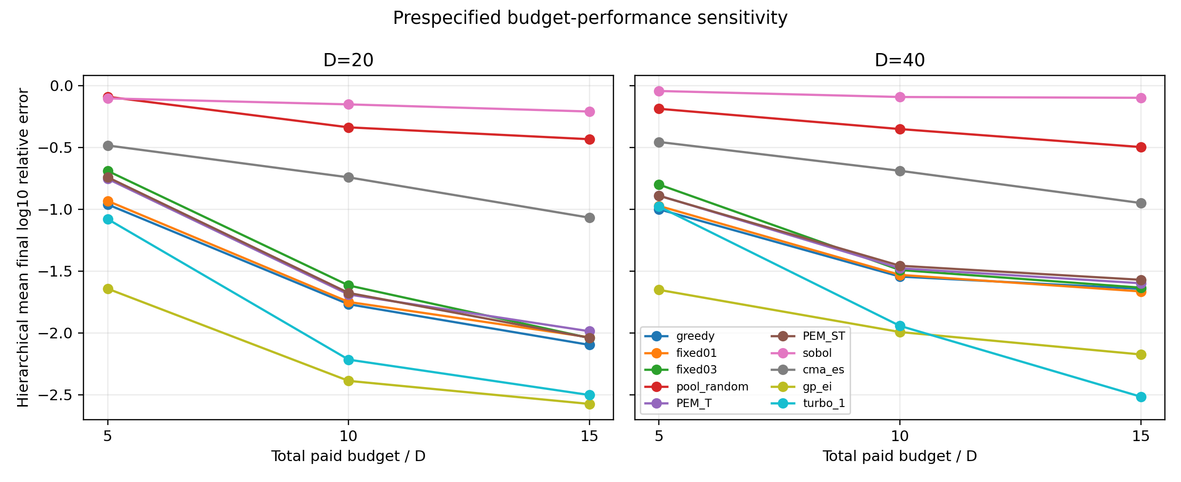
Figure S12: Budget-sensitivity endpoints
Figure S12 connects endpoint quality to total budget. Most methods improve as the allowance rises from 5D to 15D, but the monitored internal variants remain above the strongest external curves. The slopes differ by dimension, which indicates that additional budget changes the magnitude of the gap without reversing the principal mechanism conclusion.
The corresponding independent-run convergence histories are shown in Figure S13.
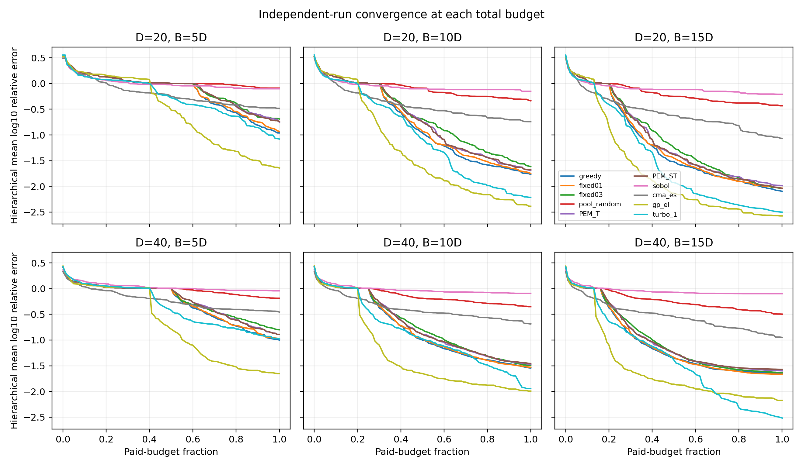
Figure S13: Budget-sensitivity convergence
Figure S13 plots each independent run against its own paid-budget fraction. The 5D, 10D, and 15D panels share early behavior where the information prefixes are equal, then separate as longer runs acquire additional labels. External methods do not share those internal prefixes. The six panels therefore expose both convergence shape and the information-order boundary used in the recovery audit.
Each budget is a separate optimization run. A longer-budget endpoint therefore supplies robustness evidence under a larger total allowance; it is not a continuation selected after observing the shorter run. The restricted five-function, two-dimension design and descriptive aggregation do not establish a general ranking.

S7.3 Prefix and information-order audit
Table S24: Results for Prefix and information-order audit
Method | Equal 5D/10D/15D prefixes | Required invariant
greedy | 90/90 | yes
fixed01 | 90/90 | yes
fixed03 | 90/90 | yes
pool_random | 90/90 | yes
PEM_T | 90/90 | yes
PEM_ST | 90/90 | yes
sobol | 90/90 | no
cma_es | 90/90 | no
gp_ei | 0/90 | no
turbo₁ | 0/90 | no

The budget-blind internal core was required to reproduce identical 5D and 10D prefixes inside the corresponding longer run; all 540 required comparisons passed. External prefix equality was recorded rather than required: 180/360 comparisons were equal. That count is an implementation observation, not an assumption used to validate external methods. Full audits replayed all 810,000 PRE/LABEL pairs, internal bounds and management states, and 7,020 raw-file hashes. No total-budget value entered the internal proposal rule.

S7.4 Recovery accounting and evidence boundary
The budget-sensitivity interruption left 8 incomplete units with 1,791 physically acquired labels. Their complete directories were archived before resumption, and each affected unit was rerun from its frozen seed. These labels never entered the 2,700 canonical trajectories. The budget-sensitivity physical ledger is therefore 811,791 calls: 810,000 canonical evaluations plus 1,791 disclosed interrupted-run calls. The additional calls are excluded from endpoints, convergence curves, and algorithm budgets.
The completed GP-EI performance batch contains 151,200 canonical algorithm evaluations. During interruption recovery, one GP-EI point (evaluation 349 of gp_ei_f02_d40ᵢ13_r2_b400) was physically queried a second time because the newer partial journal contained 348 labels while an earlier archive contained 349. The point and returned label matched exactly; the label entered the optimizer history once, so the canonical 400-step trajectory and endpoint are unchanged. The physical GP-EI ledger is therefore 151,201 calls: 151,200 canonical evaluations plus one disclosed recovery-validation call. The extra call is excluded from algorithm budgets, performance curves, and exclusive-cost analysis. The read-only recovery audit made zero objective calls and verified eight recovered trajectories (2,800 canonical evaluations), 2,014 saved second-generation labels, and 786 second-generation physical calls, one of which overlaps the earlier archive.
This section does not reverse the failed development benefit gate. The paper is positioned as a decision-consequence auditing framework and makes no general optimizer-superiority claim. Full IEEE Congress on Evolutionary Computation (CEC) confirmation is not required for that framework scope. A CEC batch started on 24 September 2026 was stopped after the scope decision; its 30 complete and 8 partial trajectories are retained as exploratory records and excluded from manuscript statistics. A verifiable author-code DRSO comparison is provided in S8.2; the three originally named but unavailable implementations continue to delimit method-specific claims.

S8 Reproducibility inventory
The archived evidence contains frozen protocols, source hashes, dependency locks, deterministic seed maps, prediction-before-label journals, candidate arrays, separate diagnostic labels, endpoint re-evaluations, raw-file hashes, analysis tables, and figure sources. Diagnostic labels never enter optimizer histories. Interrupted or repeated physical calls are disclosed separately from canonical algorithm budgets. The repository contains sources and curated revision evidence. The byte-preserving GP source bundle, frozen intervention records and lossless compact transfer release support the added results. Larger historical archives remain available from the corresponding author upon reasonable request. Frozen source revisions, data-release commits and file checksums identify the evidence.

S8.1 Finite-element audit
The EngiBench beam batch contains 50 complete runs, 10,000 canonical finite-element evaluations, 50 independent endpoint re-evaluations, zero failures, and maximum volume-fraction error 1.665e-16. The audit verifies the complete design, source hashes, 100 raw-file hashes, prediction-before-label ordering, exact endpoint replay, and separation of the earlier smoke run from method selection.

S8.2 Matched-initialization external-reference, acquisition, and SAEA sensitivity
The supplemental beam experiment gives GP-EI and TuRBO-1 exactly the same 58-point initial finite-element archive used by Greedy, fixed 01, and PEM-T in each repeat. It contains 20 complete trajectories and 4,000 algorithm-budget observations: 1,160 previously paid deterministic initial labels and 2,840 additional finite-element calls. The event-level audit finds zero failures, zero exact duplicate points, complete prediction-before-label order, and exact agreement with all ten source-archive hashes. Forty additional physical calls belong only to two independent endpoint-diagnostic rounds and never enter an optimizer history. The accepted diagnostic table has maximum absolute difference 1.50e-8 and maximum relative difference 6.23e-12.
Table S25: Results for Matched-initialization external-reference, acquisition, and SAEA sensitivity
Method | Shared-init median | Native-init median | Median shared-minus-native | Holm p | Median shared-minus-PEM-T | Wins/ties/losses vs PEM-T | Holm p
GP-EI | 2308.5 | 2117.5 | +399.8 | 0.320 | +242.8 | 1/3/6 | 0.0469
TuRBO-1 | 574.0 | 578.2 | -44.7 | 0.695 | -1372.3 | 10/0/0 | 0.00391

The initial launch stopped after a missing fixed-seed argument prevented two GP-EI workers from entering GP search; those logs contain only reused initial labels and zero subsequent objective calls. Six already-running TuRBO-1 units completed through an unaffected branch. The complete launch state was archived, the one-argument wiring error was corrected, and the remaining units resumed. The terminal audit accepts six original and fourteen corrected code hashes after verifying that the change lies outside the completed TuRBO branch. No failed or interrupted GP label enters the 20 canonical trajectories.
Two further Gaussian-process acquisition controls use the same ten 58-point archives, 200-evaluation budget, Matérn-5/2 model, 4,096-point Sobol candidate pool, and eight local optimization starts. Gaussian-process probability of improvement (GP-PI) uses an improvement margin equal to 0.01 times the current response standard deviation. Gaussian-process upper confidence bound (GP-UCB) is implemented for minimization by selecting the lowest value of mean minus 2.0 standard deviations. These 20 trajectories contain 4,000 algorithm-budget observations, including 1,160 reused labels and 2,840 additional finite-element calls. The audit verifies sequential prediction-before-label records, bounds, finite outputs, exact source-archive hashes, complete budgets, and zero exact duplicate points.
Additional shared-initialization acquisition and relation-model controls.
Table S26: Results for Matched-initialization external-reference, acquisition, and SAEA sensitivity
Method | Shared-init median | Q1 | Q3 | Median improvement after initialization | Median difference vs PEM-T | Wins/ties/losses vs PEM-T | Holm p
GP-PI | 1233.1 | 921.2 | 1399.7 | 0.517 | -876.1 | 9/0/1 | 0.0117
GP-UCB | 2308.7 | 2223.8 | 2827.3 | 0.000 | +574.6 | 2/2/6 | 0.0391
DRSO | 647.4 | 580.4 | 780.0 | 0.747 | -1334.6 | 9/0/1 | 0.0117

The different outcomes under a common surrogate and common starting archive isolate acquisition behavior. Candidate-dependent uncertainty is structurally capable of changing decisions, but its practical value depends on how uncertainty and predicted objective value are combined. GP-PI supplies a successful candidate-dependent control; the fixed-multiplier GP-UCB control does not improve the median initial incumbent under this budget. The three rows form one Holm family.
DRSO provides the requested competitive surrogate-assisted evolutionary comparison. The public author repository is frozen at commit `03c19d4280b38230e0852054922072f5aa6dcdf5` under the GNU Lesser General Public License version 3.0 (LGPL-3.0). Its relation models, unevaluated-population mechanism, reproduction, training cap of 100, and other algorithm settings remain unchanged. Population size is set from the author default of 50 to 58 only because the common archive contains 58 points. A Python 3.12 compatibility namespace supplies the removed `imp` name required by pyDOE2 and an unused optional callback import; neither compatibility file alters the DRSO search implementation.
The relation-model DRSO batch contains ten complete trajectories and 2,000 algorithm-budget observations: 580 reused initial labels and 1,420 additional finite-element calls. All 4,010 event records have sequential PRE/LABEL order, all ten source-archive and author-tree hashes match, and no trajectory contains an out-of-bounds, nonfinite, or exact duplicate point. The author-code result object, external paid-call journal, and endpoint minimum agree in every repeat. DRSO improves median compliance by 74.7% after initialization and reaches 647.4, compared with 1972.8 for PEM-T.

S8.3 Evidence boundary
The empirical residual monitor has no claimed pointwise coverage theorem, false-discovery-rate guarantee, regret bound, or global convergence theorem. Broad BBOB comparisons with external methods retain native initialization and remain descriptive; the beam sensitivity alone supplies a matched initial archive. GP-PI and GP-UCB are transparent acquisition controls, while DRSO is an author-code published SAEA. The 19-dimensional beam family does not establish performance for unrestricted 5,000-variable topology optimization. Full CEC exploration was stopped after the decision-consequence auditing scope was selected; its exploratory trajectories are excluded from all article statistics. Temporal conformal-prediction SAEA (CP-SAEA), sample-selection surrogate-assisted differential evolution (SADE-SS), and boosting Gaussian-process SAEA (BGP-SAEA) remain excluded because matching executable author implementations with frozen versions, parameters, and licenses were unavailable; similarly named public implementations are not substituted for them. DRSO closes the requested competitive-SAEA evidence category without claiming to reproduce those unavailable methods.

S9 Frozen GP intervention and immediate diagnostic accounting
This additional study is separately frozen, descriptive, and not part of the original Holm families. Input hashes and 120 decisions were committed at f1c9bbdebc35071bd935d0b11c92857f5e07201e before additional intervention labels. The initially transmitted binary ZIP was incomplete, despite an intact local author-supplied archive. Local scientific input hashes and frozen choices did not change. The public input release now uses a byte-preserving text bundle at commit 71e074945262e1dbfc223726c7216e5415385ddc, replacing the incomplete repository binary. Its restoration checks every original file hash, all segment hashes and the decoded payload hash before writing any file. It preserves all 60 original file bytes, including line endings; it does not claim to reconstruct the original ZIP container bytes. The original supplied archive remains identified by SHA-256 c59079aaf34f560ee2f3e93a55bd60e13b2fa4c53097285842580df4d3b8098b. Public distribution integrity and scientific execution integrity are separate checks.
Thirty source histories contain 6,000 budgeted algorithm observations and 580 distinct common initial labels across ten repeats. Frozen states stop at PRE(t), exclude LABEL(t), and contain only observations before 59, 101, 151, or 200. The same recorded automatic-relevance-determination (ARD) Matérn-5/2 posterior scores mean prediction, expected improvement (EI), probability of improvement (PI), and lower confidence bound (LCB) on 4,096 scrambled Sobol points plus the original action. EI uses zero margin, PI uses 0.01 times the training standard deviation, and LCB uses kappa 2. Logged hyperparameters are not refitted. All 120 source-action mean/standard-deviation comparisons satisfy rtol=atol=1e-8. Decisions and candidate records are hashed before source action labels are looked up. No additional diagnostic label enters a source optimizer history.
All controls and source-history groups. Four checkpoint estimates are averaged within each repeat before averaging ten repeats. U and DeltaU are in units of 1e-6.
Table S27: Results for Frozen GP intervention and immediate diagnostic accounting
Source history | Control | Changed (%) | Mean U (1e-6) | DeltaU vs mean (1e-6)
EI history | MEAN | 0.0 | 0.899669 | +0.000000
EI history | EI | 30.0 | 0.899669 | +0.000000
EI history | PI | 25.0 | 0.899669 | +0.000000
EI history | LCB | 52.5 | 0.000000 | -0.899669
PI history | MEAN | 0.0 | 0.347088 | +0.000000
PI history | EI | 95.0 | 0.000000 | -0.347088
PI history | PI | 7.5 | 0.347088 | +0.000000
PI history | LCB | 97.5 | 0.000000 | -0.347088
UCB history | MEAN | 0.0 | 0.877758 | +0.000000
UCB history | EI | 30.0 | 0.887232 | +0.009475
UCB history | PI | 35.0 | 1.178882 | +0.301124
UCB history | LCB | 75.0 | 0.511893 | -0.365864

The training scale ranges from 733,152 to 9.12154e+08. This can make normalized gains small even when raw compliance changes. The metric is retained as frozen; no post hoc replacement or additional p-value is used. These comparisons neither test delayed exploration nor authorize promotion.
The 480 control-state choices reduce to 261 distinct within-state actions. Source-action reuse accounts for 120 responses; exact diagnostic reuse across states accounts for 3; 138 are additional finite-element (FE) calls. Diagnostic FE time is 4.437432 s and GP state preparation time is 13.435883 s. The initial solver compatibility check made 42 calls before detecting a 4.929e-8 relative discrepancy at a large-compliance point. That discrepancy was numerical, not a failed FE response. The complete retained 60-call check uses the disclosed 1e-6 relative tolerance and passes every comparison. The original prediction replay tolerance remains 1e-8. The first 42 outputs and timings were not retained but their attempts are included. The retained solver check takes 2.327726 s. Total additional attempts for this GP revision are 240. These observed times do not establish exclusive wall-time savings.

S10 Independent load-position transfer, horizon effects and paid workflows
The protocol and executable implementation were committed at 7555d58b145a2c44b73bab5ec47d0f643a57dde1 before acquiring additional transfer labels. Conditions forcedist 0.25 and 0.75 each have ten independently seeded 58-point Sobol initializations. Fixed seed namespaces distinguish initialization, pilots and validation. The same case/step candidate namespace is shared across policies inside a phase. All policies use one shared specification; tie ordering, fit limits and budgets were not tuned using outcomes. This is within-family physical-condition transfer, not cross-domain validation.
Differences between the two additional GP experiments. The original beam wrapper, material, supports, volume 0.35 and dimension 19 are retained.
Table S28: Results for Independent load-position transfer, horizon effects and paid workflows
Setting | Frozen intervention (S9) | Independent transfer (S10)
Source state | Archived EI/PI/UCB histories | Fresh initialization in each force condition
Kernel | Logged ARD Matérn-5/2 | Isotropic Matérn-5/2
Hyperparameters | Frozen, optimizer disabled | L-BFGS-B, maximum 100 iterations, no restarts
Candidate pool | 4096 Sobol + original action | 1024 Sobol; observed points excluded
EI margin | 0 | 0.01 times training standard deviation
PI margin / LCB kappa | 0.01 scaled / 2 | 0.01 scaled / 2
GP alpha / normalization | 1e-6 / normalized targets | 1e-6 / normalized targets
Physical force position | 0.0 | 0.25 and 0.75

The transfer constant bounds are [0.05, 20] and length-scale bounds are [0.005, 2], with initial length scale 0.2. Fit convergence warnings are recorded and do not trigger restarts. Beams2D caches force-dependent matrices; each case creates a fresh problem object configured once with its actual force position. This prevents cross-condition state reuse. The environment pins NumPy 2.2.6, SciPy 1.15.3, scikit-learn 1.7.2, EngiBench 0.2.0, and cvxopt 1.3.2. These settings define a separate controlled study and do not rerun the historical ARD/continuous-refinement GP optimizer.

S10.1 Paid selection and independent validation
Each audited workflow pays 58 initial labels, 4 x 20 pilot labels, and 142 selected-policy validation labels: 280. Each complete portfolio independently pays 58 initial labels and 4 x 142 continuation labels: 626. A fixed single policy needs 200. The pilot winner is the lowest final pilot compliance, with exact ties broken in PI, mean, EI, LCB order. Selection is persisted after 138 calls and before any canonical validation label. Canonical histories start again from the initial 58 labels and never include pilot responses. Validation candidates use a different namespace; no warm-starting selector is claimed. The selected canonical trajectory and its separately paid portfolio counterpart agree exactly in every repeat. All duplicate designs across workflows are physically evaluated and counted, rather than credited as free labels.
All twenty paired endpoints. The selected-policy column is the prespecified independent canonical endpoint. All-paid best is a secondary descriptive endpoint including every pilot design; it does not replace the validation criterion. Gap is 100x(selected/portfolio-best-1).
Table S29: Results for Paid selection and independent validation
Force | Rep | Selected | Initial | Selected-policy | Portfolio-best | Gap (%) | All-paid best
0.25 | 0 | PI | 1559.326 | 1350.207 | 1350.207 | 0.000 | 1350.207
0.25 | 1 | EI | 1657.740 | 1192.164 | 805.832 | 47.942 | 1192.164
0.25 | 2 | PI | 1817.963 | 929.539 | 929.539 | 0.000 | 929.539
0.25 | 3 | EI | 3373.312 | 1048.640 | 923.095 | 13.600 | 1048.640
0.25 | 4 | PI | 1392.373 | 1152.823 | 1015.625 | 13.509 | 1152.823
0.25 | 5 | PI | 1426.446 | 1426.446 | 1195.130 | 19.355 | 1426.446
0.25 | 6 | PI | 2081.842 | 956.490 | 915.138 | 4.519 | 956.490
0.25 | 7 | MEAN | 1458.044 | 1204.446 | 1204.446 | 0.000 | 1065.517
0.25 | 8 | PI | 1189.521 | 956.887 | 956.887 | 0.000 | 956.887
0.25 | 9 | MEAN | 1774.608 | 1535.851 | 838.957 | 83.067 | 1392.803
0.75 | 0 | PI | 1287.356 | 430.374 | 430.374 | 0.000 | 430.374
0.75 | 1 | PI | 779.191 | 303.745 | 303.745 | 0.000 | 303.745
0.75 | 2 | LCB | 653.215 | 454.896 | 315.137 | 44.349 | 375.564
0.75 | 3 | PI | 703.816 | 326.950 | 326.950 | 0.000 | 326.950
0.75 | 4 | MEAN | 607.672 | 481.780 | 351.951 | 36.889 | 327.563
0.75 | 5 | PI | 644.397 | 335.272 | 332.477 | 0.841 | 312.168
0.75 | 6 | PI | 697.634 | 383.191 | 325.992 | 17.546 | 383.191
0.75 | 7 | PI | 997.734 | 677.303 | 174.014 | 289.223 | 597.821
0.75 | 8 | PI | 583.133 | 429.673 | 274.350 | 56.615 | 285.959
0.75 | 9 | PI | 720.317 | 303.082 | 211.908 | 43.025 | 253.360

The primary median paired gaps are 9.013698% and 27.217435%. Exact portfolio-best matches are 4/10 and 3/10. The selected counts are PI 6, EI 2, and mean 2 at force 0.25, and PI 8, LCB 1, and mean 1 at force 0.75. Exact pilot-end ties occur in 7 and 4 repeats; counts should not be interpreted independently of the tie rule. The secondary all-paid gaps have medians of 9.013698% and 2.115716%. The discrepancy between primary and secondary endpoints is disclosed because the practical availability of a pilot design differs from evidence that the chosen policy transfers well.
Each 200-call fixed policy compared with the 280-call selected workflow. Median effects are paired 100 x (selected/fixed - 1); negative favors selection. Wins/ties/losses are descriptive, not tests of superiority or equivalence.
Table S30: Results for Paid selection and independent validation
Force | Fixed policy | Median fixed compliance | Paired effect (%) | Selection wins/ties/losses
0.25 | MEAN | 1102.310 | +0.000 | 4/2/4
0.25 | EI | 1233.521 | -1.813 | 5/3/2
0.25 | PI | 956.689 | +0.000 | 1/6/3
0.25 | LCB | 1360.425 | -8.978 | 7/1/2
0.75 | MEAN | 326.834 | +0.420 | 3/2/5
0.75 | EI | 379.451 | -5.682 | 5/1/4
0.75 | PI | 359.232 | +0.000 | 1/8/1
0.75 | LCB | 475.896 | -6.764 | 5/3/2

Selecting the best fixed policy retrospectively from these validation outcomes would be a separate selection procedure. No such200-call oracle advantage is attributed to the audit or its comparator.

S10.2 Horizon separation
Pilot improvement from the common initial incumbent. First and 20-step columns are medians of per-repeat percentages. The final count concerns the same pilot trajectory.
Table S31: Results for Horizon separation
Force | Policy | First step (%) | 20 steps (%) | Zero first, positive20 /10
0.25 | MEAN | 0.000 | 13.006 | 6
0.25 | EI | 0.000 | 9.706 | 4
0.25 | PI | 0.000 | 8.592 | 5
0.25 | LCB | 0.000 | 2.514 | 4
0.75 | MEAN | 0.000 | 42.350 | 8
0.75 | EI | 0.000 | 13.491 | 5
0.75 | PI | 0.000 | 46.765 | 7
0.75 | LCB | 0.000 | 3.649 | 4

Figure S14: Pilot improvement across twenty steps under the two force positions.
Figure S14 plots condition-specific median incumbent improvement over the pilot horizon. It illustrates why a first action without gain is not a sufficient rejection rule. These are whole-policy trajectories with diverging histories; the figure does not estimate a first-action treatment effect with an identical continuation. Pilot-to-canonical selection transfer is a further question because the canonical candidate stream is independent.

S10.3 Costs, recovery and evidence integrity
Complete additional FE-attempt boundary for this revision. Historical experiments before the revision are not included.
Table S32: Results for Costs, recovery and evidence integrity
Component | Physical attempts | Use in reported endpoints
Added frozen GP intervention | 138 | Separate diagnostics only
Solver compatibility verification | 102 | Never optimizer training
Earlier complete transfer execution | 18120 | Prior checked endpoints; raw journals unavailable in current workspace
Retained unchanged-protocol transfer recovery | 18120 | Retained canonical and pilot records, labels used once
Total including recovery | 36480 | No repeated attempt is hidden in a budget200 trajectory

The prior transfer journals became unavailable in the working environment before their raw release. An explicit recovery record at 62560a245a8b804dcff3ce00aa45aae0af9f3884 preserves the unchanged scientific configuration and caps additional recovery calls at 18,120. All twenty previously recorded selected-policy and portfolio-best endpoints are reproduced. Recovery contributes additional physical cost, not additional independent repeats or a changed inferential family. The initial zero-call bootstrap failure from the earlier launch adds no FE cost. The retained20 cases comprise2,320 physical initialization calls,1,600 pilot calls and 14,200 canonical postinitial calls. Their 100 full-budget trajectories contain 20,000 algorithm observations because initialization is shared among forks inside each workflow.
Retained observed component times summed across ten repeats per condition, in seconds. Four workers run concurrently; sums are not exclusive elapsed-time benchmarks.
Table S33: Results for Costs, recovery and evidence integrity
Force | Audited FE | Portfolio FE | Audited GP/selection | Portfolio GP/selection
0.25 | 90.395 | 194.651 | 57.242 | 175.964
0.75 | 87.050 | 190.999 | 53.674 | 171.385

The analyzer validates complete PRE/LABEL pairing, 906 physical calls per case, 280/626 workflow counts, 20 pilot steps and 142 canonical steps per policy, selection before validation, correct seed namespaces, identical initial history hashes, exclusion of pilot labels from every canonical history, exact selected/portfolio trajectory replay, and every endpoint and component-time sum. It makes zero additional FE calls. The compact release regenerates deterministic Sobol points and reconstructs each retained source JavaScript Object Notation Lines (JSONL) file byte for byte, checked against its SHA-256; no objective call is needed to restore or analyze the records. Original full journals remain the source of timing and information-boundary checks.
There are no added p-values, confidence guarantees, retrospective deployment tolerances, claims of cross-domain transfer, or demonstrated production wall-time savings. The two loads strengthen within-family applicability. They do not establish optimizer superiority, a competitive selection advance over warm-starting, or validation of unrestricted 5,000-variable topology optimization.

