Instruction

# Admin Instruction:

Admin can check in people, display prize, draw winner, manage user, manage attendee, manage prize, manage vendor

1. Login win Admin credential

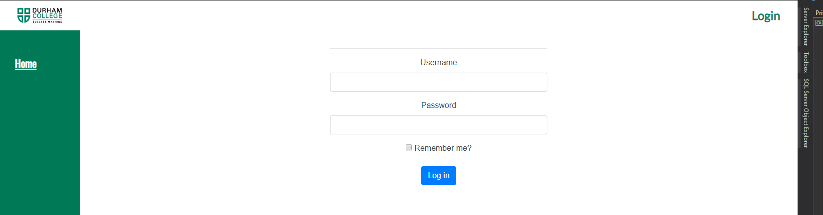

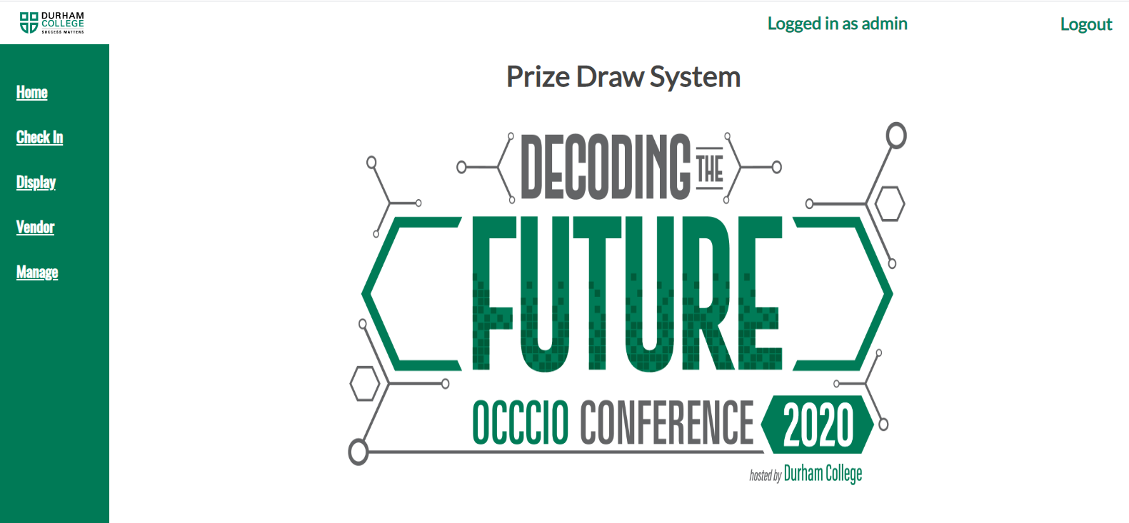

To access admin functionality, navigate to manage tab

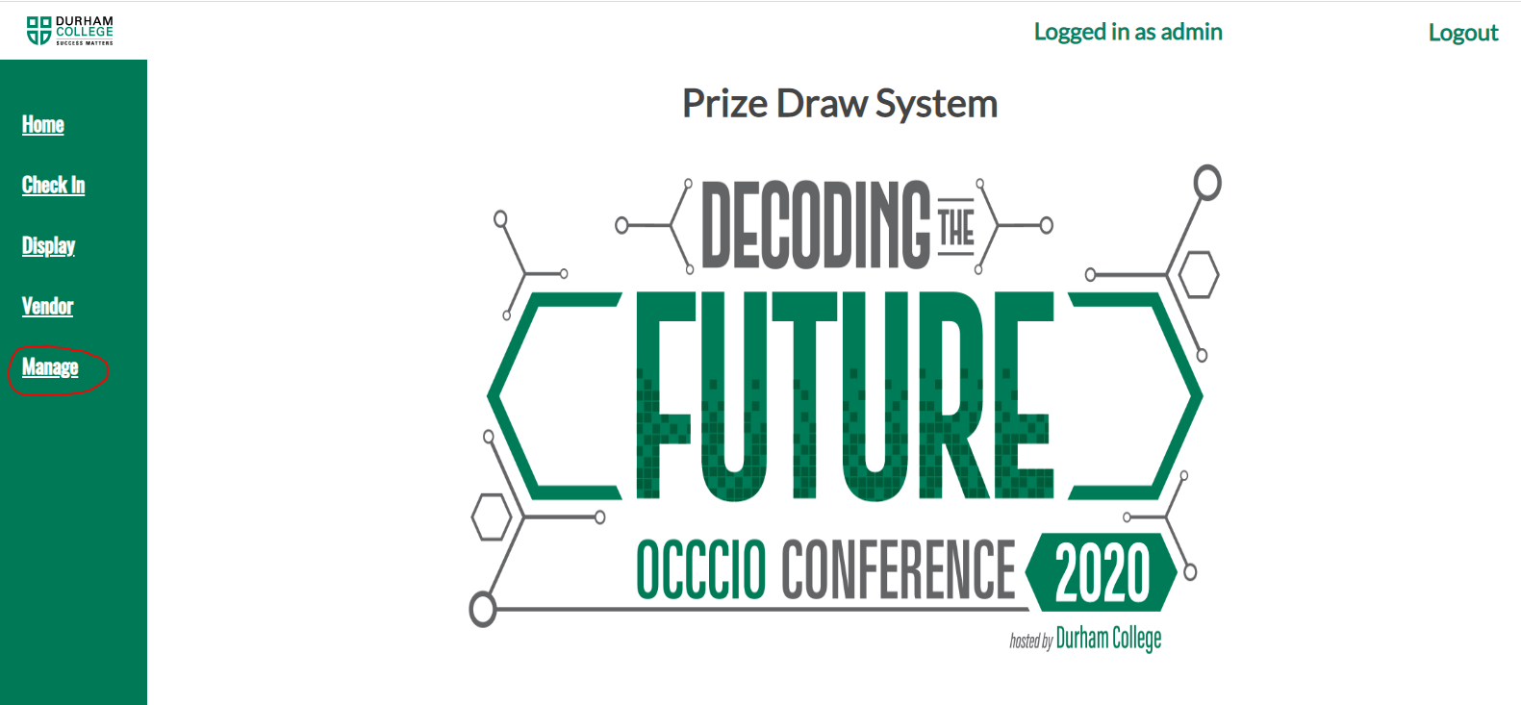

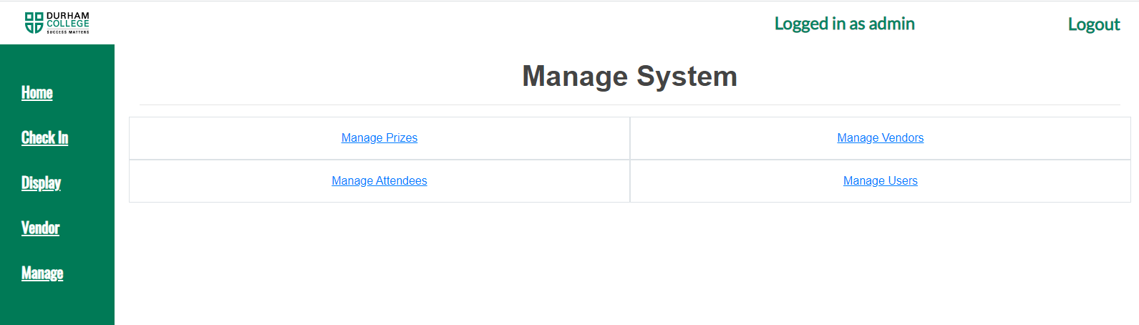

To Manage vendor

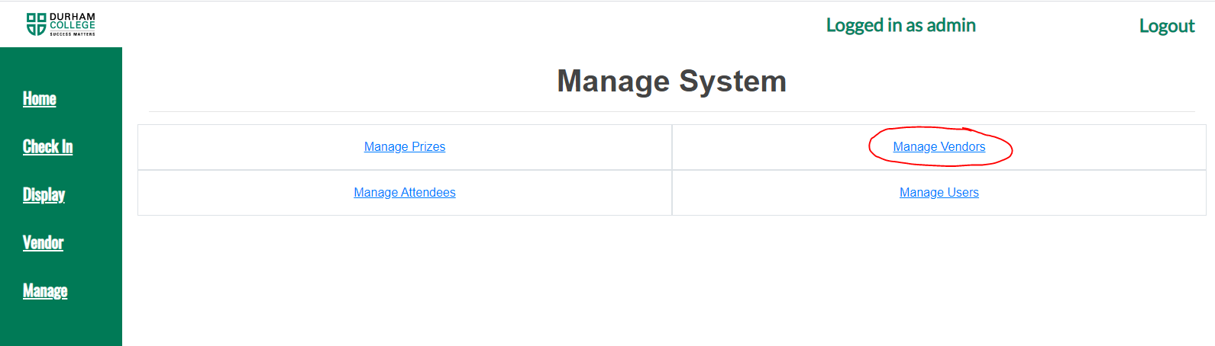

Adding new vendor

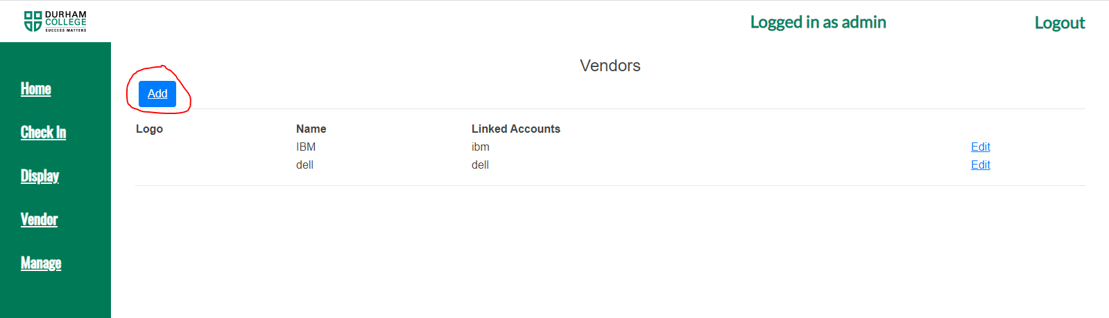

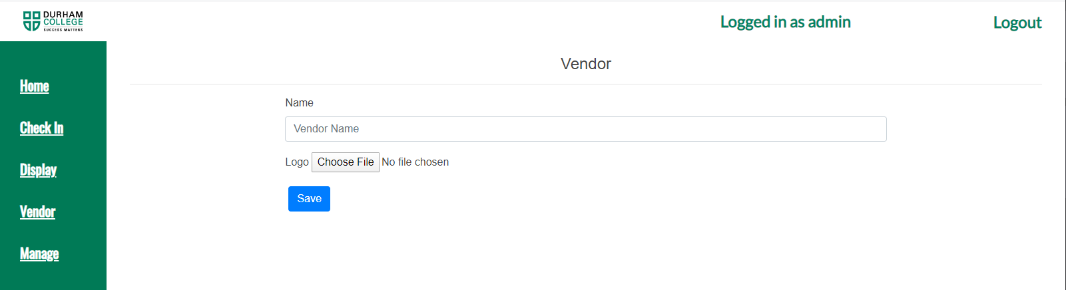

To manage prize

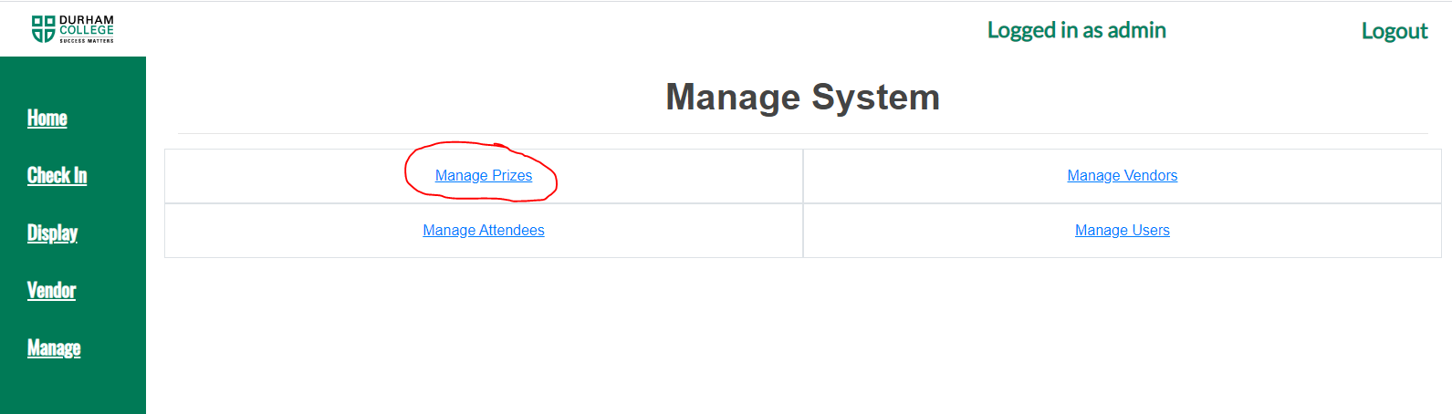

Add prize

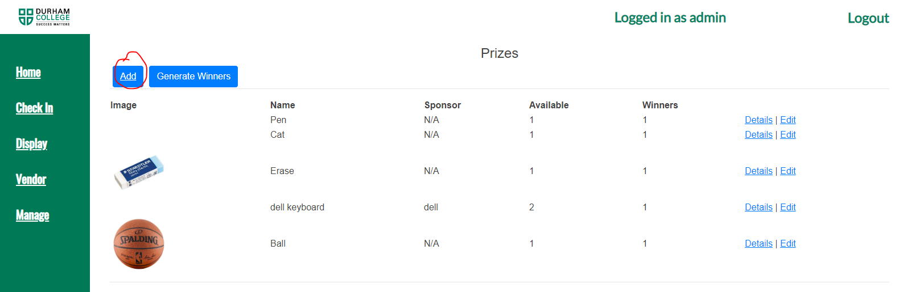

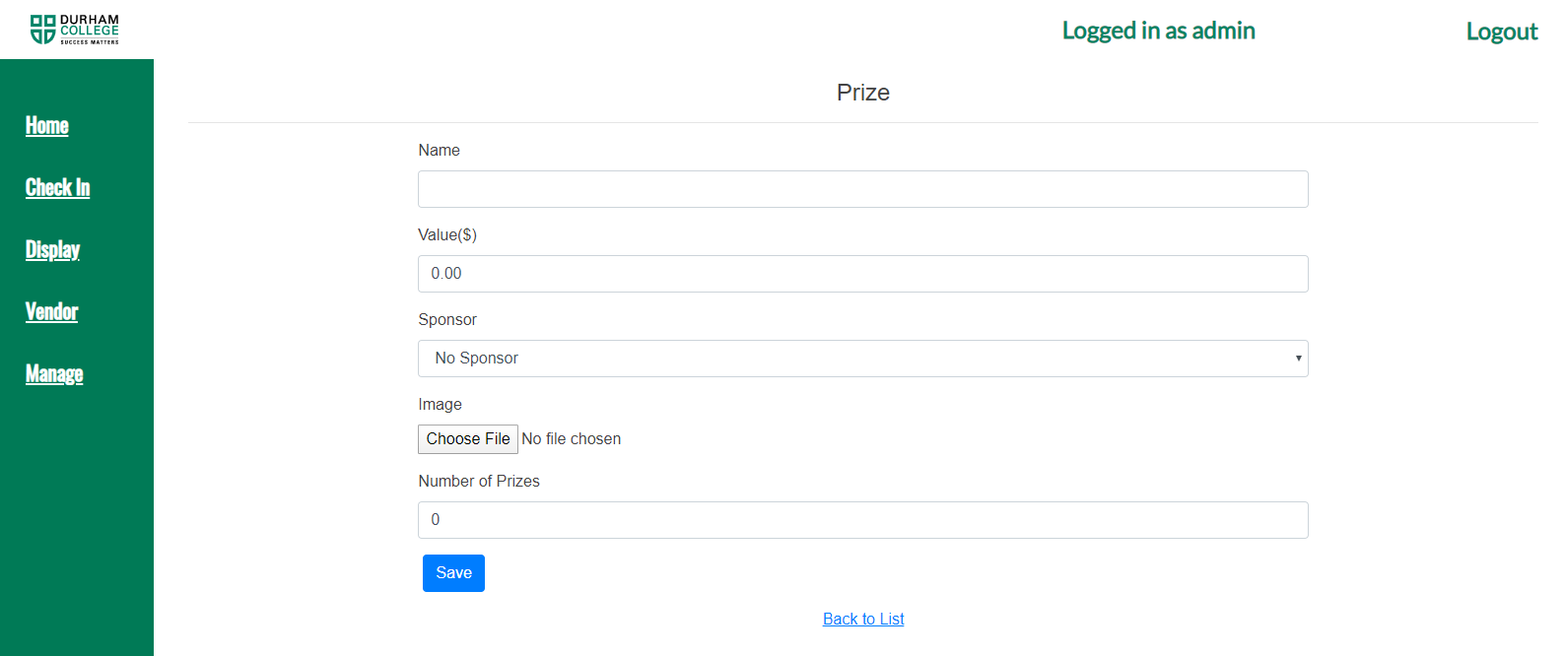

To see prize details

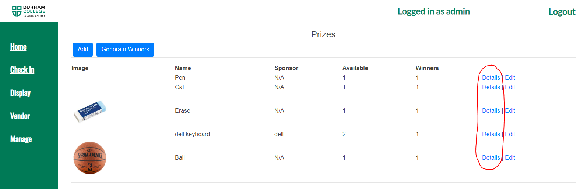

To edit prize

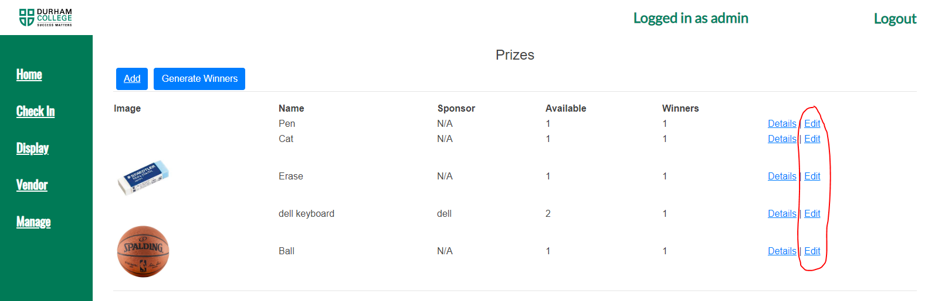

To manage users

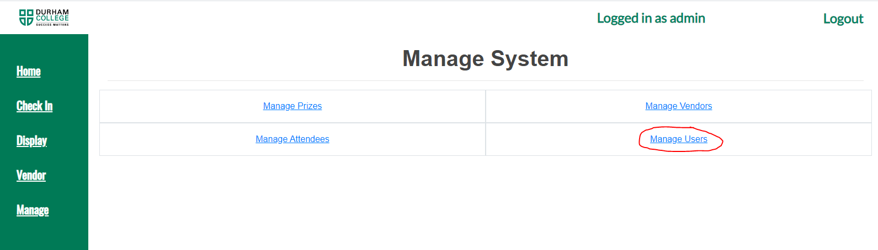

Adding new user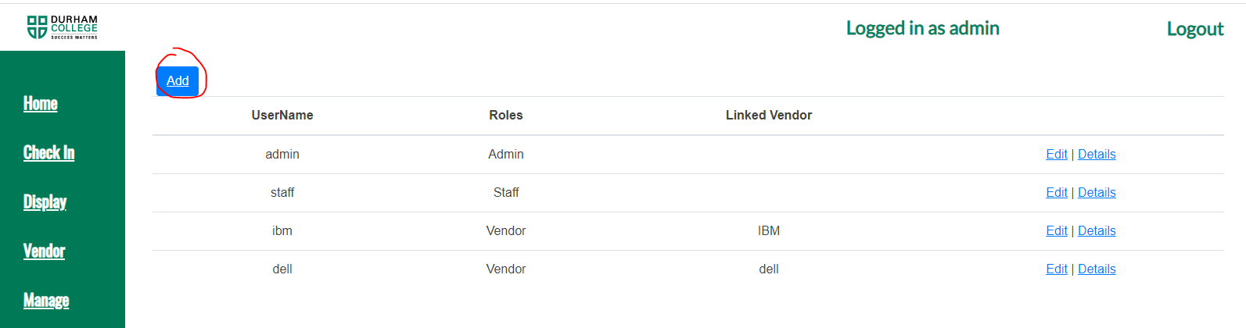

To Manage attendees

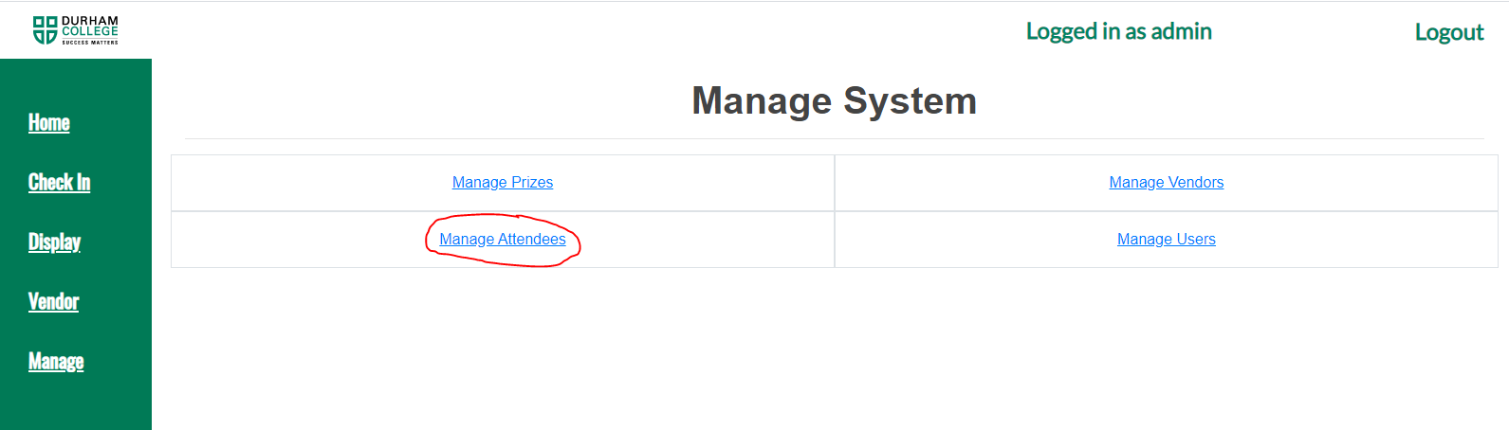

Importing attendee from .csv file

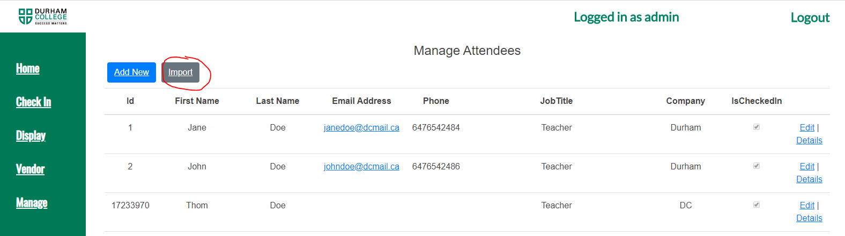

Add new attendees

